

**Supplementary Materials for the article**

“Red-light thresholds for induced seismicity in the UK”

*by*

*Ryan Schultz, Brian Baptie,*

*Benjamin Edwards, & Stefan Wiemer*

Correspondence to Ryan Schultz (Ryan.Schultz@sed.ethz.ch)

**This file includes:**

Figures S1-S12

**Supplementary Figures**

**Figure S1. Formation depth map for the UK.** Depth contours for the top of the HF target formations. Data is from Limestone Coal Formation (Carboniferous) for the Midland Valley Basin [Monaghan, 2014], the Bowland Shale (Mississippian) top [Andrews, 2013], and the Kimmeridge Clay (Upper Jurassic) top for the Weald Basin [Andrews, 2014].

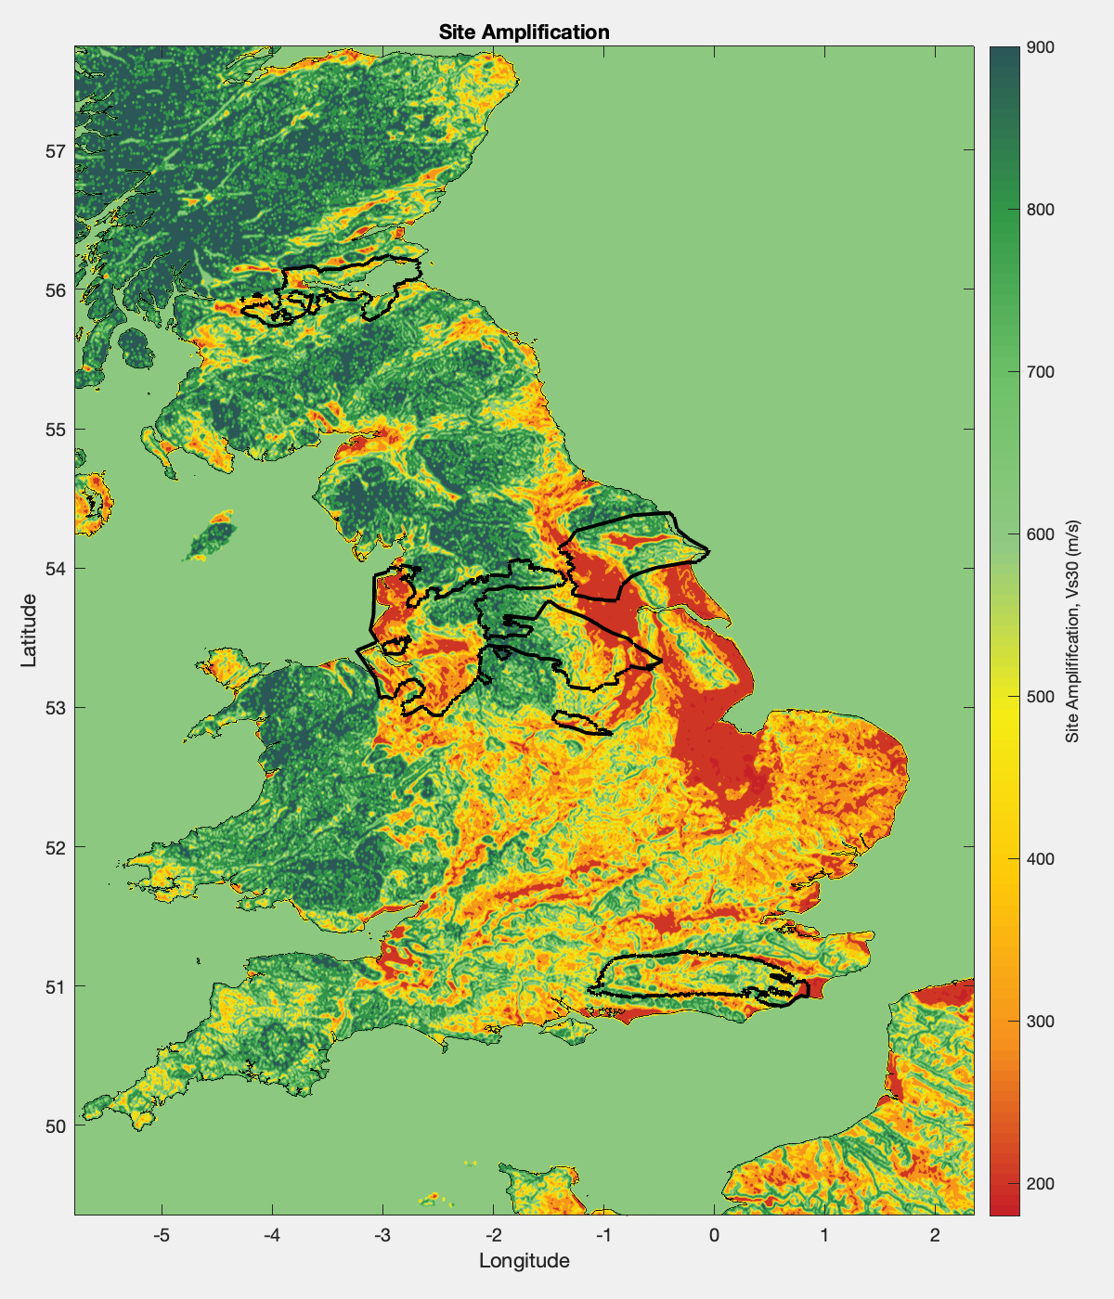

**Figure S2. Site amplification map of the UK.** Larger map of VS30, a proxy for site amplification is shown for the UK (black line). Data is from a global VS30 compilation database [Heath et al., 2020].

**Figure S3. Population density map for the UK.** Larger map of the local population is shown for the UK region and the HF plays (white polygons). The black background denotes zero population areas. Data is from the LandScan 2018 database [Rose et al., 2018].

**Figure S4. Nuisance, fragility, and vulnerability functions.** Chance of encountering risks are displayed as a function of ground motion (top row) and as a function of magnitude (bottom row) for an average earthquake at 3 km depth, 5 km away, and a VS30 of 300 m/s. The typical probabilities (thick lines) are shown alongside a distribution of 100 perturbations (thin lines). Nuisance functions are from Schultz et al. [2021a], fragility functions are from Korswagen et al. [2019], vulnerability functions are from Crowley & Pinho [2020], and the GMPE is from Edwards et al. [2021].

**Figure S5. Comparison of vulnerability functions.** Here we compare the vulnerability function from the Groningen [Crowley & Pinho, 2020] against the ones from the USGS PAGER system [Jaiswal et al., 2009; 2010]. Ground motions are converted to Intensity via a conversion relationship [Caprio et al., 2015].

**Figure S6. Annual population trend for the UK.** Annual population growth in the UK (blue line) is shown for the past three decades. In 2018, there were 67 million people in the UK. Data is from an online database [UN-PD, 2023].

**Figure S7. PH-1 earthquake impact scenarios.** Comparison of risk metrics between the ML 1.2 5 May 2011 (darker green bars), ML 1.4 5 May 2011 (lighter green bars) and ML 2.3 1 April 2011 PH-1 events (red bars) alongside 50th percentile estimated tolerances for risk (dashed lines). Risk metrics of nuisance (a-c) and damage (d) are considered. Plot is analogous to Figure 6.

**Figure S8. HH-1 earthquake impact scenarios.** Comparison of risk metrics between the ML 2.5 18 June 2018 (green bars), ML 2.5 1 April 2018 (orange bars) and ML 3.0 5 July 2018 (ML 3.2 27 February 2019) HH-1 events (red bars) alongside 50th percentile estimated tolerances for risk (dashed lines). Risk metrics of nuisance (a-c) and damage (d) are considered. Plot is analogous to Figure 6.

**Figure S9. Iso-nuisance combination maps.** Plots of iso-nuisance maps based on empirically derived CDI 2-4 nuisance tolerances (panels on top row). These three iso-nuisance maps are combined by taking the minimum red-light value at each grid point (bottom left panel). The controlling nuisance degree is shown for each grid point (bottom right panel).

**Figure S10. Iso-damage combination maps.** Plots of iso-damage maps based on empirically derived DS 1-2 damage tolerances (panels on top row). These two iso-damage maps are combined by taking the minimum red-light value at each grid point (bottom left panel). The controlling damage state is shown for each grid point (bottom right panel).

**Figure S11. The proposed TLP retrospectively applied to PNR-1z.** Stimulation operations (black lines) for individual stages (text labels) are shown alongside the induced earthquakes (blue circles) and our proposed TLP thresholds (solid-coloured lines). Purple lines approximately indicate how an adaptive TLP would change with time, based on catalogued data from the previous stage stimulation. The proposed red-light (both adaptive and static) would not have been triggered for the PNR-1z case. Red-light moment magnitudes were estimated using an ML-MW conversion relationship [Edwards et al., 2021]. Top panel contains the first half of stage stimulations, bottom panel contains the second half. Plot is analogous to Figure 10.

**Figure S12. The proposed TLP retrospectively applied to PH-1.** Stimulation operations (black lines) for individual stages (text labels) are shown alongside the induced earthquakes (blue circles) and our proposed TLP thresholds (solid-coloured lines). The proposed (static) red-light would have been triggered for the PH-1 case, by the ML 2.3 event. Not enough data is available to provide a pseudo adaptive TLP. Plot is analogous to Figure 10.