**Supplementary Material for Detection of Hidden Low-Frequency Earthquakes in Southern Vancouver Island with Deep Learning**

**Jiun-Ting Lin1, Amanda M. Thomas2, Loïc Bachelot2, Douglas R. Toomey2, Jake Searcy3, Diego Melgar2**

1Lawrence Livermore National Laboratory, Livermore, CA, USA

2Department of Earth Sciences, University of Oregon, Eugene, OR, USA

3School of Computer and Data Sciences, University of Oregon, Eugene, OR, USA

Corresponding author: Jiun-Ting Lin (lin51@llnl.gov)

**Contents of this file**

Figure S1 to S9

**Introduction**

This supporting information includes 9 figures supporting the main text. Part of the work was performed under the auspices of the U.S. Department of Energy by Lawrence Livermore National Laboratory under Contract DE-AC52-07NA27344. This is LLNL Contribution Number LLNL-JRNL-855845.

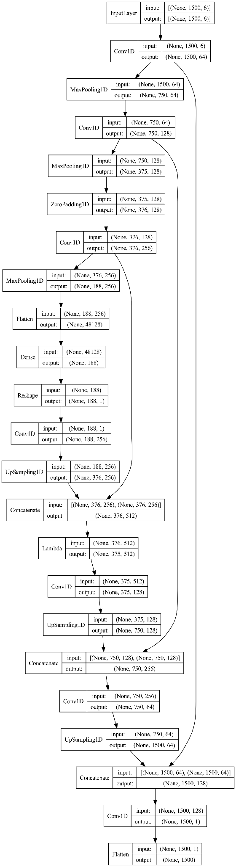

*Figure S1. Model architecture for this study. Inputs are scaled 3-components waveforms with their corresponding sign values, comprising a total of 6 channels. The output is represented by a single channel showing the possibility of P or S arrival.*

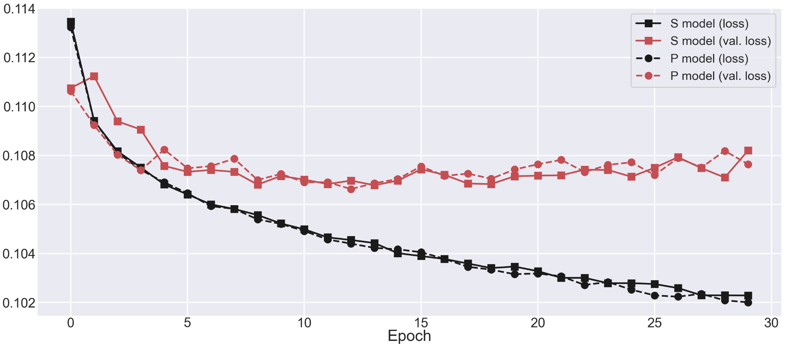

*Figure S2. Training and validation losses for the P and S model.* During each epoch, approximately 700,000 waveforms are processed.

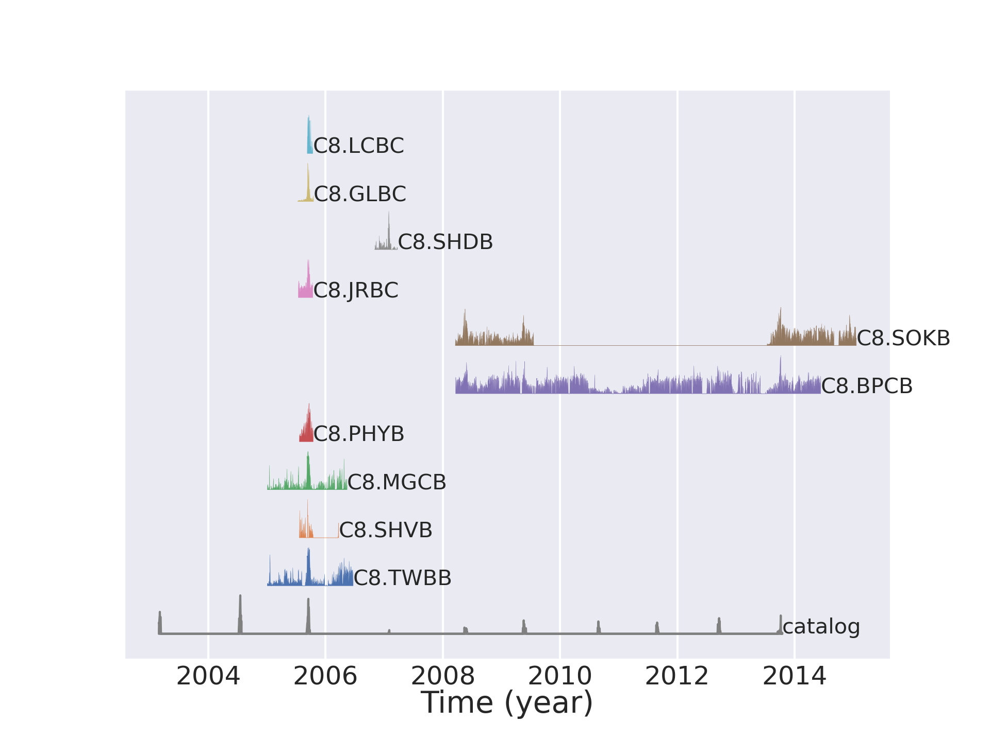

*Figure S3. Model performance on 10 unused stations. The station locations are shown in Figure 1.*

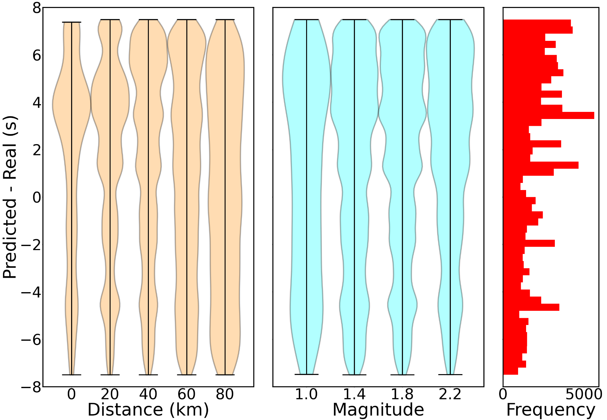

*Figure S4. Distribution of P arrival time misfits in different distance and magnitude groups, evaluated by ~130,000 testing data. Given the large misfit, we exclude P arrivals from the locating analysis.*

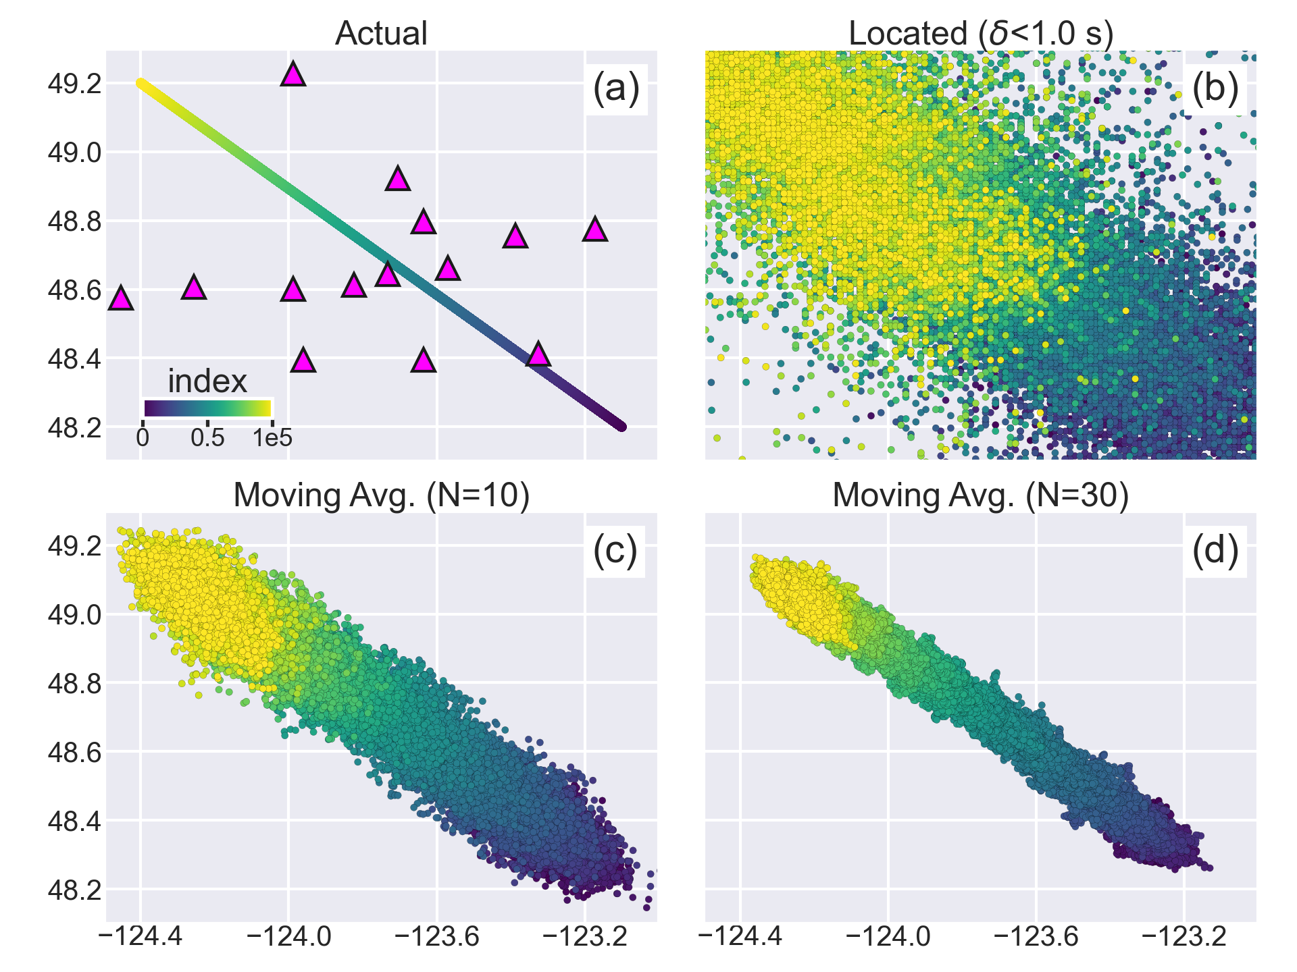

*Figure S5. Same as Figure 9. Locating sensitivity test of 100,000 simulated events moving from SE to NW. (a) Actual location of the 100,000 events color-coded by their index number. (b) Locating result with averaged travel time residual <1.0 s. (c) Moving average of the located result with N=10 sources. (d) Same as (c), but for N=30 sources.*

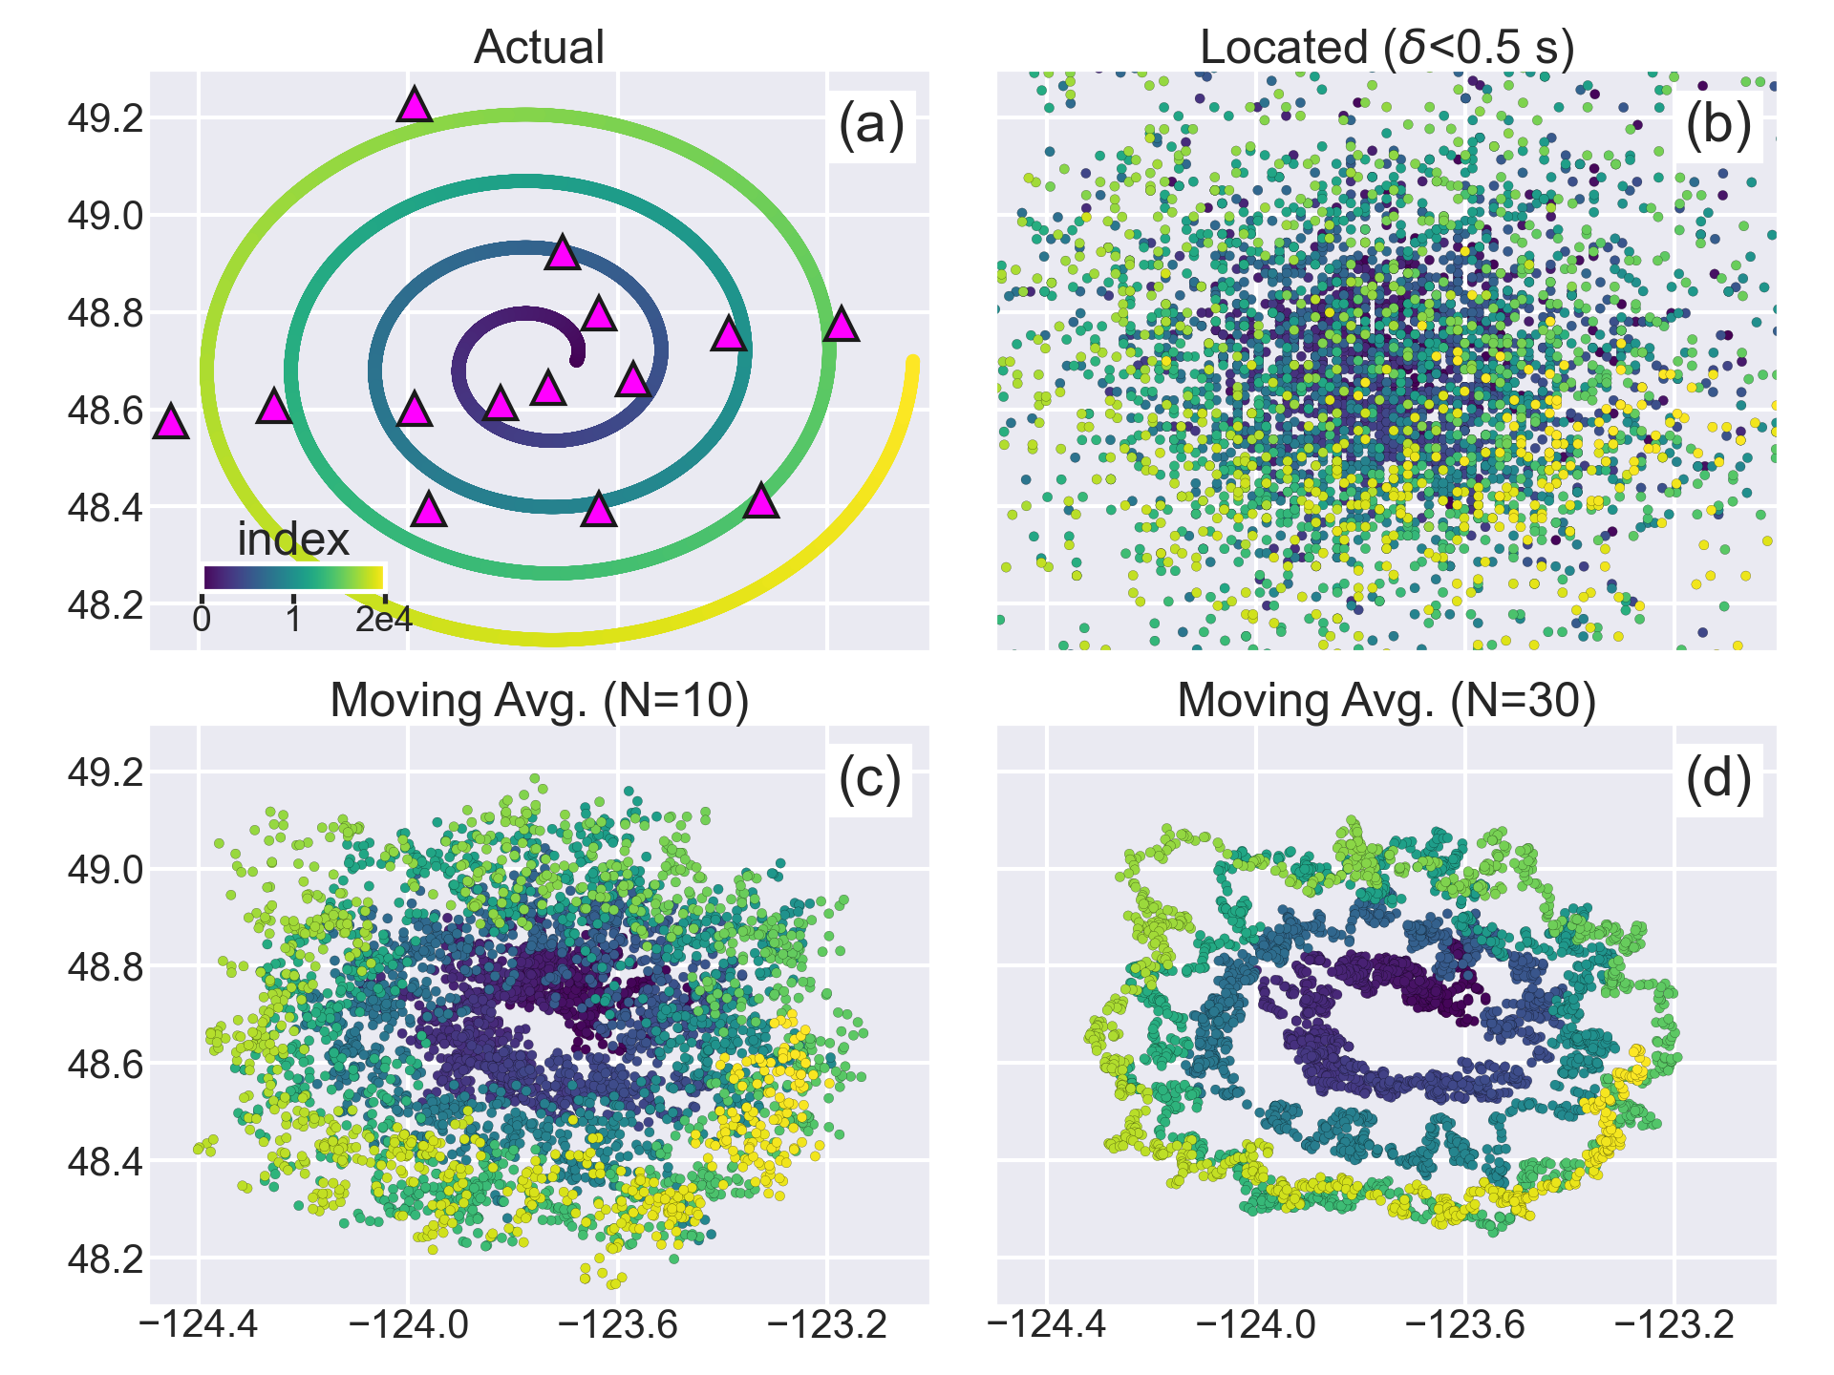

*Figure S6. Same as Figure 9. Locating sensitivity test of 20,000 simulated events with a spiral shape. (a) Actual location of the events color-coded by their index number. (b) Locating result with averaged travel time residual <0.5 s. (c) Moving average of the located result with N=10 sources. (d) Same as (c), but for N=30 sources.*

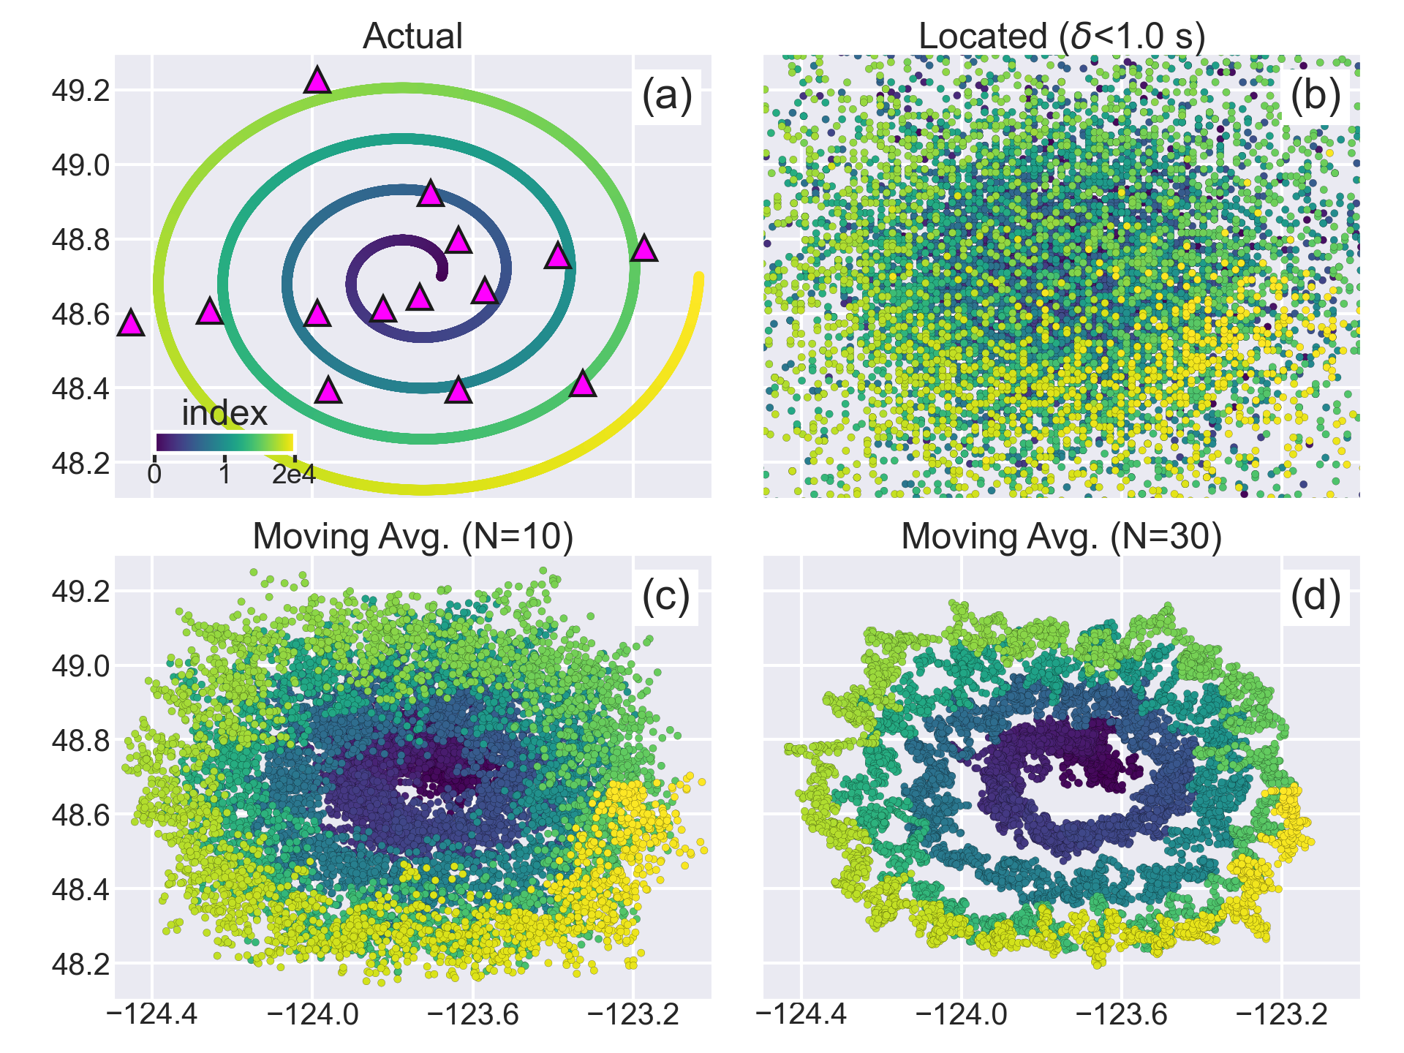

*Figure S7. Same as Figure 9. Locating sensitivity test of 20,000 simulated events with a spiral shape. (a) Actual location of the events color-coded by their index number. (b) Locating result with averaged travel time residual <1.0 s. (c) Moving average of the located result with N=10 sources. (d) Same as (c), but for N=30 sources.*

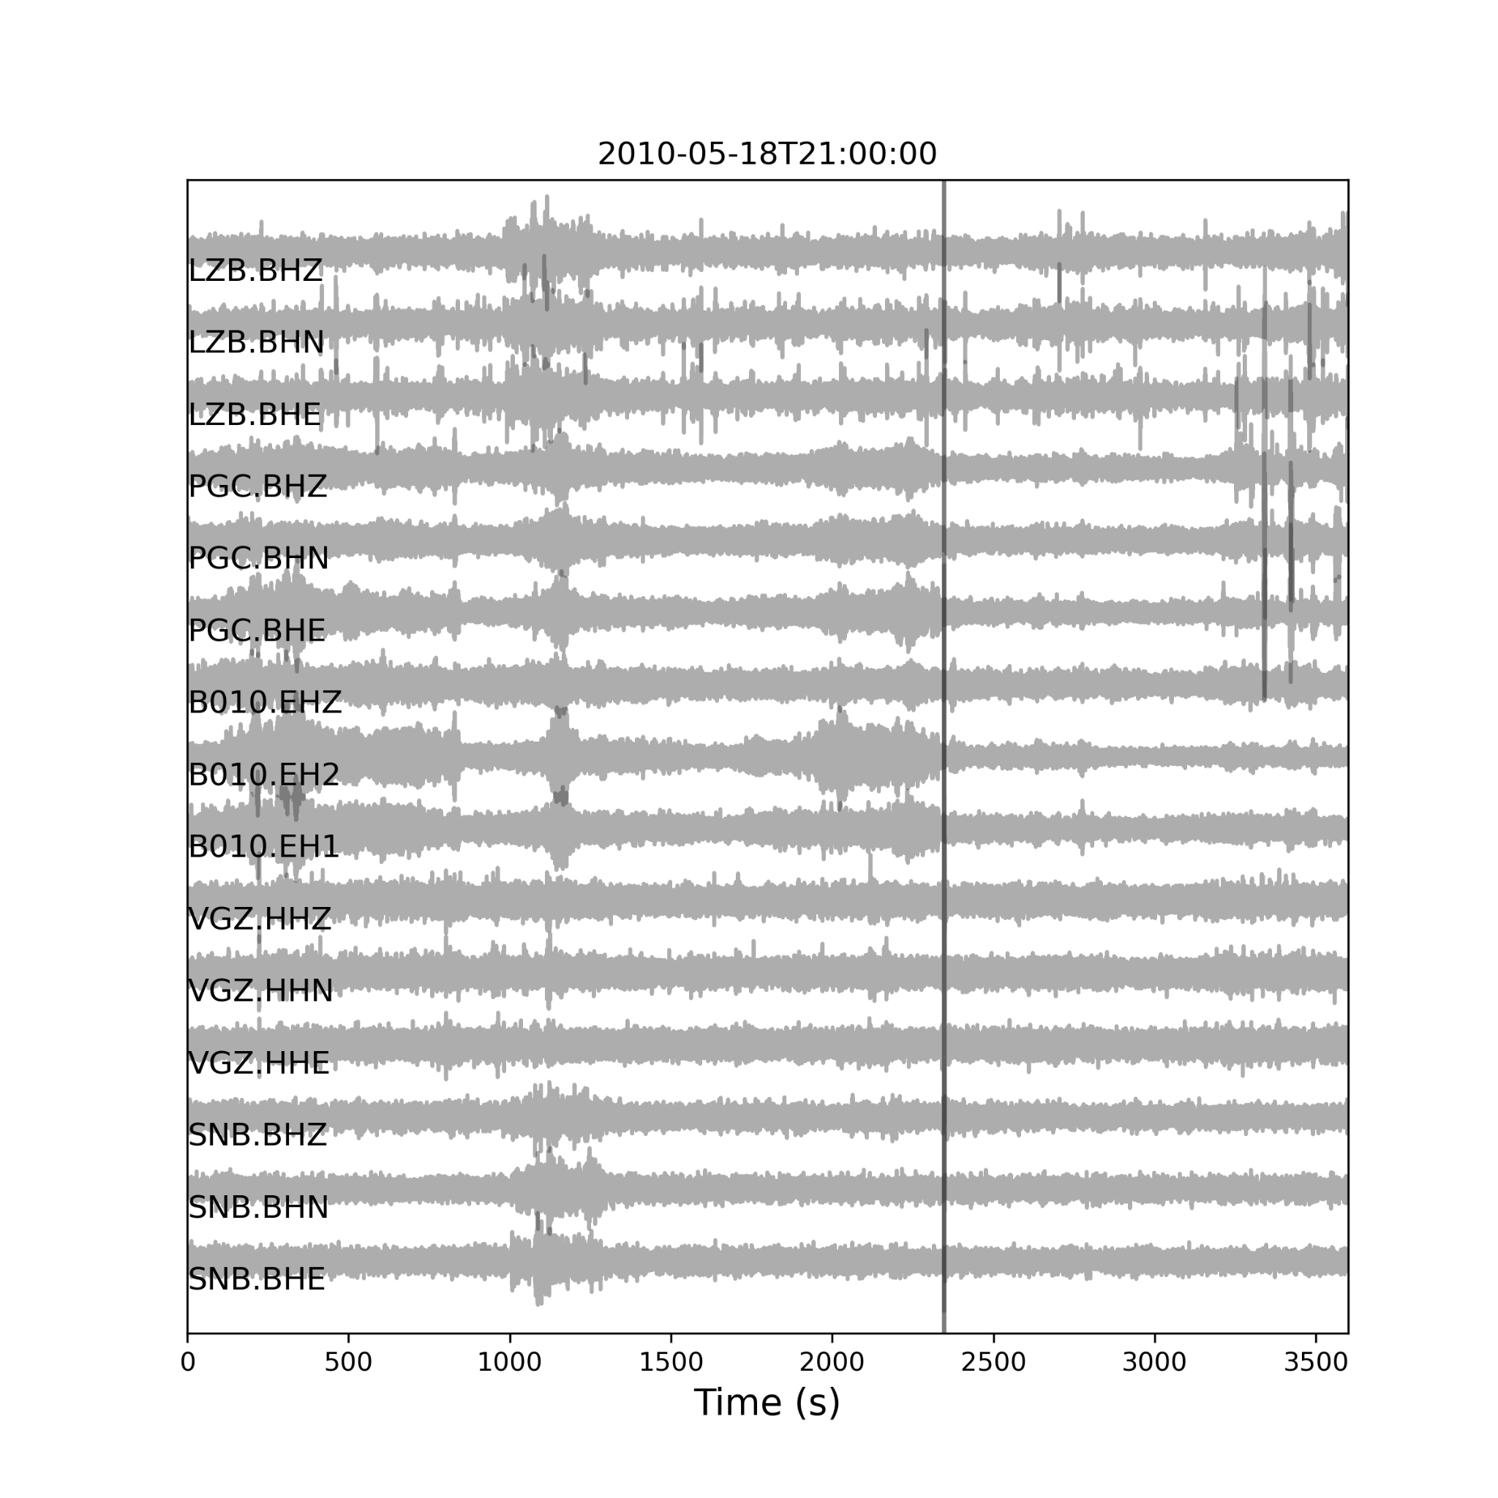

*Figure S8. Time series of plausible tremors signal at 5 stations, spanning a maximum distance of 50 km, on May 18th. The time series start at 2010-05-18T21:00:00 with a duration of 1 Hr.*

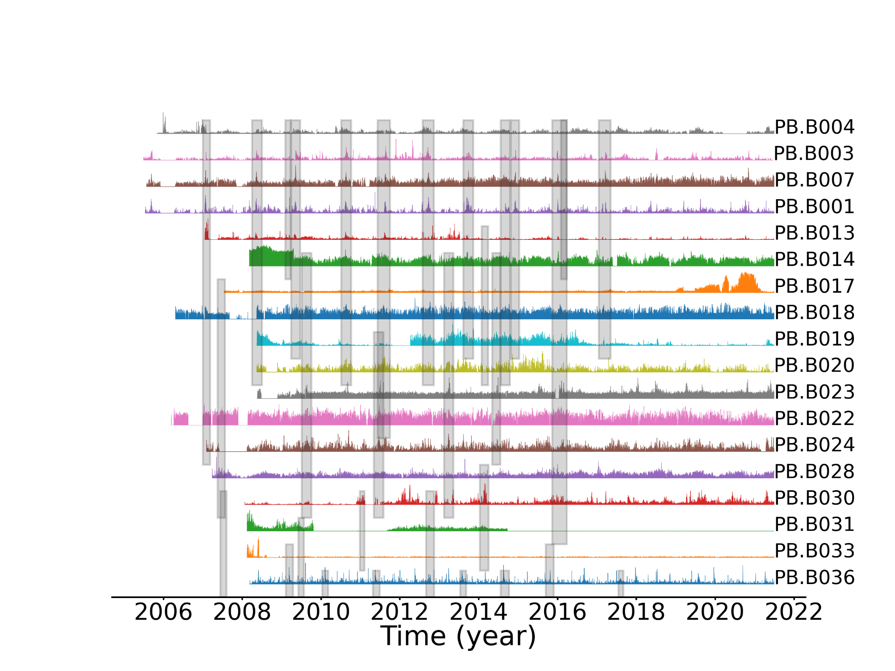

*Figure S9. Model detection results for new stations spanning from central to southern Cascadia region. The time series show the daily detection number for all the stations, normalized by their maximum value. Stations are sorted by their latitude from north (top: PB.B004) to south (bottom: PB.B036). Light gray shaded areas mark the SSE results from Michel et al. (2019). The results show that while the peak LFE detections are consistent with the SSEs, the overall results are noisy.*