Seismica
Supporting Information for
Validation of tsunami earthquake ground-motion simulations using near-field observational data: Rupture parameter constraints from the 2010 Mentawai event
T. A. Nye^{1,†}, V. J. Sahakian¹, D. Melgar¹
¹Department of Earth Sciences, University of Oregon, Eugene, Oregon, USA
†Now at the US Geological Survey, Moffett Field, California, USA

Contents of this file

Figures S1 to S9

Introduction
This electronic supplement contains the illustrations of the kinematic slip models used to generate synthetic waveforms for the 2010 Mentawai tsunami earthquake, a comparison between the original coarse slip model from Yue et al. (2014) and our finely discretized model, an illustration of the matched filter technique implemented, examples of observed ringing and effects of varying the shallow velocity structure, and an example of M_{PGA} estimation. Rupture files and waveforms for the simulations can be accessed via the accompanying Zenodo dataset (Nye et al., 2024).

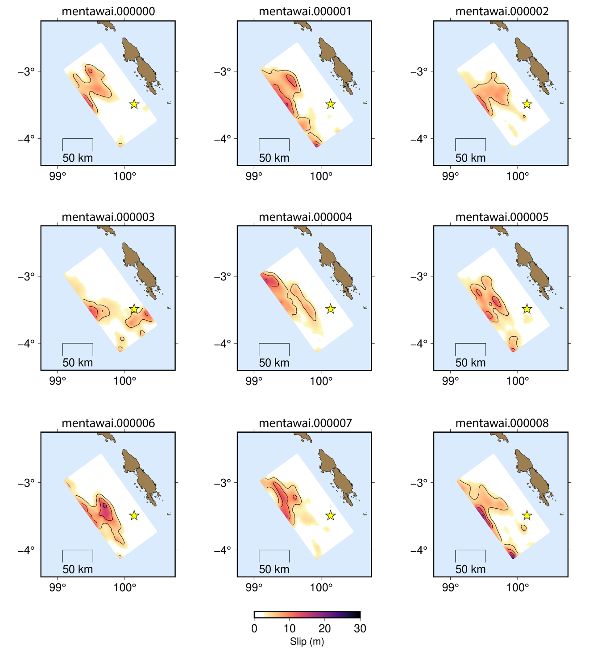
Figure S1. Slip models for all 30 initial stochastic ruptures (i.e., mentawai.000000, mentawai.000001, …, mentawai.000029, respectively).

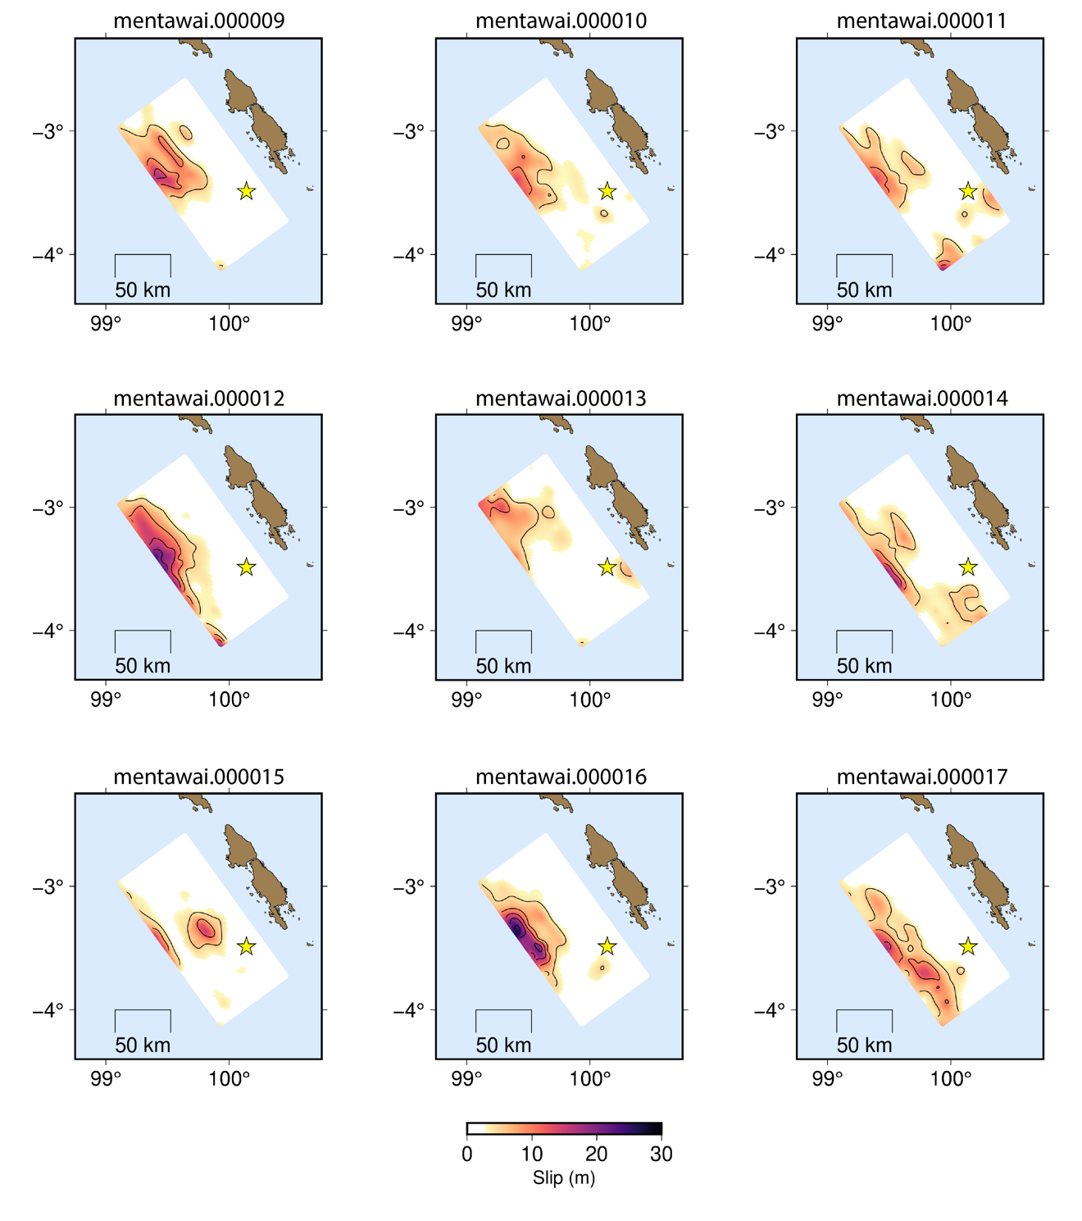
Figure S1. Continued…
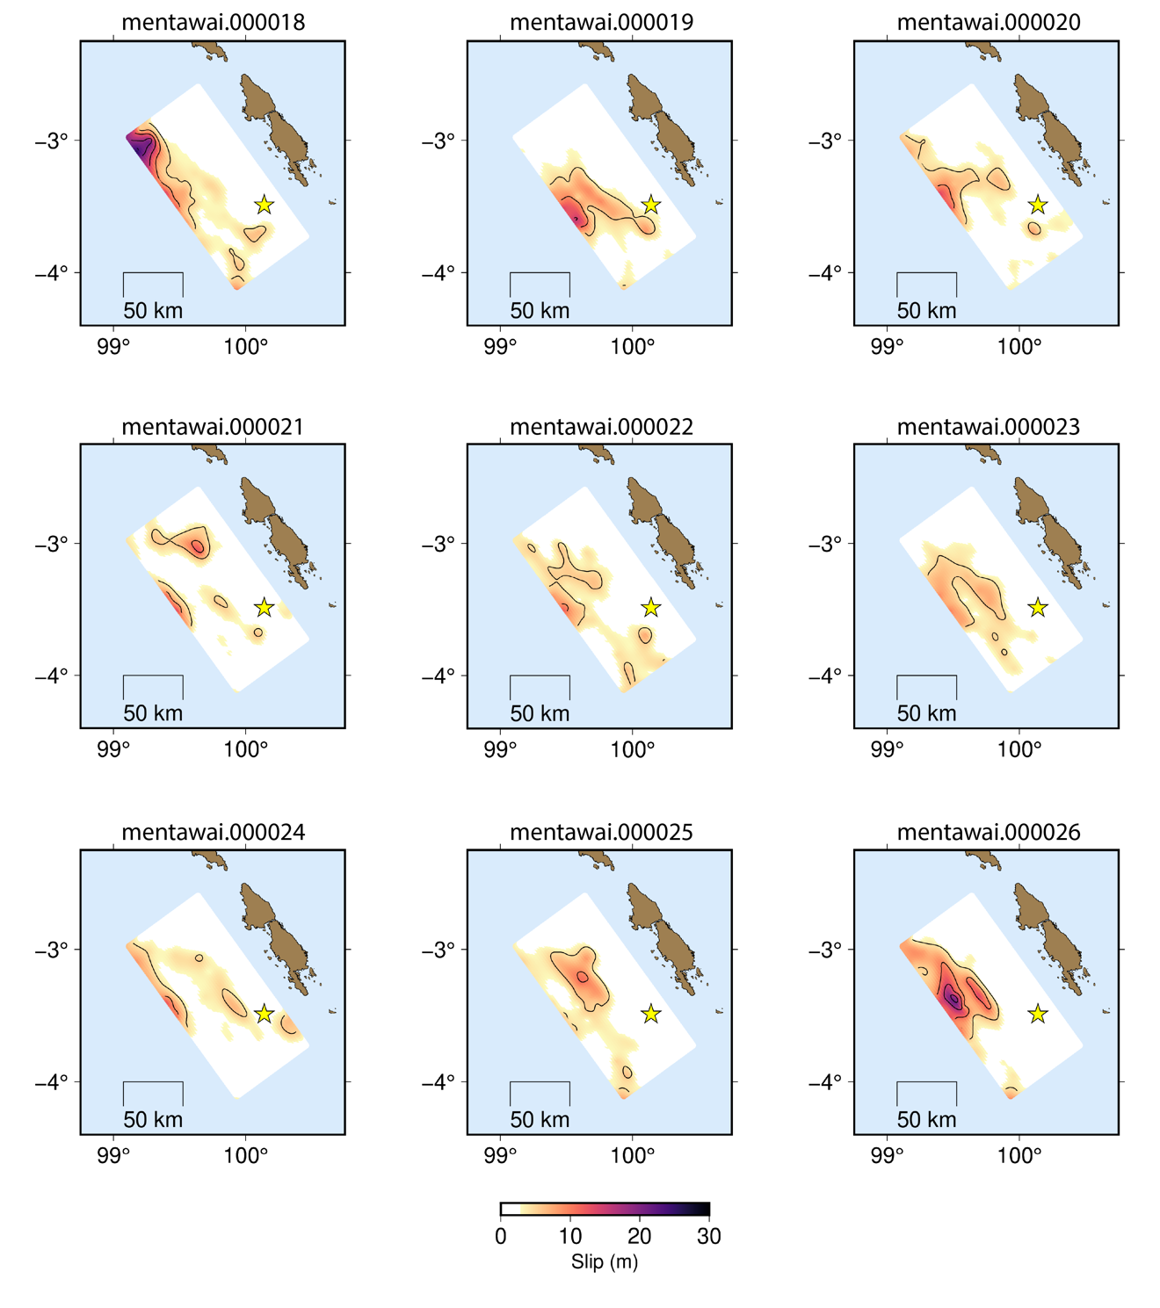
Figure S1. Continued…
Figure S1. Continued…

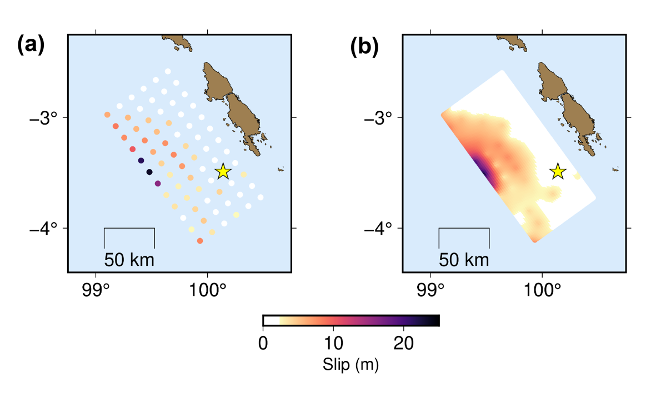
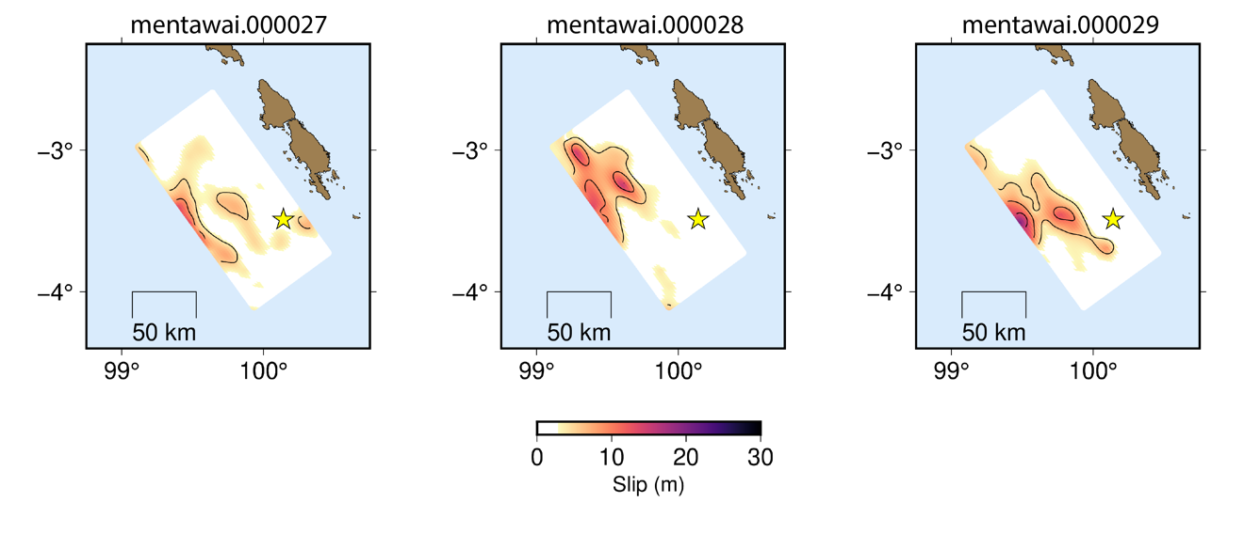
Figure S2. (a) Coarsely discretized slip model from Yue et al. (2014). (b) Finely discretized version of the slip model from (a) used as the mean slip model for this study.
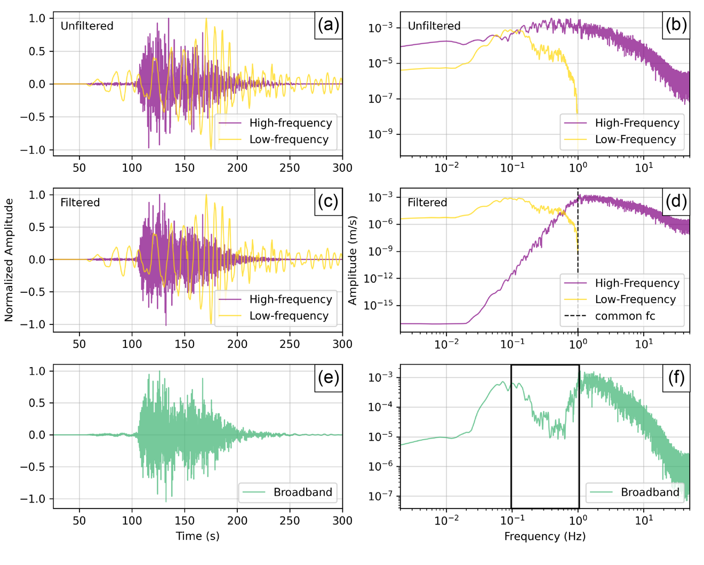
Figure S3. (a) Illustration of the simulation matched filter process using a common corner frequency (f_{c}) for both the lowpass and highpass filters. (a) Normalized amplitudes of the individual low-frequency (yellow) and high-frequency (purple) waveforms in units of acceleration prior to any filtering. (c) Normalized amplitudes of the individual lowpass filtered low-frequency (yellow) and highpass filtered high-frequency (purple) waveforms, both with a filter f_{c} of 1 Hz. (e) Normalized amplitude of the resulting broadband waveform after combing the waveforms in (c). (b,d,f) Fourier amplitude spectra of the waveforms in (a,c,e). The dashed line in (d) indicates the filter f_{c}, and the black box in (f) highlights the artificial notch in the broadband spectrum.

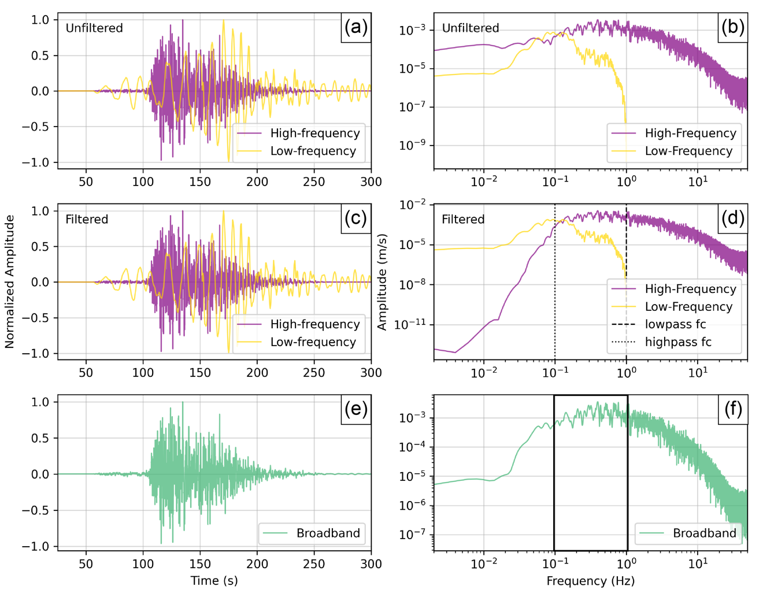
Figure S4. Illustration of the matched filter process using a separate corner frequency (f_{c}) for the lowpass and highpass filters. (a) Normalized amplitudes of the individual low-frequency (yellow) and high-frequency (purple) waveforms in units of acceleration prior to any filtering. (c) Normalized amplitudes of the individual low-frequency (yellow) waveform lowpass filtered with a filter f_{c} of 1 Hz, and the high-frequency (purple) waveform highpass filtered with a filter f_{c} of 0.1 Hz. (e) Normalized amplitude of the resulting broadband waveform after combing the waveforms in (c). (b,d,f) Fourier amplitude spectra of the waveforms in (a,c,e). The dashed and dotted lines in (d) indicate the lowpass and highpass filter f_{c}, respectively, and the black box in (f) highlights the smoothed spectrum absent of an artificial notch.

Figure S5. Observed HR-GNSS displacement waveforms for the 2010 M7.8 Mentawai event.
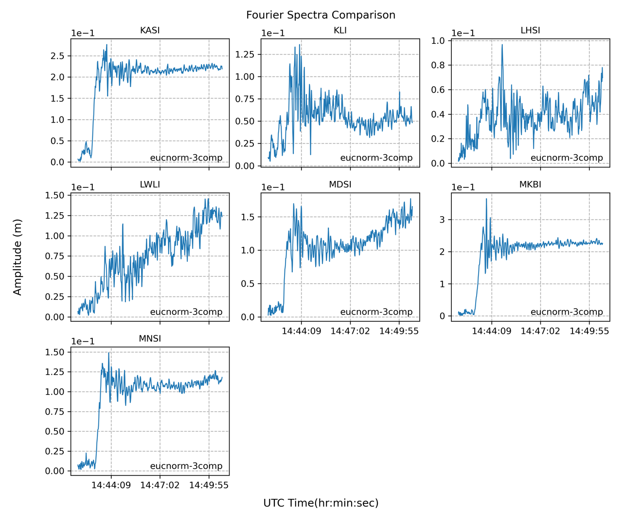
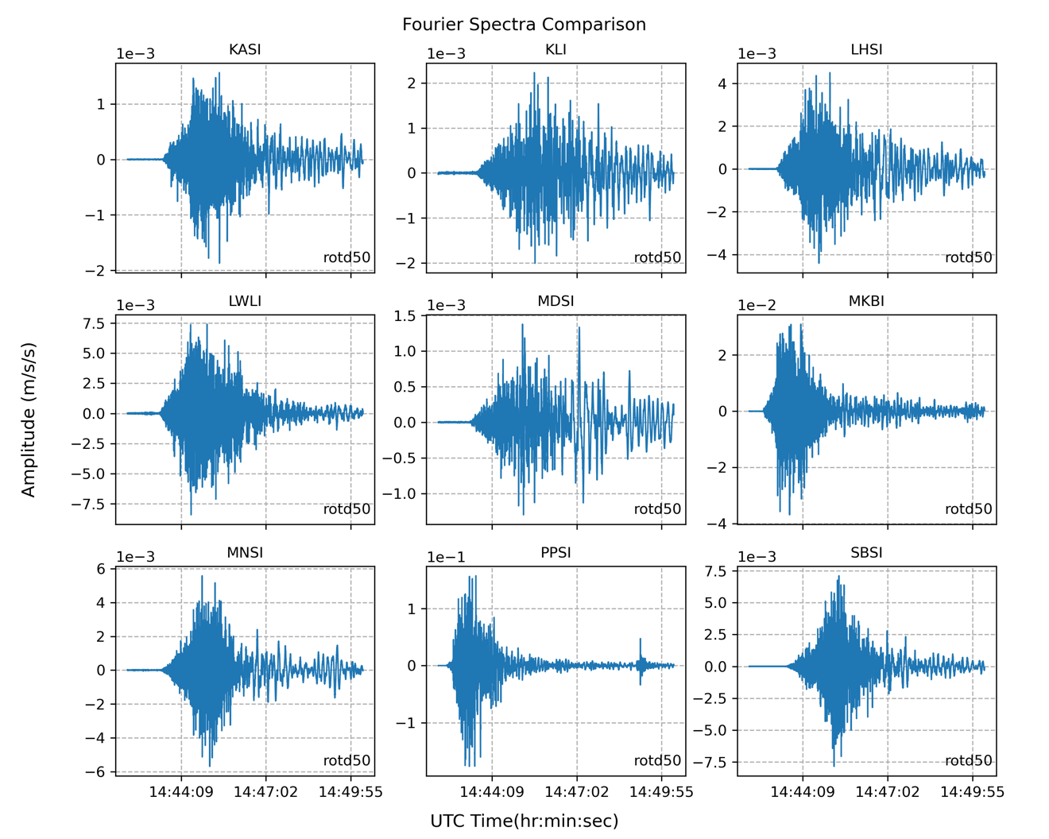
Figure S6. Observed strong-motion acceleration waveforms for the 2010 M7.8 Mentawai event.

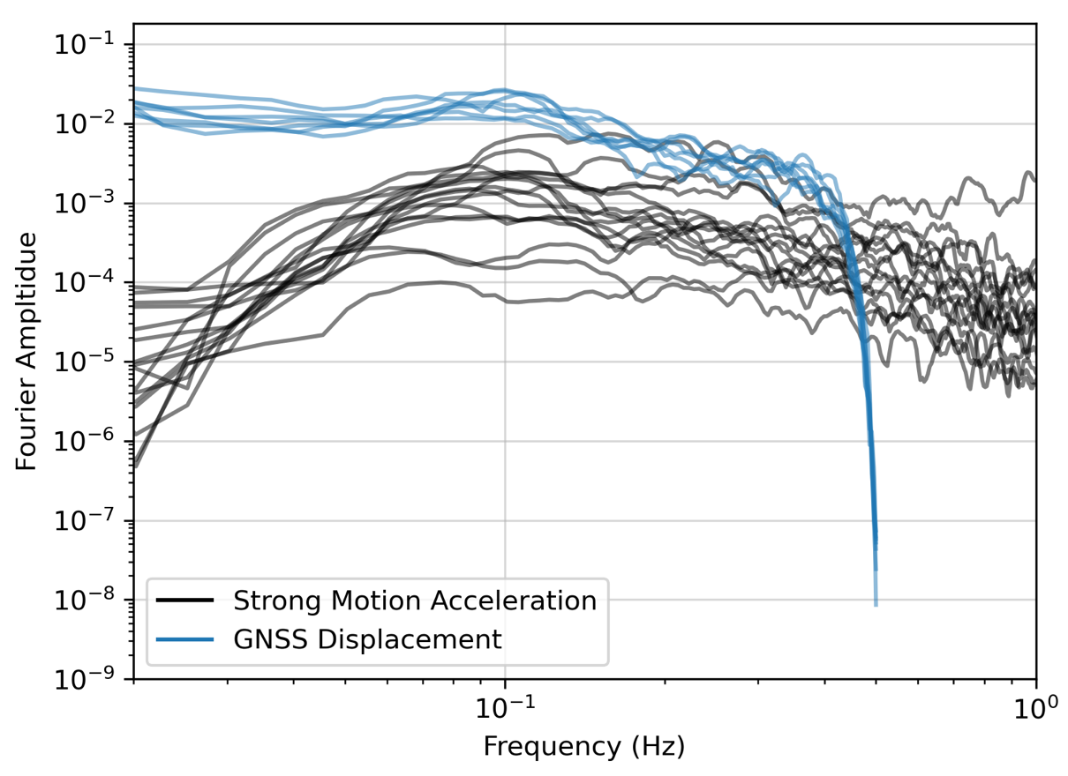
Figure S7. Fourier amplitude spectra of the ringing observed in the strong-motion and GNSS recordings of the 2010 Mentawai event. To capture the ringing, the records were trimmed to start at 2010–10–25T14:47:02Z. For both the seismic and geodetic data, the energy peaks around 0.1 Hz.

Figure S8. (left) Comparison between the original velocity model used for this study and three variations of the velocity model using softer layers in the shallow subsurface. (right) Binned displacement Fourier amplitude spectra for three example HR-GNSS stations using the different velocity models.
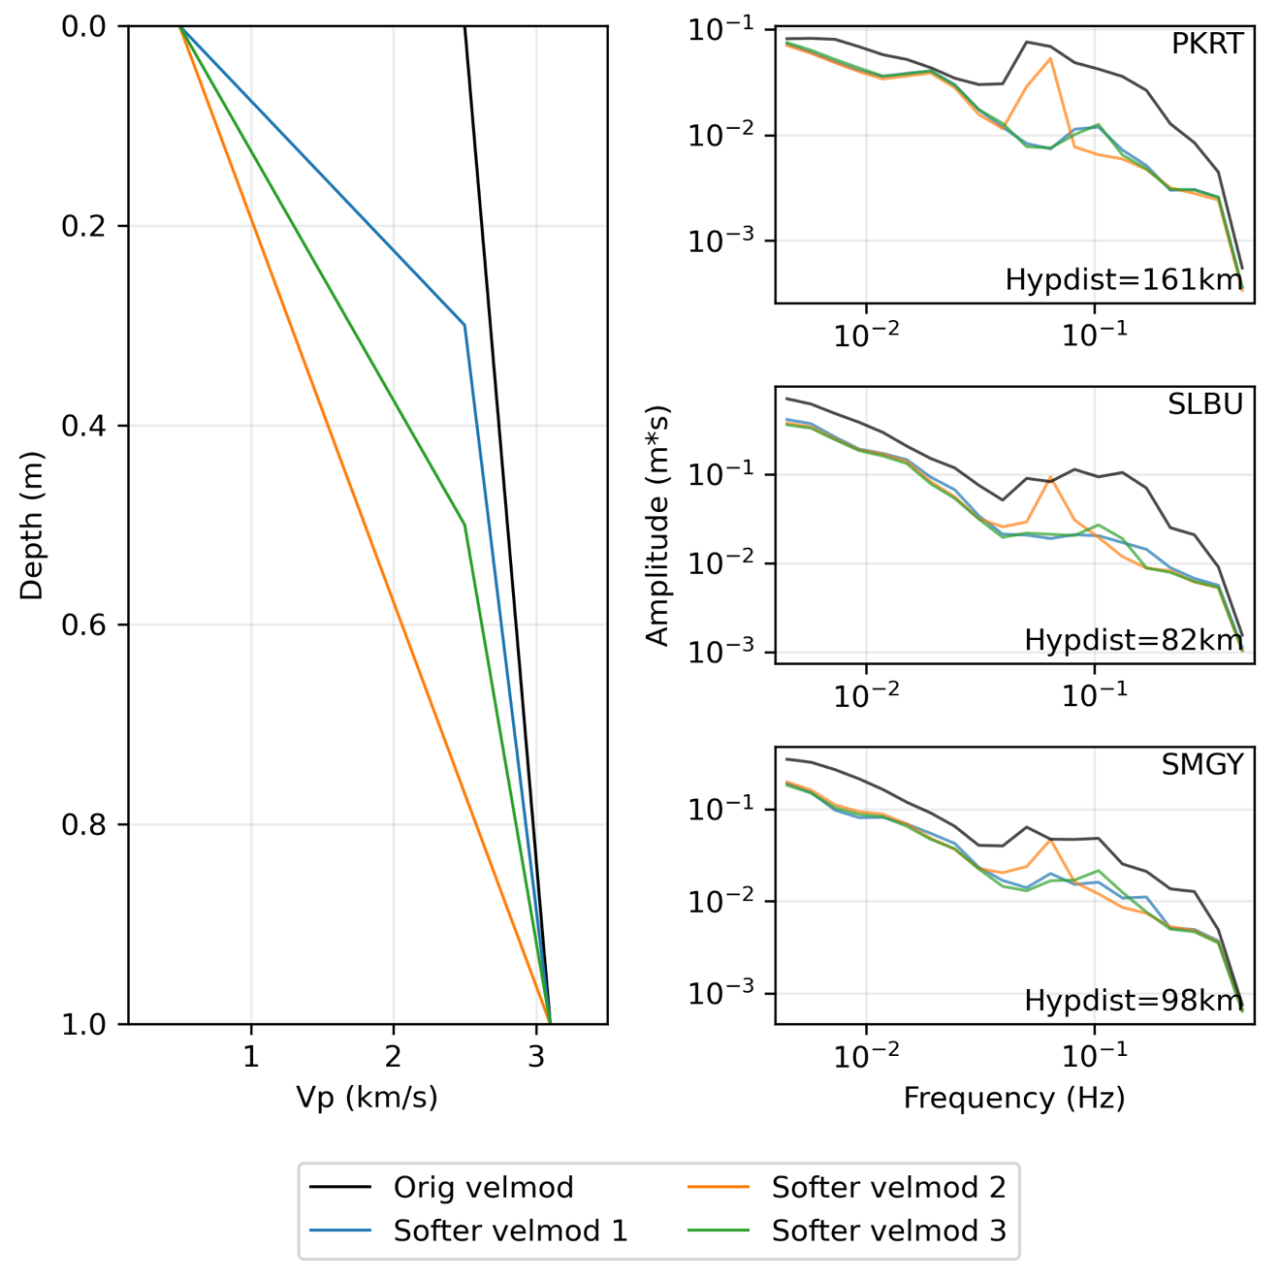

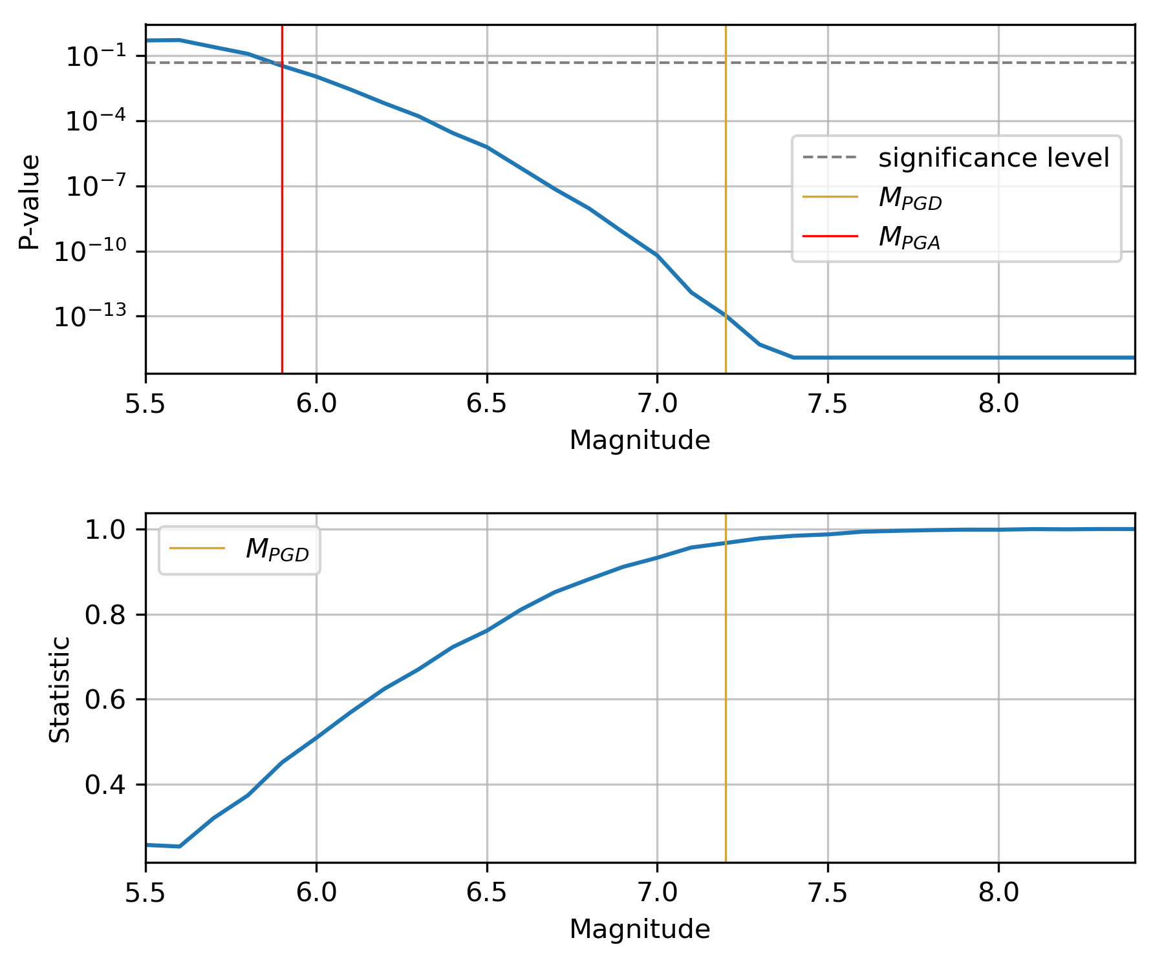
Figure S9. Example solvation for M_{PGA} for one stochastic event with one set of parameters. (top) P-value for Kolgomorov–Smirnov (K–S) tests performed between simulated PGA values and GMM PGA predictions for trial magnitudes ranging M5.5-8.5. M_{PGD} and M_{PGA} for this event are indicated by the gold and red lines, respectively. (bottom) Statistic values for the K–S tests.

Data and code availability
Observed data for the 2010 Mentawai tsunami earthquake were obtained from Muzli Muzli of the Agency for Meteorology, Climatology, and Geophysics of Indonesia (BMKG) and from the Rhul et al. (2019) database. These data were recorded by HR-GNSS instruments operated by the Badan Informasi Geospasial (BIG) and strong-motion stations operated by the BMKG. Simulated data were generated using FakeQuakes, and the codes are available online at https://github.com/dmelgarm/MudPy. Inversion data used for simulating the Mentawai event were obtained from Yue et al. (2014). Rupture files and waveforms for the simulations can be accessed via our online Zenodo dataset (Nye et al., 2024). Maps were produced using the Generic Mapping Tools software (Wessel et al., 2019) with a digital elevation model downloaded from GMTSAR (Sandwell et al., 2011), and all analyses were completed with in-house code, available online at https://github.com/taranye96/tsuquakes. This includes a parameter configuration file for simulating data with FakeQuakes, and all major codes used for processing and analysis of the data.

References
Nye, T., Sahakian, V. J., & Melgar, D. (2024). 2010 Mentawai tsunami earthquake simulations [Dataset]. Zenodo. https://doi.org/10.5281/zenodo.10023345
Ruhl, C. J., Melgar, D., Chung, A. I., Grapenthin, R., & Allen, R. M. (2019). Quantifying the value of real‐time geodetic constraints for earthquake early warning using a global seismic and geodetic dataset. Journal of Geophysical Research: Solid Earth, 124(4), 3819–3837. https://doi.org/10.1029/2018JB016935
Sandwell, D., Mellors, R., Tong, X., Wei, M., & Wessel, P. (2011). Open radar interferometry software for mapping surface deformation. Eos Transactions American Geophysical Union, 92(28). https://doi.org/10.1029/2011EO280002
Wessel, P., Luis, J. F., Uieda, L., Scharroo, R., Wobbe, F., Smith, W. H. F., & Tian, D. (2019). The Generic Mapping Tools version 6. Geochemistry, Geophysics, Geosystems, 20(11), 5556–5564. https://doi.org/10.1029/2019GC008515
Yue, H., Lay, T., Rivera, L., Bai, Y., Yamazaki, Y., Cheung, K. F., Hill, E. M., Sieh, K., Kongko, W., & Muhari, A. (2014). Rupture process of the 2010 Mw 7.8 Mentawai tsunami earthquake from joint inversion of near-field HR-GPS and teleseismic body wave recordings constrained by tsunami observations. Journal of Geophysical Research: Solid Earth, 119(7), 5574–5593. https://doi.org/10.1002/2014JB011082

