**Supplementary Tables and Figures**

Table S1. 1D velocity structure used for this study.

|  |  |  |  |
| --- | --- | --- | --- |
| Depth(km) | Vp(km/sec) | Vs(km/sec) | Density(kg/m^3) |
| 0-0.75 | 2.400 | 1.385 | 2200 |
| 0.75-1.5 | 4.000 | 2.309 | 2400 |
| 1.5-45 | 5.716 | 3.300 | 2700 |

Figure S1. Catalog of aftershock locations for the Chihshang earthquake sequence. Data are from the “SeisBlue” catalog from Sun et al. (2024), and have been relocated using the double-difference location algorithm HypoDD (Waldhauser & Ellsworth, 2000). Locations of the mapped traces of the Longitudinal Valley Fault (LVF), and the Central Range Fault (CRF) are shown.

Figure S2. Distribution of surface slip from our sub-pixel optical image correlation results. The location of the main asperity (shown as a dashed black line in Figure 1B) is located approximately between 30-40 km distance.

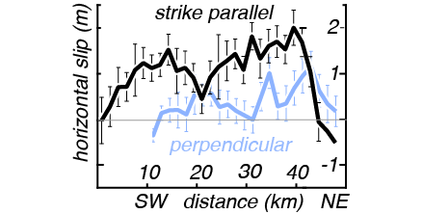

Figure S3. The waveform misfit diagrams for the 5 stations shown in Figure 4A..

Figure S4a. Waveform misfit as a function of nondimensional prestress ${\overline{τ}}^{0}=(τ^{0}-τ^{d})/(τ^{s}-τ^{d})$ (Kaneko and Lapusta, 2010)

Figure S4b. The plot of waveform misfit as a function of frictional cohesion.

Figure S5. The waveform comparisons including HGSD using the preferred model for stations that are not shown in Figure 4A.

Figure S6. Location of the stations as shown in the main paper and supplemental Figure S3.

グラフ

Figure S7. Velocity seismogram of F073 for the default case but with a homogeneous half-space.

ダイアグラム

Figure S8. Velocity seismograms of F073 for the default case but with uniform Dc (= 0.3 m).

Figure S9. Snapshots of slip rate and the final slip distributions for our preferred multi-patch model (left panels) and the single-patch model (right panels). Numerical oscillations are due to the marginal resolution of the fault model.

Figure S10. Modelled particle motion plots for Station JPIN resulting from rupture of a 10 km-scale asperity on the Long Valley Fault (plot of fault slip shown in Fig. S11). Assumed parameters are the same as the preferred multi-patch model of the CRF shown in Figure 4C except for uniform prestress rake angle of 45o (i.e., oblique left-lateral slip), μs=0.60, and μd=0.45. Since the precise location of JPIN relative to the LVF slip patch is uncertain, we show synthetic particle motions at two stations (JPIN and JPIN’) separated by 3 km apart. Inferred slip on the LVF of up to 1 m results in limited (<15 cm) of displacement at the surface near GPS site JPIN. This demonstrates that triggered slip on the LVF does not change the main findings of this study.

Figure S11. Slip rate (left panels) and slip magnitude (right panels) for a 10x10 km model asperity with 70° dip angle (see Fig. S8). Slip reaches a maximum of ~1 m at 8 km depth, and tapers to 20-30 cm at the free surface, qualitatively similar to the inferred slip on the LVF by Tang et al. (2023).

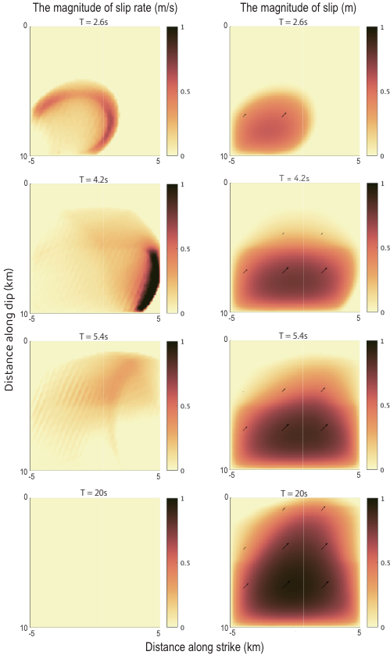

**References**

Sun, Wei-Fang, Sheng-Yan Pan, Chun-Ming Huang, Zhuo-Kang Guan, I-Chin Yen, Chun-Wei Ho, Tsung-Chih Chi (2024). Deep learning-based earthquake catalog reveals the seismogenic structures of the 2022 Mw 6.9 Chihshang earthquake sequence. *Terrestrial, Atmospheric and Oceanic Sciences* 35, no. 1 (2024): 5.

Waldhauser, Felix, and William L. (2000). Ellsworth. A double-difference earthquake location algorithm: Method and application to the northern Hayward fault, California. *Bulletin of the seismological society of America* 90, no. 6: 1353-1368.