Seismica
Supporting Information for
Validation Framework for semi-stochastic simulations in Cascadia earthquake early warning
Tara Nye^{1,†}, Valerie J. Sahakian¹, Angela Schlesinger², Diego Melgar¹, Alireza Babaie Mahani^{2,‡}, Amy Williamson³, Eli Ferguson², Angela Lux³, Benoît Pirenne²

¹Department of Earth Sciences, University of Oregon, Eugene, Oregon, USA
²Ocean Networks Canada, University of Victoria, British Columbia, Canada
³Berkeley Seismology Lab, University of California Berkeley, Berkeley, California, USA
†Now at AECOM, Oakland, California, USA
‡Now at BGC Inc., Vancouver, British Columbia, Canada

Contents of this file

Text S1 to S3
Figures S1 to S5
Equations S1 to S5
Table S1

Introduction
This electronic supplement contains details of simulation model parameters (Text S1; Equations S1–S4), five figures (Figures S1–S5), a brief analysis of the noise of Ocean Networks Canada’s ocean bottom seismometers (Text S2, Equation S5; Table S1), and an analysis of the effects of GNSS noise on PGD (Text S3). Rupture files and waveforms for the simulations can be accessed via the accompanying Borealis repository (Nye et al., 2026).

Text S1. User-Defined Parameters Used for Earthquake Simulation
We generate our Cascadia Subduction Zone synthetic dataset using the earthquake simulation module FakeQuakes from the MudPy repository (Melgar et al., 2016; Melgar et al., 2025). FakeQuakes allows users to modify parameters which control the rupture kinematics and waveform modeling. We used standard/recommended values for most parameters. Here, we describe specific parameters we modified for our simulations.

K–L expansion nodes: The slip vector (s) for the kinematic rupture model is created using Karhunen Loéve (K–L) expansion, which combines eigenvalues ($λ$) and eigenvectors ($v$) of a covariance matrix (LeVeque et al., 2016; Melgar et al., 2016). For subfault i, this is modeled using the equation below, where $μ$ is the mean slip and z is a normally-distributed random weight.
 | $$s_{i}=μ_{i}+ \sum_{k=1}^{N}{z_{k}\sqrt{λ_{k}}}v_{k}$$ | (S1)

The total number of eigenmodes is equal to the number of subfaults, but because the eigenvalues decay quickly, the series can be truncated to N modes for faster computation. Higher modes describe high-frequency components of the slip pattern, which are desirable for seismic wave generation. We use 72 modes for our simulation, which we find adequately captures high-frequency ground motions and is significantly higher than the number of modes used for geodetic purposes (~3) (LeVeque et al., 2016).
High-frequency stress parameter: The stress parameter (equivalent to the Brune high-frequency stress parameter; Brune, 1970) controls subfault corner frequency and seismic moment scaling in the source term of the stochastic model for high-frequency simulation. Stress parameters range orders of magnitude and do not appear to be magnitude-dependent (Baltay et al., 2011), and stress parameter–depth dependence studies have had varied conclusions (Abercrombie et al., 2011; Baltay et al., 2011). For simplicity, we use a single value of 5 MPa for all events, which is within a reasonable range of stress parameters for interface events (3–12 MPa; Atkinson and Macias, 2009).
Attenuation Parameters: The high-frequency amplitude spectra for individual subfaults ($A_{i}$) is modeled as a function of the radiation scale factor $C_{ij}$, source specrum $S_{i}$, path attenuation $G_{ij}$, and high-frequency decay $P$ for subfault i, ray type j, and frequency f.
 | $$A_{i}\left(f\right)=\sum_{j=1,M}{C_{ij}}S_{i}\left(f\right)G_{ij}\left(f\right)P\left(f\right)$$ | (S2)
The path attenuation term $G_{ij}$ is modeled as an exponential decay dependent on the travel-time weighted Q values from the 1D model (Equation S3; Graves and Pitarka, 2010).
 | $$G_{ij}\left(f\right)=\frac{I_{i}(f)}{r_{ij}}exp\left[-πf^{1-x}\sum_{k=1,L}{t_{ijk}/q_{k}}\right]$$ | (S3)
Here, $I_{i}(f)$ represents gross impedance from the quarter-wavelength theory, $r_{ij}$ is the total path length, x is the frequency-dependence of the attenuation, $t_{ijk}$ is the travel time, and $q_{k}$ is the Q value for each subfault i, ray type j, frequency f, and velocity layer k. We use a frequency factor x equal to 0.8 opposed to the default value of 0.6. Atkinson and Macias (2009) determined the appropriate frequency factor for the Cascadia region to be nearly half that at 0.45, but they constrained this value using only four events and three stations. We find a value of 0.8 better reflects predicted ground-motion trends from the empirical Next Generation Attenuation Subduction ground-motion model (Parker et al., 2020).
The high-frequency attenuation term P is modeled as an exponential decay dependent on $κ$ (Anderson and Hough, 1984), which can be site-specific.
 | $$P\left(f\right)=exp⁡(-πκf)$$ | (S4)
We use a uniform value of 0.04 s for all sites, as the site-specific response is not well constrained for all stations in this dataset.

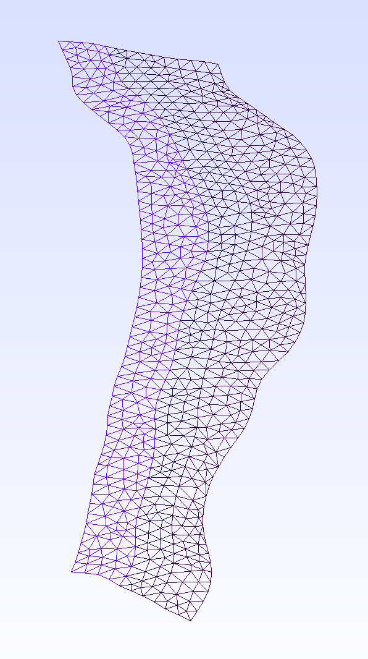
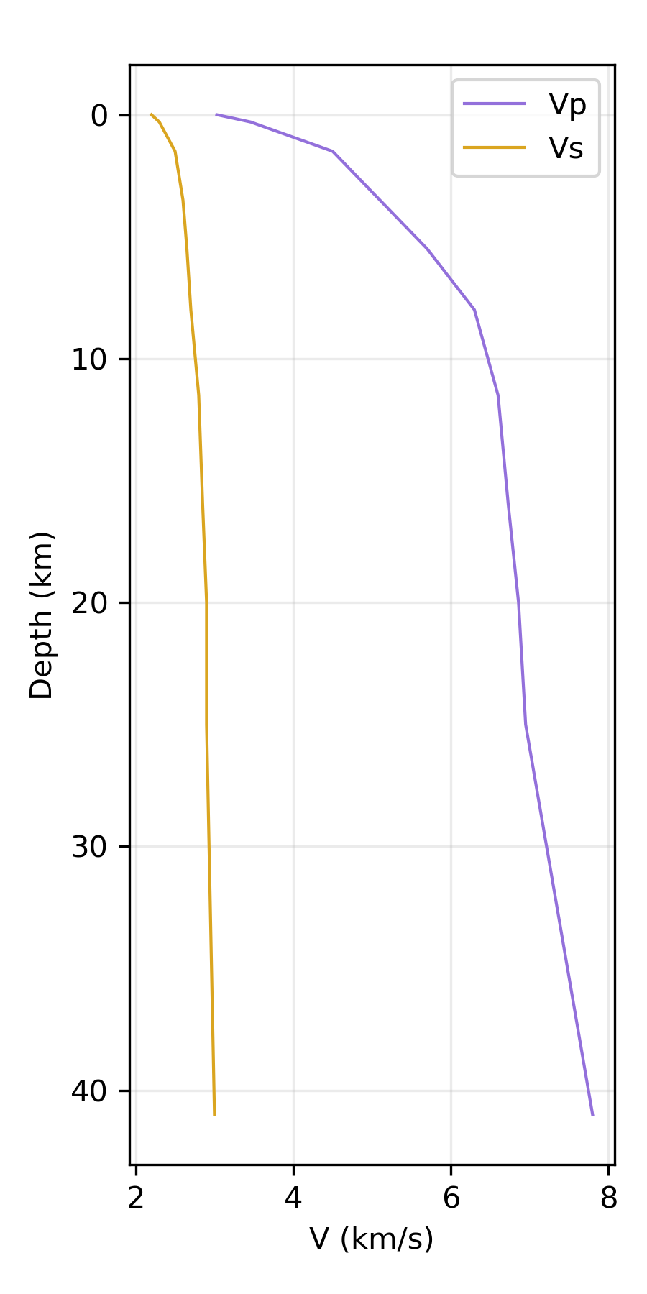
Figure S1. (left) Mesh file of the fault model and (right) velocity model used to generate Cascadia rupture scenarios and waveforms (files from Melgar et al., 2016) The velocity model reflects the updates based on modifications described in the main text.

Text S2. Ocean Bottom Seismometer Noise Analysis
Ocean Networks Canada (ONC) operates an underwater cabled network, NEPTUNE (North-East pacific Time-Series Undersea Networked Experiments), which drapes over the Cascadia Subduction Zone. We present a brief noise analysis comparing the offshore NEPTUNE instruments to the ONC coastal land accelerometer AL2H.
One day of acceleration data (02/20/2022) is downloaded for each of the instruments. The decibel difference in noise (db) between each offshore site and AL2H is calculated using Equation S5, with the overlines denoting time series means, and summarized in Table S1.
 | $$db = 20log_{10}\left(\frac{\overline{\left|offshore noise\right|}}{\overline{\left|AL2H noise\right|}}\right)$$ | (S5)

Table S1. Offshore noise variation from AL2H in decibels (db)
Station | db from AL2H Noise
BACME | -16.63
CBC27 | -21.41
NC89 | -6.12
CQS64 | -19.7
*Note: Offshore station NCBC is not listed because it was dug out prior to 02/20/2022. An earlier date was not used for comparison because ONC land site data were not continuously archived at that time.
Although ocean bottom seismometers generally have higher environmental noise levels compared to land sensors (Hilmo and Wilcock, 2020), the NEPTUNE sites are completely buried and exhibit lower noise levels compared to AL2H. See for example offshore station BACME (Figure S2).
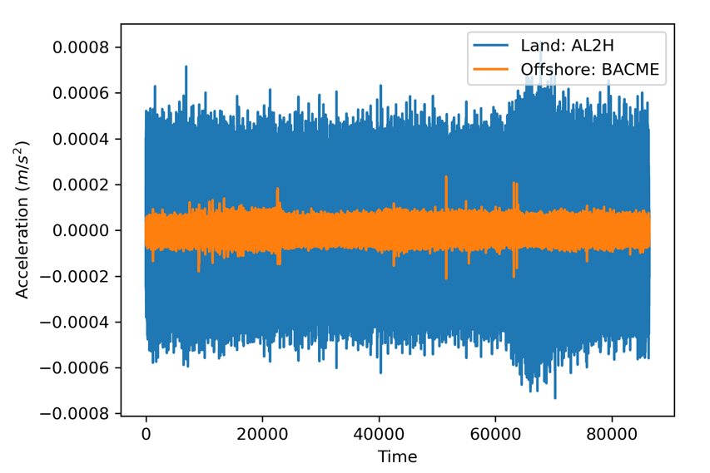
Figure S2. Station noise comparison for the land site AL2H and the offshore site BACME from 02/20/2022.

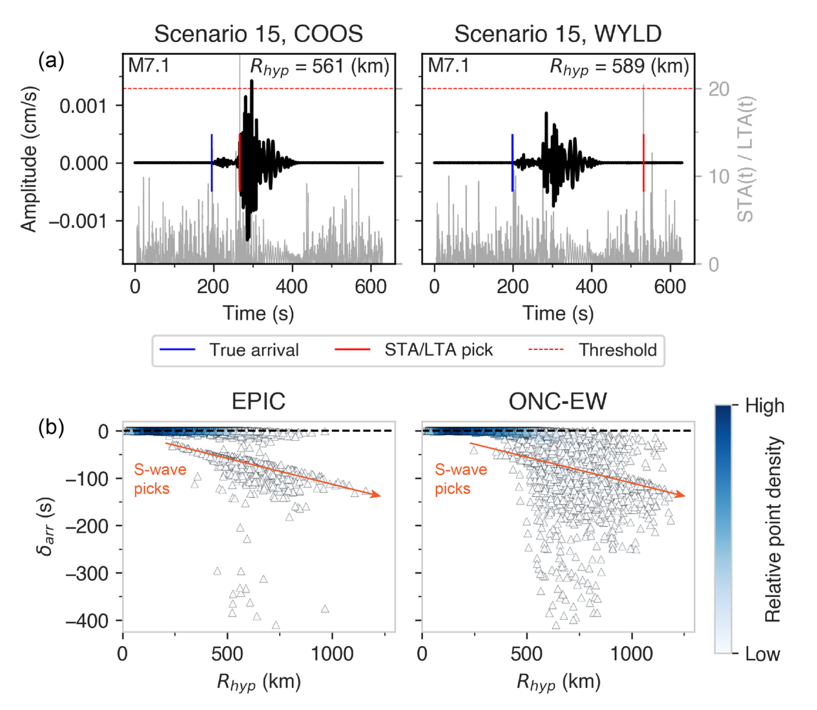
Figure S3. (a) Example outlier event detection picks using EPIC parameter configuration (i.e., STA(s)/LTA(s)/threshold = 0.05/5/20) for Scenario 15 at stations COOS (left) and WYLD (right). The STA/LTA picker triggered on the S-wave at COOS and on coda noise at WYLD. (b) Detection time residuals (δ_{arr}; true P-arrival minus STA/LTA pick) for each simulation that triggered the STA/LTA algorithm. Residuals are plotted as a function of hypocentral distance (R_{hyp}) and colored by the relative density of observations, estimated using a kernel density function. The zero-residuals are indicated by a dashed line. The linear bias with distance (marked by the orange arrows) represents records that triggered the picker on the S-wave.

Text S3. Analysis of GNSS Noise, SNR, and PGD
Simulated peak ground displacement (PGD) exhibits a greater bias with the Goldberg et al. (2021) empirical PGD model when increased levels of GNSS noise are added to the simulations, especially for lower magnitude events (see main text Figure 5). This bias arises from a decrease in the signal-to-noise ratio (SNR) (Figure S4). Larger magnitude events have a stronger signal and are more easily distinguishable from the background noise. For example, Figure S4a–b compares simulated GNSS waveforms with various noise levels from an M7.3 and an M9.0 event. The M7.3 signal is indistinguishable with the addition of 90th percentile noise and is barely discernable even with the addition of lower noise levels. Conversely, the M9.0 signal is still discernable regardless of the noise level, and PGD is only minorly affected. Figure S4c–d highlights the relationship between event magnitude, SNR, and the resulting PGD bias (δ_{PGD}) for the different noise levels. As expected, lower levels of noise result in increased SNR, and larger magnitude events have higher SNRs overall (Figure S4c). Relating this to δ_{PGD}, we find that residuals are large and highly scattered for recordings with a SNR < 4, which occurs for nearly all M < 7 events, regardless of noise levels. δ_{PGD} trends towards zero with increased SNR, and records with a SNR > 50 are consistently within the GMM uncertainty, which occurs for M > 8 events. This analysis highlights the real impact high GNSS noise levels can have on apparent PGD, even for moderate magnitude events. These effects should be considered when using PGD to characterize earthquake sources.

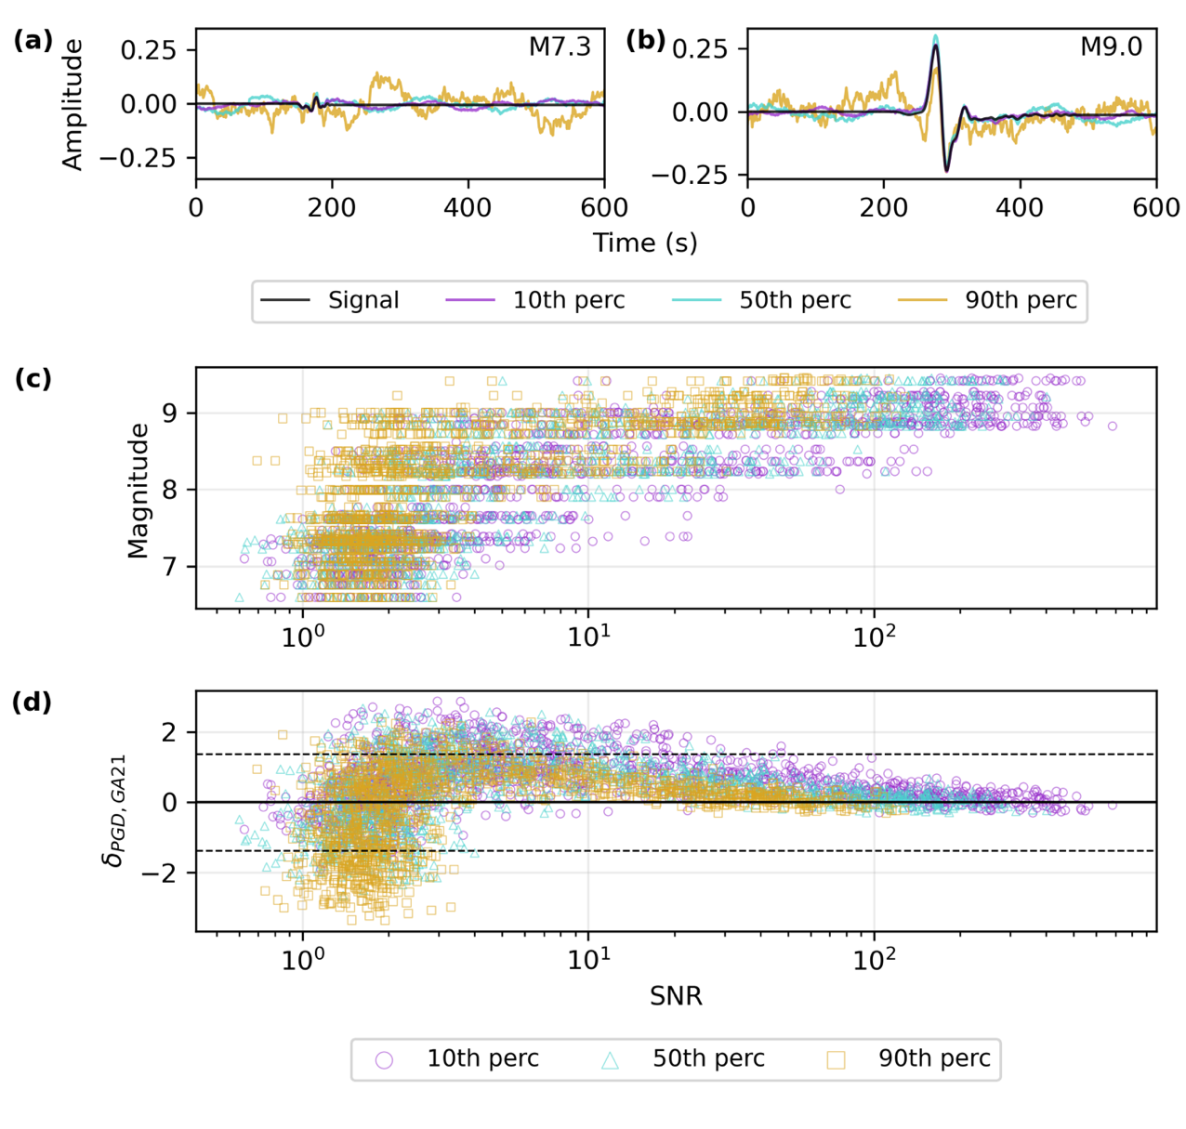
Figure S4. Evaluation of synthetic GNSS noise and its effect on apparent PGD. (a–b) The raw signal waveform and the signal with additions of synthetic noise at 10th, 50th, and 90th percentiles for a M 7.3 and M 9.0 event. Relationship of SNR with (c) event magnitude and (d) PGD residuals (δ_{PGD}) using the Goldberg et al. (2021) joint model for records with closest rupture distances (R_{rup}) $≤$ 400 km. Marker symbols denote the percentile of synthetic noise added to the GNSS records. The dashed black lines represent the Goldberg et al. (2021) standard deviation. Residuals are large and highly scattered for recordings with a SNR < 4, which occurs for nearly all events with M < 7, regardless of absolute noise levels. δ_{PGD} trends towards zero with increased SNR, and records with a SNR > 50 are consistently within the GMM uncertainty, which occurs for events with M > 8.

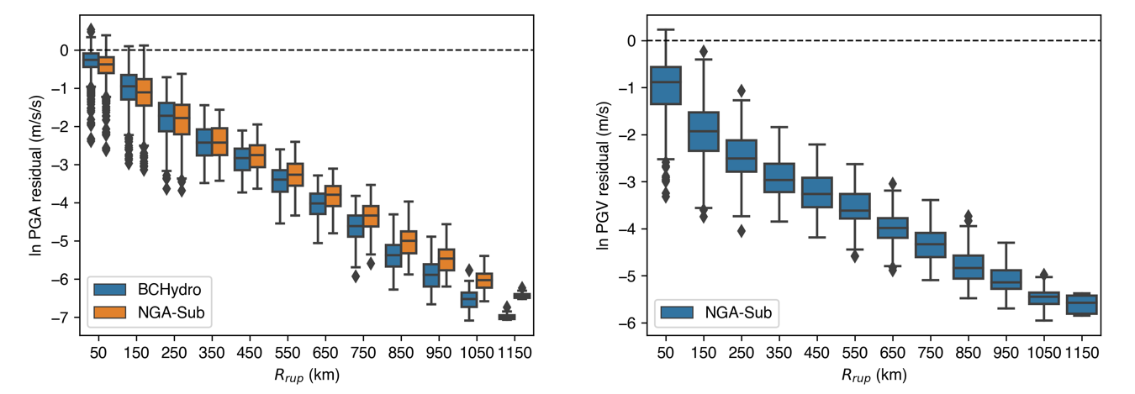
Figure S5. (left) PGA and (right) PGV residuals ln(GMM/simulation ground motion) as a function of closest rupture distance (R_{rup}). The color boxes indicate the ground-motion model used (BCHydro: Abrahamson et al., 2016, 2018; NGA-SUB: Parker et al., 2020). These simulations were generated using original attenuation parameters but have since been modified to reduce the linear attenuation bias, as described in the main text.

References
Abercrombie, R. E., Trugman, D. T., Shearer, P. M., Chen, X., Zhang, J., Pennington, C. N., Hardebeck, J. L., Goebel, T. H. W., & Ruhl C. J. (2021). Does earthquake stress drop increase with depth in the crust?. Journal of Geophysical Research: Solid Earth, 126(10), 1–22. doi: 10.1029/2021JB022314
Abrahamson N.A., Gregor N., & Addo K. (2016). BC Hydro ground motion prediction equations for subduction earthquakes. Earthquake Spectra, 32, 23–44. doi: 10.1193/051712EQS188MR
Abrahamson, N., Kuehn, N., Gulerce, Z., Gregor, N., Bozorgnia, Y., Parker, G., Stewart, J., Chiou, B., Idriss, I.M., Campbell, K., & Youngs, R. (2018). Update of the BC Hydro Subduction Ground-Motion Model using the NGA-Subduction Dataset. PEER Report 2018/02. Pacific Earthquake Engineering Research Center, University of California, Berkeley, California. doi: 10.55461/OYCD7434
Anderson, J. G., & Hough, S. E. (1984). A model for the shape of the Fourierfourier amplitude spectrum of acceleration at high frequencies. Bulletin of the Seismological Society of America, 74(5), 1969–1993. doi: 10.1785/BSSA0740051969
Atkinson, G. M., & Macias, M. (2009). Predicted ground motions for great interface earthquakes in the Cascadia Subduction zone. Bulletin of the Seismological Society of America, 99(3), ﻿1552–1578. doi: ﻿10.1785/0120080147
Baltay, A., Ide, S., Prieto, G., & Beroza, G. (2011). Variability in earthquake stress drop and apparent stress. Geophysical Research Letters, 38(6), 1–6. doi: ﻿10.1029/2011GL046698
Brune, J. N. (1970). Tectonic stress and the spectra of seismic shear waves from earthquakes. Journal of Geophysical Research, 75(26), 4997–5009. doi: 10.1029/JB075i026p04997
Goldberg, D. E., Melgar, D., Hayes, G. P., Crowell, B. W., & Sahakian, V. J. (2021). A ground-motion model for GNSS peak ground displacement. Bulletin of the Seismological Society of America, 111(5), 2393–2407. doi: ﻿10.1785/0120210042
Graves, R. W., & Pitarka, A. (2010). Broadband ground-motion simulation using a hybrid approach. Bulletin of the Seismological Society of America, 100(5A), 2095–2123. doi: 10.1785/0120100057
Hilmo, R., & Wilcock, W. S. D. (2020). Physical sources of high-frequency seismic noise on Cascadia Initiative ocean bottom seismometers. Geochemistry, Geophysics, Geosystems, 21(10), 1–20. doi: ﻿10.1029/2020GC009085
LeVeque, R. J., Waagan, K., González, F. I., Rim, D., & Lin, G. (2016). Generating random earthquake events for probabilistic tsunami hazard assessment. Pure and Applied Geophysics, 173, 3671–3692. doi: 10.1007/s00024-016-1357-1
Melgar, D. (2025). Consideration of rupture kinematics increases tsunami amplitudes in far-field hazards assessments. EarthArXiv. doi: 10.31223/X5BQ61
Melgar, D., Leveque, R. J., Dreger, D. S., & Allen, R. M. (2016). Kinematic rupture scenarios and synthetic displacement data: An example application to the Cascadia subduction zone. Journal of Geophysical Research: Solid Earth, 121(9), 6658–6674. doi: 10.1002/2016jb013314
Nye, T., Schlesinger, A., Sahakian, V., Melgar, D., Mahani, A. B., Williamson, A., Ferguson, E., Lux, A., and Pirenne, B.. (2026). Cascadia subduction zone earthquake simulations for earthquake early warning testing. doi: 10.5683/SP3/CZECEG
Parker, G.A, Stewart, J.P., Boore, D.M., Atkinson, G.A., & Hassani, B. (2020). NGA-Subduction Global Ground-Motion Models with Regional Adjustment Factors. PEER Report 2020/03. Pacific Earthquake Engineering Research Center, University of California, Berkeley, California.

