Supplemental Content to:

Foreshocks, aftershocks, and static stress triggering of the 2020 M_{w} 4.8 Mentone Earthquake in west Texas

David C. Bolton^{1,2*}, Nadine Igonin³, Yangkang Chen², Daniel Trugman⁴, Alexandros Savvaidis², and Peter Hennings²
¹Institute for Geophysics, Jackson School of Geoscience, University of Texas at Austin, Austin, TX
²Bureau of Economic Geology, Jackson School of Geosciences, University of Texas at Austin, Austin, TX
³University of Texas at Dallas, Department of Sustainability and Earth Systems Sciences, Dallas, TX
⁴Nevada Seismological Laboratory, University of Nevada at Reno, Reno, NV

*Corresponding author: David C. Bolton (chas.bolton@beg.utexas.edu)

Seismic Moment Measurements
Because of the low signal-to-noise of the P-wave arrivals, we measure the seismic moments of 11 earthquakes and mainshock using S-wave data (Trugman and Savvaidis, 2021). We follow previous studies and place a 10.5-s time around the S-wave data that starts 0.5-s prior to the S-wave arrival time and extends 10-s after the arrival time (Yoon et al., 2019; Figure S1). We then de-trend the signal, deconvolve the instrument response, and convert the velocity spectrum to a displacement spectrum for each horizontal component of each station. Finally, we independently measure the S-wave spectrum for each horizontal component using a multitaper approach and compute the vector sum of the two horizontal components for each station (Prieto et al., 2009).
With the spectral measurements in hand, we estimate the seismic moment by fitting the measured displacement spectra with a Boatwright spectral model (Boatwright, 1980), which has the following general form:
$A\left(f\right)=\frac{Ω_{0}}{{[1+({f/f_{c})}^{nγ}]}^{\frac{1}{γ}}}$ . (S1)
In Equation 1, Ω₀, denotes the low-frequency plateau of the displacement spectra, f represents frequency, f_{c} represents the corner frequency, n controls the high-frequency fall-off of the spectra, and γ controls the shape of the spectrum (Brune, 1970; Boatwright, 1980; Abercrombie, 2021). In this work, we fix n and γ to 2, consistent with an omega-squared and Boatwright model (Aki, 1967; Boatwright, 1980).
The low-frequency plateau of the displacement spectra, Ω₀, is proportional to the seismic moment and should be measured at the lowest frequency possible. Using measurements of Ω₀ and mechanical properties of the subsurface, we calculate the seismic moment as follows:
$Mo=\frac{Ω_{0}*4π*ρ*V_{s}^{3}*r}{2*R_{s}}$ . (S2)
ρ denotes the average density, V_{s} represents the S-wave velocity, r is the distance between the source and receiver, and R_{s} accounts for the S-wave radiation pattern; the factor of 2 in the denominator accounts for the free surface effect. We use a local S-wave velocity model and assume an average density of 2.5 g/cm³. To avoid the strong low-frequency noise in the continuous waveform data, we measure Ω₀ between 1-3 Hz and use a Boatwright spectral model to back-propagate the measurements to zero frequency (Trugman and Savvaidis, 2021; Igonin et al., 2023; Figure S2). These corrections are generally quite small for earthquakes with M_{L} 1-2 because their theoretical corner frequencies are greater than the frequency band that we measure Ω₀ (i.e., > 3 Hz.) However, these corrections are more significant for the larger M_{L} 4+ earthquakes that have theoretical corner frequencies <= 3 Hz. (Figures S4). Hence, measuring Ω₀ between 1-3 Hz is likely to underestimate the true seismic moment, and corrections such as those shown in Figure S2 are needed. We demonstrate that the backpropagation measurements of the seismic moment are roughly independent of the choice of stress drop (Figure S3). For each earthquake, we measure the seismic moment at each station and take the median of these measurements to represent the final seismic moment. Once the seismic moments are computed, we then convert the seismic moments to a moment-magnitude, M_{w} using the following equation:
${ M}_{w}=\frac{2}{3}*\log_{10}\left(Mo\right)-6.07$. (S3)
To lend confidence in our seismic moment measurements, we cross-plot seismic moment and moment magnitude with M_{L} and demonstrate that the mapping between M_{L} and M_{w} is consistent with previous work (Trugman and Savvaidis, 2021; Figure S3).

Empirical Greens Functions
The use of EGFs (Empirical Greens Functions) to correct the observed spectrum for path and site effects is a well-studied approach for measuring corner frequencies and estimating source properties of earthquakes (e.g., Mueller, 1985; Abercrombie, 2021). The EGF approach assumes that if two earthquakes of different magnitudes are co-located and recorded on the same instrument, then the source term (i.e., source-time function) of the larger earthquake can be recovered through spectral division. In this work, we use EGFs to measure the corner frequency of the M_{L} 4.0 foreshock. Due to the bandlimited nature of the seismic data, we are unable to estimate the corner frequencies of the smaller M_{L} 1-2 earthquakes. Therefore, we assume that the smaller M_{L} 1-2 earthquakes are representative of the 3000+ earthquakes studied by Trugman and Savvaidis, (2021) and assume that they have stress drops between 0.5-8 MPa (see main text for details).
We estimate the corner frequency of the M_{L} 4.0 foreshock using an EGF approach and a Boatwright spectral model with the following form:
$\frac{{A(f)}_{1}}{{A(f)}_{2}}=\frac{M_{01}}{M_{02}}{\left(\frac{1+{\left(\frac{f}{f_{c1}}\right)}^{γη}}{1+{\left(\frac{f}{f_{c2}}\right)}^{γη}}\right)}^{\frac{1}{γ}}$ , (S4)
where f_{c1} and f_{c2} are the corner frequencies of the larger (i.e., target event) and smaller earthquake (i.e., EGF event), respectively. Similarly, M_{O1} and M_{O2} are the seismic moments (as estimated above) for the larger and smaller earthquakes, respectively. We set n and γ to 2, consistent with an omega-squared spectral decay and Boatwright model (Aki, 1967; Boatwright, 1980). For a given station, we ensure a SNR >= 3 between 1-20 Hz and independently measure the spectral ratio between the largest foreshock (i.e., the M_{L} 4.0) and 5 co-located M_{L} 1-2 earthquakes (Figure S4). For a given earthquake pair, we take the median of all the spectral ratios across all common stations and use this as the final observed spectral ratio (Figure S4). We use a minimum of 3 stations to derive the observed spectral ratio. We then minimize an L2-norm between the observed and modeled spectral ratios and set FC₁ and FC₂ as free parameters in the inversion. We then average the best fitting FC₁ across all event pairs and use this to estimate the rupture radius of the M_{L} 4.0 foreshock. We ignore FC₂ due to the bandlimited nature of the data at frequencies > 10 Hz (see Figure S5). If we assume that each earthquake represents the slip along a circular fault patch, then the radius of the fault patch can be estimated as follows:
$a=\frac{k*V_{s}}{f_{c}}$ , (S5)
where a is the source radius, k is a model-specific parameter that depends on the rupture velocity and details of rupture propagation (e.g., Kaneko and Shearer, 2014), and f_{c} is the corner frequency. In this work, we follow the model presented in Kaneko and Shearer (2014) and set k = 0.26, appropriate for S-waves with rupture velocities in the range of 0.8-0.9 V_{s..} The EGF analysis indicates that the corner frequency of the M_{L} 4.0 is ~ 3.5 Hz. After rearranging Equation 1 in the main text, this produces an average stress drop of ~ 15 MPa, consistent with previous work. (e.g., Trugman and Savvaidis, 2019). We then use measured rupture radius from Equation S5 and seismic moment to model the static-stresses imparted by the M_{L} 4.0 foreshock as described in the main text.

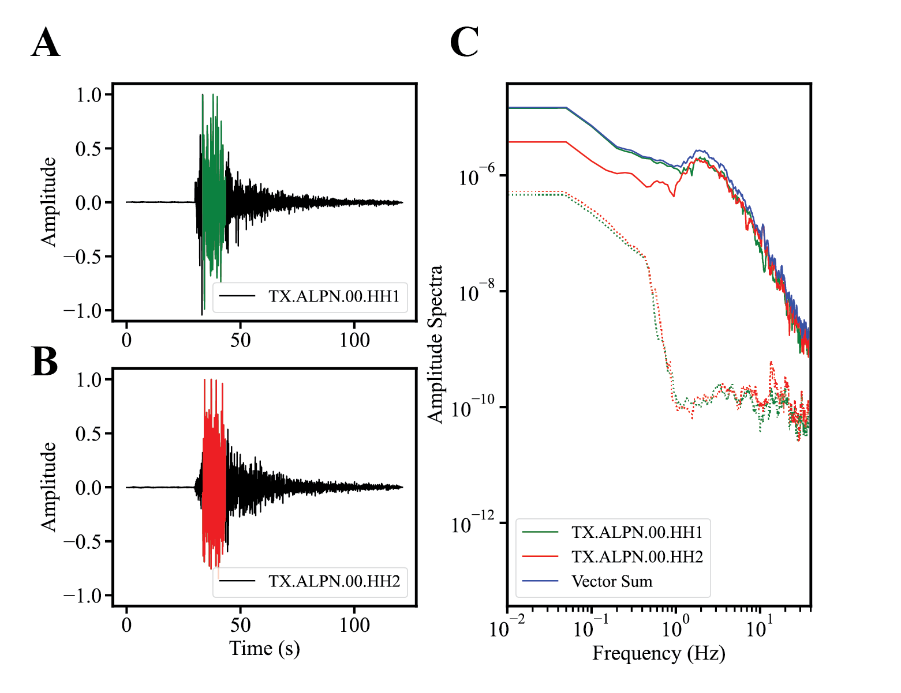
Figure S1: A-B. Time-series data for the M_{L} 4.1 foreshock recorded on two horizontal components for channel ALPN. Highlighted in green (panel A) and red (panel B) are the 10.5 s windows surrounding the S-wave data. C Amplitude spectra for the green and red S-wave data identified in panels A and B (solid lines). For each station we compute the spectrum of the vector sum of the horizontal components. Also, shown are noise spectra (dotted lines) for 10.5 s noise windows that precede the P-wave data. Note, that both traces are contaminated with low-frequency noise < 1 Hz.

Figure S2: Schematic demonstrating the effect of measuring the low frequency plateau, and thus, the seismic moment above the theoretical corner frequency. The measured corner frequency is denoted by the intersection of the two green dotted lines while the theoretical corner frequency and low-frequency plateau is represented by the intersection of the two red-lines. Note, that this problem only exists for large magnitude events that have corner frequencies < 3 Hz (i.e., the bandwidth which we measure the seismic moment); see text above for details. We account for this bias by back-propagating the moment to zero frequency using a boatwright spectral model. That is, we rearrange Equation S1 in the and solve for Ω_{0.} The theoretical corner frequency is calculated assuming a 1, 10, and 100 MPa stress drop (see Figure S3).
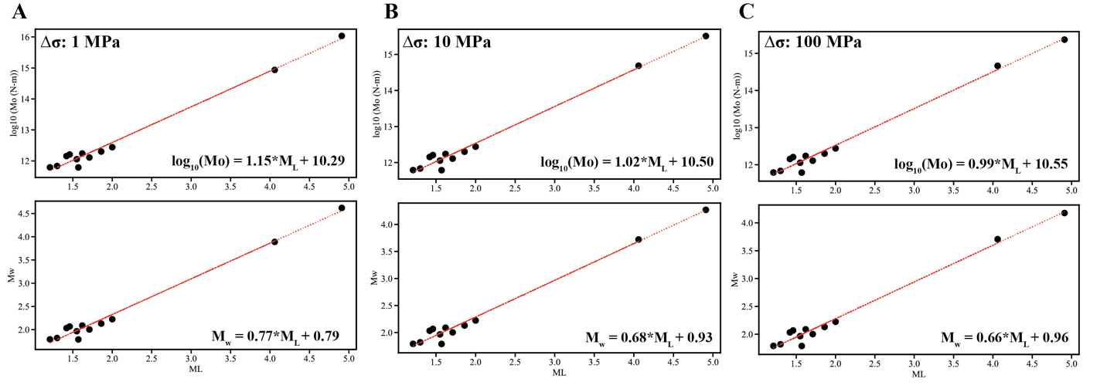
Figure S3: Seismic moment, M_{o}, and moment magnitude, M_{w,} cross-plotted with M_{L} for stress drops between 1-100 MPa. The seismic moments are corrected for by back-propagating the spectral measurements obtained in the 1-3 Hz band to zero frequency using a Boatwright spectral model. The data in panels A-C demonstrate that the choice of stress drop in the backpropagation step does not have a significant effect on our estimates of the seismic moment. The scaling between M_{w} and M_{L} for a 1 MPa stress drop is consistent with results found in Trugman and Savvaidis, (2021): M_{w} = 0.71 + 0.76*ML.

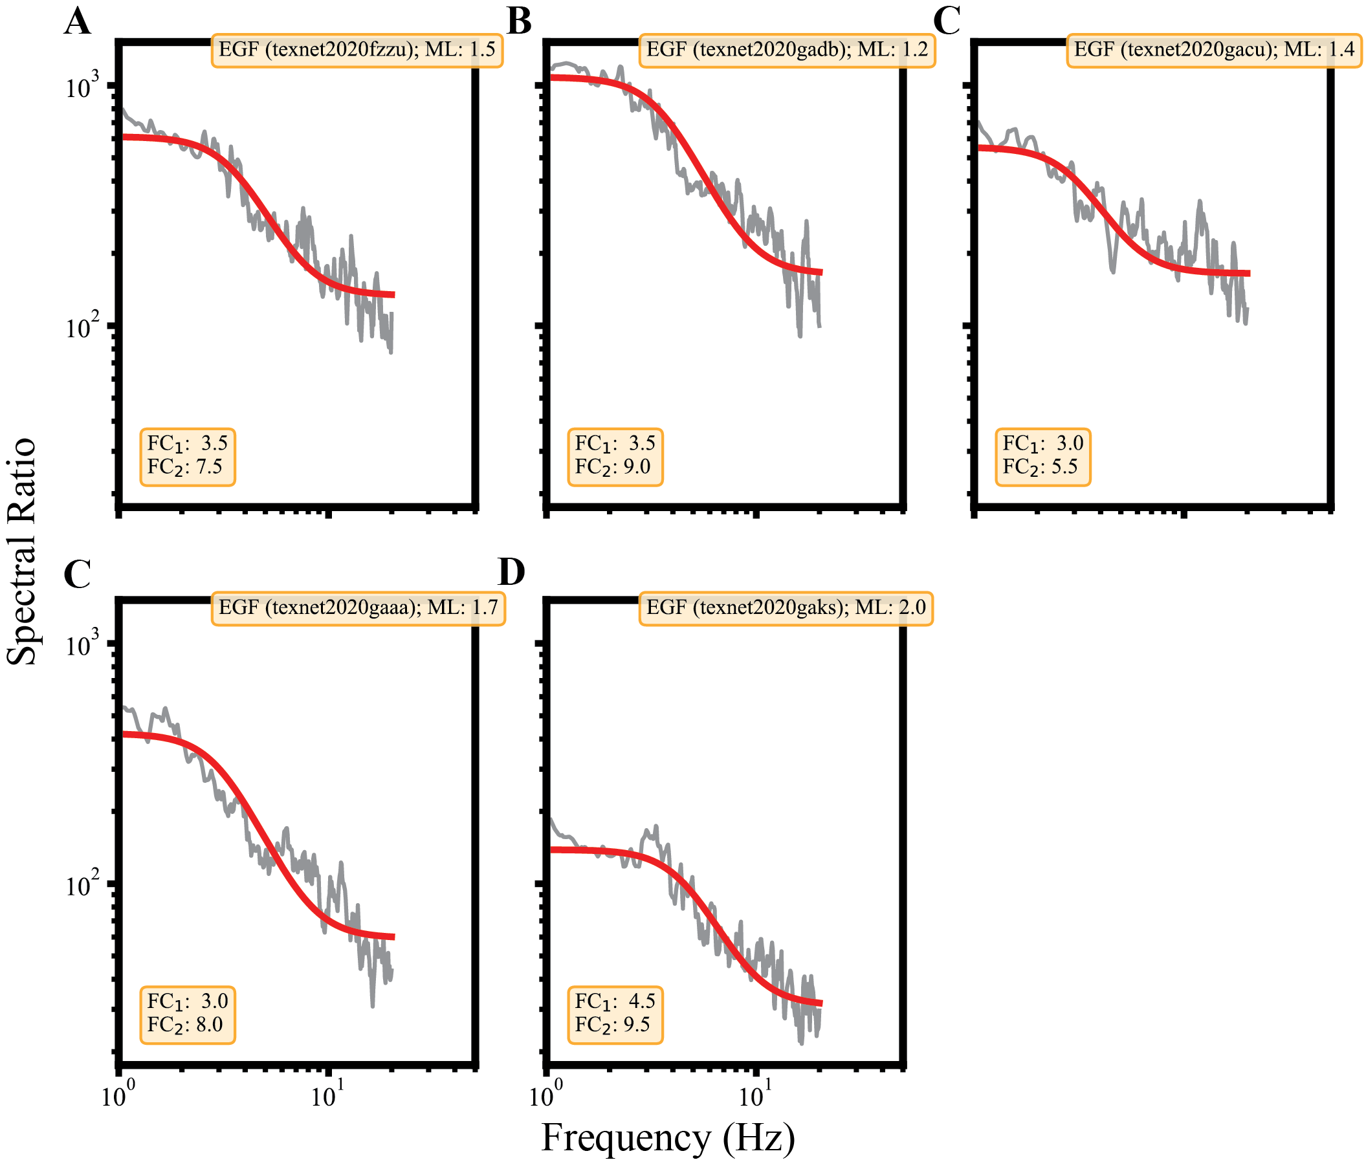

Figure S4: A. Spectral ratios between the largest M_{L} 4.0 foreshock and 5 co-located smaller earthquakes (i.e., EGFs). Each subpanel denotes the spectral ratio between the M_{L} 4.0 and a particular EGF. The grey line denotes the median of all spectral ratios using stations that are common between the EGF and M_{L} 4.0. The red line denotes the best fitting model between the observed and theoretical spectrum; the best fitting corner frequencies are highlighted at the bottom of each panel. We average the best fitting FC₁ across all event pairs and use this to estimate the rupture radius of the M_{L} 4.0 foreshock. We ignore FC₂ due to the bandlimited nature of the data at frequencies > 10 Hz (see Figure S5 for additional details).

Figure S5: A. Spectral ratio between the largest foreshock and a representative smaller, M_{L} 2.0, earthquake. Note, that the observed spectral ratio never asymptotes at FC₂. That is, the observed ratio continues to decrease beyond 10 Hz and is beyond the bandwidth for which we have a SNR > 3. B L-2 norm of misfits between the observed and theoretical spectral ratios. The data show that FC₂ is not well constrained from the data. That is, FC₂ can vary between 5-30 Hz, with little influence on the overall misfit. Hence, the bandlimited nature of the seismic signals limits the use of EGFs for estimating corner frequencies of the smaller M_{L} 1-2 foreshocks.

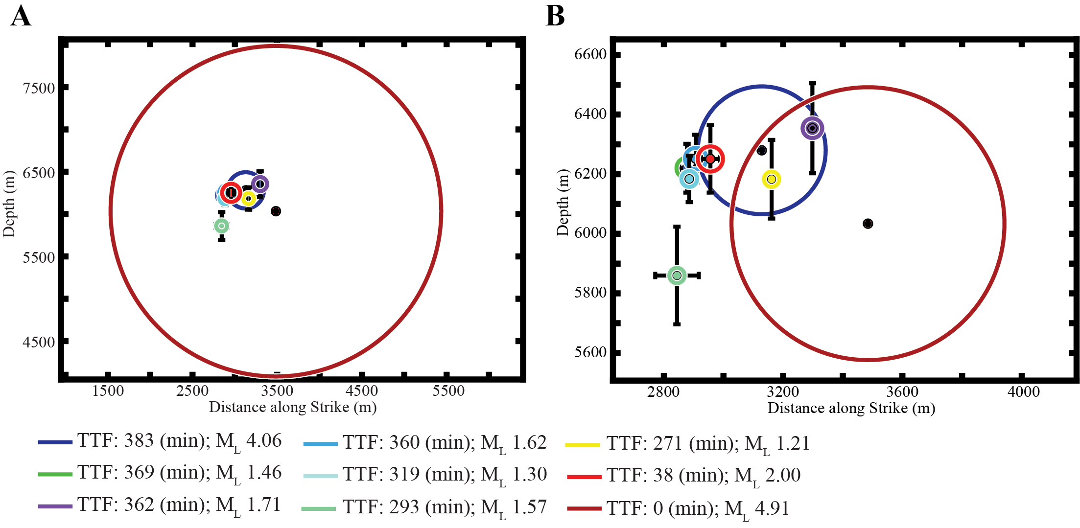
Figure S6: A-B Source radii of the Mentone sequence plotted along the fault plane. Source radii for M_{L} 1-2 earthquakes and mainshock are derived assuming a constant stress drop of 0.5 MPa (A) and 8 MPa (B). This range is $±$ 4x the median stress drop (i.e., 2 MPa) found in Trugman and Savvaidis, (2021), and thus, accounts for event-to-event variability that is expected for earthquakes in the Delaware Basin of west Texas. Rupture radius of the M_{L} 4.0 foreshock is calculated using EGFs as described above. Circles are color coded according to time until the mainshock, which we denote as time-to-failure (TTF). Error bars represent relative location uncertainties from GrowClust. For the M_{L} 1-2 earthquakes and mainshock, we plot the rupture area using Equation 1 in the main text. The rupture areas are denoted with thick-solid lines and are color coded according to TTF. Note, that we only plot the “main-cluster” of earthquakes identified in Figures 1B and 1D, as the point here is to investigate the potential for overlapping source radii. For stress drops between 0.5-8 MPa, the data show that ~ 7/11 foreshocks re-ruptured areas along the fault plane that slipped in previous foreshocks. Also, note that the mainshock re-ruptured part of the fault plane that slipped during the M_{L} 4.0 foreshock.

Figure S7: Slip and stress modeling results from the model described in Andrews (1980). A-B Fault and shear stress distribution as a function of position along the fault. Slip reaches its maximum in the center of the fault patch and slowly tapers off to zero at the edges of the fault patch. Similarly, the stress drops within the interior of the fault patch, reaches a peak outside the rupture tip, and decays non-linearly with distance from the rupture tip. C-D 2D map view of the slip and shear stress distribution across a circular fault patch.
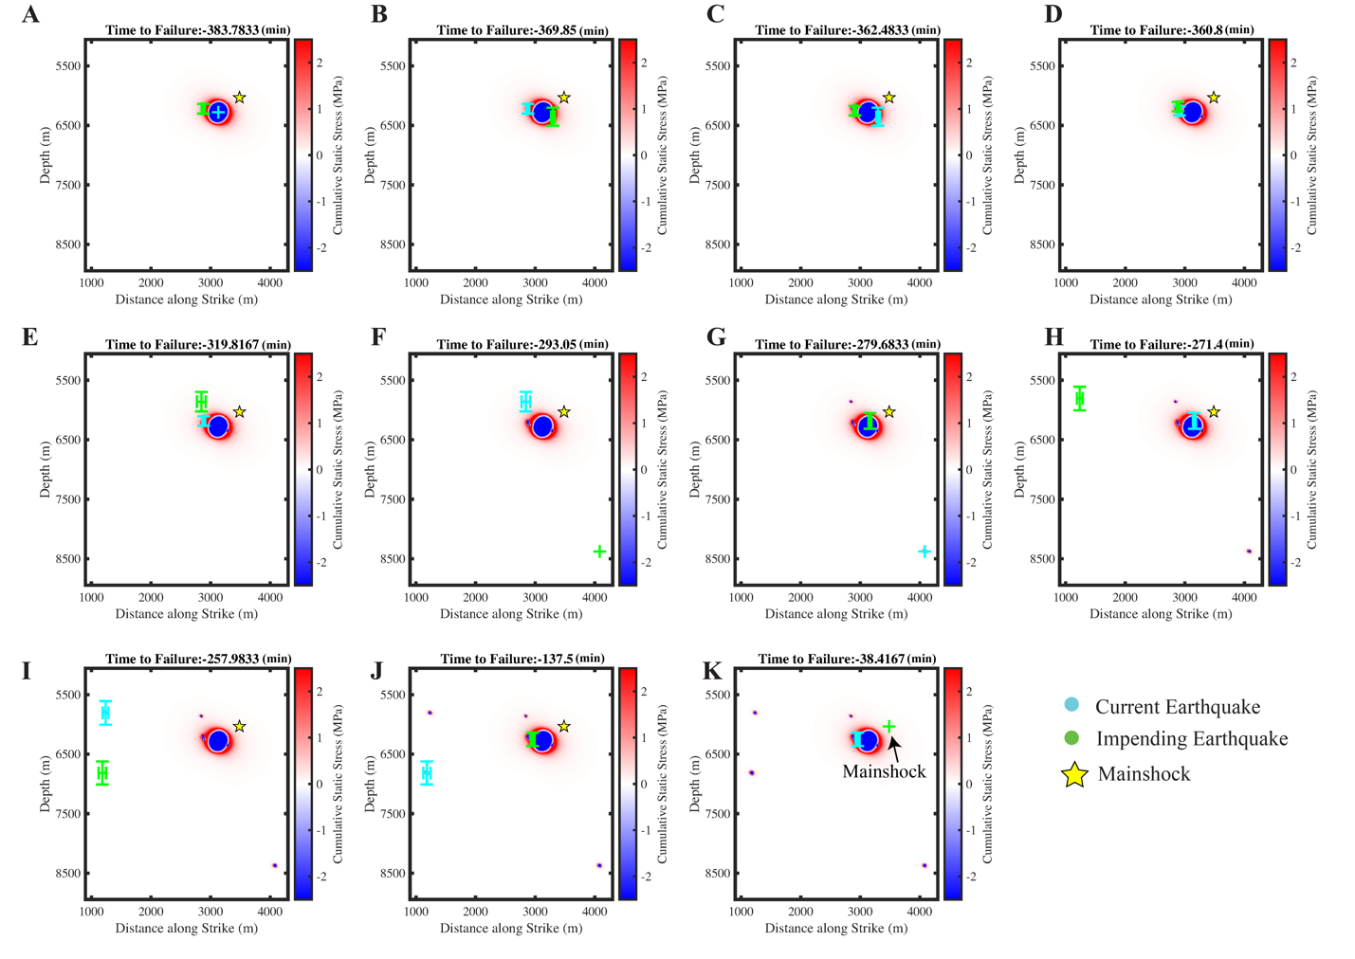
Figure S8: The sequence of 11 earthquakes that preceded the mainshock plotted along the fault plane as a function of time to the main-shock origin time (denoted here as time-to-failure). In each subplot, we plot the location of the “current” earthquake with a cyan circle and the impending earthquake with a green circle. The fault plane is color coded by the cumulative static stress imparted from previous events. Static stresses for the M_{L} 1-2 earthquakes are computed assuming a 8 MPa stress drop. Static-stresses associated with the M_{L} 4.0 foreshock are computed using derived source properties from EGFs (see Figure S4). Note, that the static-stresses along the fault plane are dominated from the stress perturbation imparted by the first foreshock (M_{L} 4.0). All but one earthquake (i.e., panel H) and the mainshock nucleated in area where the shear stress was increased from previous events.

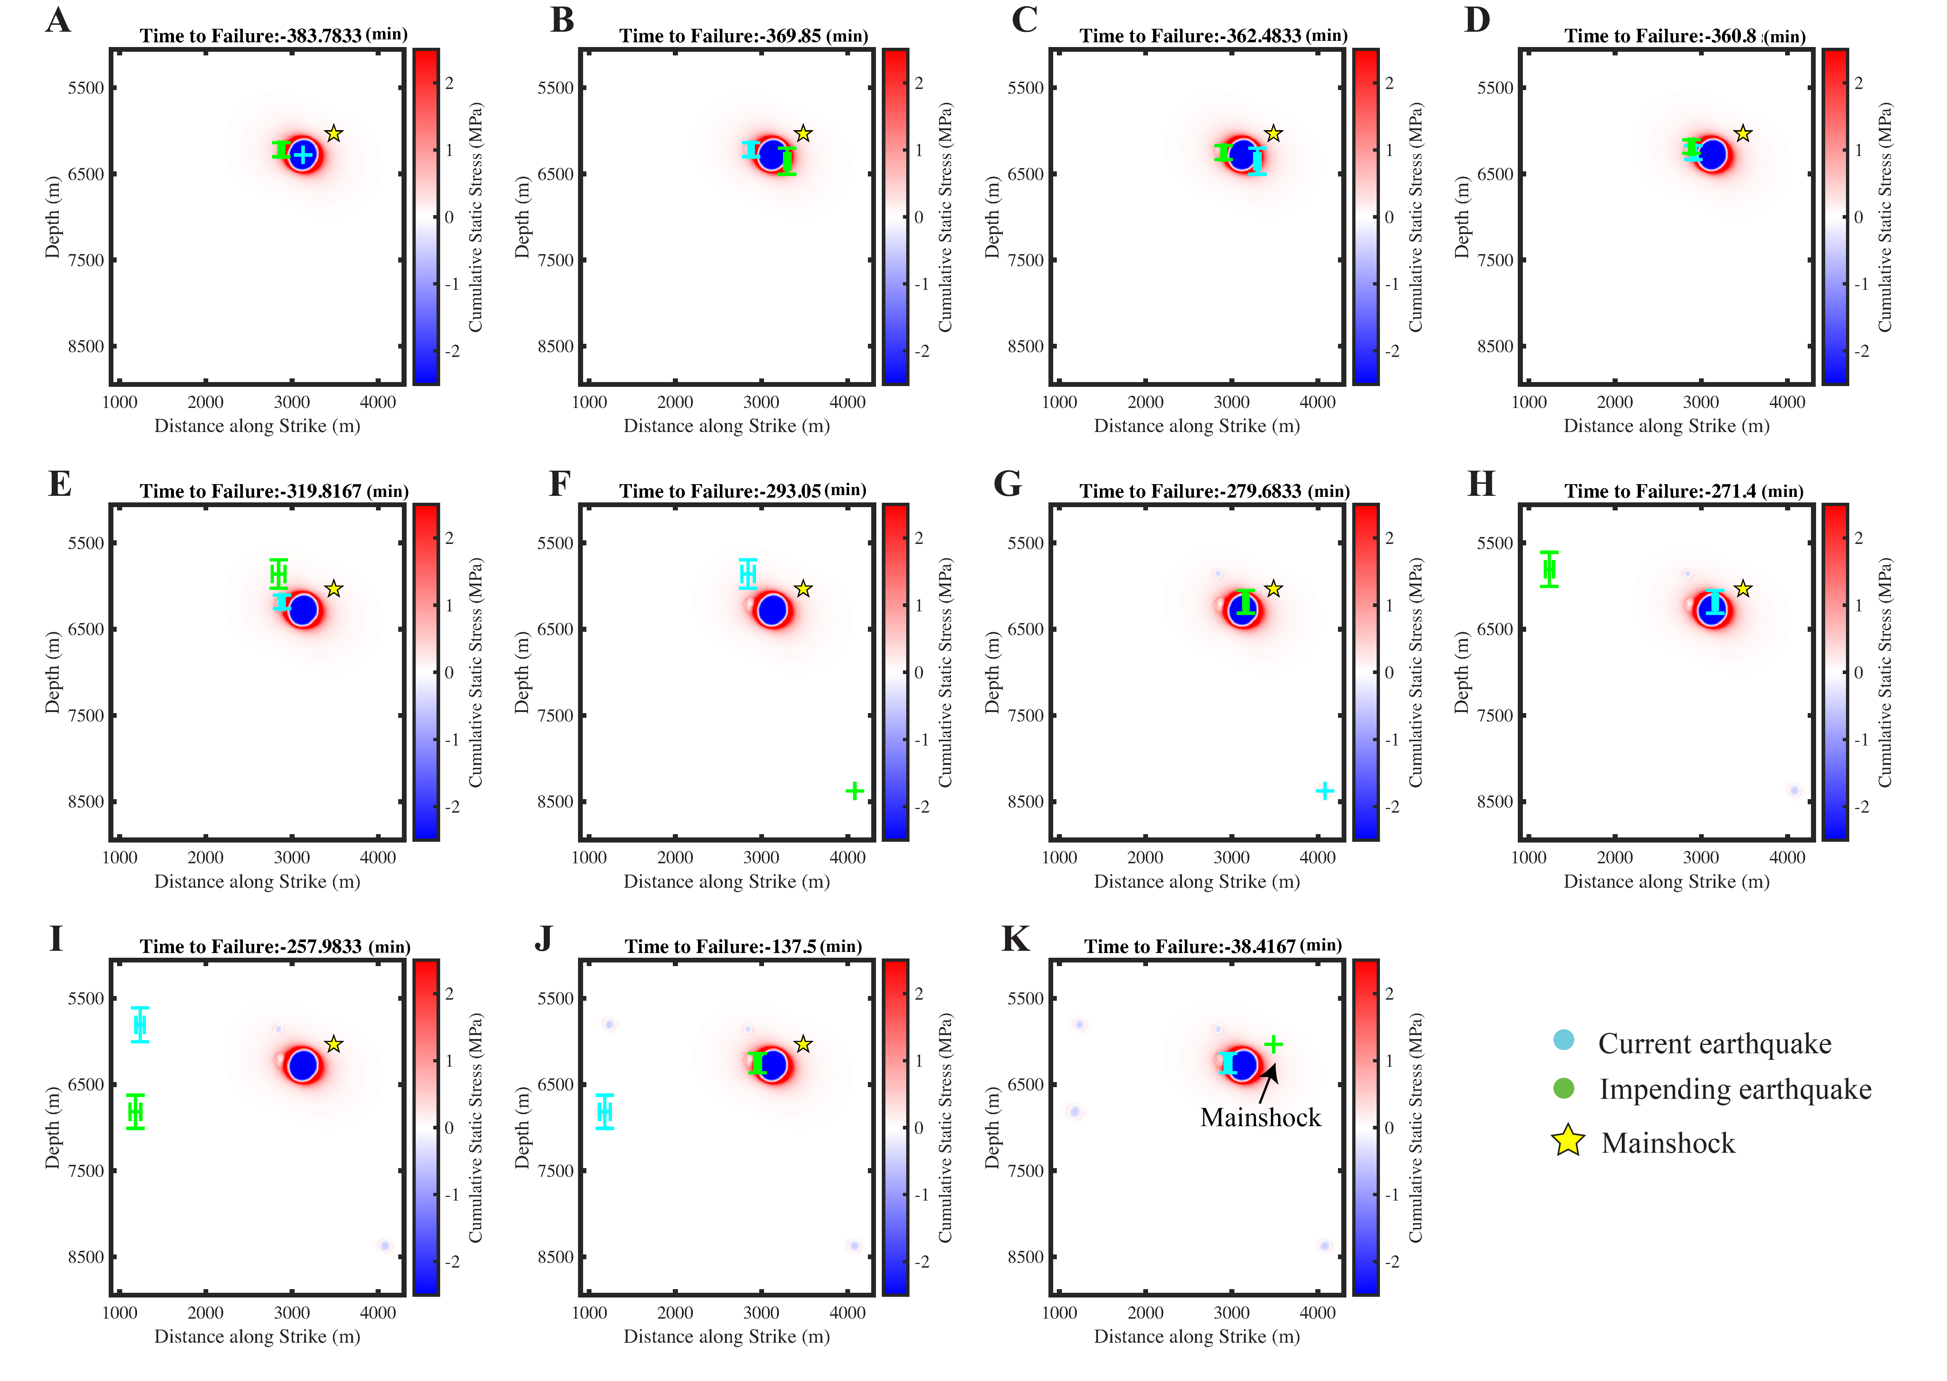
Figure S9: The sequence of 11 earthquakes that preceded the mainshock plotted along the fault plane as a function of time to the main-shock origin time (denoted here as time-to-failure). In each subplot, we plot the location of the “current” earthquake with a cyan circle and the impending earthquake with a green circle. The fault plane is color coded by the cumulative static stress imparted from previous events. Static stresses for the M_{L} 1-2 earthquakes are computed assuming a 0.5 MPa stress drop. Static-stresses associated with the M_{L} 4.0 foreshock are computed using derived source properties from EGFs (see Figure S4). Note, that the static-stresses along the fault plane are dominated from the stress perturbation imparted by the first foreshock (M_{L} 4.0). All but one earthquake (i.e., panel H) and the mainshock nucleated in area where the shear stress was increased from previous events.

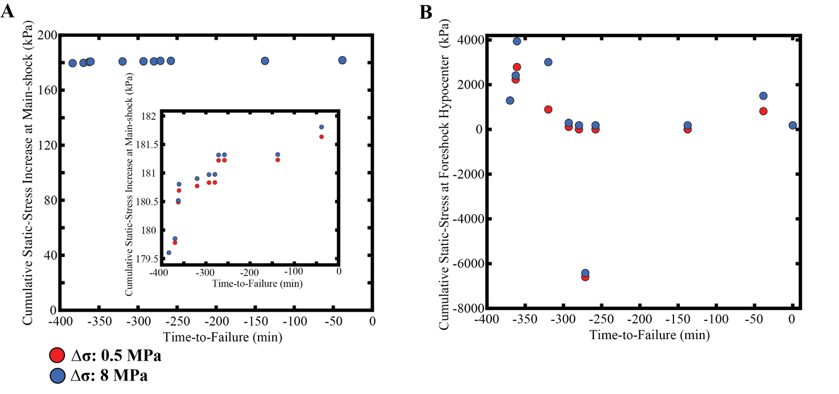
Figure S10. A. Cumulative static-stress increase at the hypocenter of the Mentone mainshock. Static-stresses associated with the initial M_{L} 4.0 foreshock are computed using derived source properties from EGFs. For the smaller M_{L} 1-2 earthquakes that follow the M_{L} 4.0, we modeled their static stresses assuming a 0.5 (blue circles) and 8 (red circles) MPa stress drop. The first foreshock (M_{L} 4.0) imparted ~ 180 kPa of stress (see also Figure 5) at the location of the Mentone mainshock, while the remaining 10 earthquakes with M_{L} 1-2 imparted < 2 kPa of stress at the hypocenter. B. Cumulative static-stresses at earthquake hypocenters leading up to the mainshock. Irrespective of the choice of stress drops for the small M_{L} 1-2 earthquakes, the data show that 9/11 earthquakes nucleated in areas that experienced an increase in shear stress from previous events. Only one event (TTF -271 min) nucleated in an area where the shear stress decreased. Note that events with TTF of 137.5, 257, and 279 (min) nucleated in areas where the shear stress increased between 1-2 kPa.

