Supplementary material to
Rupture Dynamics and Near-Fault Ground Motions of the Mw7.8 Kahramanmaraş, Turkey earthquake of February 6, 2023

Hideo Aochi
Bureau de Recherches Géologiques et Minières, Orléans, France
Laboratoire de Géologie de l’Ecole Normale Supérieure, CNRS UMR 8538, PSL Research University, Paris, France (aochi.hideo@gmail.com)

Víctor M. Cruz-Atienza
Departamento de Sismología, Instituto de Geofísica, Universidad Nacional Autónoma de México, Ciudad de México, Mexico

List of Figures
Figure S1-S8.
Movie S1.
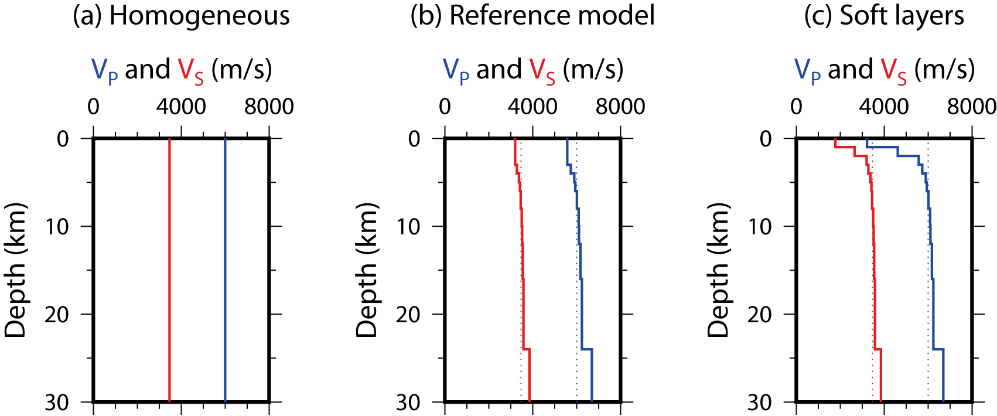
Figure S1: Structure models used for the seismic wave propagation simulations in FDM. (a) Homogeneous model, the same as the rupture simulations in BIEM. (b) Adopted 1D structure model in this paper, the same as the model (c) except for the soft surface layers. (c) 1D structure model used in the Marama region (Aochi et al., 2017). The difference is that the shallow soft layers are ignored in model (b) above 3 km depth.
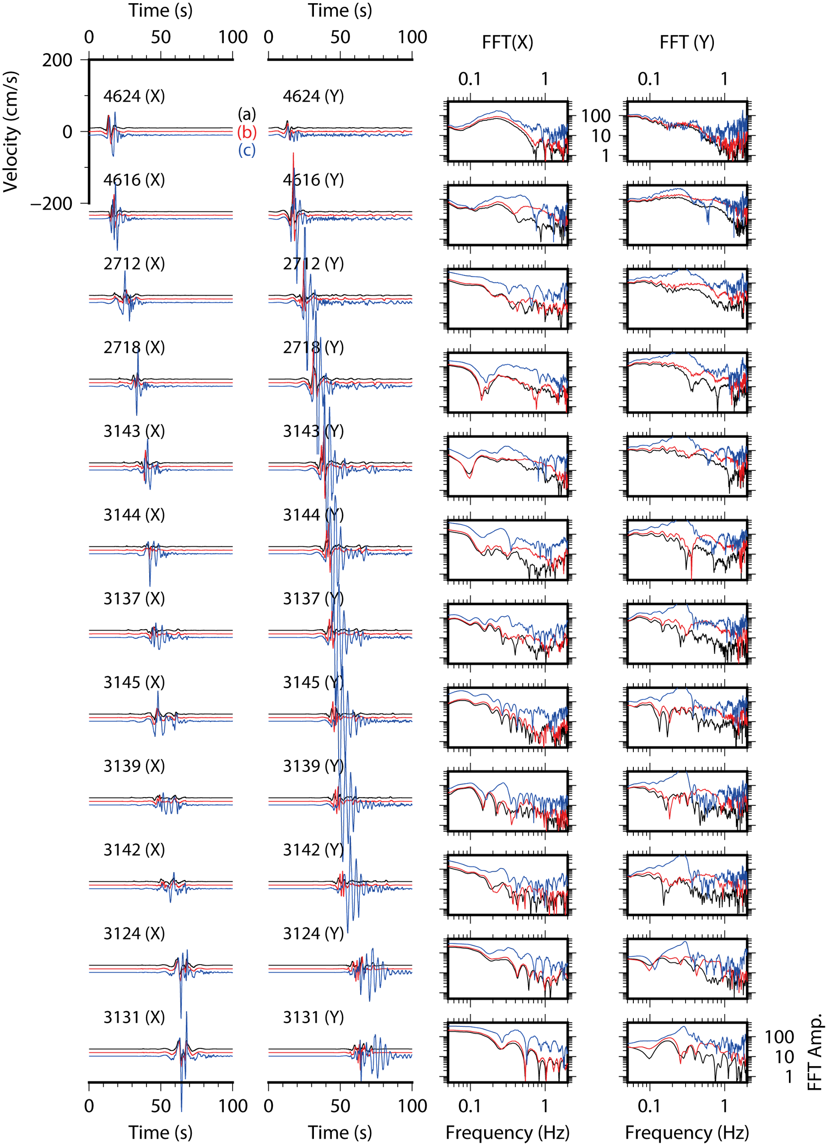
Figure S2: Synthetic ground motions at selected stations along the fault by finite difference simulation for the same earthquake rupture scenario. The station locations are shown in Figure 1b. The rupture scenario is simulated in Figure 8b. Three models use three different structure models from Figure S1. (a) homogeneous model, (b) adopted 1D structure model in the main text and (c) 1D structure model including the soft layers of slow velocity. The waveforms are filtered between 0.1 and 1 Hz. The corresponding FFT amplitude is shown on the right panels. Since the rupture scenario is the same, the first pulse representing the rupture front passage is similar in the three models in the timing and form, except for the amplitude. The models (a) and (b) does not produce any significant waves after the rupture front passage. However, the model (c) generates significant resonance especially in the Y-component, perpendicular to the fault, which can be recognized both in time and frequency domains. The later phases have larger amplitude than the first part, but this does not exist in the observations (Figure 9). Thus we adopt model (b) for the seismic wave propagation, which characterize well the rupture process and the regional medium for discussing the near-field ground motions.
(A)
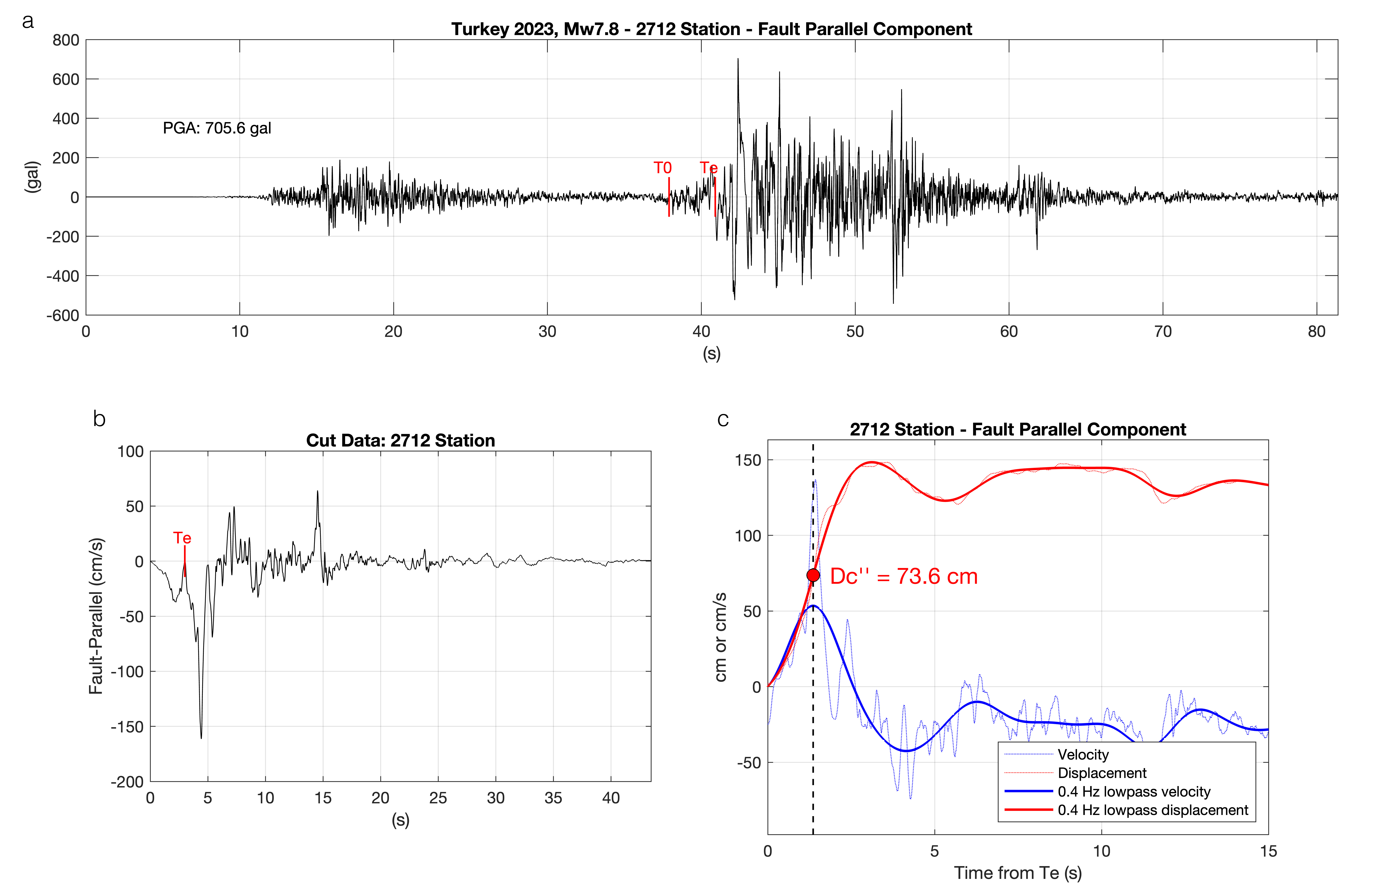
Figure S3: Strong motion data processing at the station denoted in the headers for the estimation of fault cohesive zone parameters. (a) Fault-parallel raw acceleration record, where Te is the estimated arrival time of the main shock wave and T0 is the initial time for further analysis. (b) velocity window starting at T0 after one integration using an automated baseline correction algorithm and 1 s tapering. (c) Velocity and displacement seismograms starting at Te both, lowpass filtered at 0.4 Hz and unfiltered. The estimate of Dc’’ is given on panel c (see main text and Figure 4). (A) 2712, (B) 2718, (C) 3143, (D) 3144, (E) 3137, (F) 3145, (G) 3139, (H) 3142, (I) 3132 and (J) 3131.

(B)
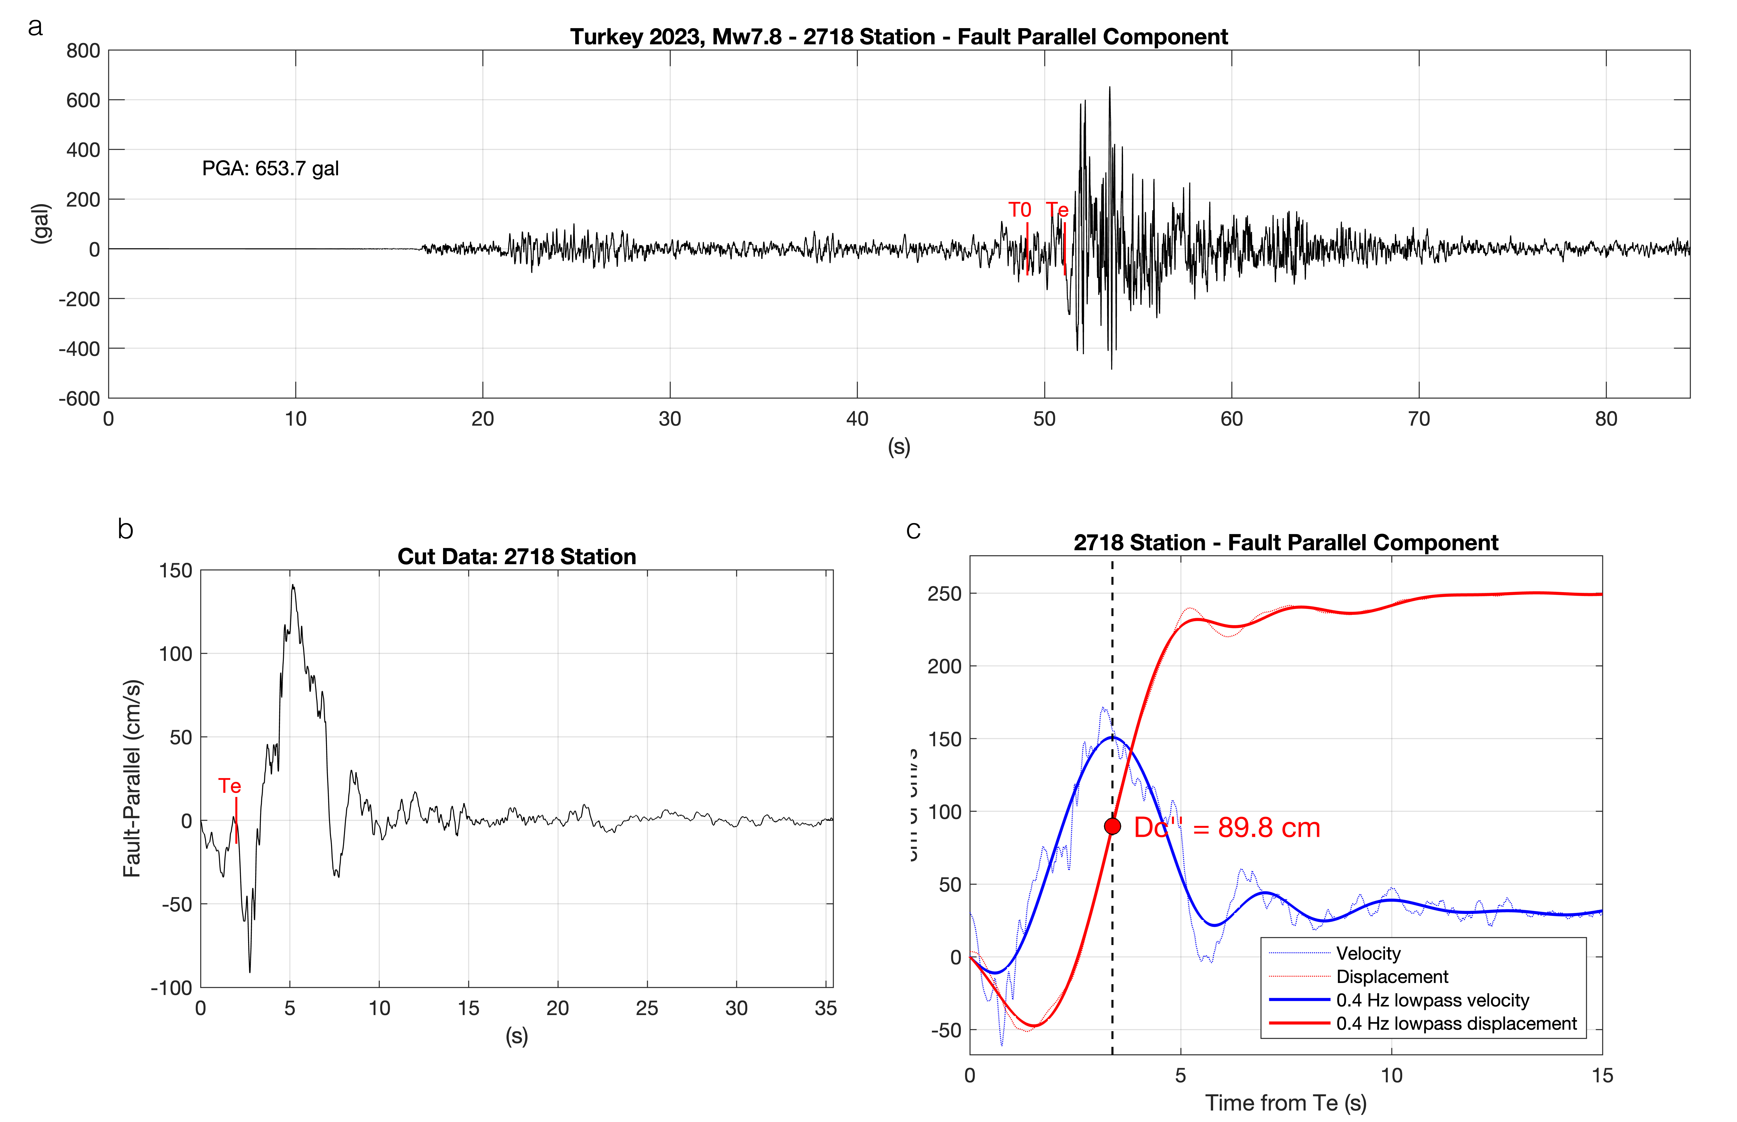
(C)
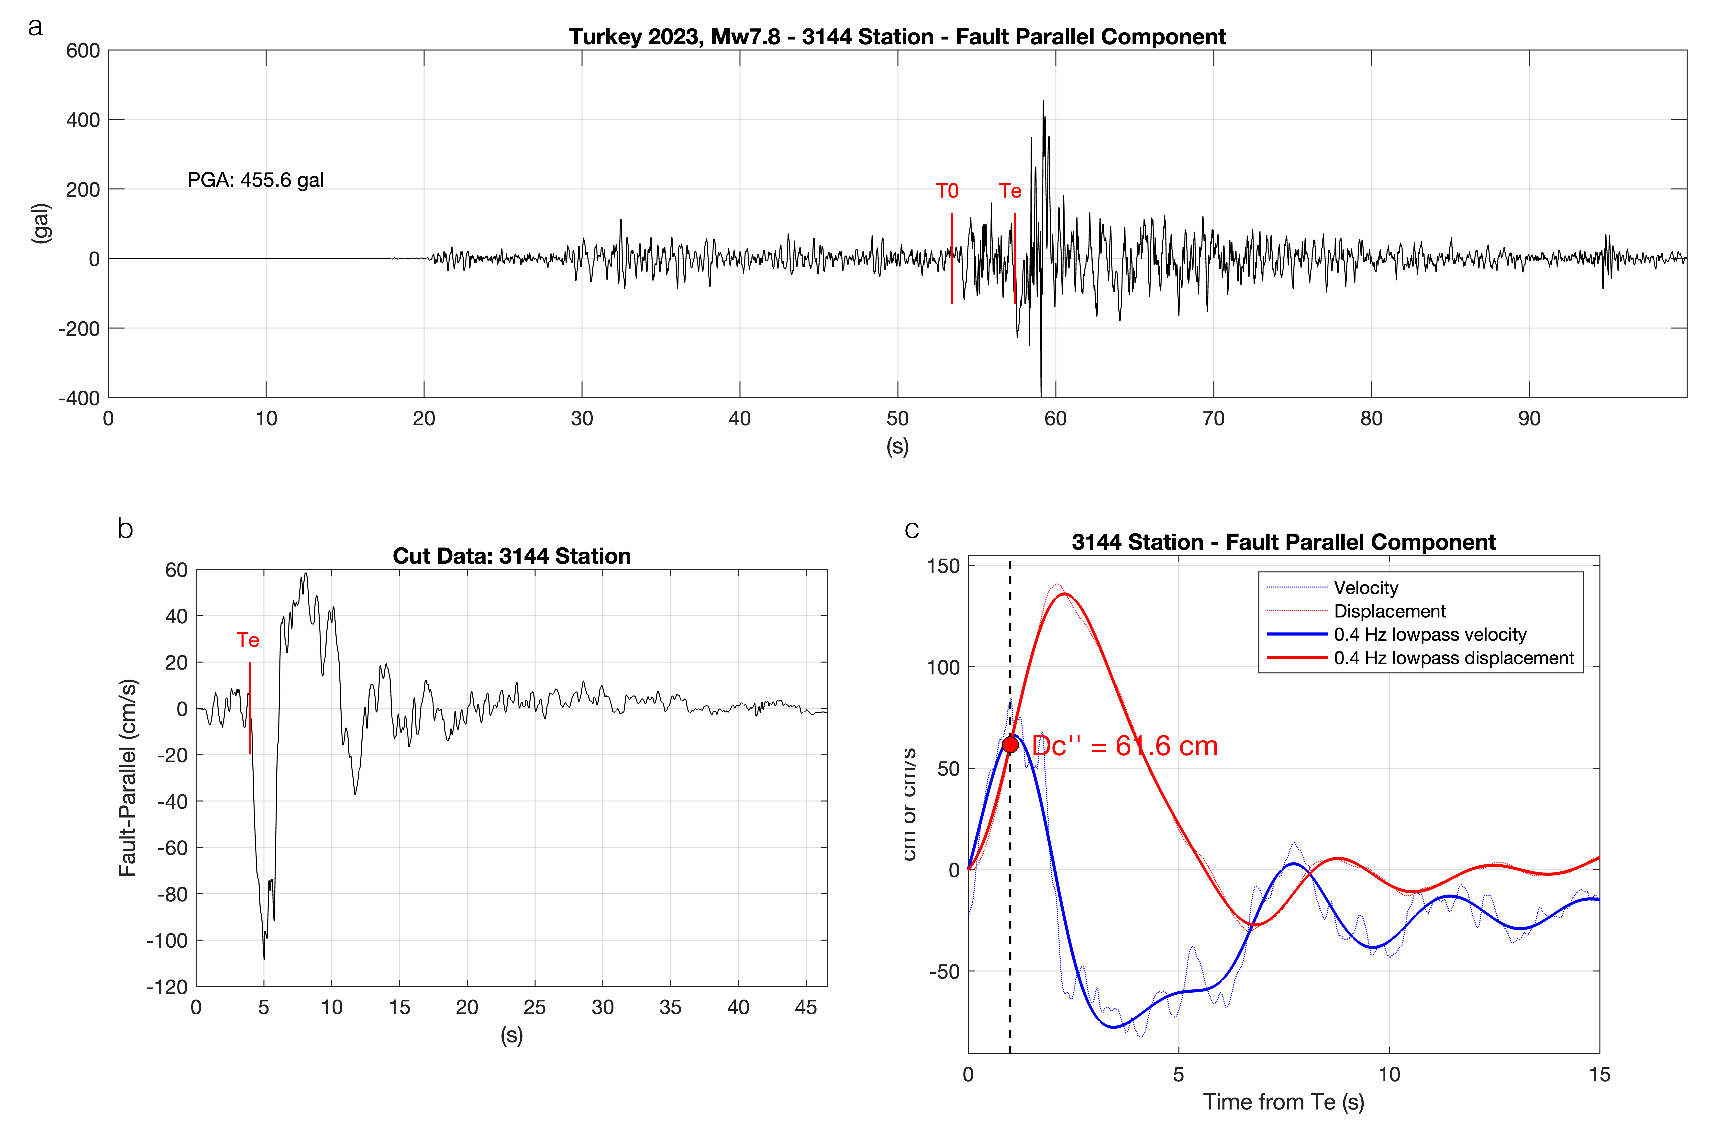
Figure S3: Continued.

(D)
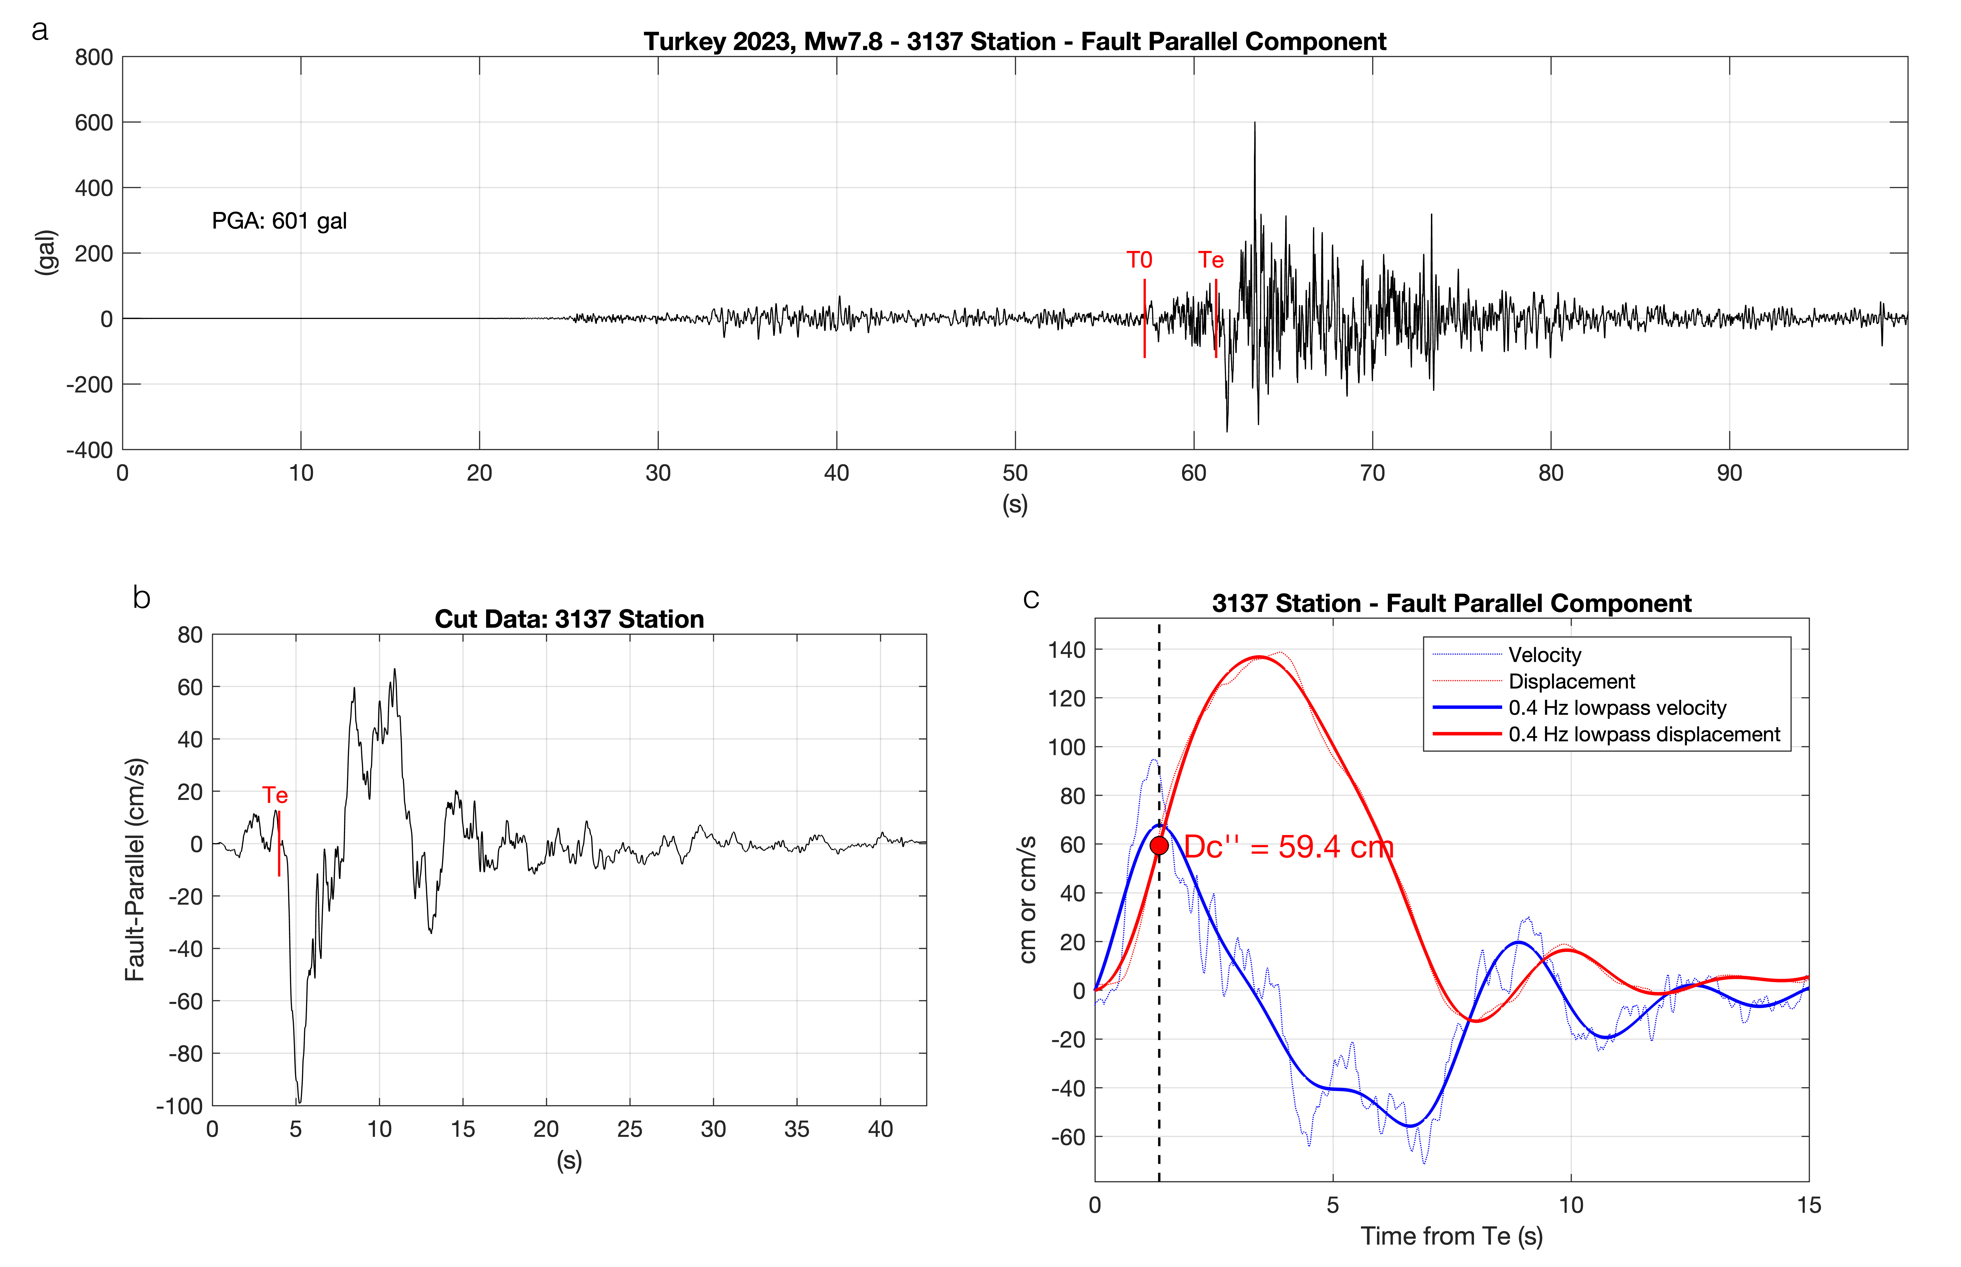
(E)
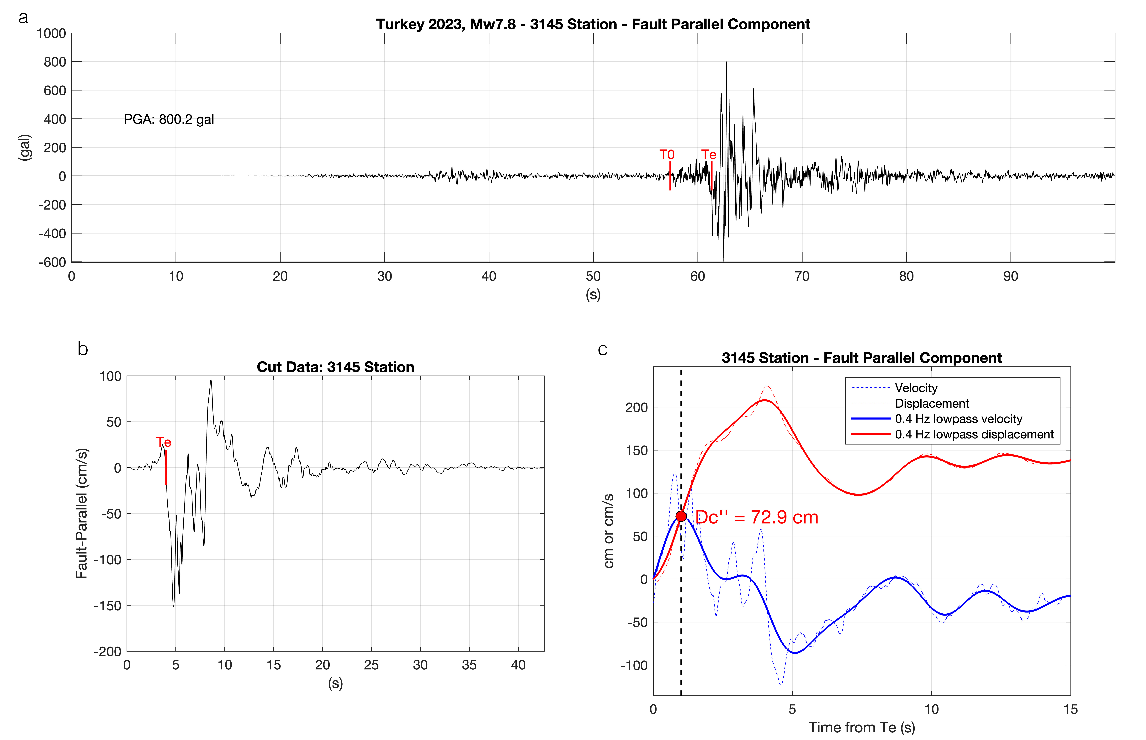
Figure S3: Continued.

(F)
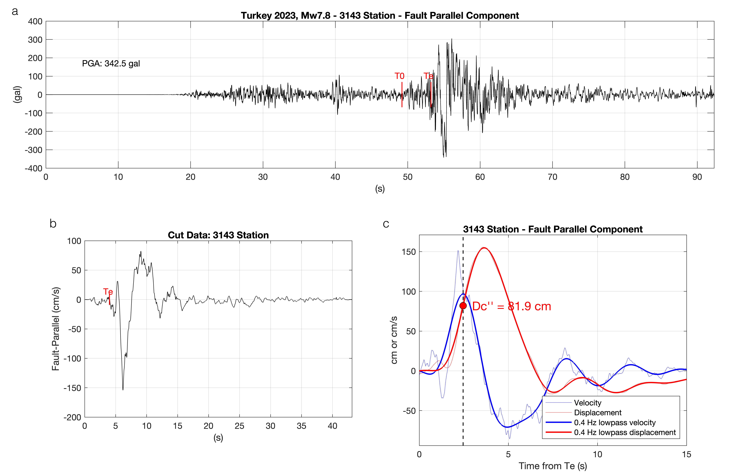
(G)
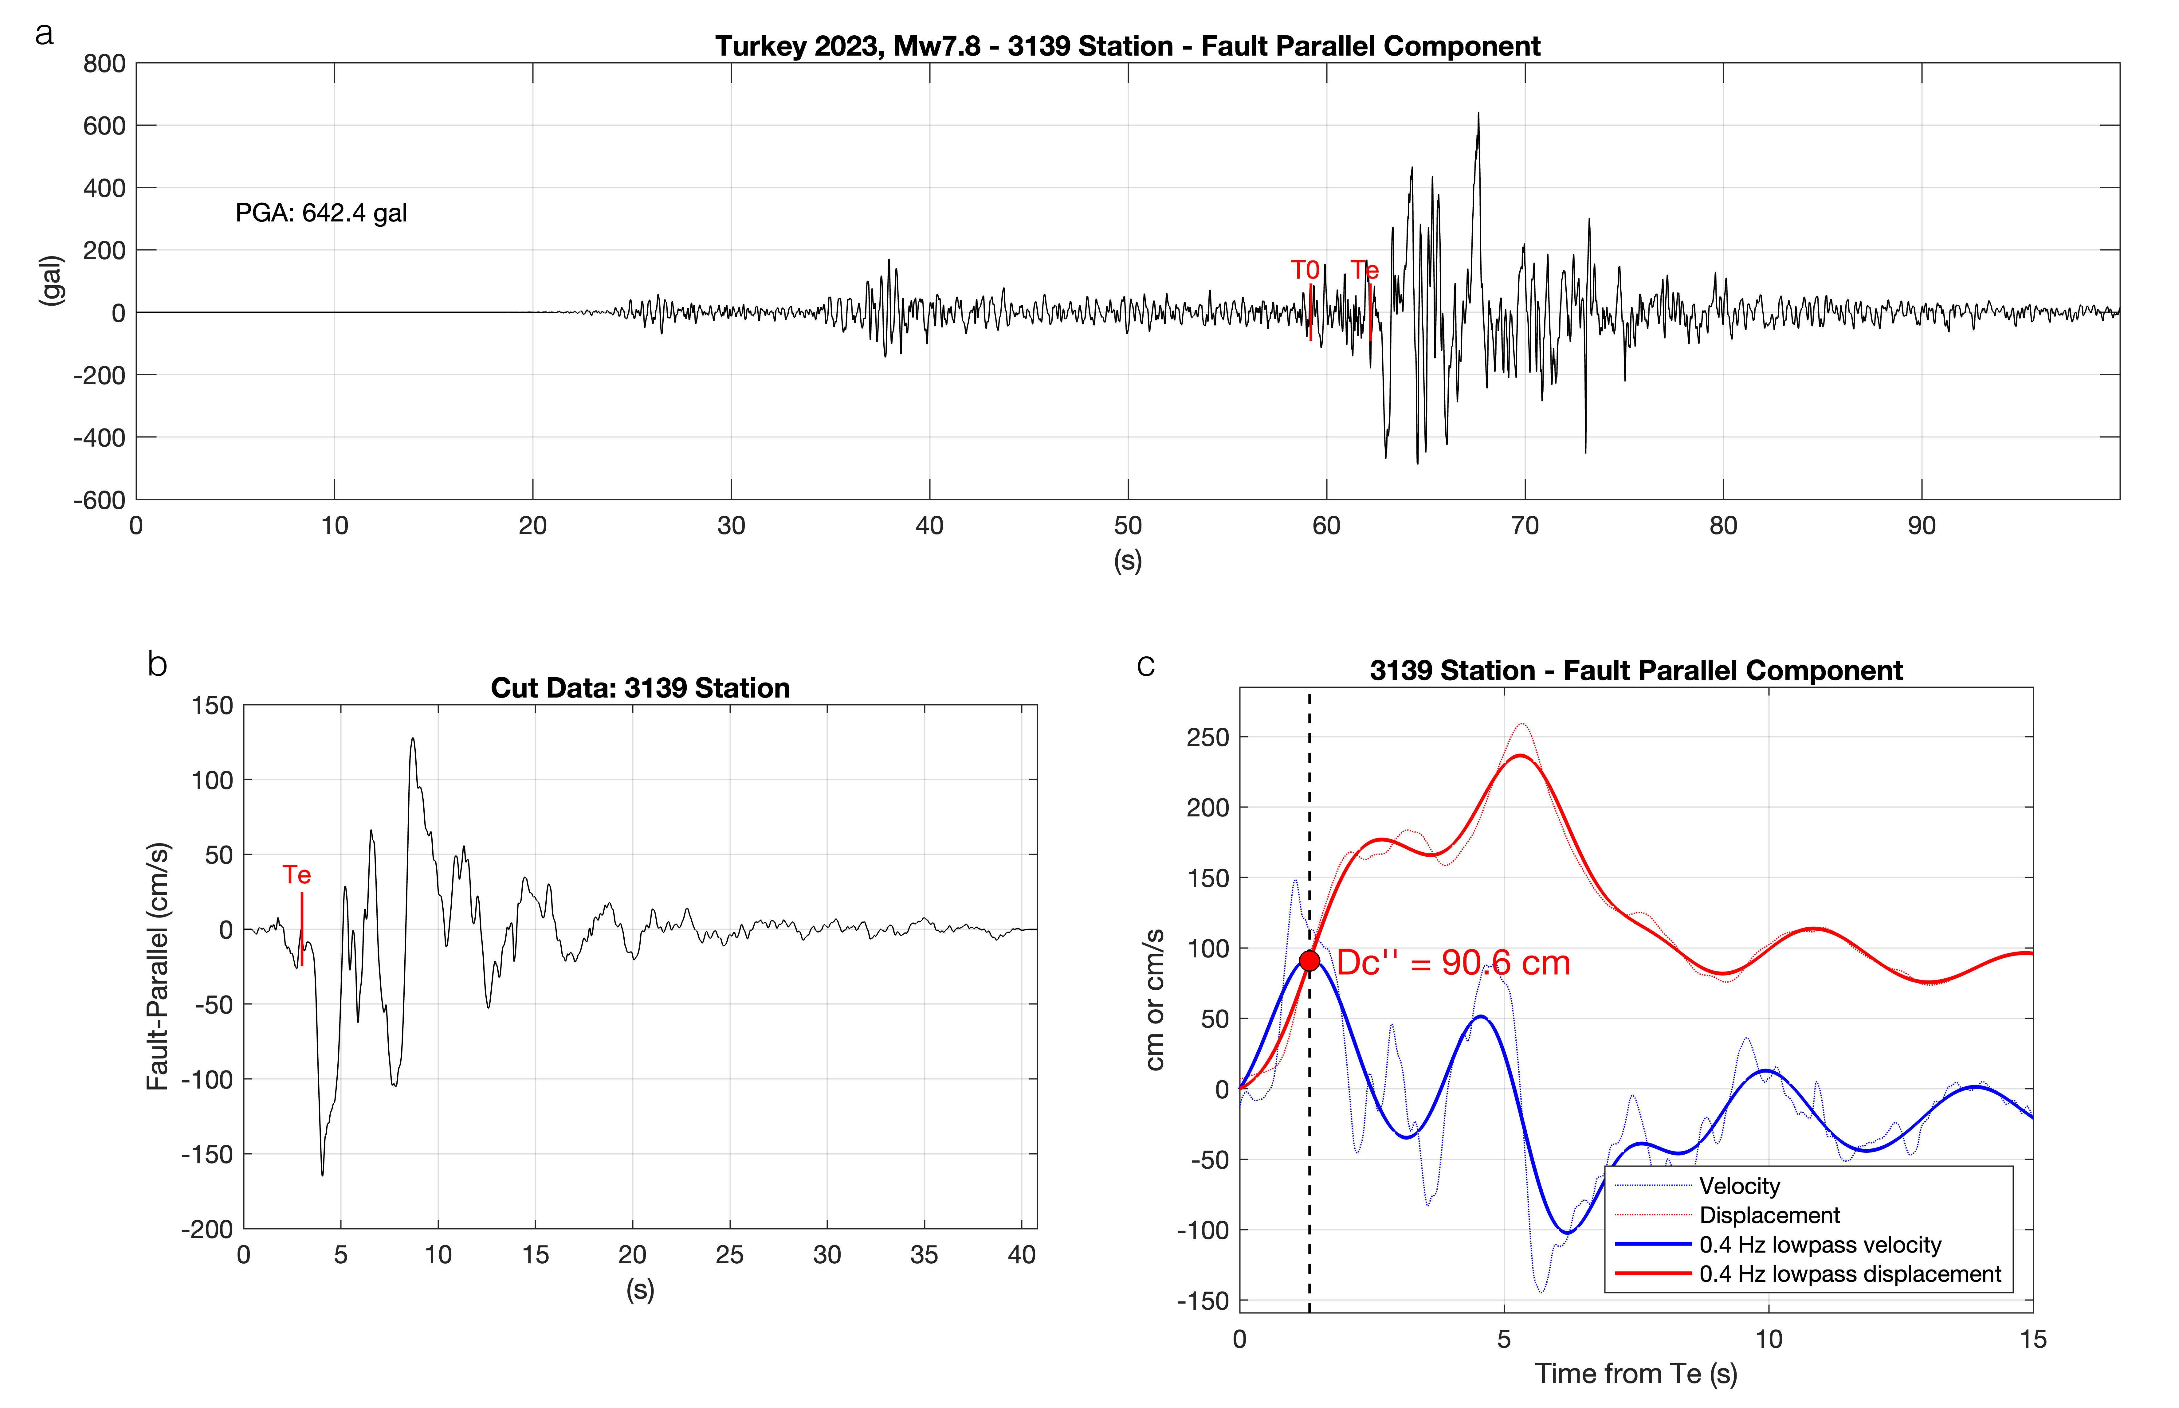
Figure S3: Continued.

(H)
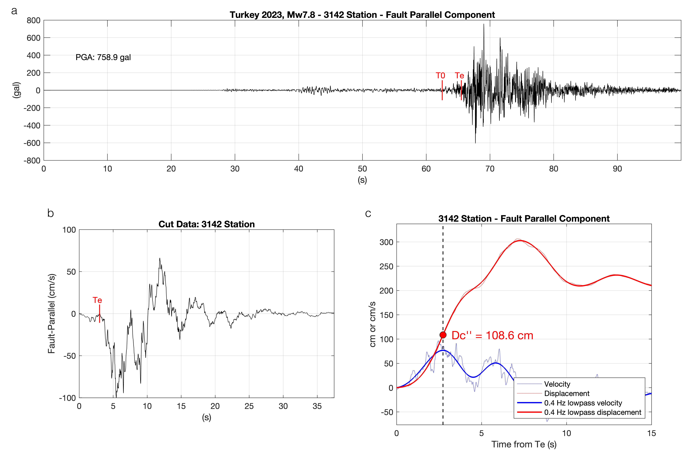
(I)
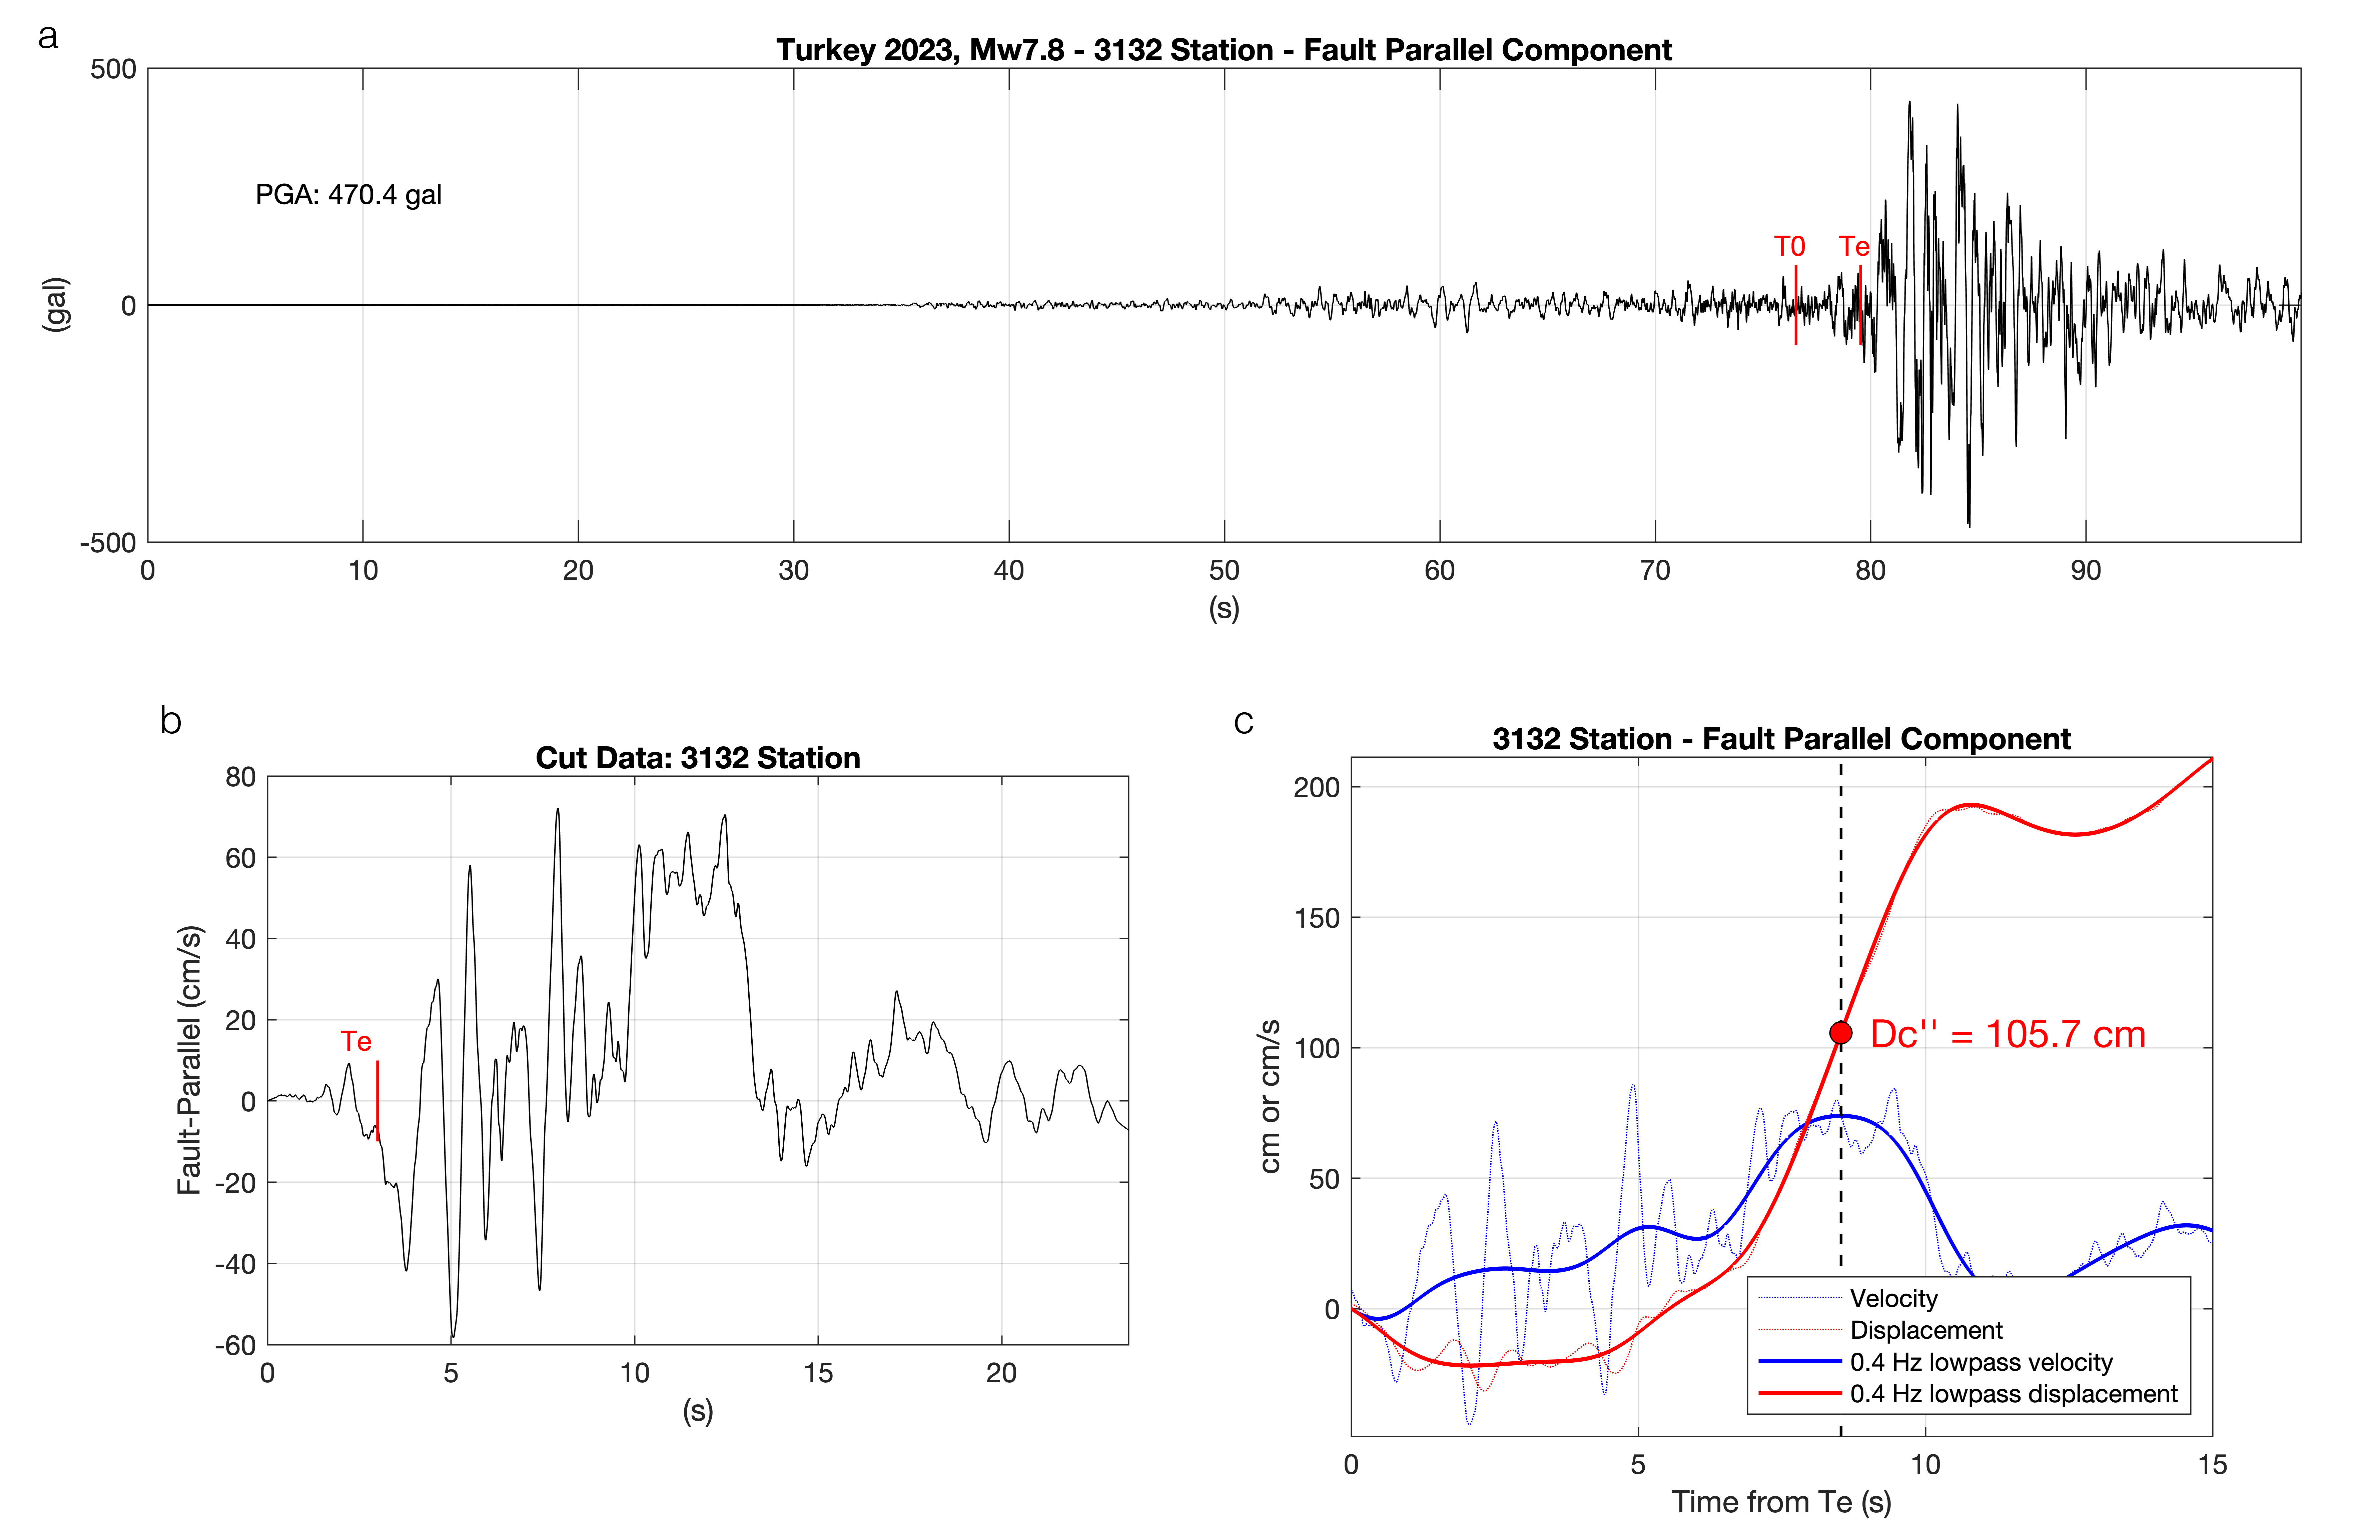
Figure S3: Continued.

(J)
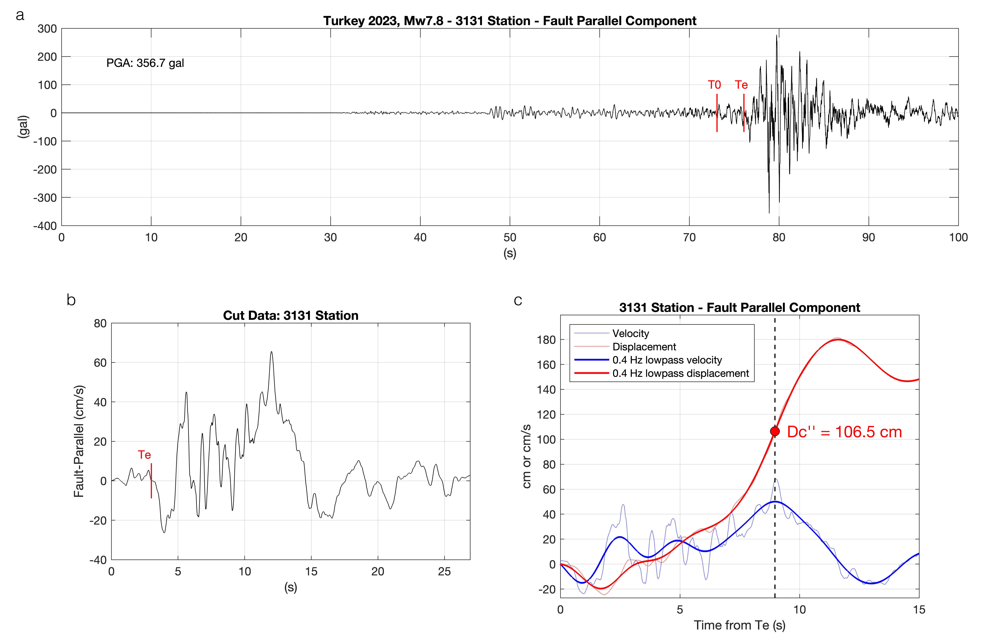
Figure S3: Continued.

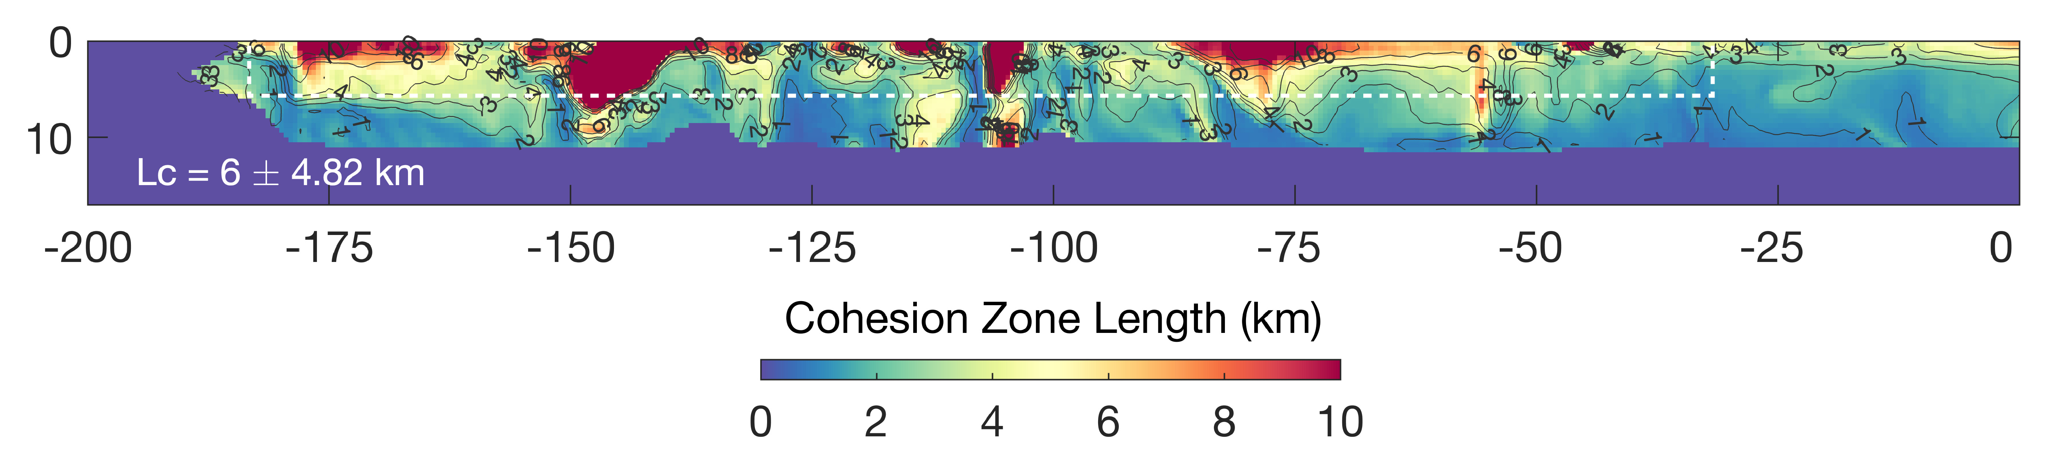
Figure S4. Cohesion zones length, Lc, determined for the simulation shown in Figure 11 within the white rectangle. The average value of 6 km along with the standard deviation is reported in the figure, where the minimum and maximum values of Lc are 1.01 and 29.9 km.
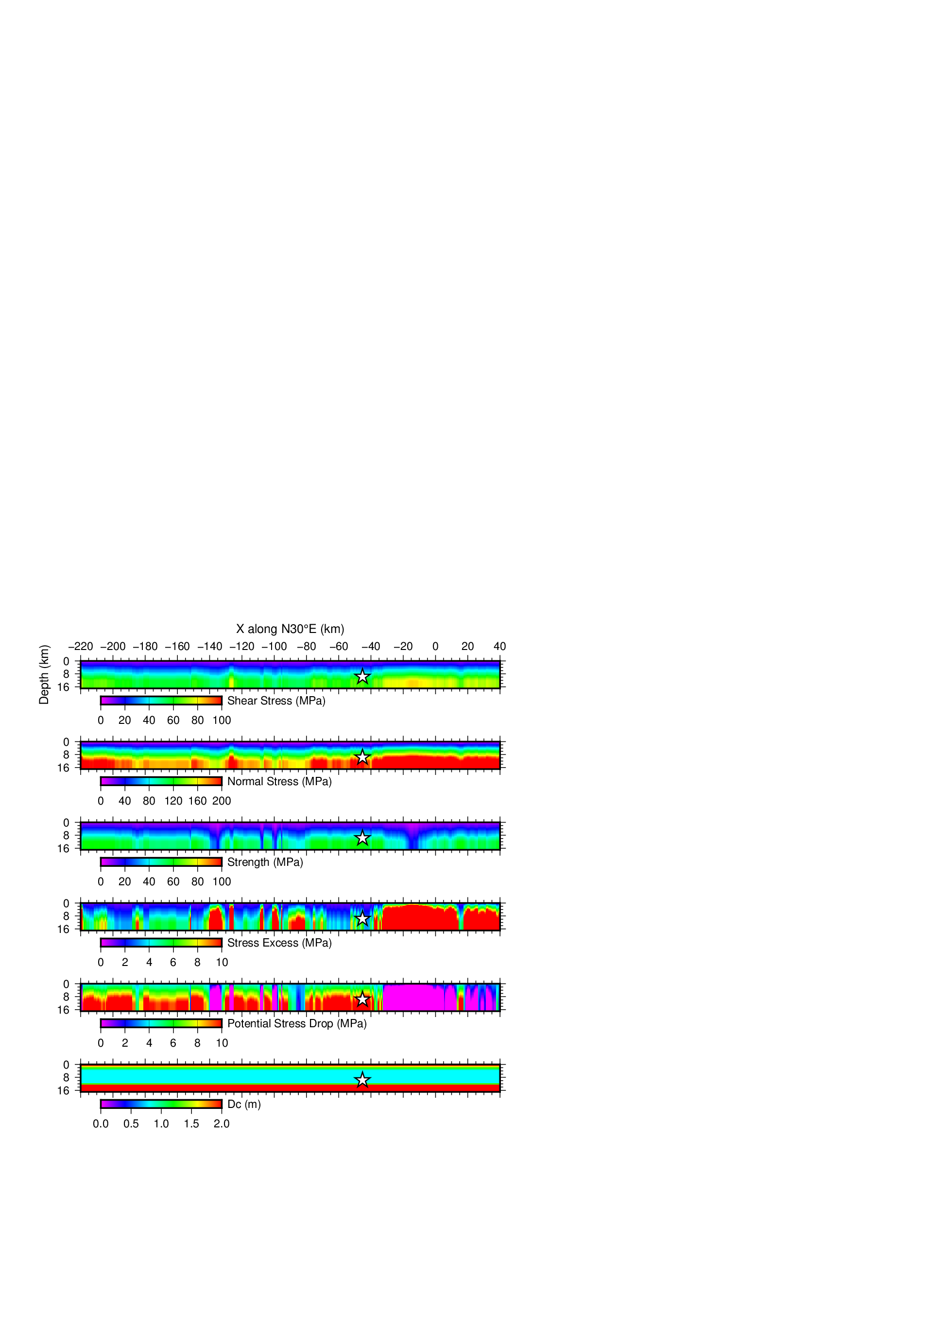
Figure S5. Initial condition for a case under uniform principal stress loading ($Φ$ = N30°E, $T$ = 0.80). The fault geometry is shown in Figure 1. From top to bottom, initial shear stress ($τ$), initial normal stress ($σ_{n}$), fault strengh ($τ_{p}$), stress excess ($τ_{p}-τ$), stress drop ($Δτ=τ-τ_{r}$) and critical slip displacement ($D_{c}$). The nucleation point (X = -50 km) is indicated as a start.
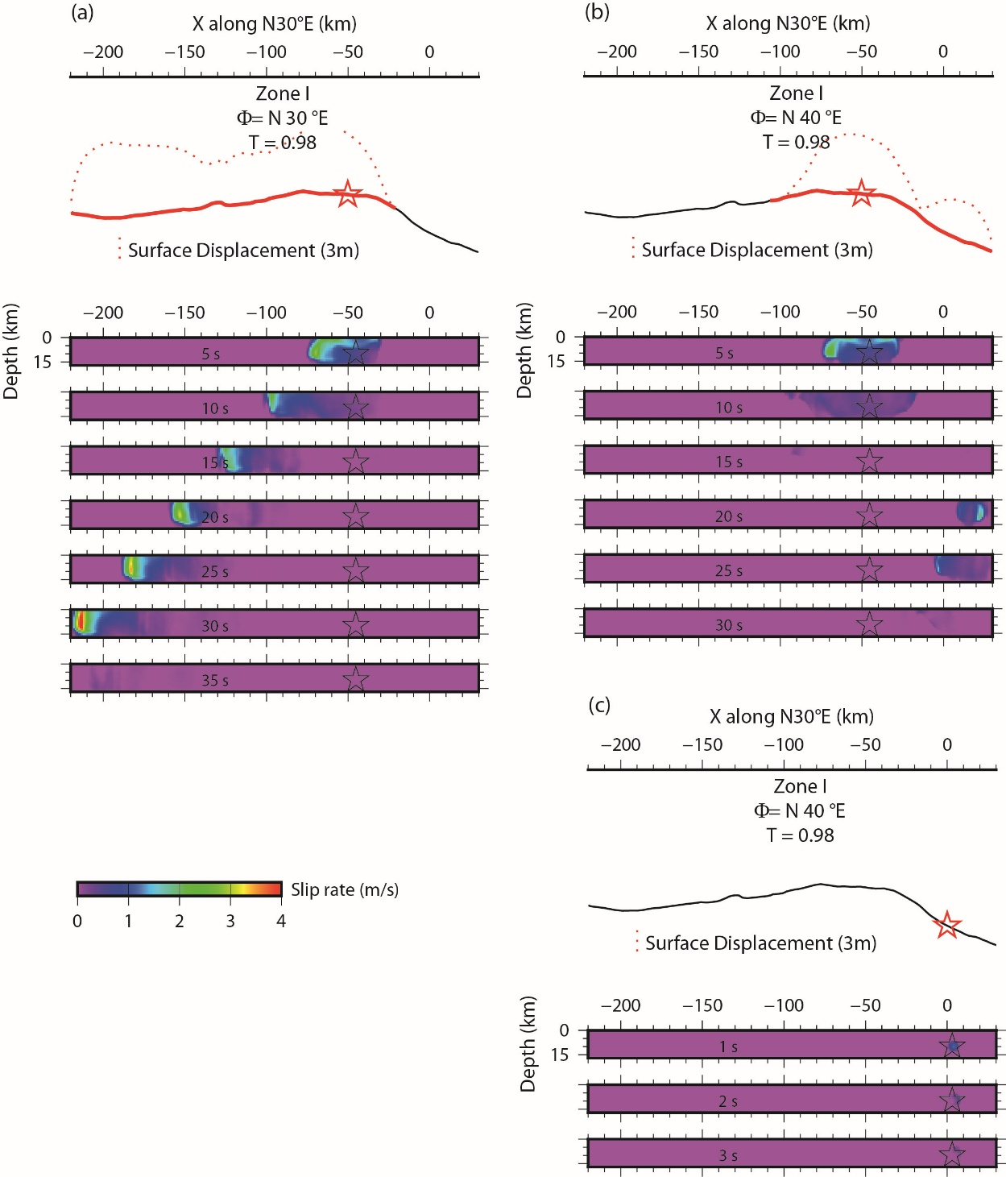
Figure S6. Snapshots of the three selected cases (A,B and C) from Figure 6, where the stress level is supposed extremely high (T = 0.98) in order to explore the possibility of the entire rupture under a uniform stress condition. It is high enough for some part of the faults so that the rupture propagates very fast (case A), but the fault geometry remains as a barrier to arrest the rupture. In the cases B and C, the nucleation positions are different under the same initial stress field, and this reads to the different rupture scenarios even in the terms of the ruptured area. In case B, the rupture is launched on the relatively favorite position so that it is enlarged bilaterally, and this allows triggering the rupture in the north-eastern portion of the fault. However in case C, the selected nucleation position is not favorable enough to grow up spontaneously and the rupture is terminated quickly. These are the common features in the parameter study in Figure 5. We need to assume a high T-value to go further along the non-linear fault, but the rupture process itself becomes so fast. In the analysis of Figure 6, we then seek a T-value, sufficiently high enough to have a long rupture length, but the least level.

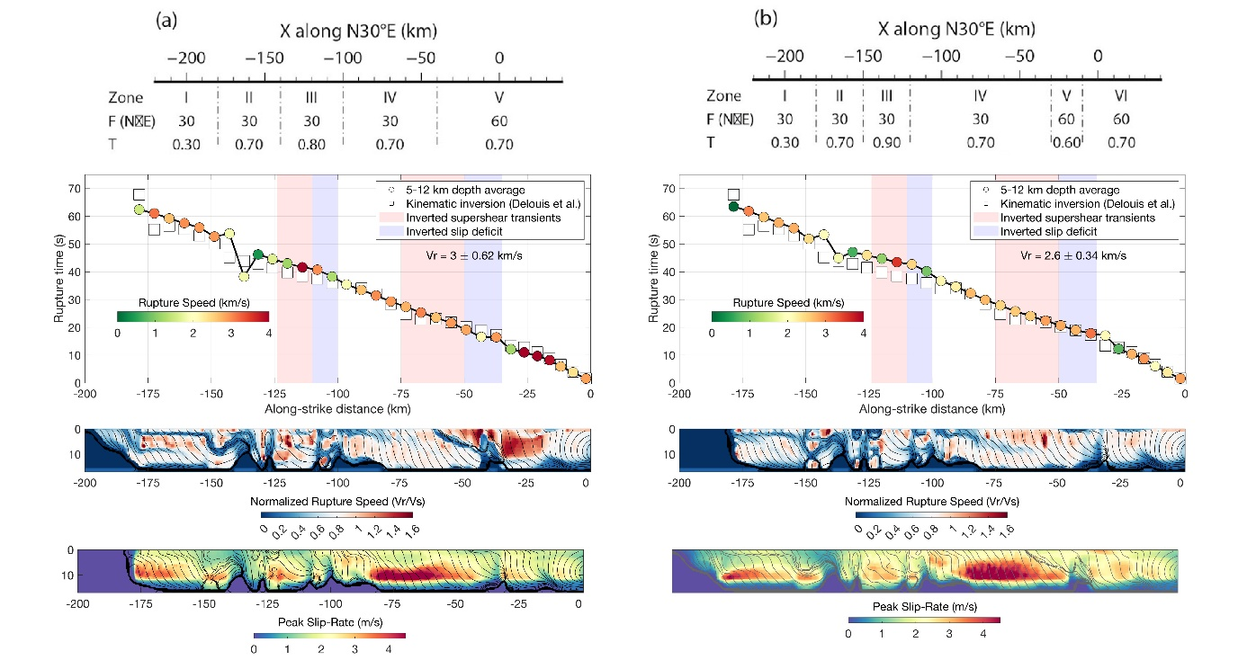
Figure S7. Rupture propagation for 5-zone and 6-zone models.

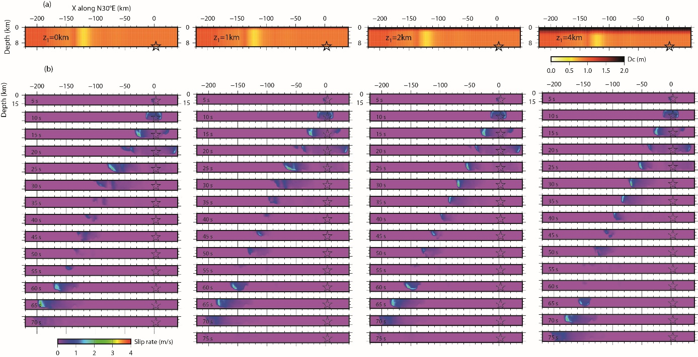
Figure S8. The parameter study on the depth-dependency of Dc value controlled by the depth $z_{1}$ ($z_{1}$ = 0, 1, 2 and 4 km). Above this depth, it is commonly supposed that $D_{c}$ becomes longer up to 2 m as the reference model. Below it, $D_{c}$ is constant up to 12 km depth. (a) Four models of different $z_{1}$, while the horizontal variation is the same. (b) The snapshots of the dynamic rupture simulations. We observe that the rupture propagates faster in the case of $z_{1}$ = 0, 1 km. On the other hand, the rupture is disturbed a lot in the middle in the case of $z_{1}$ = 4 km. The rupture propagation is globally steady. The most. Therefore, this test indicates that there should always exist a stable shallow layer with a long$D_{c}$. The $D_{c}$ value estimated from the near-fault ground motion might be representative for the seismogenic depth below the shallow zone.

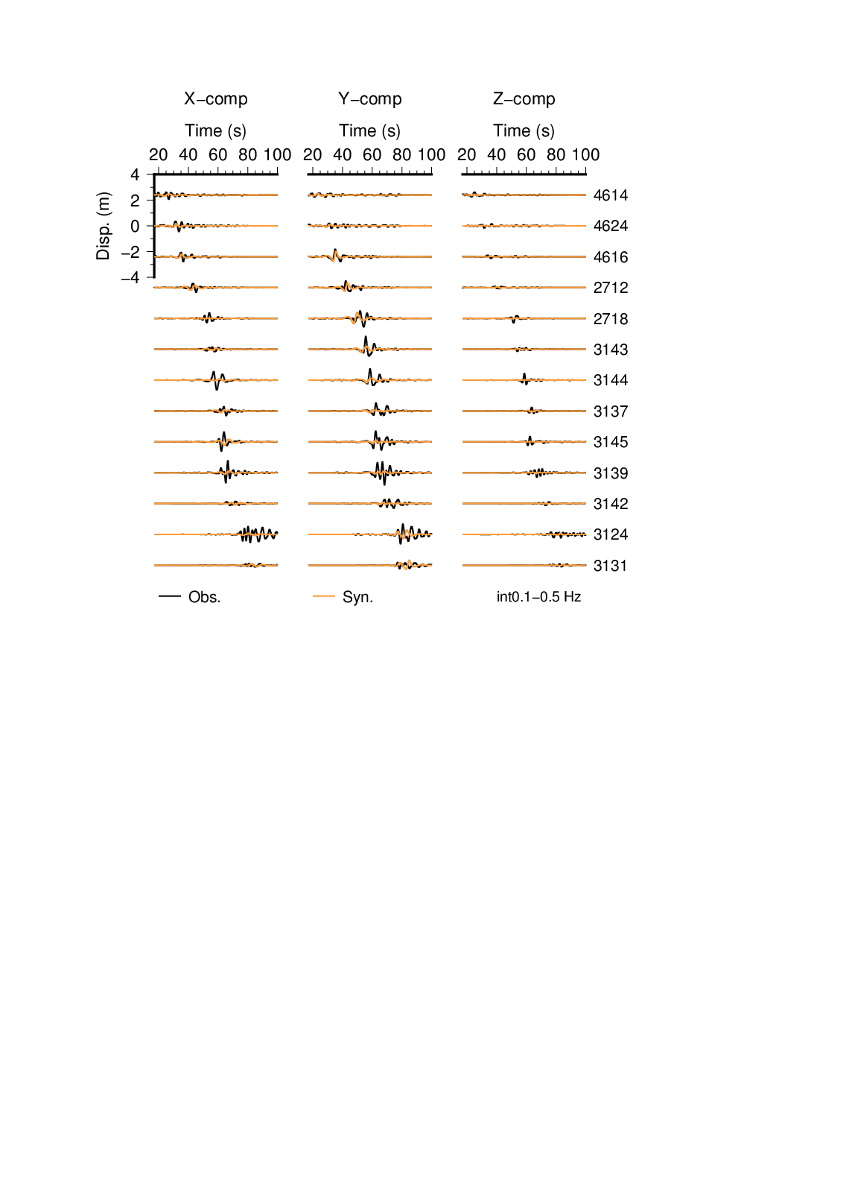
Figure S9. Comparison of synthetics and observation from the simulation of 7-zone stress model with horizontal variation of Dc (Figure 12b). The seismograms are filtered between 0.1 and 0.5 Hz to clarify the arrival of the rupture front.

