Supplementary Material for the article

“Chasing the ghost of fracking in the Vaca Muerta Formation: Induced seismicity in the Neuquén Basin, Argentina”

by

Ryan Schultz, Guillermo Tamburini-Beliveau,
Sebastián Correa-Otto, & Javier A. Grosso-Heredia

published in



Contents of this file

Supplementary Figures S1-S31

Supplementary Figures

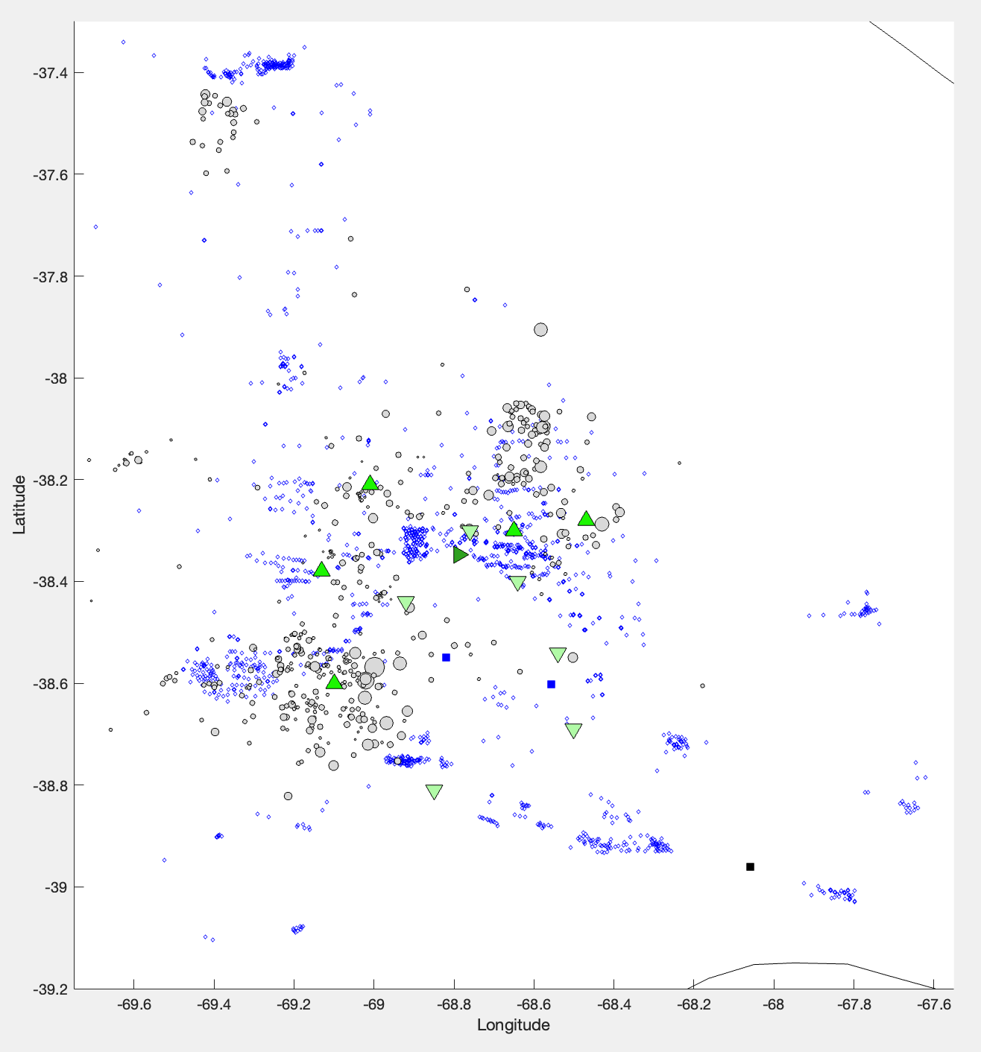

Figure S1. Map of the seismic stations. The locations of stations (green triangles), alongside the catalogue of earthquakes (grey circles) and locations of hydraulic fracturing wells (blue diamonds). Stations used in the PhD project [Correa-Otto, 2021] are those that were available for 2014-2020 (upward triangles, green) and from 2014-2016 (downward triangles, light green); nearby INPRES stations are also shown (rightward triangle, dark green). Blue and black squares are the locations of bodies of water and the city of Neuquén, respectively.

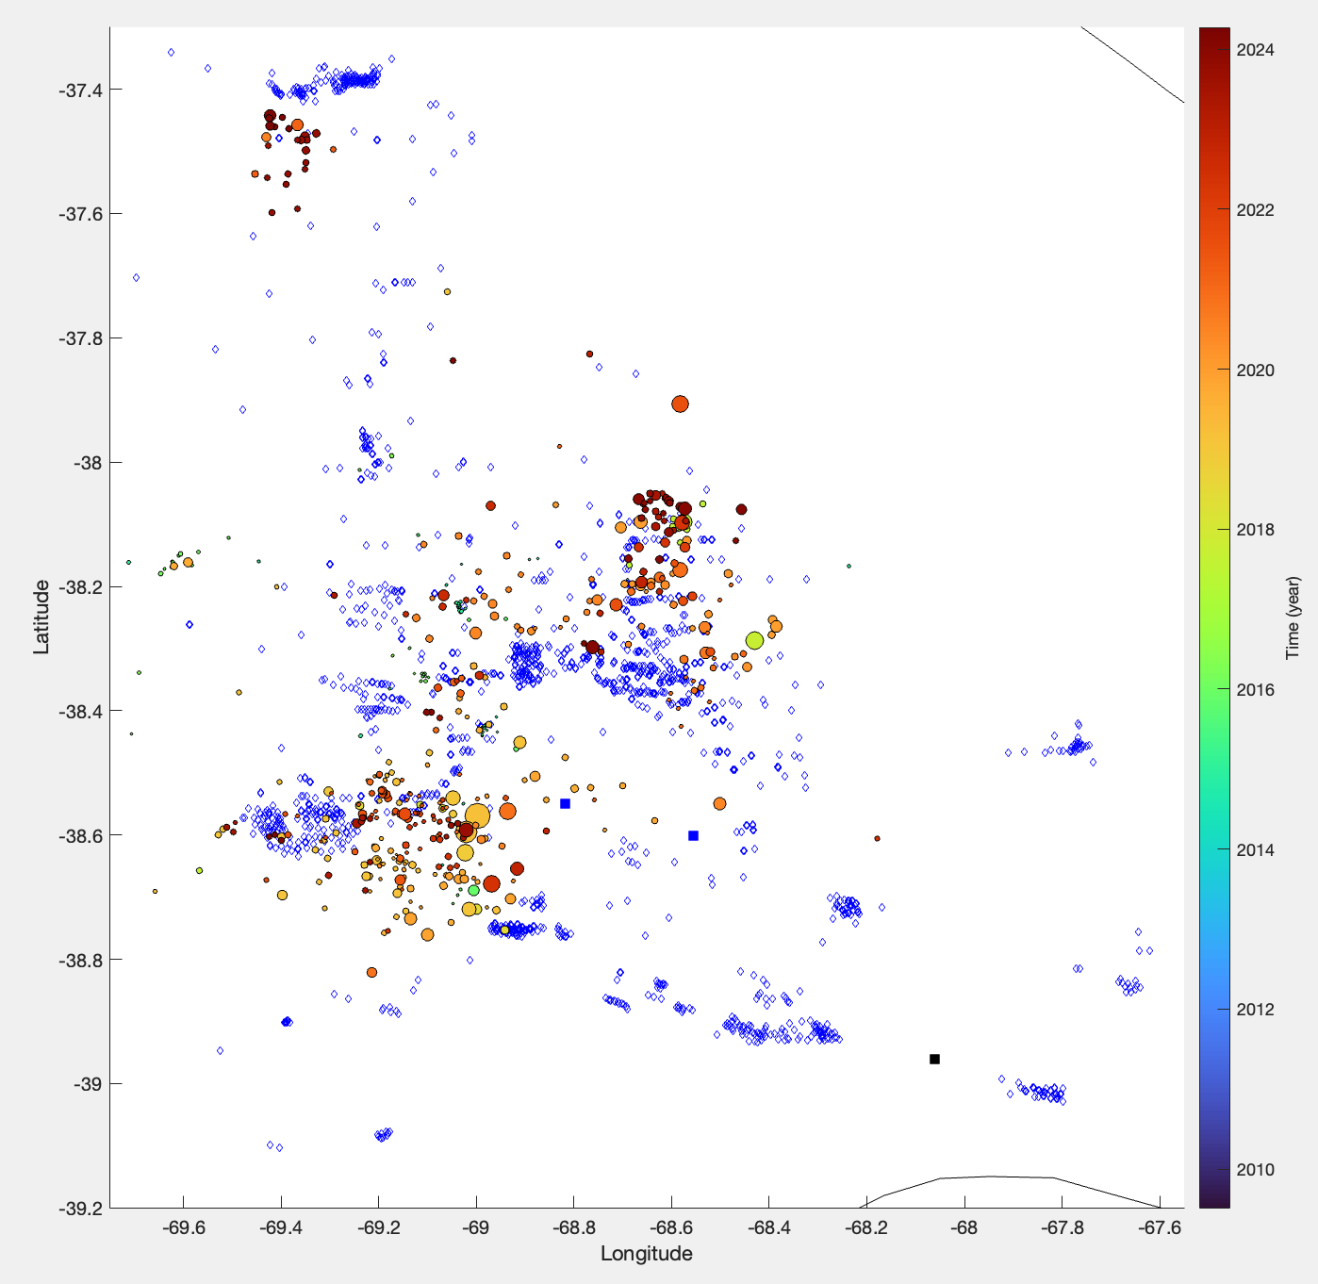

Figure S2. Spatiotemporal visualization of the earthquake catalogue. The catalogue of earthquakes (circles) coloured according to their origin times. Blue and black squares are the locations of bodies of water and the city of Neuquén, respectively. Blue diamonds show the locations of hydraulic fracturing wells, for reference.

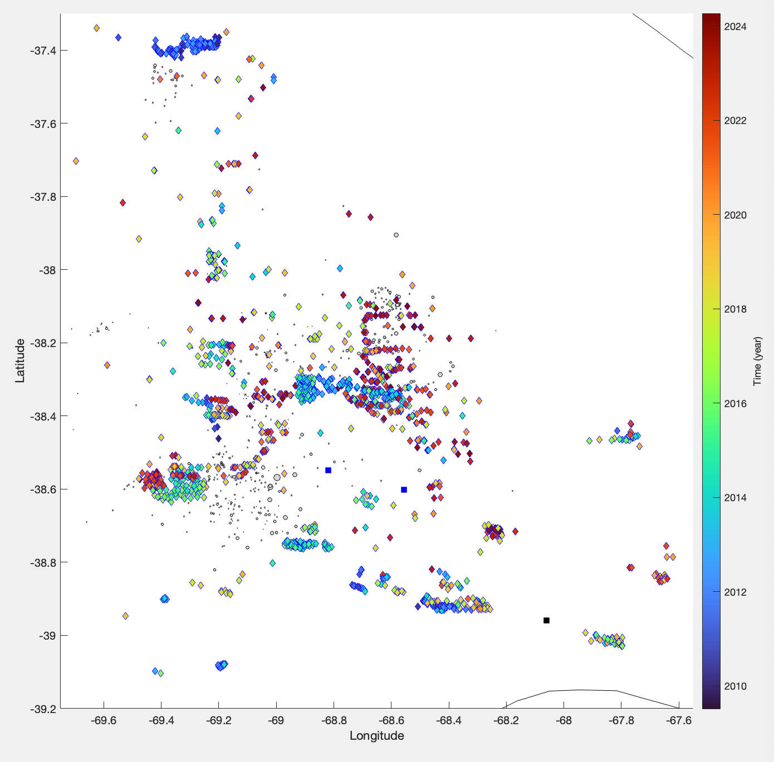

Figure S3. Spatiotemporal visualization of the hydraulic fracturing database. The database of known hydraulic fracturing well locations (diamonds) coloured according to timing of stimulation. Blue and black squares are the locations of bodies of water and the city of Neuquén, respectively. Grey circles show the locations of earthquakes, for reference.

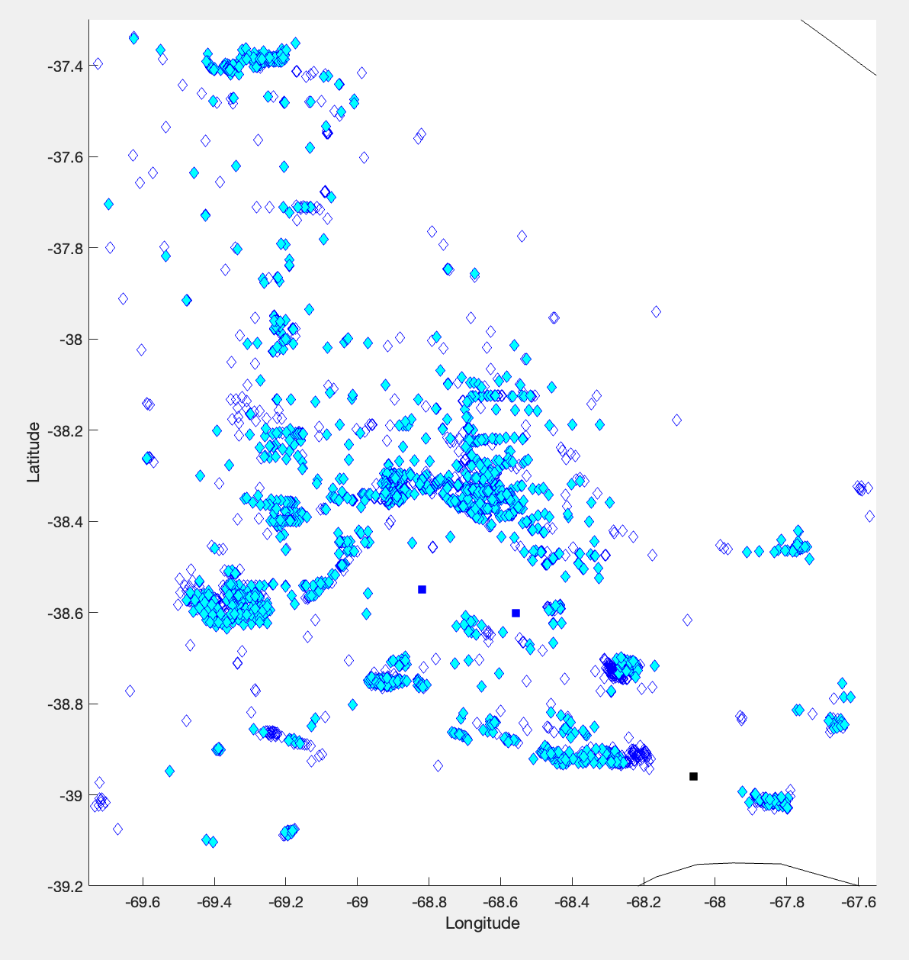

Figure S4. Incompleteness of the hydraulic fracturing database. The database of known hydraulic fracturing well locations (blue diamonds) is plotted in comparison to those that also have known times/volumes (cyan filled diamonds). Of the full database of 4097 wells, 3433 have complete timing/stimulation data. Blue and black squares are the locations of bodies of water and the city of Neuquén, respectively.

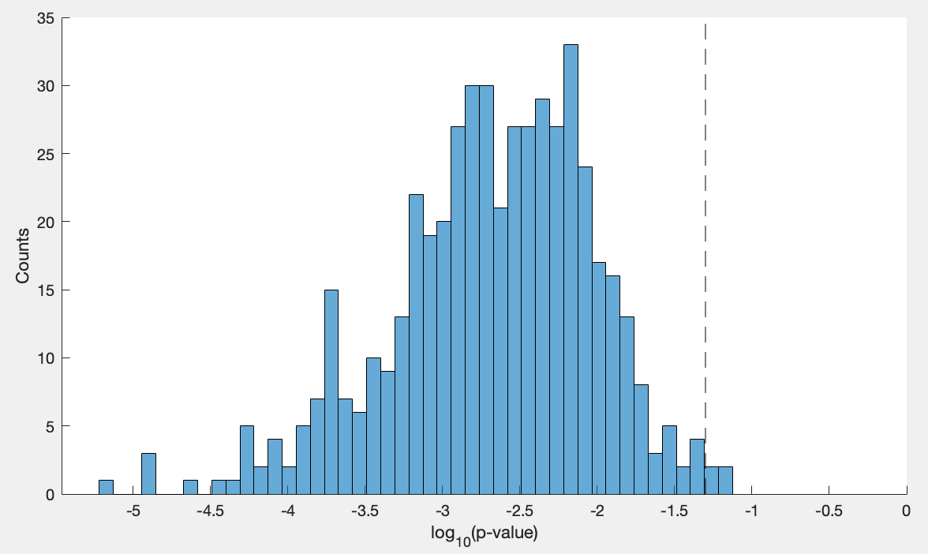

Figures S5. Bootstrapped KS-test p-values. The distribution of (log-10) p-values from KS-testing alongside the 95% confidence level (dashed line).

SAF from this study (w/ more restrictive spatial-scores).
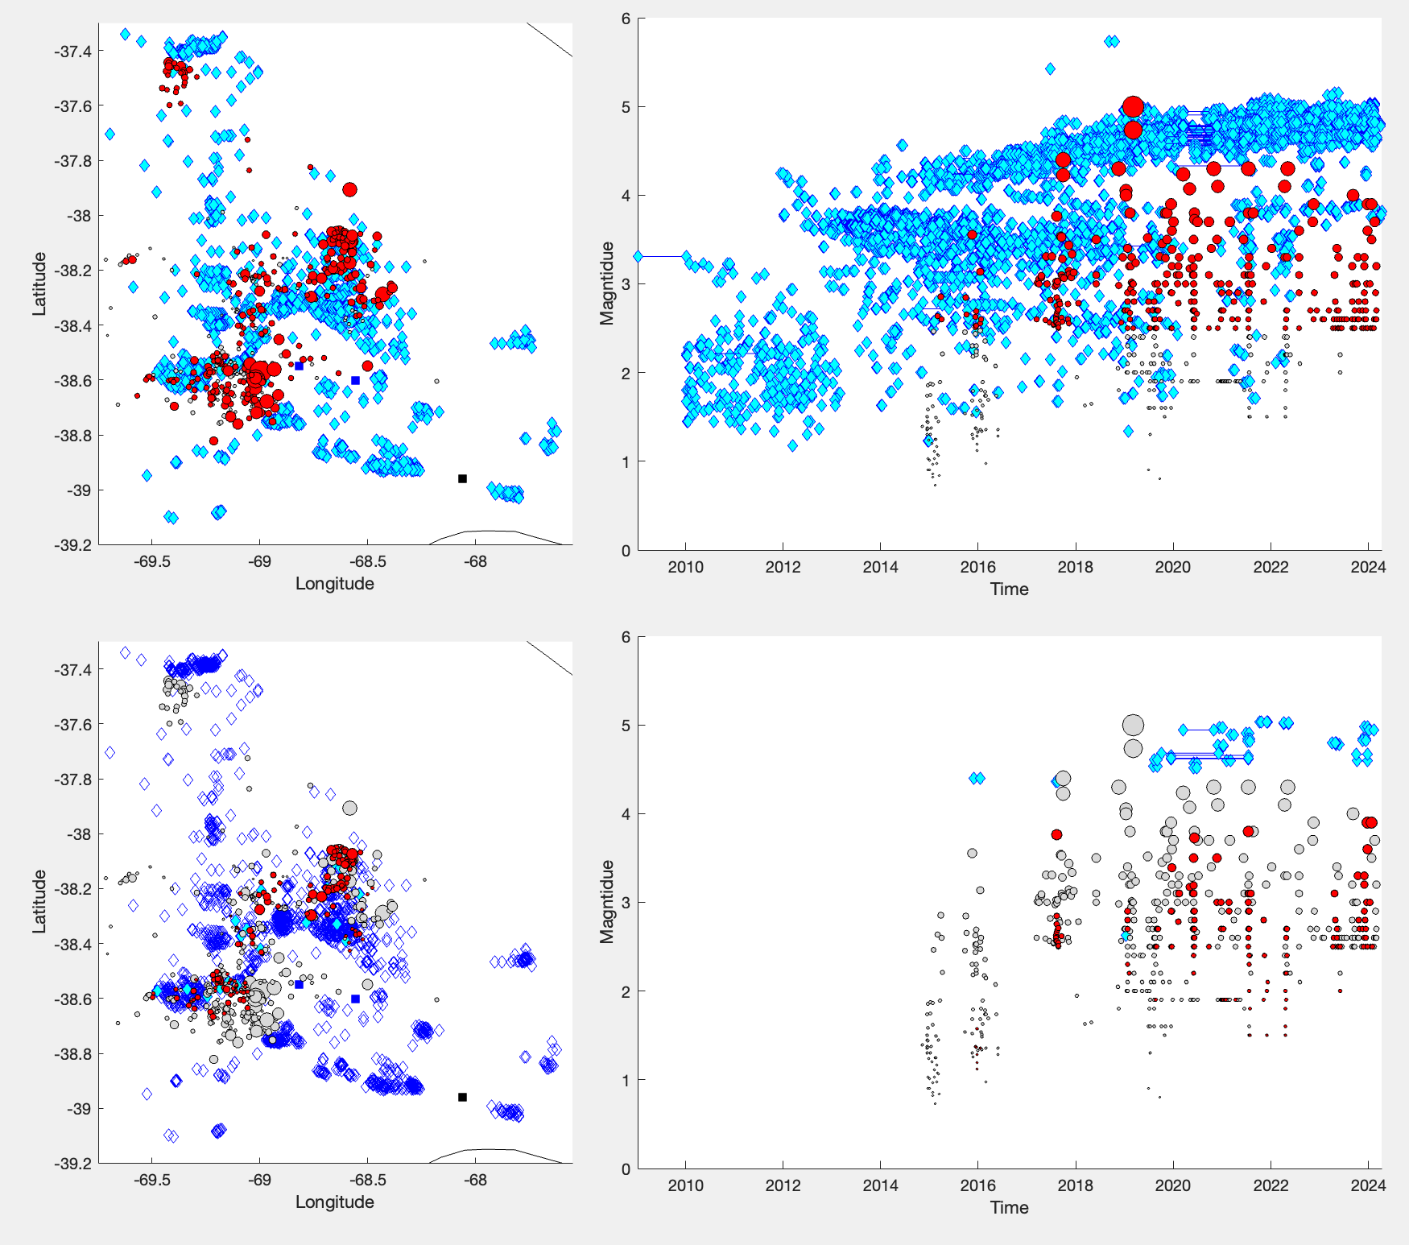

Figure S6. Alternative SAF. (left column) Maps with locations of earthquakes (circles) and hydraulic fracturing operations (diamonds). (right column) Temporal timings of hydraulic fracturing operations (two diamonds linked with a blue line) and earthquake magnitudes (circles). Comparisons are made between the full (top row) and filtered (bottom row) datasets. Unassociated operations/earthquakes have faded colors. Plot is analogous to Figure 4, just using more restrictive spatial/temporal-scoring functions within SAF processing.

SAF from Lomax & Savvaidis, [2019].
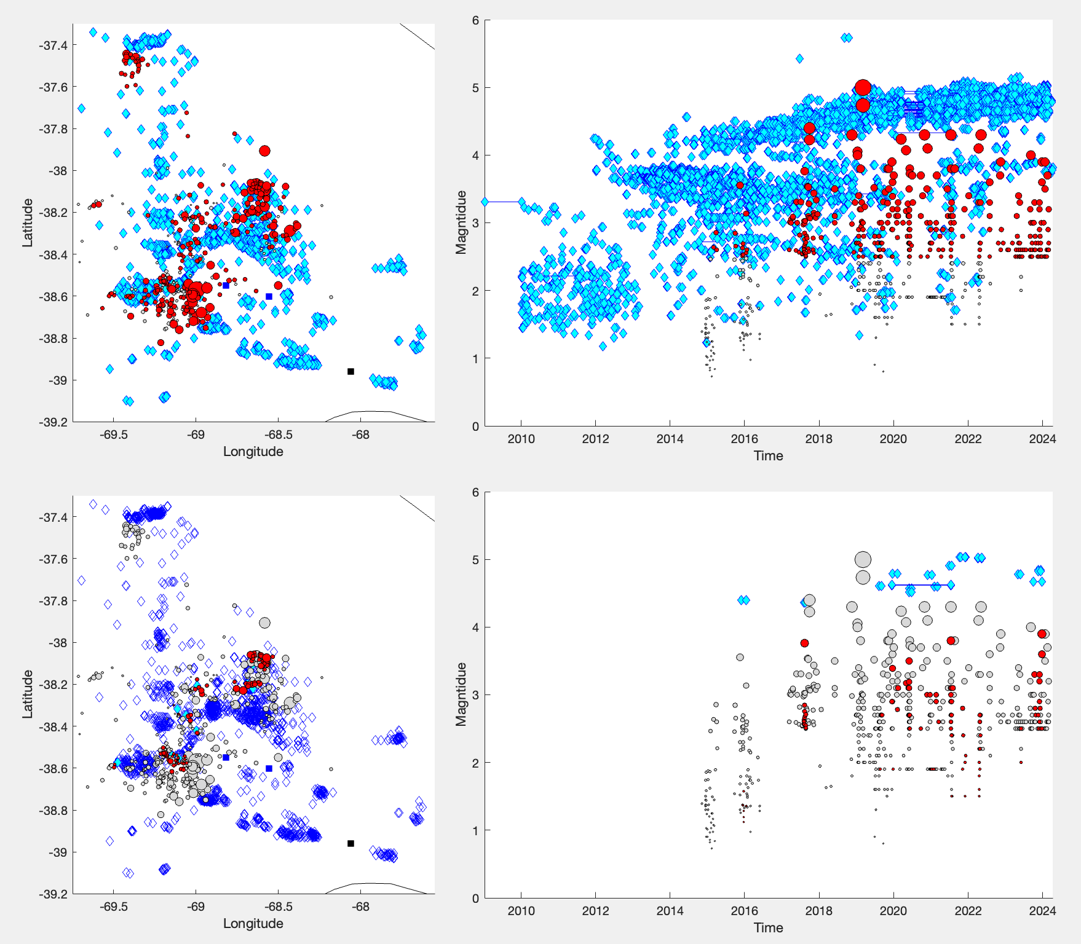

Figure S7. Alternative SAF. (left column) Maps with locations of earthquakes (circles) and hydraulic fracturing operations (diamonds). (right column) Temporal timings of hydraulic fracturing operations (two diamonds linked with a blue line) and earthquake magnitudes (circles). Comparisons are made between the full (top row) and filtered (bottom row) datasets. Unassociated operations/earthquakes have faded colors. Plot is analogous to Figure 4, just using SAF processing from a prior study [Lomax & Savvaidis, 2019].

SAF from Savvaidis et al., [2020].

Figure S8. Alternative SAF. (left column) Maps with locations of earthquakes (circles) and hydraulic fracturing operations (diamonds). (right column) Temporal timings of hydraulic fracturing operations (two diamonds linked with a blue line) and earthquake magnitudes (circles). Comparisons are made between the full (top row) and filtered (bottom row) datasets. Unassociated operations/earthquakes have faded colors. Plot is analogous to Figure 4, just using SAF processing from a prior study [Savvaidis et al., 2020].

SAF from Ghofrani & Atkinson, [2020].
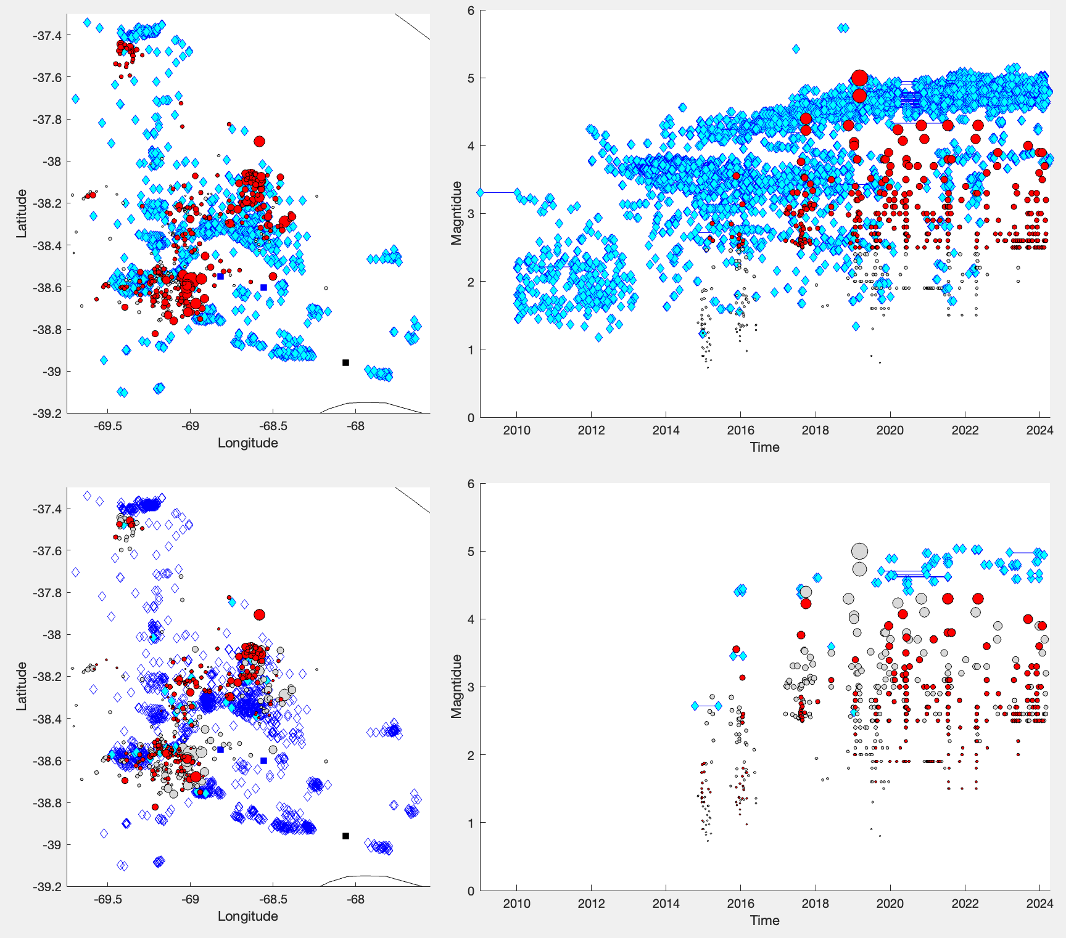

Figure S9. Alternative SAF. (left column) Maps with locations of earthquakes (circles) and hydraulic fracturing operations (diamonds). (right column) Temporal timings of hydraulic fracturing operations (two diamonds linked with a blue line) and earthquake magnitudes (circles). Comparisons are made between the full (top row) and filtered (bottom row) datasets. Unassociated operations/earthquakes have faded colors. Plot is analogous to Figure 4, just using SAF processing from a prior study [Ghofrani & Atkinson, 2020].

SAF from Ghofrani & Atkinson, [2021].
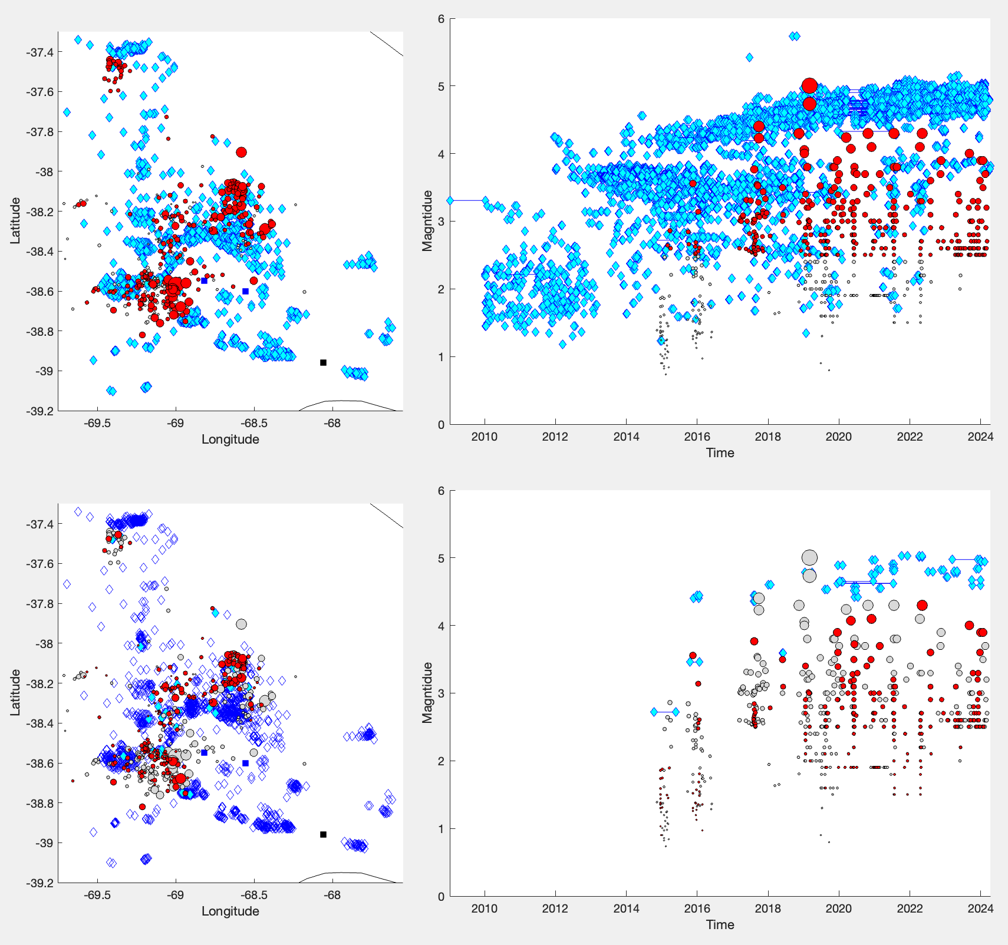

Figure S10. Alternative SAF. (left column) Maps with locations of earthquakes (circles) and hydraulic fracturing operations (diamonds). (right column) Temporal timings of hydraulic fracturing operations (two diamonds linked with a blue line) and earthquake magnitudes (circles). Comparisons are made between the full (top row) and filtered (bottom row) datasets. Unassociated operations/earthquakes have faded colors. Plot is analogous to Figure 4, just using SAF processing from a prior study [Ghofrani & Atkinson, 2021].

SAFbs from this study (w/ more restrictive spatial-scores).
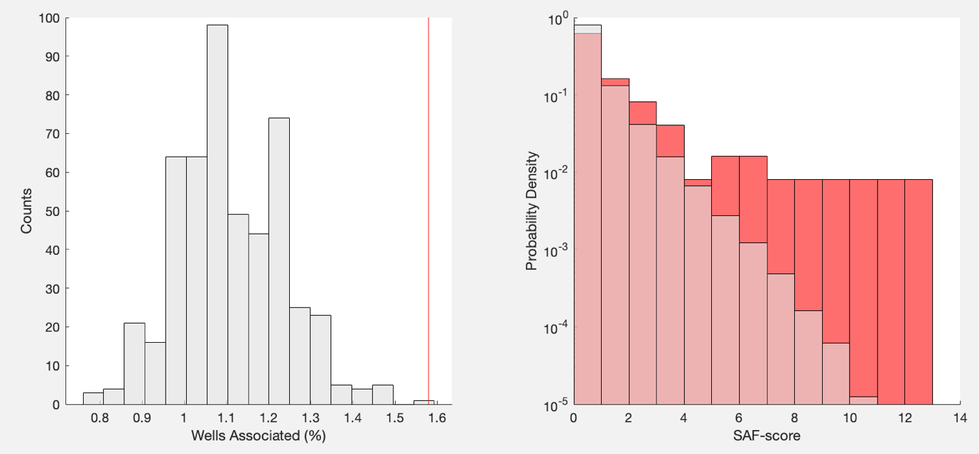

Figure S11. Bootstrapped (alternative) SAF results. (left) The basin-scale percentage of wells associated with earthquakes via SAF (red-line), in comparison to the association percentages when reshuffling catalogues (grey bars). (right) The distribution of SAF-scores for the regular dataset (red bars), in comparison with reshuffled data (grey bars). Plot is analogous to Figure 5, just using more restrictive spatial/temporal-scoring functions within SAF processing.

SAFbs from Lomax & Savvaidis, [2019].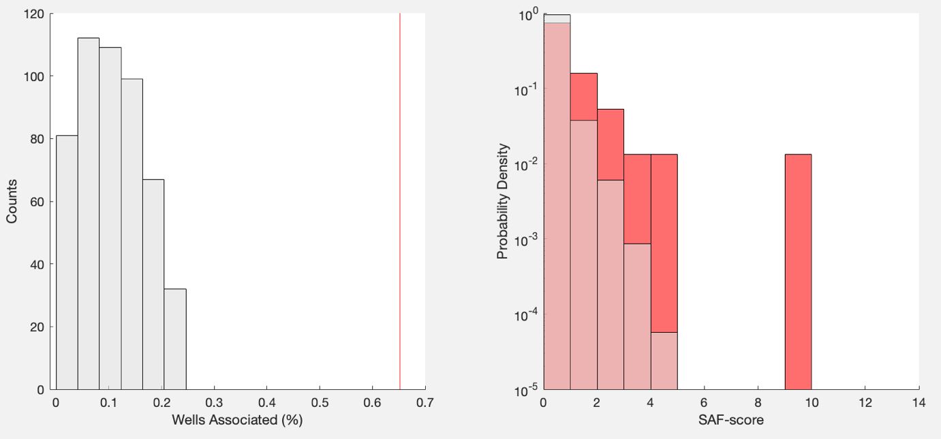

Figure S12. Bootstrapped (alternative) SAF results. (left) The basin-scale percentage of wells associated with earthquakes via SAF (red-line), in comparison to the association percentages when reshuffling catalogues (grey bars). (right) The distribution of SAF-scores for the regular dataset (red bars), in comparison with reshuffled data (grey bars). Plot is analogous to Figure 5, just using SAF processing from a prior study [Lomax & Savvaidis, 2019].

SAFbs from Savvaidis et al., [2020].
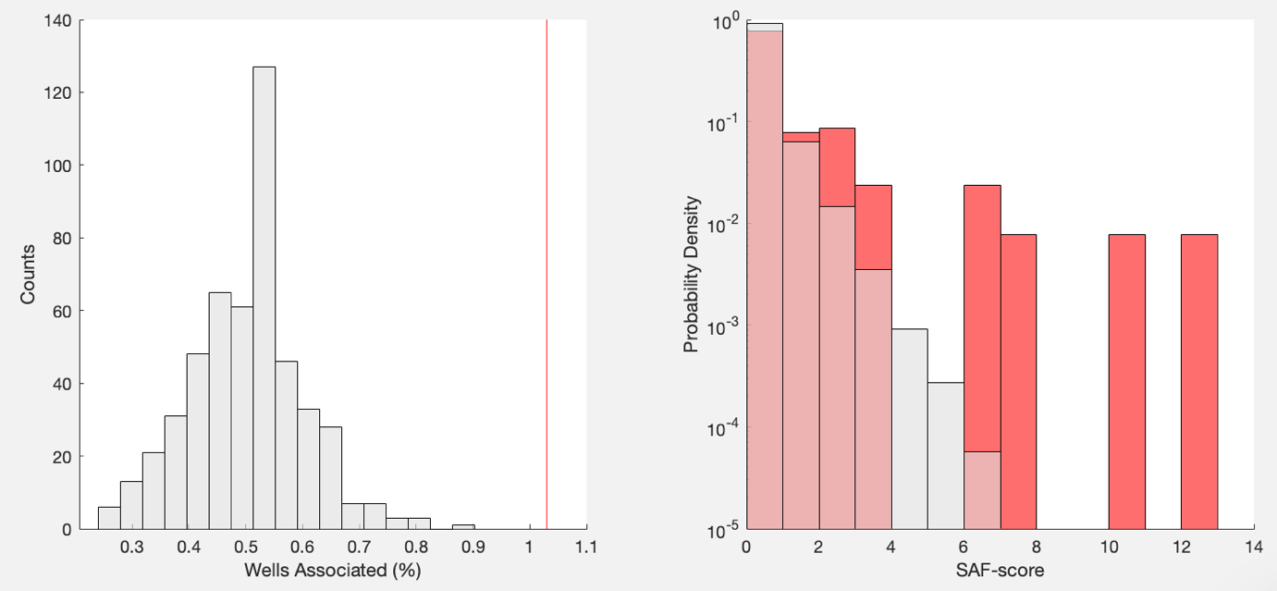

Figure S13. Bootstrapped (alternative) SAF results. (left) The basin-scale percentage of wells associated with earthquakes via SAF (red-line), in comparison to the association percentages when reshuffling catalogues (grey bars). (right) The distribution of SAF-scores for the regular dataset (red bars), in comparison with reshuffled data (grey bars). Plot is analogous to Figure 5, just using SAF processing from a prior study [Savvaidis et al., 2020].

SAFbs from Ghofrani & Atkinson, [2020].
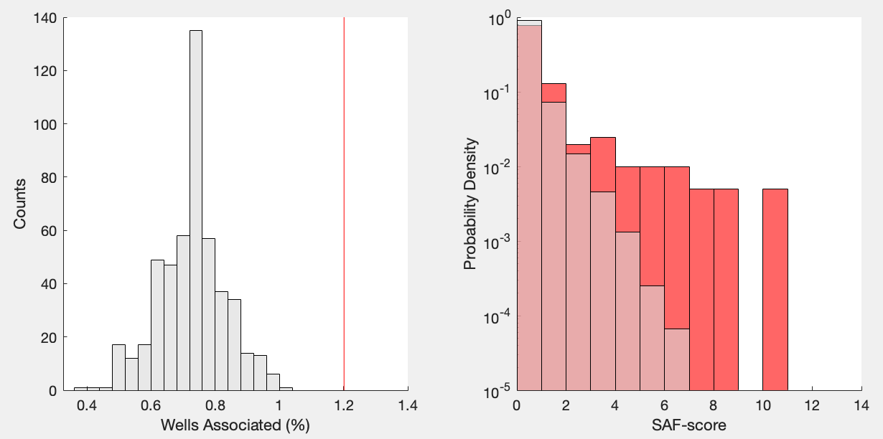

Figure S14. Bootstrapped (alternative) SAF results. (left) The basin-scale percentage of wells associated with earthquakes via SAF (red-line), in comparison to the association percentages when reshuffling catalogues (grey bars). (right) The distribution of SAF-scores for the regular dataset (red bars), in comparison with reshuffled data (grey bars). Plot is analogous to Figure 5, just using SAF processing from a prior study [Ghofrani & Atkinson, 2020].

SAFbs from Ghofrani & Atkinson, [2021].
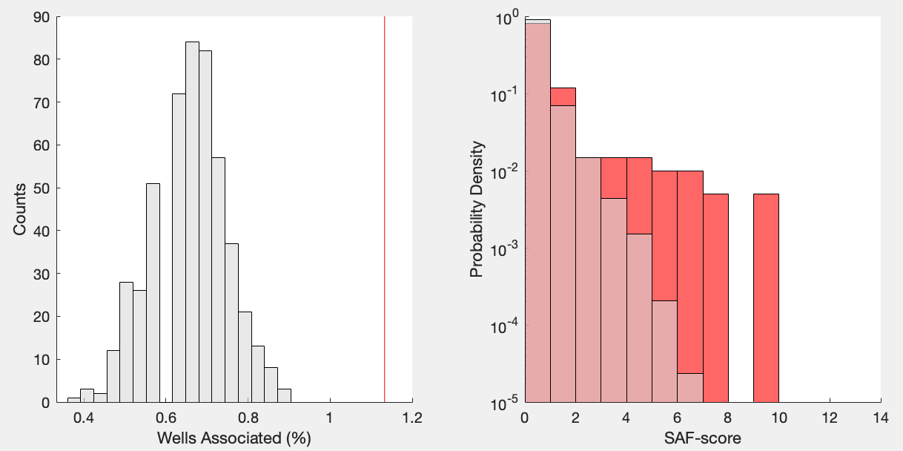

Figure S15. Bootstrapped (alternative) SAF results. (left) The basin-scale percentage of wells associated with earthquakes via SAF (red-line), in comparison to the association percentages when reshuffling catalogues (grey bars). (right) The distribution of SAF-scores for the regular dataset (red bars), in comparison with reshuffled data (grey bars). Plot is analogous to Figure 5, just using SAF processing from a prior study [Ghofrani & Atkinson, 2021].

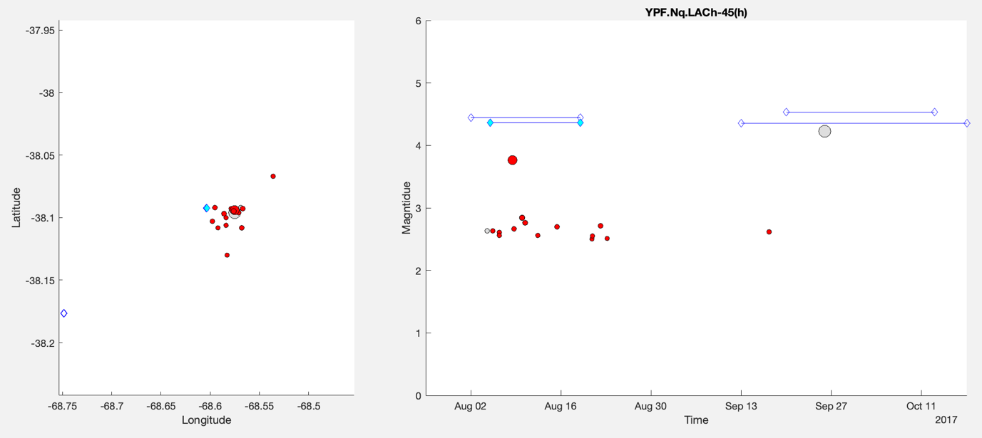

Figure S16. SAF-identified case of induced seismicity. (left) Map of earthquakes (circles) and nearby wells (diamonds). (right) Timeseries of earthquake magnitudes (circles) and nearby wells (diamonds & lines). The ‘unique well identifier’ in the plot title provides the well name. In both panels, earthquakes (red/grey) and wells (cyan/white) are coloured according to if they are/aren’t SAF-identified.

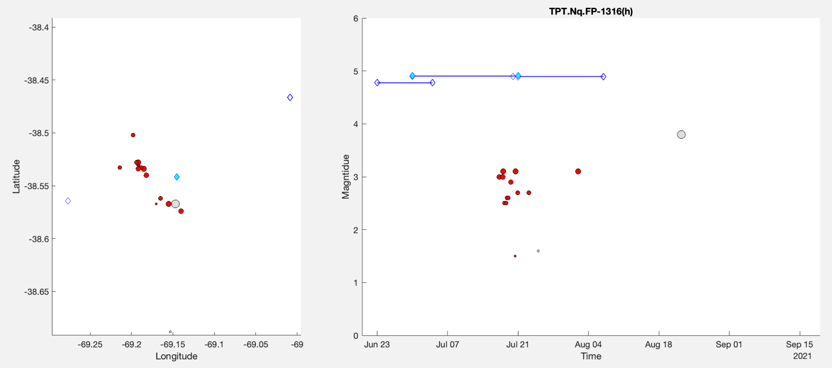

Figure S17. SAF-identified case of induced seismicity. (left) Map of earthquakes (circles) and nearby wells (diamonds). (right) Timeseries of earthquake magnitudes (circles) and nearby wells (diamonds & lines). The ‘unique well identifier’ in the plot title provides the well name. In both panels, earthquakes (red/grey) and wells (cyan/white) are coloured according to if they are/aren’t SAF-identified.

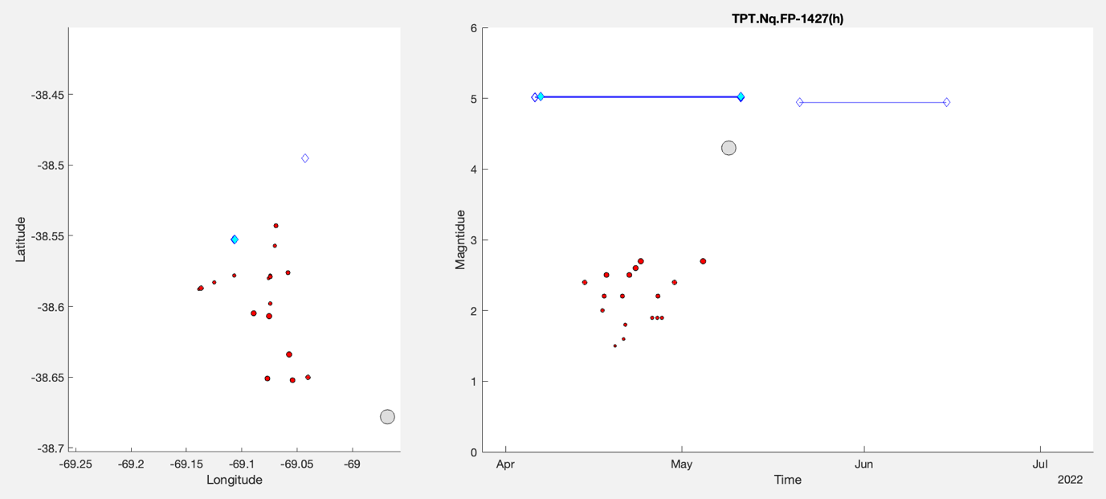

Figure S18. SAF-identified case of induced seismicity. (left) Map of earthquakes (circles) and nearby wells (diamonds). (right) Timeseries of earthquake magnitudes (circles) and nearby wells (diamonds & lines). The ‘unique well identifier’ in the plot title provides the well name. In both panels, earthquakes (red/grey) and wells (cyan/white) are coloured according to if they are/aren’t SAF-identified.

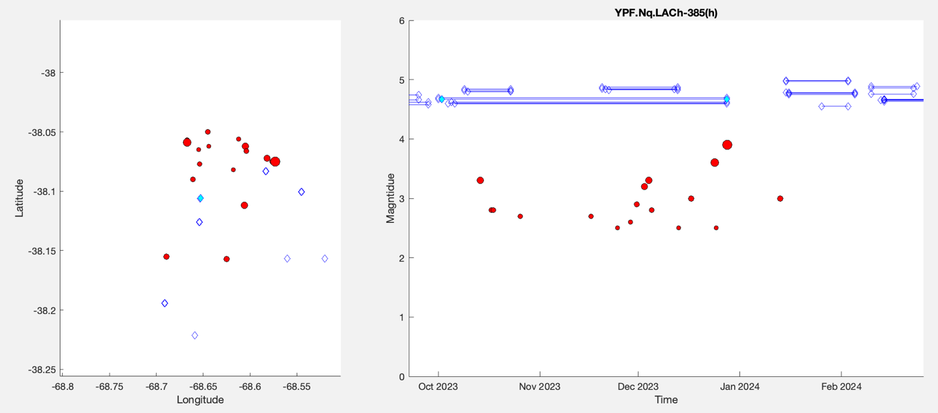

Figure S19. SAF-identified case of induced seismicity. (left) Map of earthquakes (circles) and nearby wells (diamonds). (right) Timeseries of earthquake magnitudes (circles) and nearby wells (diamonds & lines). The ‘unique well identifier’ in the plot title provides the well name. In both panels, earthquakes (red/grey) and wells (cyan/white) are coloured according to if they are/aren’t SAF-identified.

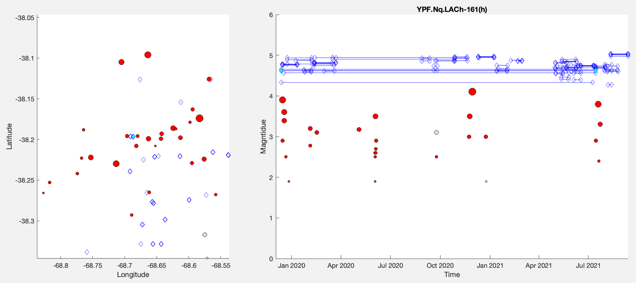

Figure S20. SAF-identified case of induced seismicity. (left) Map of earthquakes (circles) and nearby wells (diamonds). (right) Timeseries of earthquake magnitudes (circles) and nearby wells (diamonds & lines). The ‘unique well identifier’ in the plot title provides the well name. In both panels, earthquakes (red/grey) and wells (cyan/white) are coloured according to if they are/aren’t SAF-identified.

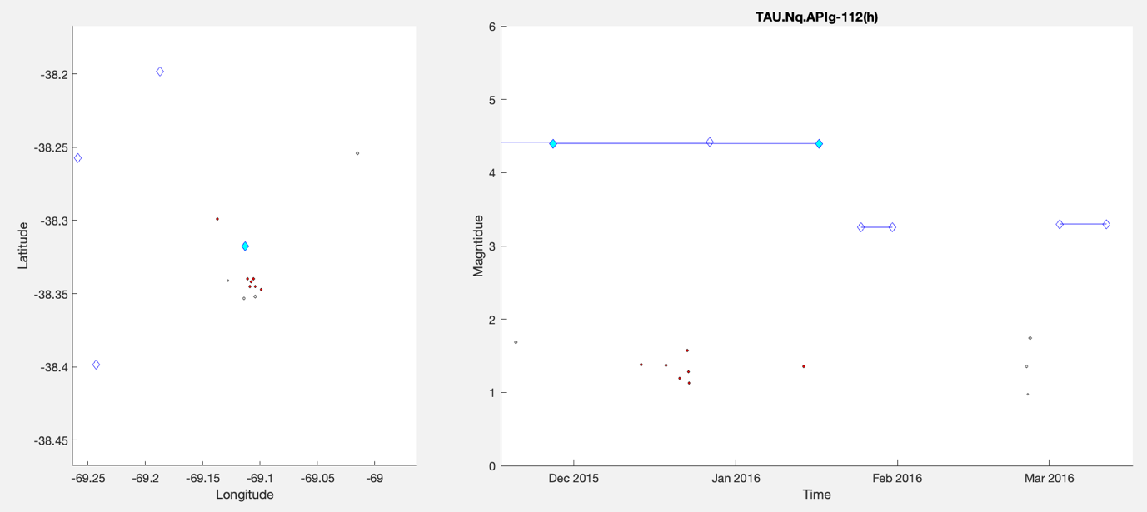

Figure S21. SAF-identified case of induced seismicity. (left) Map of earthquakes (circles) and nearby wells (diamonds). (right) Timeseries of earthquake magnitudes (circles) and nearby wells (diamonds & lines). The ‘unique well identifier’ in the plot title provides the well name. In both panels, earthquakes (red/grey) and wells (cyan/white) are coloured according to if they are/aren’t SAF-identified.

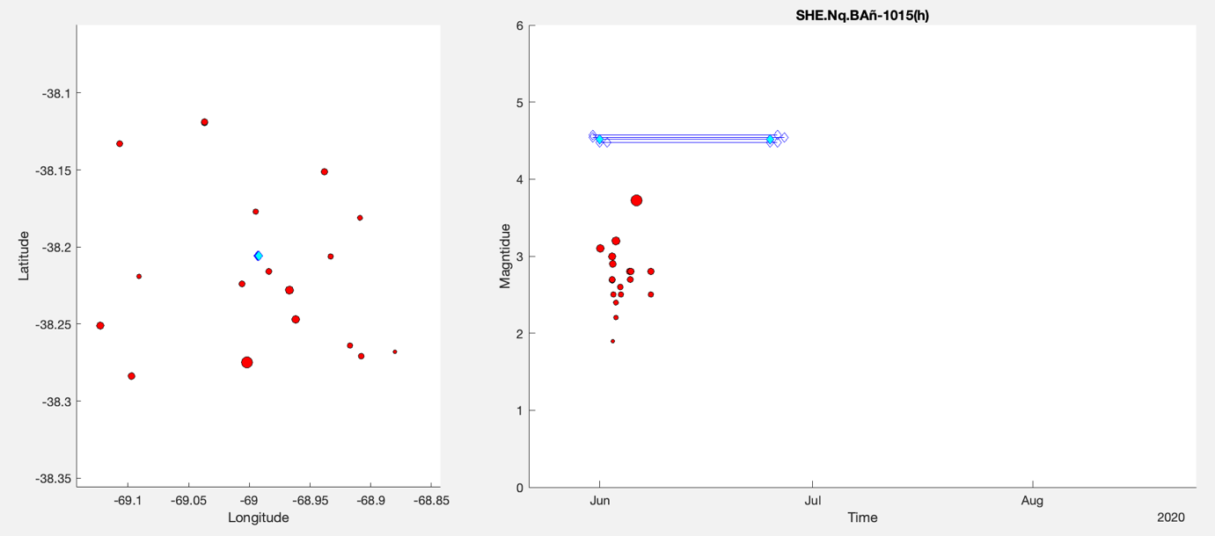

Figure S22. SAF-identified case of induced seismicity. (left) Map of earthquakes (circles) and nearby wells (diamonds). (right) Timeseries of earthquake magnitudes (circles) and nearby wells (diamonds & lines). The ‘unique well identifier’ in the plot title provides the well name. In both panels, earthquakes (red/grey) and wells (cyan/white) are coloured according to if they are/aren’t SAF-identified.

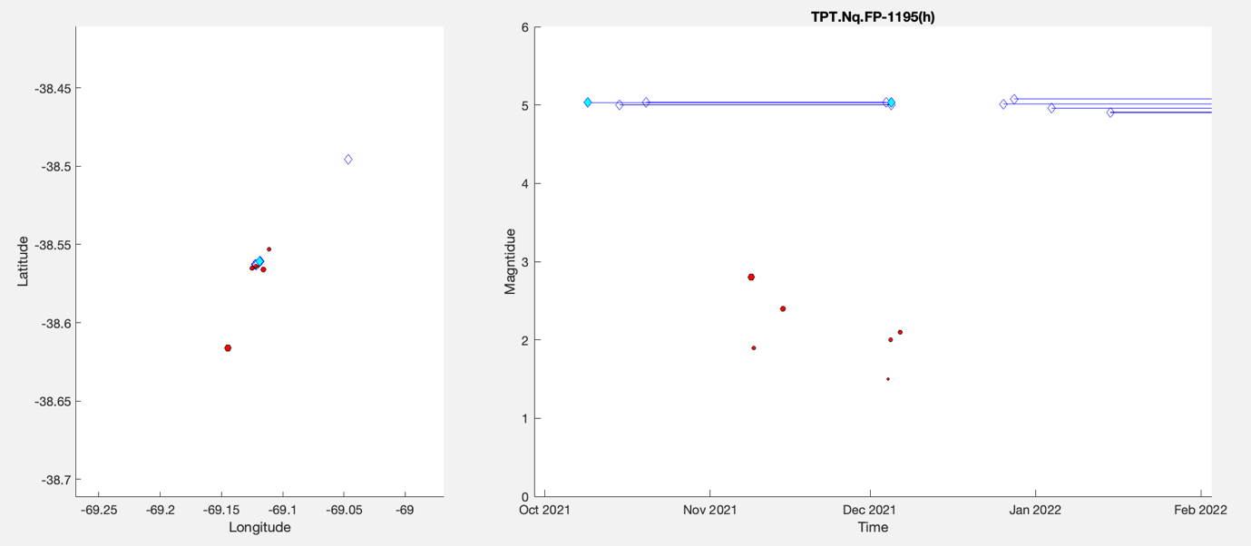

Figure S23. SAF-identified case of induced seismicity. (left) Map of earthquakes (circles) and nearby wells (diamonds). (right) Timeseries of earthquake magnitudes (circles) and nearby wells (diamonds & lines). The ‘unique well identifier’ in the plot title provides the well name. In both panels, earthquakes (red/grey) and wells (cyan/white) are coloured according to if they are/aren’t SAF-identified.

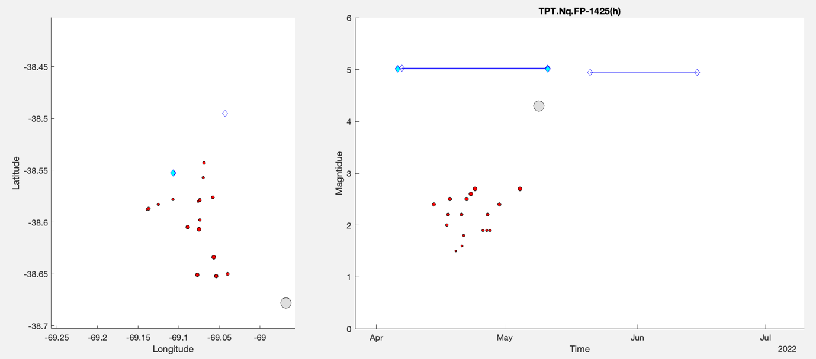

Figure S24. SAF-identified case of induced seismicity. (left) Map of earthquakes (circles) and nearby wells (diamonds). (right) Timeseries of earthquake magnitudes (circles) and nearby wells (diamonds & lines). The ‘unique well identifier’ in the plot title provides the well name. In both panels, earthquakes (red/grey) and wells (cyan/white) are coloured according to if they are/aren’t SAF-identified.

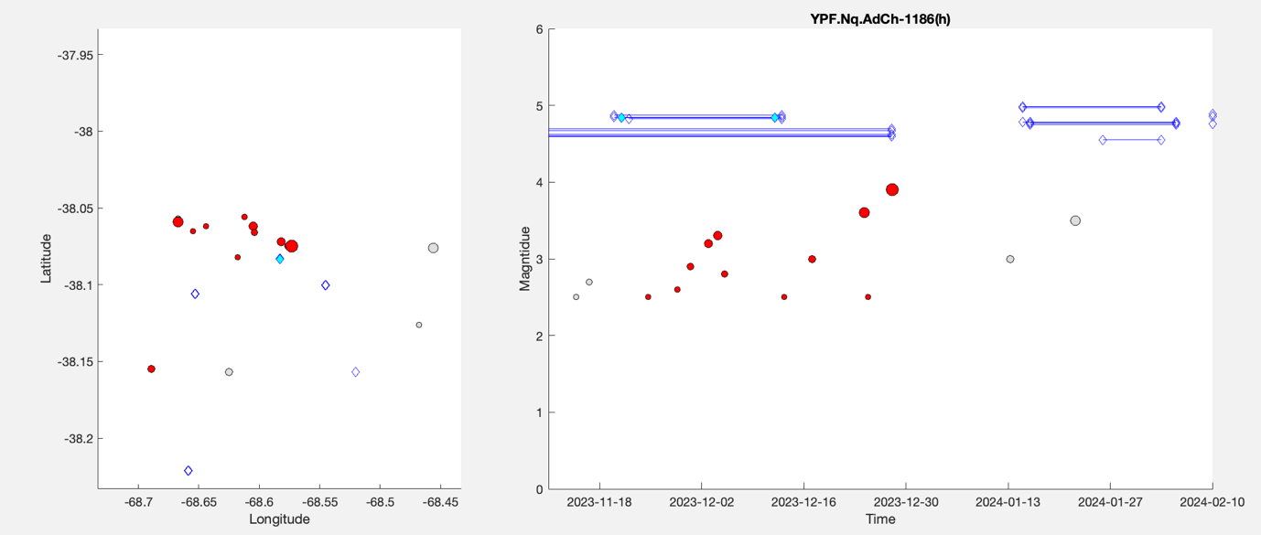

Figure S25. SAF-identified case of induced seismicity. (left) Map of earthquakes (circles) and nearby wells (diamonds). (right) Timeseries of earthquake magnitudes (circles) and nearby wells (diamonds & lines). The ‘unique well identifier’ in the plot title provides the well name. In both panels, earthquakes (red/grey) and wells (cyan/white) are coloured according to if they are/aren’t SAF-identified.

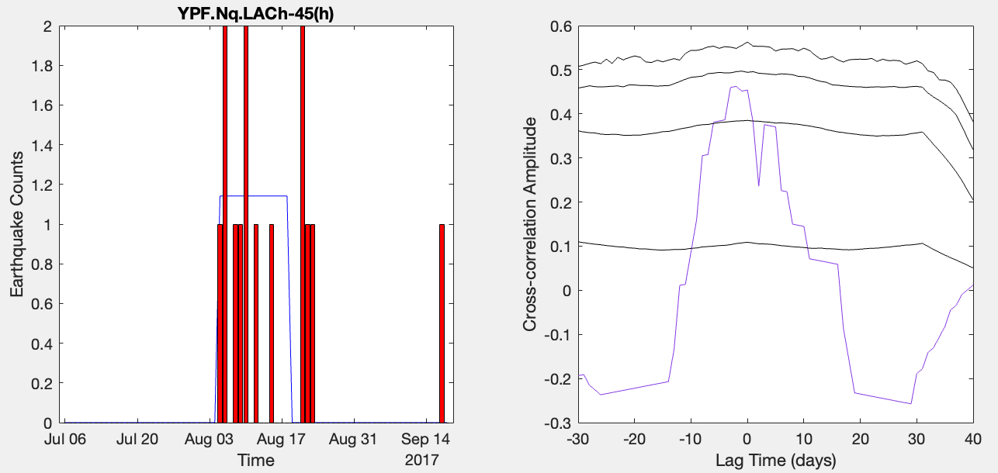
Effective Injection Rate (m³/min)
68%
95%
99.7%
99.99%

Figure S26. Cross-correlation reshuffling test for a single operation. (left panel) Timeseries data of earthquake rates (red/grey bars) and effective injection rates (blue lines), for a single high SAF-scoring operation. (right panel) cross-correlation of timeseries data (purple line) alongside confidence intervals (black lines) from reshuffling tests. Plot is using a subset of the data from Figure 6.

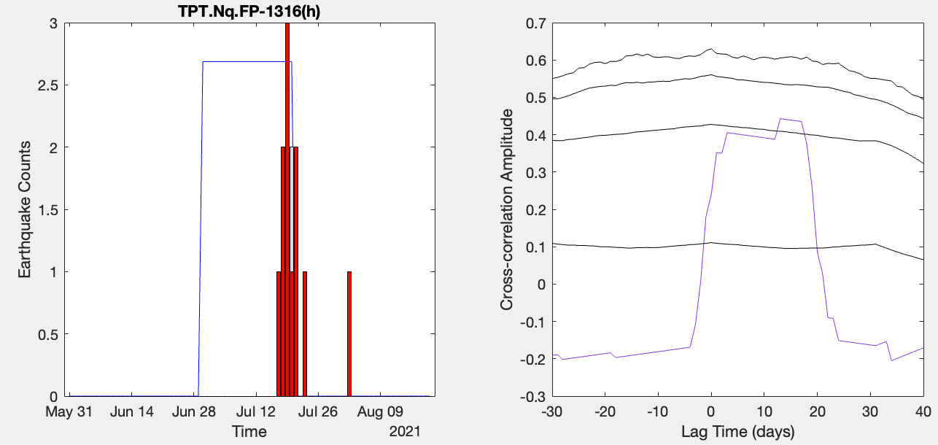
99.99%
99.7%
68%
95%
Effective Injection Rate (m³/min)

Figure S27. Cross-correlation reshuffling test for a single operation. (left panel) Timeseries data of earthquake rates (red/grey bars) and effective injection rates (blue lines), for a single high SAF-scoring operation. (right panel) cross-correlation of timeseries data (purple line) alongside confidence intervals (black lines) from reshuffling tests. Plot is using a subset of the data from Figure 6.

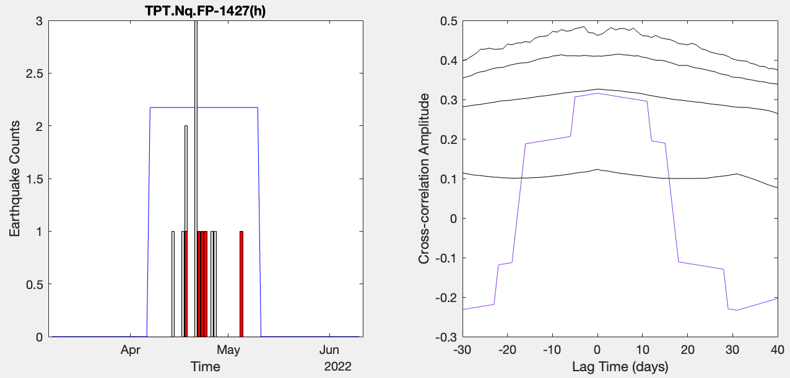
95%
68%
99.99%
99.7%
Effective Injection Rate (m³/min)

Figure S28. Cross-correlation reshuffling test for a single operation. (left panel) Timeseries data of earthquake rates (red/grey bars) and effective injection rates (blue lines), for a single high SAF-scoring operation. (right panel) cross-correlation of timeseries data (purple line) alongside confidence intervals (black lines) from reshuffling tests. Plot is using a subset of the data from Figure 6.

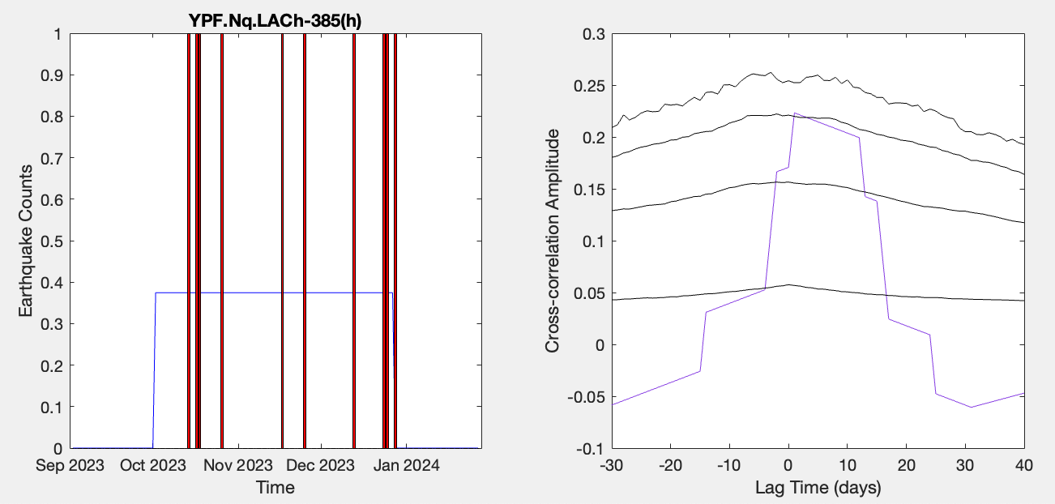
68%
99.7%
99.99%
95%
Effective Injection Rate (m³/min)

Figure S29. Cross-correlation reshuffling test for a single operation. (left panel) Timeseries data of earthquake rates (red/grey bars) and effective injection rates (blue lines), for a single high SAF-scoring operation. (right panel) cross-correlation of timeseries data (purple line) alongside confidence intervals (black lines) from reshuffling tests. Plot is using a subset of the data from Figure 6.

68%
99.7%
99.99%
95%
Effective Injection Rate (m³/min)

Figure S30. Cross-correlation reshuffling test for a single operation. (left panel) Timeseries data of earthquake rates (red/grey bars) and effective injection rates (blue lines), for a single high SAF-scoring operation. (right panel) cross-correlation of timeseries data (purple line) alongside confidence intervals (black lines) from reshuffling tests. Plot is using a subset of the data from Figure 6.

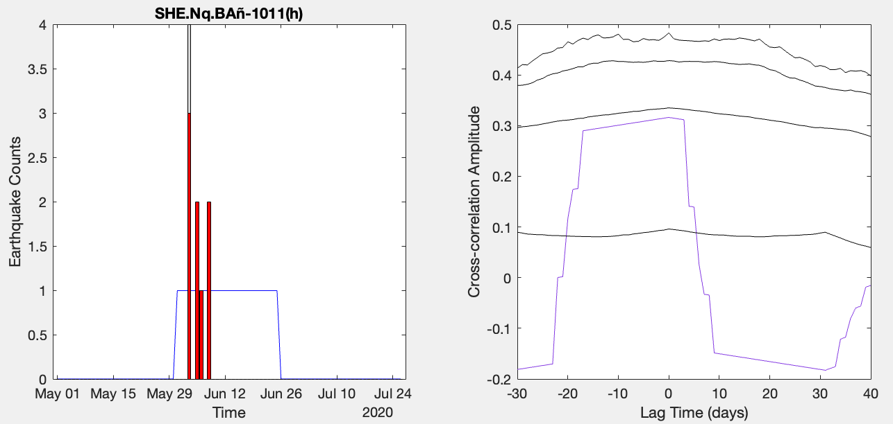
68%
95%
99.7%
99.99%
Effective Injection Rate (m³/min)

Figure S31. Cross-correlation reshuffling test for a single operation. (left panel) Timeseries data of earthquake rates (red/grey bars) and effective injection rates (blue lines), for a single high SAF-scoring operation. (right panel) cross-correlation of timeseries data (purple line) alongside confidence intervals (black lines) from reshuffling tests. Plot is using a subset of the data from Figure 6.

