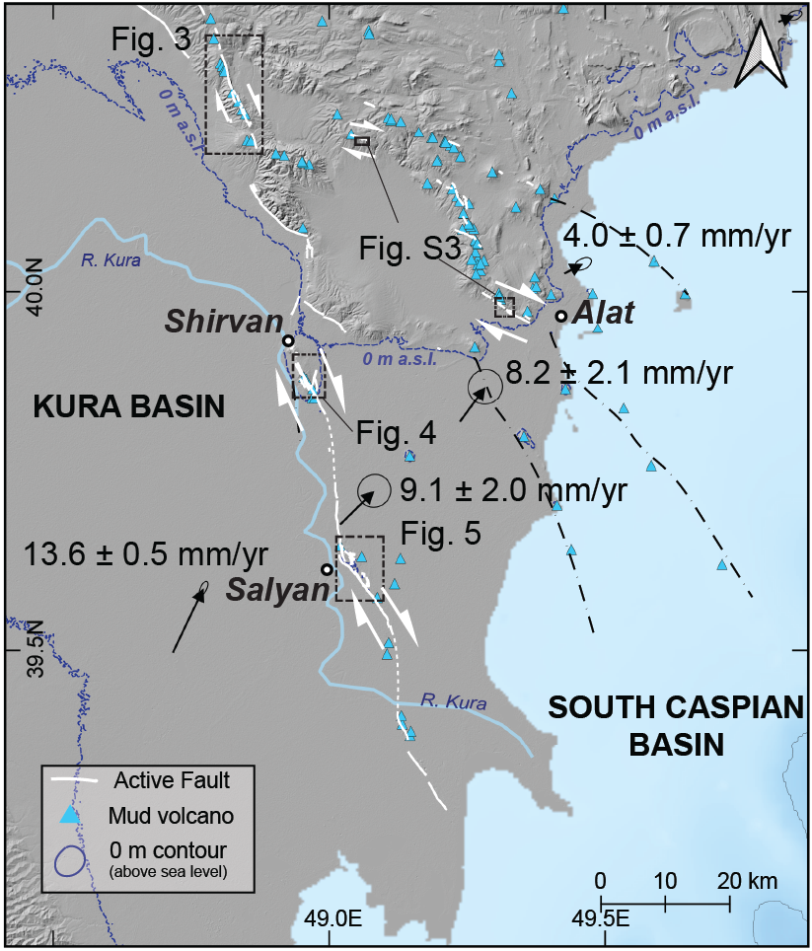
Figure S1. Active faults in the Shirvan region and GNSS velocity vectors for the area (after Khorrami et al. 2019). Blue triangles show the location of active mud volcanoes, white lines show the fault mapping in this study. The blue line shows the 0 m above sea level (a.s.l.) contour. Highlighted on this map are four study areas (see below). Elevation data is from SRTM and has been overlaid on to a Google Earth image.
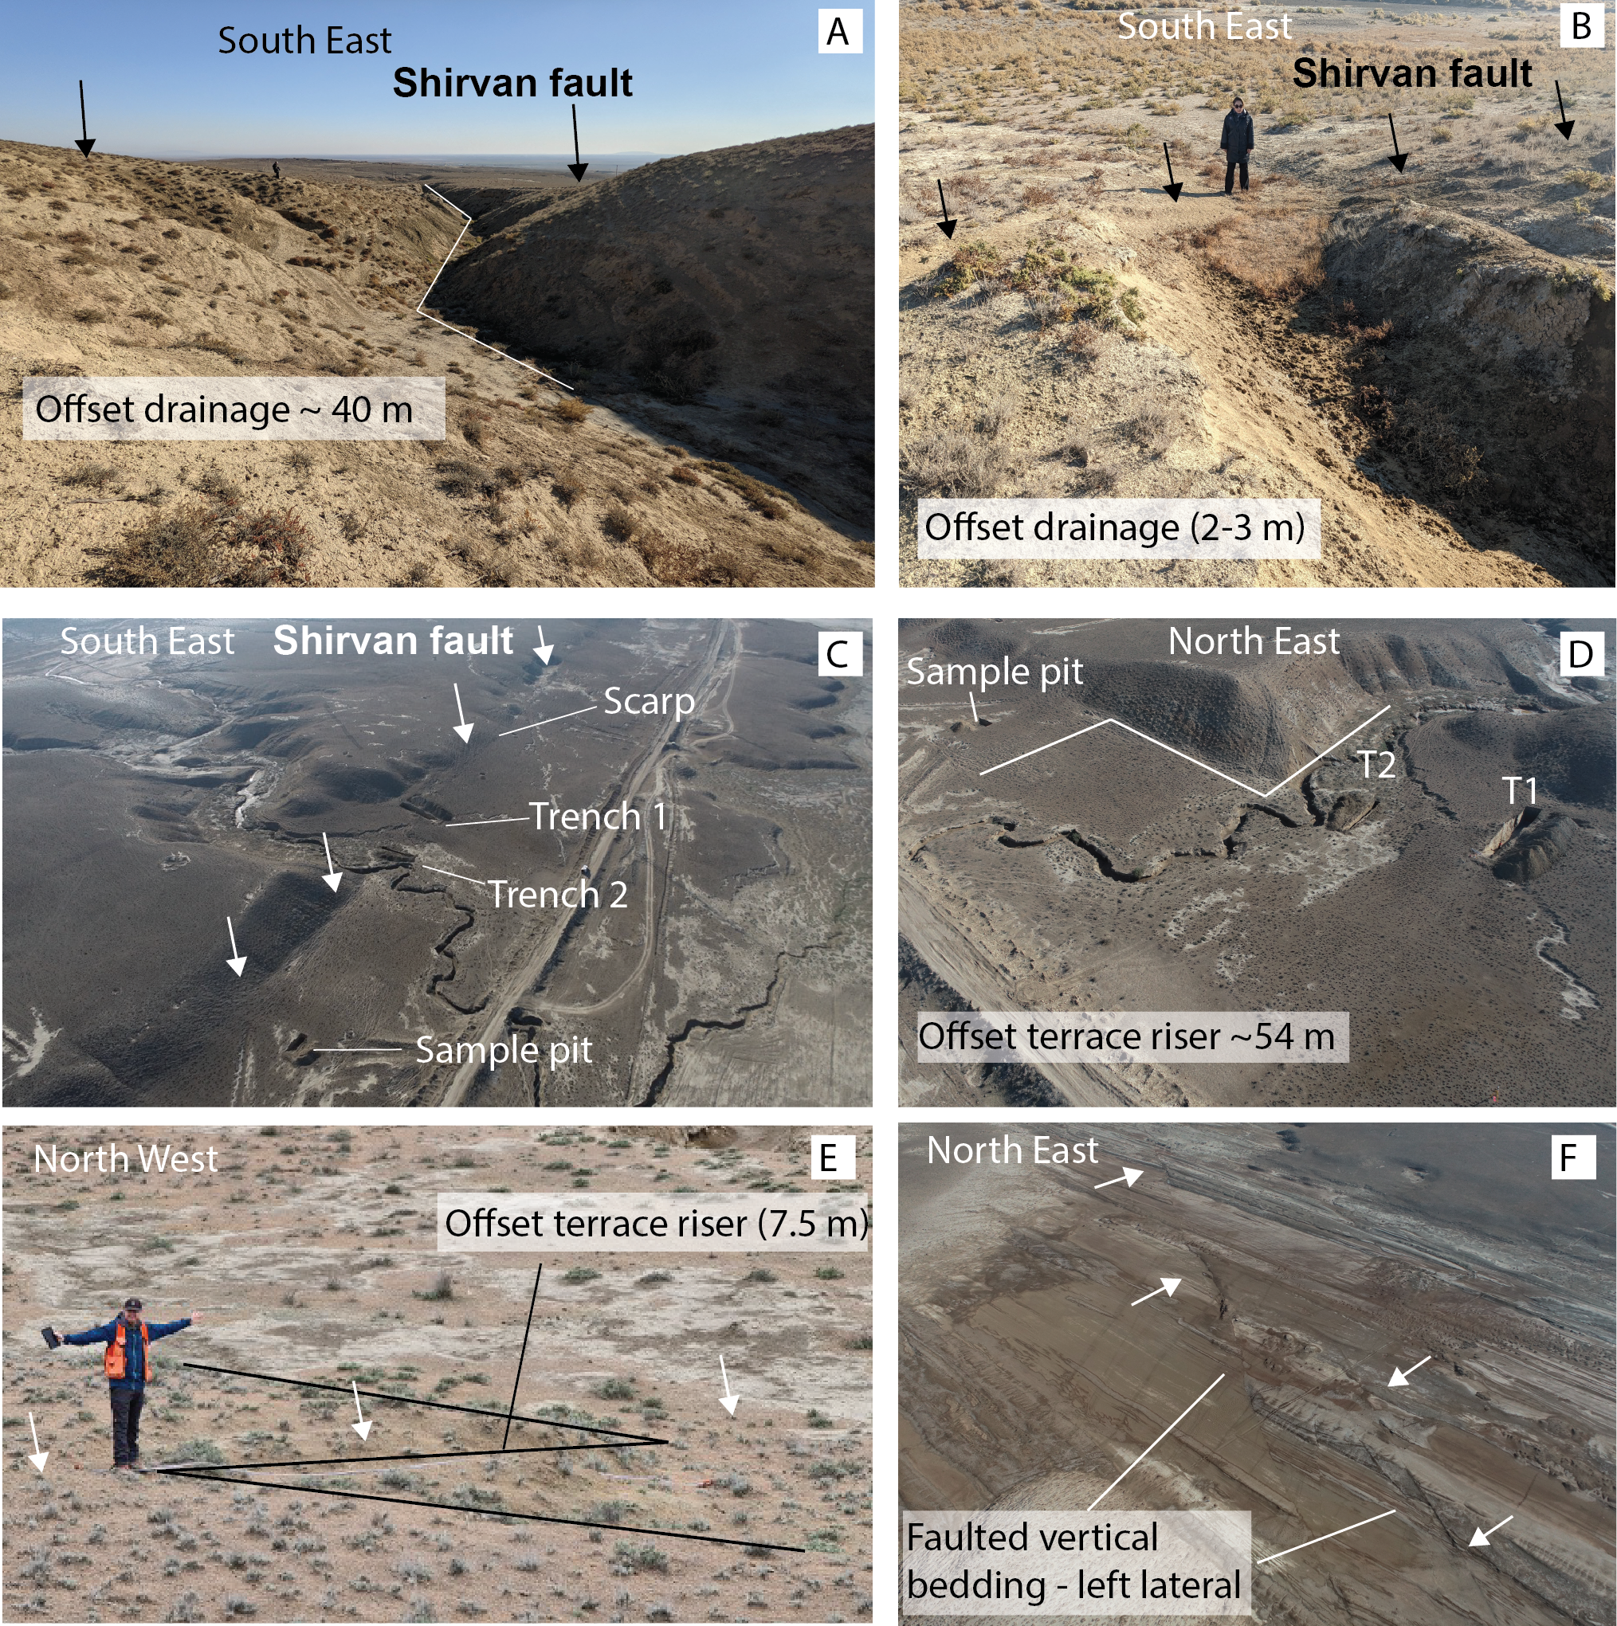
Figure S2. Field photographs of the Shirvan fault zone. A and B show two offsets at the Shirvan site in Fig. 4D. C and D are oblique drone images of the trench site at Salyan (Fig. 5). E shows the 7.5 m offset terrace riser, near the trench site (see Fig. 6). F shows an oblique drone image of antithetic left-lateral faulted vertical bedding planes (shown on Fig. 5).
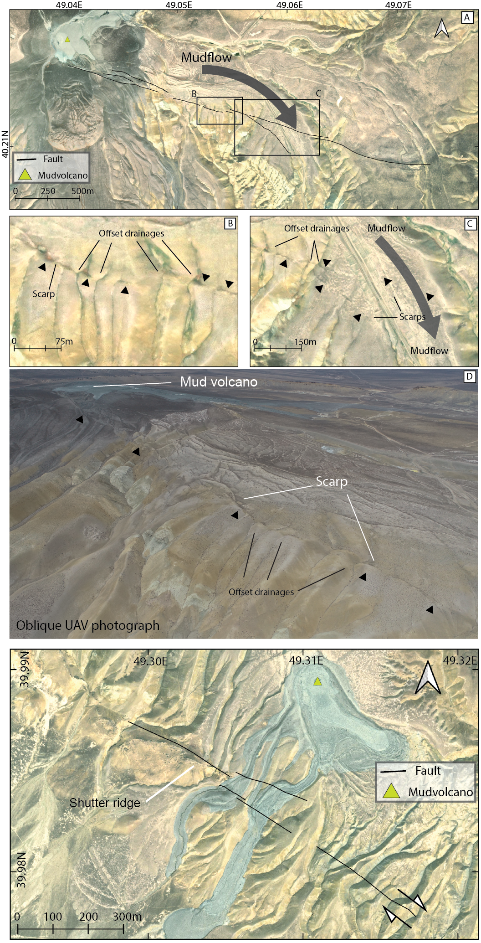
Figure S3. Northwest of Alat (Fig. 3) ESRI imagery showing fault scarps, offset drainages and a mud volcano at the NW end of the panel. Panel B shows a fault scarp with offset drainage channels. Panel C shows two parallel fault scarps and offset drainage channels. The offset drainage channels indicate a dextral motion of the fault. Panel D shows an oblique drone image of faulting. It shows offset drainages, scarps and mud volcanoes. Panel E shows the fault trace near Alat (Fig. 3) shown on ESRI imagery. Mud volcano complex at the fault trace. Motion is interpreted by the sense offset drainages and shutter ridges and is consistent with dextral strike-slip faulting.

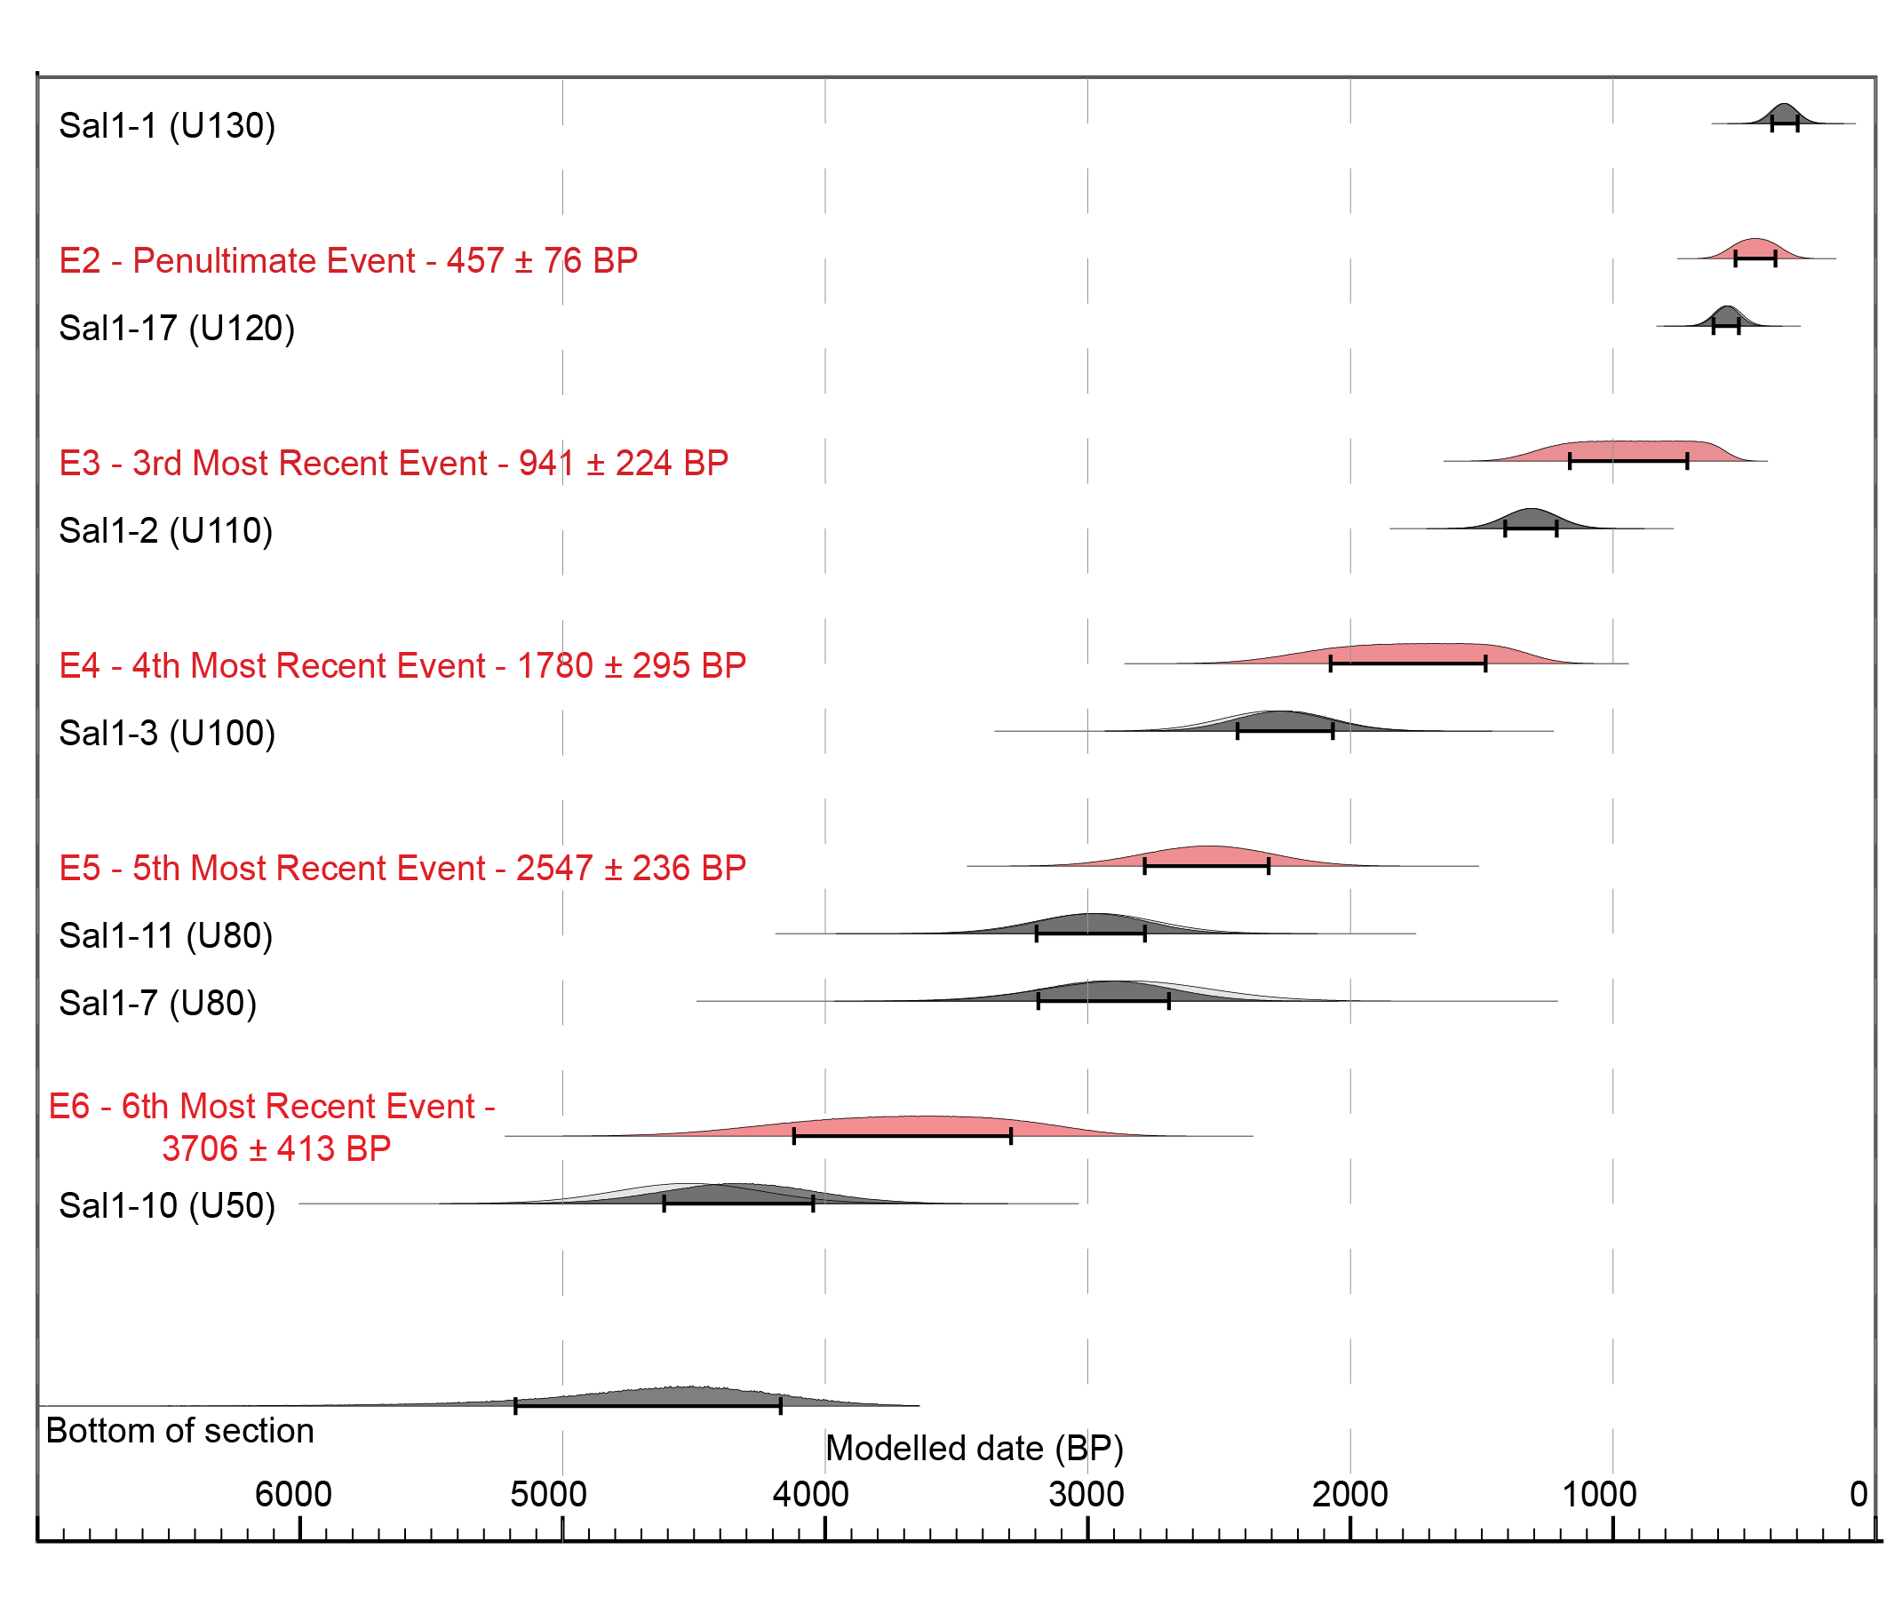
Figure S4. Age model from Oxcal v4.4 of the event horizons constrained by IRSL dating techniques. Samples are from trench 1 (Sal1-x) shown in Figs 11, and 13. E2 – E6 represents six paleo-earthquakes with the most likely dates. E1 is constrained by Sal1-1.

Table S1 shows the location and age of the IRSL samples from trenches 1 and 2. The location in the cross section is shown in Figs 7, 8, and 9.
Trench | Latitude | Longitude | Elevation (m a.s.l.) | Field Code | Lab Code | Depth (m) | Age (yr) |  | 1 sigma uncertainty
Trench 1 | 39.5906 | 49.0633 | -13.764 | SAL1 - 1 | 22148 | 0.05 | 350 | ± | 50
Trench 1 | 39.5906 | 49.0633 | -13.764 | SAL1 - 2 | 22149 | 0.45 | 1310 | ± | 100
Trench 1 | 39.5906 | 49.0633 | -13.764 | SAL1 - 3 | 22150 | 0.85 | 2290 | ± | 200
Trench 1 | 39.5906 | 49.0633 | -13.764 | SAL1 - 7 | 22154 | 0.84 | 2850 | ± | 310
Trench 1 | 39.5906 | 49.0633 | -13.764 | SAL1 - 10 | 22157 | 2.37 | 4520 | ± | 280
Trench 1 | 39.5906 | 49.0633 | -13.764 | SAL1 - 11 | 22158 | 1.45 | 2970 | ± | 230
Trench 1 | 39.5906 | 49.0633 | -13.764 | SAL1 - 17 | 22164 | 0.10 | 560 | ± | 50
Trench 2 | 39.5908 | 49.0631 | -13.463 | SAL2 - 2 | 22167 | 0.15 | 530 | ± | 90
Trench 2 | 39.5908 | 49.0631 | -13.463 | SAL2 - 3 | 22168 | 0.27 | 420 | ± | 60
Trench 2 | 39.5908 | 49.0631 | -13.463 | SAL2 - 4 | 22169 | 1.30 | 460 | ± | 70

Table S2 shows the location and type of material sampled for radiocarbon dating. The ages have been calibrated using the OxCal v4.4.4 model using the Marine 20 curve and delta R adjustment from previous studies around the Caspian Sea.
Name | Location | Latitude (º) | Longitude (º) | Elevation (m asl) | Material | Calibrated Age  (years cal. BP)
Sal23-C1 | Salyan Trench 1 | 39.5906 | 49.0633 | -13.8 | Shell | 14175 - 14921
Sal23-C2 | Salyan Trench 1 | 39.5906 | 49.0633 | -13.8 | Shell | 14106 - 14854
Sal22-C1 | Salyan Sample pit | 39.5914 | 49.062 | -12.8 | Charcoal | 1744 - 2099
Sal22-C2 | Salyan Sample pit | 39.5914 | 49.062 | -12.8 | Charcoal | 1824 - 2145
Sal21-S1 | Salyan Qad surface | 39.5914 | 49.062 | -11.4 | Shell | 35040 - 35520
Shi21-S2 | Shirvan surface | 39.8663 | 48.9676 | 64 | Shell | 35570 - 36070

