Supplementary Data for: “Subducted Structure in Central Cascadia from Margin-Crossing Seismic Tomography”

Experiment Year | Number of Stations | Pg Picks | Pn Picks | PmP Picks | Average Uncertainty (ms)
1989 | 15 | 6780 | 211 | 729 | 48
1996 | 29 | 10903 | 63 | 2351 | 50
2012 | 47 | 79176 | 29792 | 27763 | 52
2021 | 118 | 208908 | 82677 | 45518 | 18
Total | 209 | 305767 | 112743 | 76361 | 29
Table S1. Number of stations and travel time picks used from each experiment with average 1σ uncertainties. The greater uncertainty estimate for the 2012 data (Tréhu et al., 2023) is likely due a difference in how much uncertainty was attributed to poorly quantified uncertainties due to the modeling process since the source, sensors, timing base and signal-to-noise were similar for the 2012 and 2021 datasets.

Experiment Year | Pg Average Uncertainty (ms) | Pn Average Uncertainty (ms) | PmP Average Uncertainty (ms)
Test 1
Pg RMS: 121 ms, Pn RMS: 123 ms, PmP RMS: 146 ms
1989 | 22 | 40 | 40
1996 | 21 | 40 | 42
2012 | 24 | 40 | 40
2021 | 33 | 40 | 40
Test 2
Pg RMS: 164 ms, Pn RMS: 143 ms, PmP RMS: 144 ms
1989 | 43 | 80 | 88
1996 | 42 | 80 | 83
2012 | 40 | 62 | 79
2021 | 44 | 55 | 54
Table S2. Tests conducted to examine how changes to pick uncertainties impact the model fit.

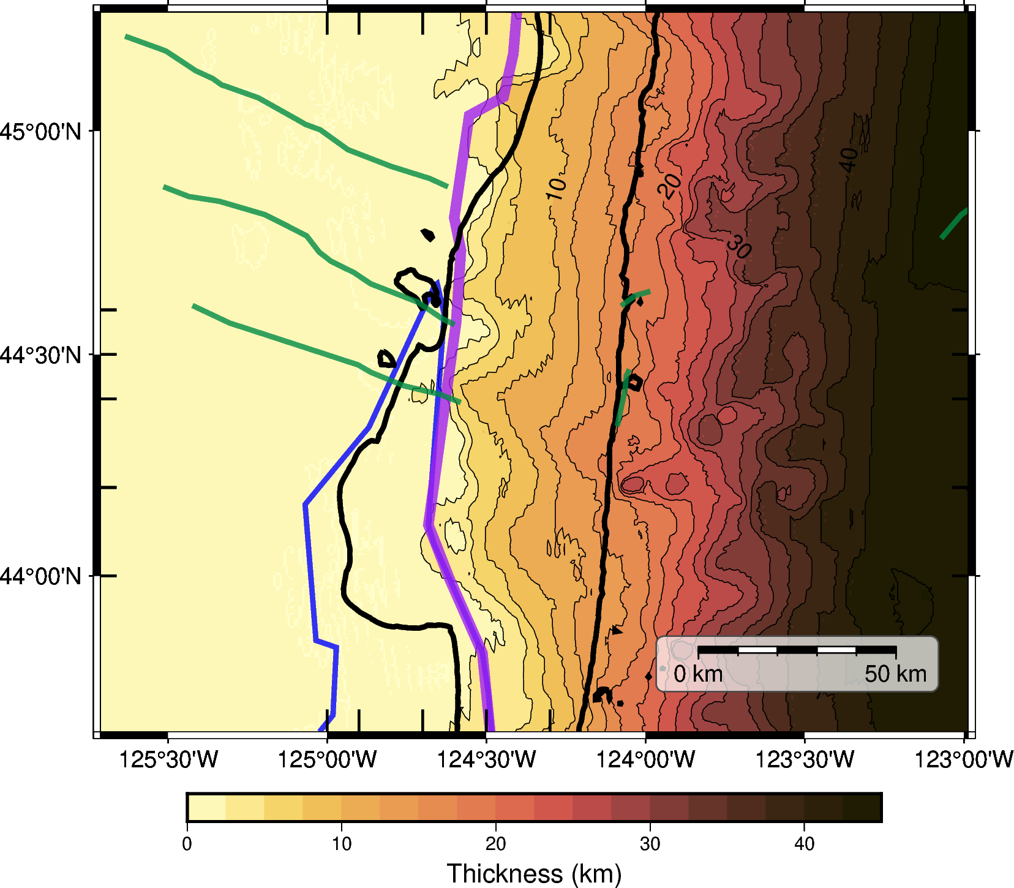

Figure S1. Vertical thickness between the inferred top of subducting plate crust (6 km above the final model Moho) and the 5.5 km/s velocity isosurface.

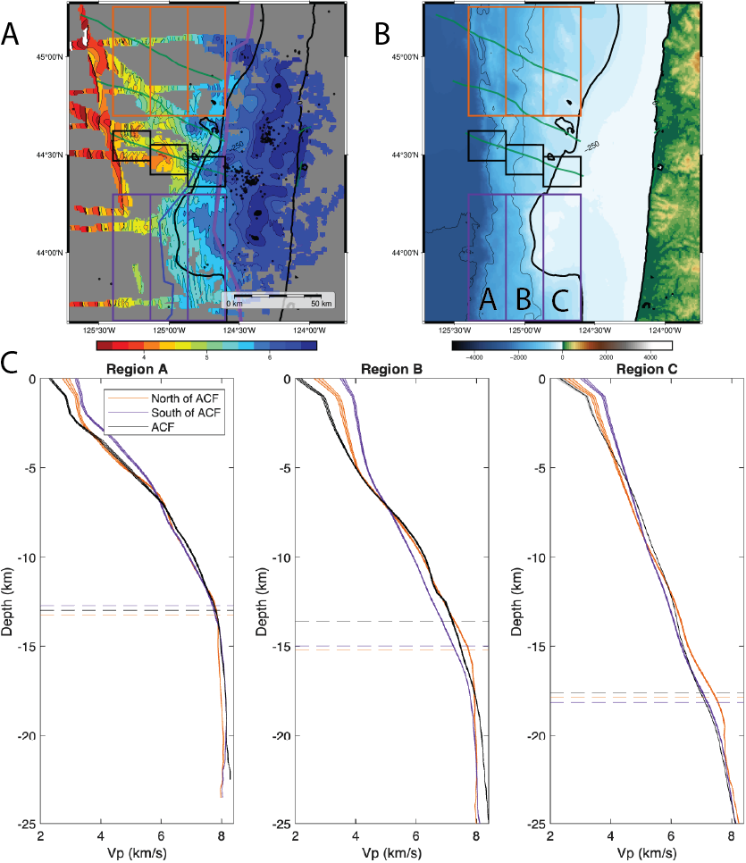
Figure S2. (A) P-wave velocity structure from the final model, shown for a depth interval 6–7 km above the modeled Moho interface. (B) High-resolution topography from the Global Multi-Resolution Topography Synthesis (Ryan et al., 2009). Boxes delineate regions north of the ACF, south of the ACF, and surrounding the ACF. Labels A (west), B (central), and C (east) correspond to the profiles shown in (C). (C) Average P-wave velocity as a function of depth for each region: north of the ACF (orange), south of the ACF (purple), and surrounding the ACF (black). Shaded areas indicate ±2 standard deviations from the mean. Horizontal dashed lines mark the average Moho depth for each region.

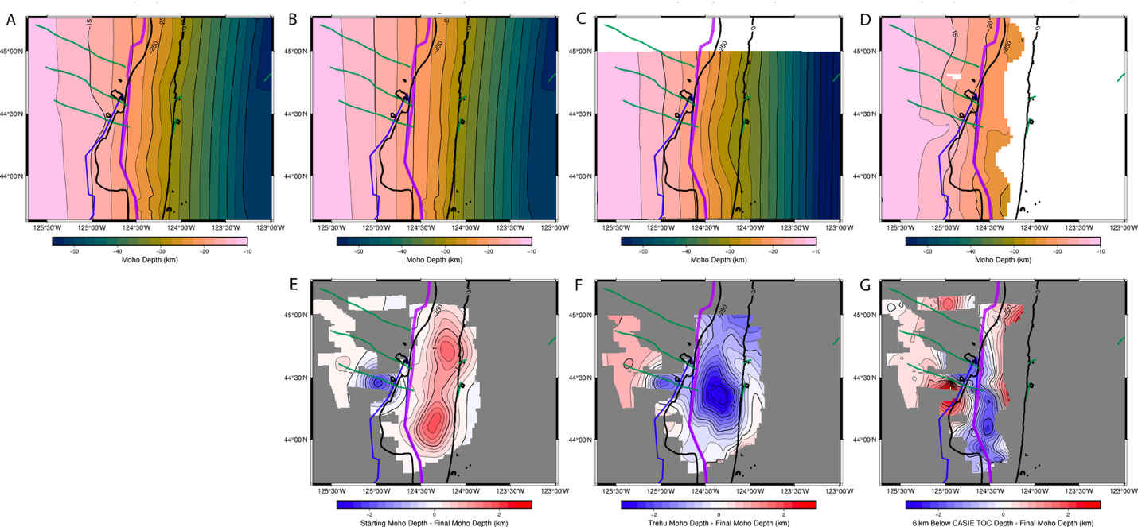
Figure S3. (A) Final model Moho interface from this study. (B) Starting model Moho from Ashraf & Hooft (2026). (C) Final Moho interface from Tréhu et al. (2023). (D) Top of crust interface from Carbotte et al. (2024) shifted downward by 6 km to approximate the Moho. (A-D) Use a contour interval of 2.5 km. (E-G) Plots show changes in Moho depth relative to the interfaces shown in (B-D), respectively. Red indicates regions where the final Moho from this study is deeper, while blue represents areas where it is shallower. Contours are plotted every 0.25 km.

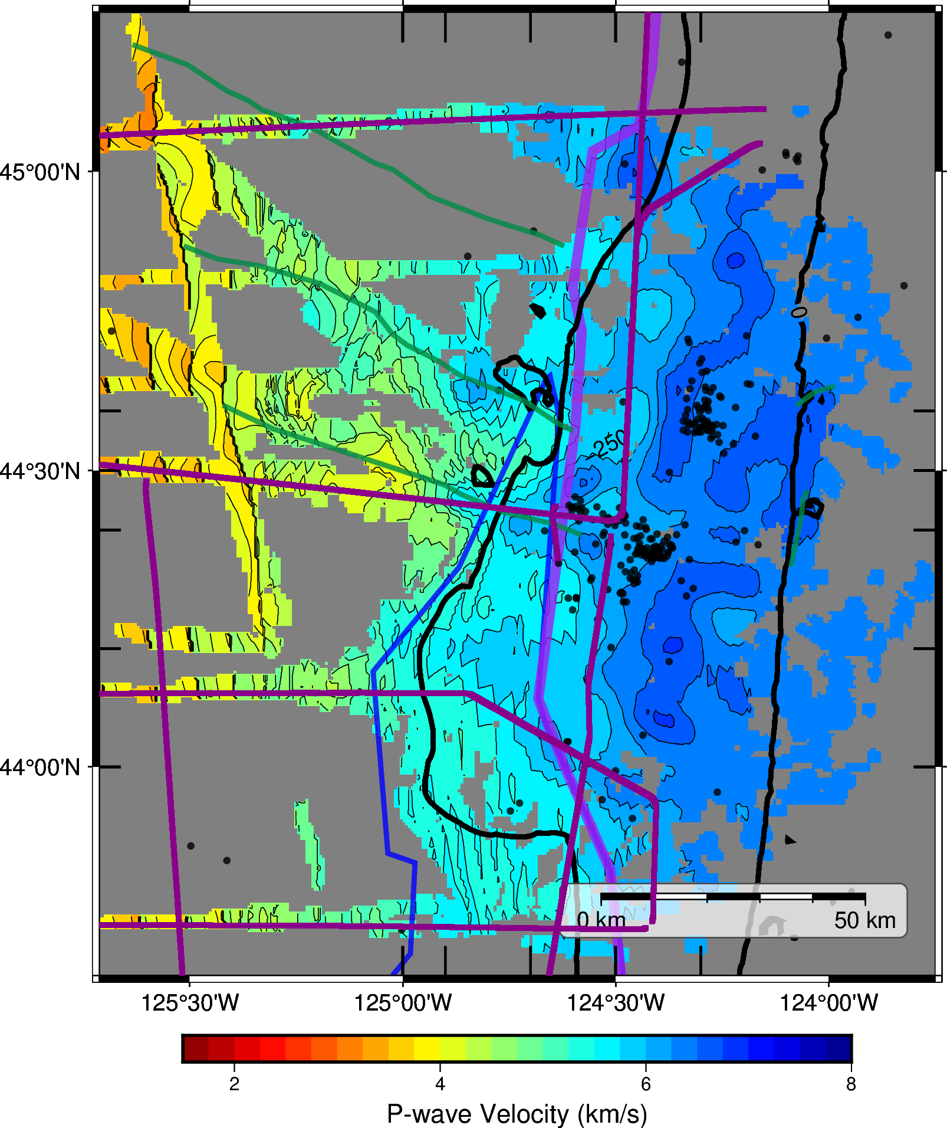

Figure S4. Average velocities through the final P-wave velocity model between 6-7 km above the final Moho. The color palette is the same as the one used in Figures 5, 6 and 7. Thin purple lines represent the CASIE21-MCS airgun shot lines (Carbotte et al., 2024).

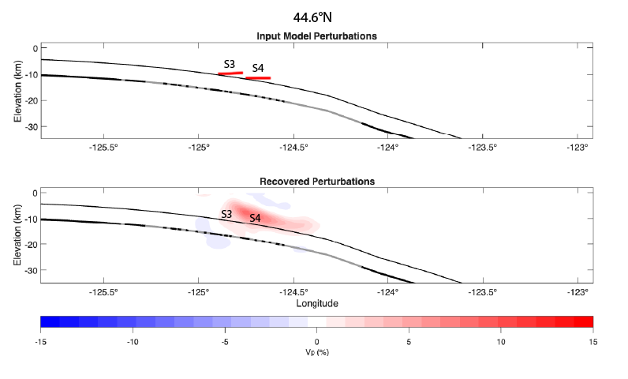
Figure S5. Additional hypothesis test assessing the ability to recover high‑velocity anomalies on top of the subducting crust. Panel 1 illustrates east-west cross sections through the input model containing perturbations designed to replicate anomalies S3 and S4. Panel 2 shows the corresponding recovered perturbations. The thick black line denotes the Moho interface, with gray shading indicating regions that are well resolved. The thin black line represents the approximate top of the subducting crust, positioned 6 km above the Moho.

Feature | Age Estimates from the Literature | Dating Method | Source
MTD 44.003°N | 44.56 kyr, 118.94 kyr; 84 kyr | Biostratigraphic analysis, constant sedimentation rate; constant sedimentation rate | Babendreier et al., 2023;  (Babendreier, n.d.)4/27/26 3:49:00 PM
MTD at 43.643°N | 75 kyr, 201 kyr | Biostratigraphic analysis, constant sedimentation rate | Babendreier et al., 2023
Deeply buried slide at 44.133°N | 1328 kyr | Constant sedimentation rate | Tréhu et al., 2022
Alvin Canyon Fault | 380 ± 50 kyr | Sedimentation rates | Goldfinger et al., 1997
Daisy Bank Fault | 380 ± 50 kyr | Sedimentation rates | Goldfinger et al., 1997
Wecoma Fault | 650 ± 50 kyr | Sedimentation rates | Goldfinger et al., 1997
Yachats Basalts and Mafic Dike | 37 Ma | 40Ar/39Ar dating | Wells et al., 2014;  Tréhu et al., 2023
Siletz terrane | 56-49 Ma | 40Ar/39Ar dating | Wells et al., 2014
Table S3. Summary of dating results for features within the central Oregon forearc from the literature.

Seamounts | Latitude | Longitude | Diameter (km) | Approximate time seamounts crossed the deformation front (kya)
S1 | 45.2°N | 124.6°W | 10-12 | 200
S2 | 44.6°N | 124.8°W | 8 | 170
S3 | 44.45°N | 124.8°W | 5 | 150
S4 | 44.4°N | 124.6°W | 10 | 210
S5 | 43.7°N | 124.9°W | 7 | 170
M2 | 44.35°N | 124.5°W | 10 | 290
M4 | 44.2°N | 124.6°W | 20 | 180
G1 | 44.2°N | 125.0°W | 6-8 | 120
G2 | 44.5°N | 124.30°W | 8 | 350
Table S4. Table includes the approximate location and dimensions of each seamount identified in our final velocity model as well as the time each seamount (age unknown) crossed the deformation front.

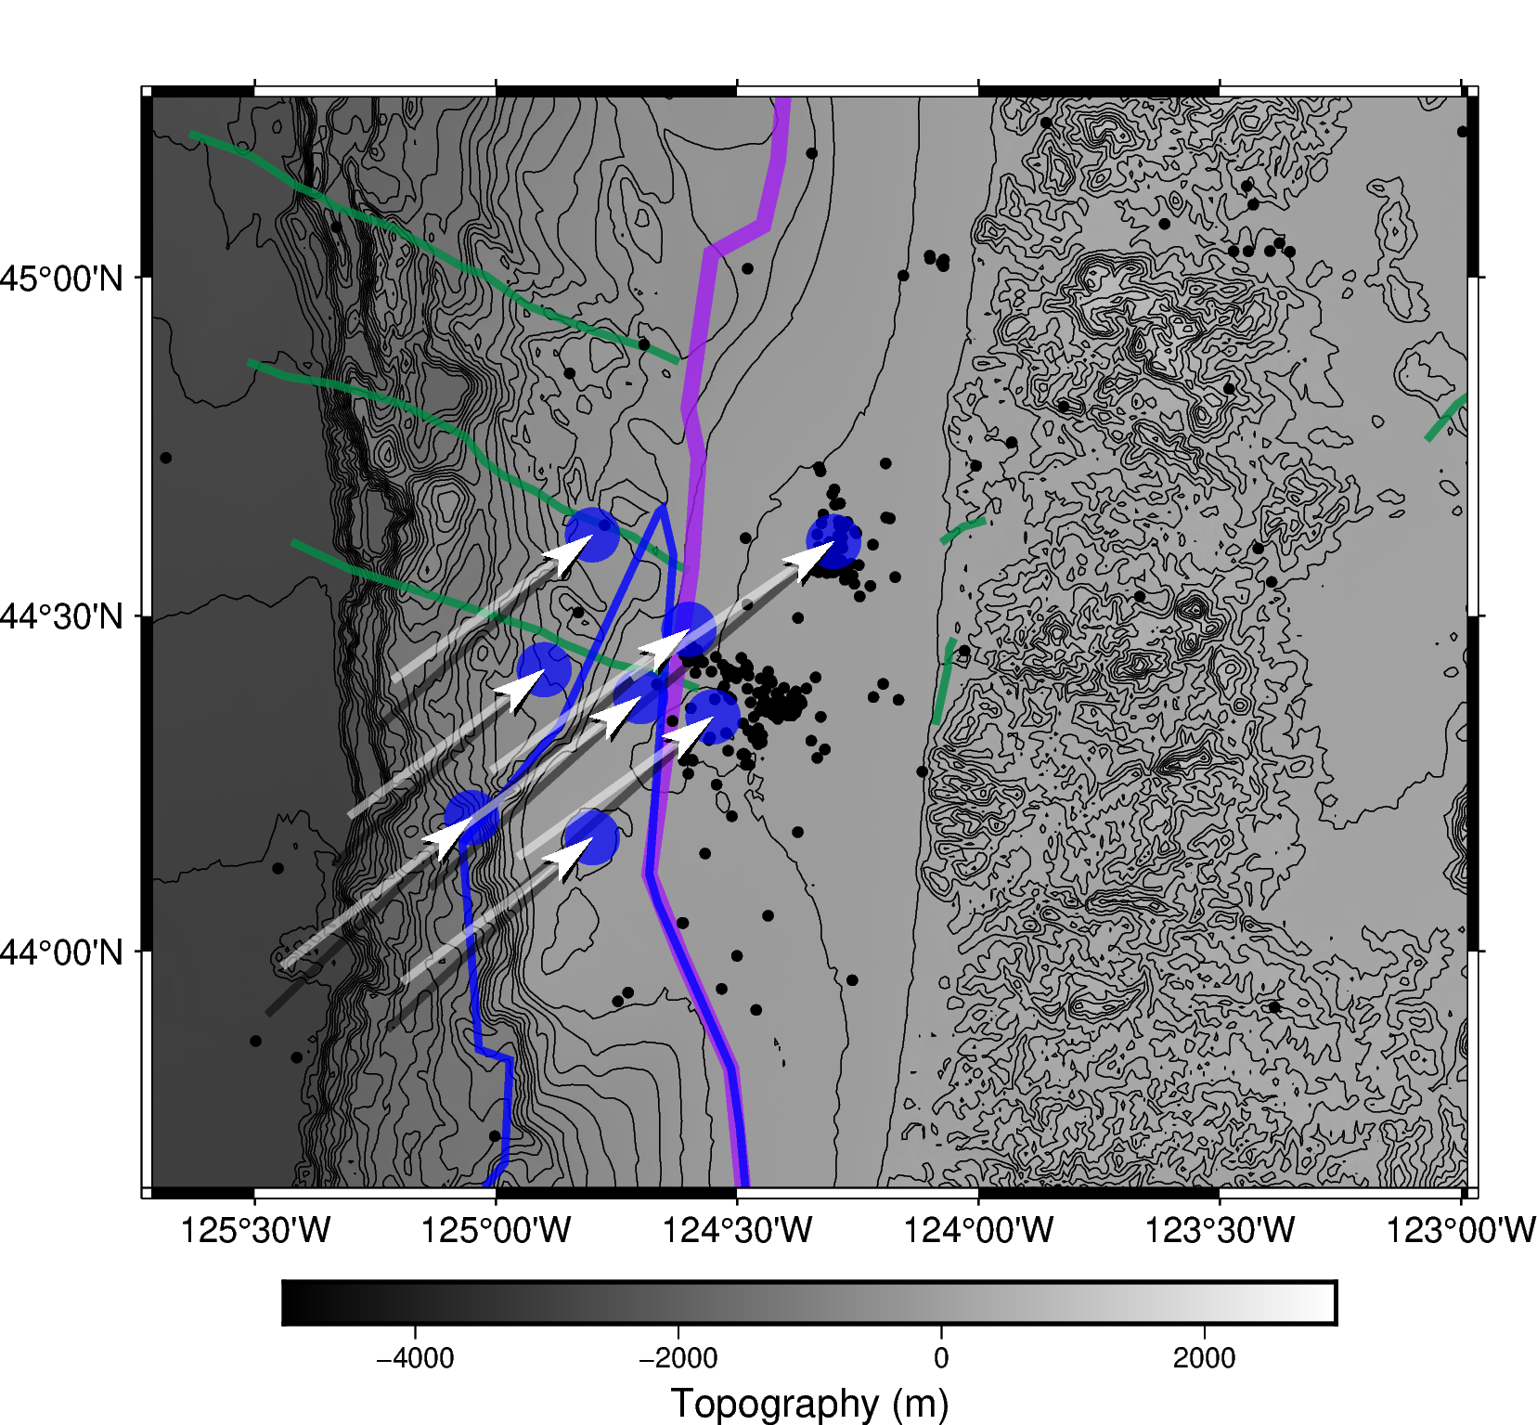
Figure S6. Map comparing seamount trajectories using different plate motion models. Black arrows show trajectories of the proposed seamounts calculated using the motion of the Juan de Fuca plate relative to stable North America from DeMets et al. (2010). The white arrows show the trajectories using the Juan de Fuca plate relative to the Oregon Block by combining the results of DeMets et al. (2010) and McCaffrey et al. (2007). Each arrow represents movement over 1.5 myr.
References

Ashraf, A., & Hooft, E. E. E. (2023). Shoreline crossing Moho geometry of the Cascadia slab: CascadiaMoho1.0. Seismica, 2(4). https://doi.org/10.26443/seismica.v2i4.1674
Babendreier, C. M. (n.d.). Seismic investigation of massive submarine landslide deposits offshore Oregon and subducting North American plate along the Puerto Rico Trench. Retrieved February 25, 2025, from https://repositories.lib.utexas.edu/items/81ef94ce-9555-4a66-8859-211557034b00
Carbotte, S. M., Boston, B., Han, S., Shuck, B., Beeson, J., Canales, J. P., Tobin, H., Miller, N., Nedimovic, M., Tréhu, A., Lee, M., Lucas, M., Jian, H., Jiang, D., Moser, L., Anderson, C., Judd, D., Fernandez, J., Campbell, C., … Gahlawat, R. (2024). Subducting plate structure and megathrust morphology from deep seismic imaging linked to earthquake rupture segmentation at Cascadia. Science Advances, 10(23), eadl3198. https://doi.org/10.1126/sciadv.adl3198
Goldfinger, C., Kulm, L. D., Yeats, R. S., McNeill, L., & Hummon, C. (1997). Oblique strike-slip faulting of the central Cascadia submarine forearc. Journal of Geophysical Research: Solid Earth, 102(B4), 8217–8243. https://doi.org/10.1029/96JB02655
Tréhu, A. M., Davenport, K., Kenyon, C. B., Carbotte, S. M., Nabelek, J. L., Toomey, D. R., & Wilcock, W. S. D. (2023). Deformation of the Juan de Fuca Plate Beneath the Central Cascadia Continental Margin (44°-45°N) in Response to an Upper Plate Load. Earth Science, Systems and Society, 3, 10085. https://doi.org/10.3389/esss.2023.10085
Tréhu, A. M., Tominaga, M., Lyle, M., Davenport, K., Phrampus, B. J., Favorito, J., Zhang, E., Lenz, B. L., Shreedharan, S., Yelisetti, S., & Party, T. R. S. (2022). The Hidden History of the South-Central Cascadia Subduction Zone Recorded on the Juan de Fuca Plate Offshore Southwest Oregon. Geochemistry, Geophysics, Geosystems, 23(9), e2021GC010318. https://doi.org/10.1029/2021GC010318
Wells, R., Bukry, D., Friedman, R., Pyle, D., Duncan, R., Haeussler, P., & Wooden, J. (2014). Geologic history of Siletzia, a large igneous province in the Oregon and Washington Coast Range: Correlation to the geomagnetic polarity time scale and implications for a long-lived Yellowstone hotspot. Geosphere, 10(4), 692–719. https://doi.org/10.1130/GES01018.1

