Supplemental materials for

The Distribution of Interseismic Locking on the Cascadia Subduction Zone Using Bayesian Methods
Anna E. R. Pearson¹, David A. Schmidt¹

Table of Contents

- Figure S1: Prior for the strike-slip and dip-slip components in the preferred model
- Figure S2: Results from a set of different priors
- Figure S3: Example set of locking models resampled from the probabilistic posterior distributions
- Figure S4: Rotational signal in the residuals
- Figure S5: Convergence of sampling process
- Table S1: Parameters used to construct the prior distributions
- Text S1: Explanation of how we chose parameters used to construct the prior distributions

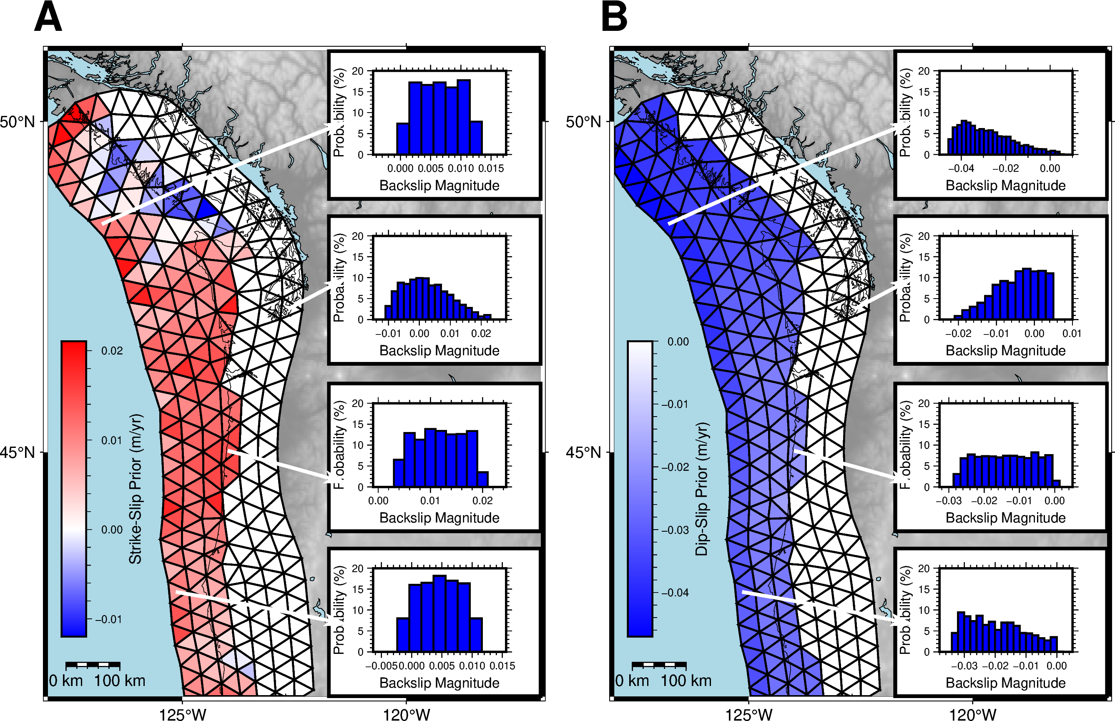
Figure S1. Example of truncated Gaussian distributions used as a prior for the preferred model, showing the mean of the prior along the plate interface, with inset histograms showing the truncated Gaussian distributions of backslip (m/yr) for four fault elements, (a) Prior for the strike-slip component. Note that the projection of the plate motion vector onto the geometry of some of the patches creates a negative value for the mean, (b) Prior for the dip-slip component. In the strike-slip direction, positive corresponds to sinistral back-slip motion, or dextral slip. In the dip-slip direction, positive corresponds to reverse back-slip motion, or normal slip.

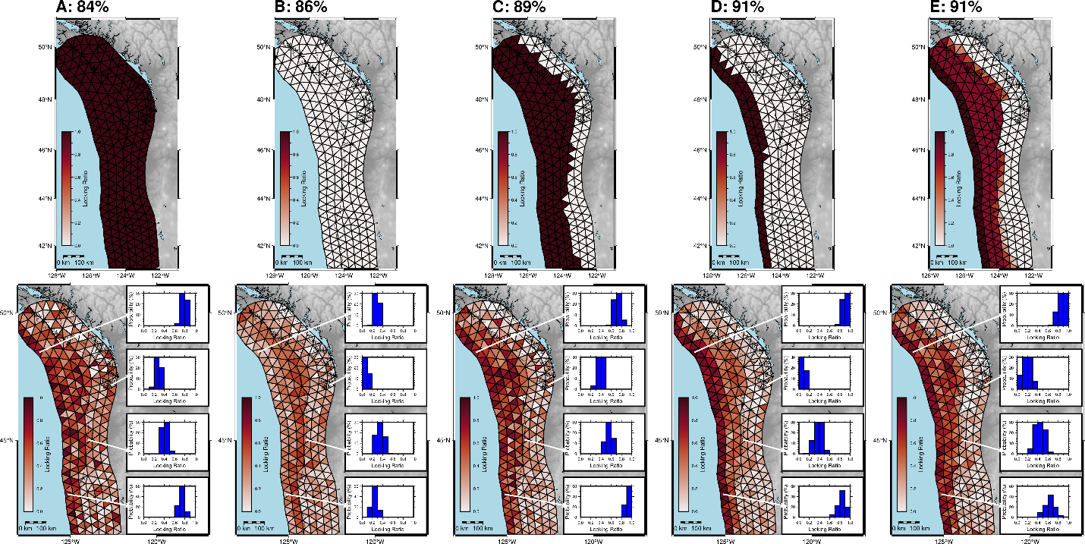
Figure S2. Mean locking ratio assigned to the prior distribution (top row) and mean locking ratio from the posterior distribution (bottom row), with inset histograms of distributions for four fault elements, for each of a series of prior assumptions. Each column corresponds to a separate Bayesian inversion run. Percentage shown above each column is the R-squared value, showing the amount of variation in the surface deformation data that can be explained by the output model velocities (i.e. R-squared equal to 100% means the data are perfectly fit by the model). (a) End-member model: prior model assumes fully locked, (b) End-member model: prior assumes fully creeping, (c) Prior assumes transition from locked to creeping at 30 km depth, (d) Prior assumes transition from locked to creeping at 10 km depth, and (e) Prior assumes a smoothed decrease in locking with depth, which is a variation of the prior used for the preferred fault model.

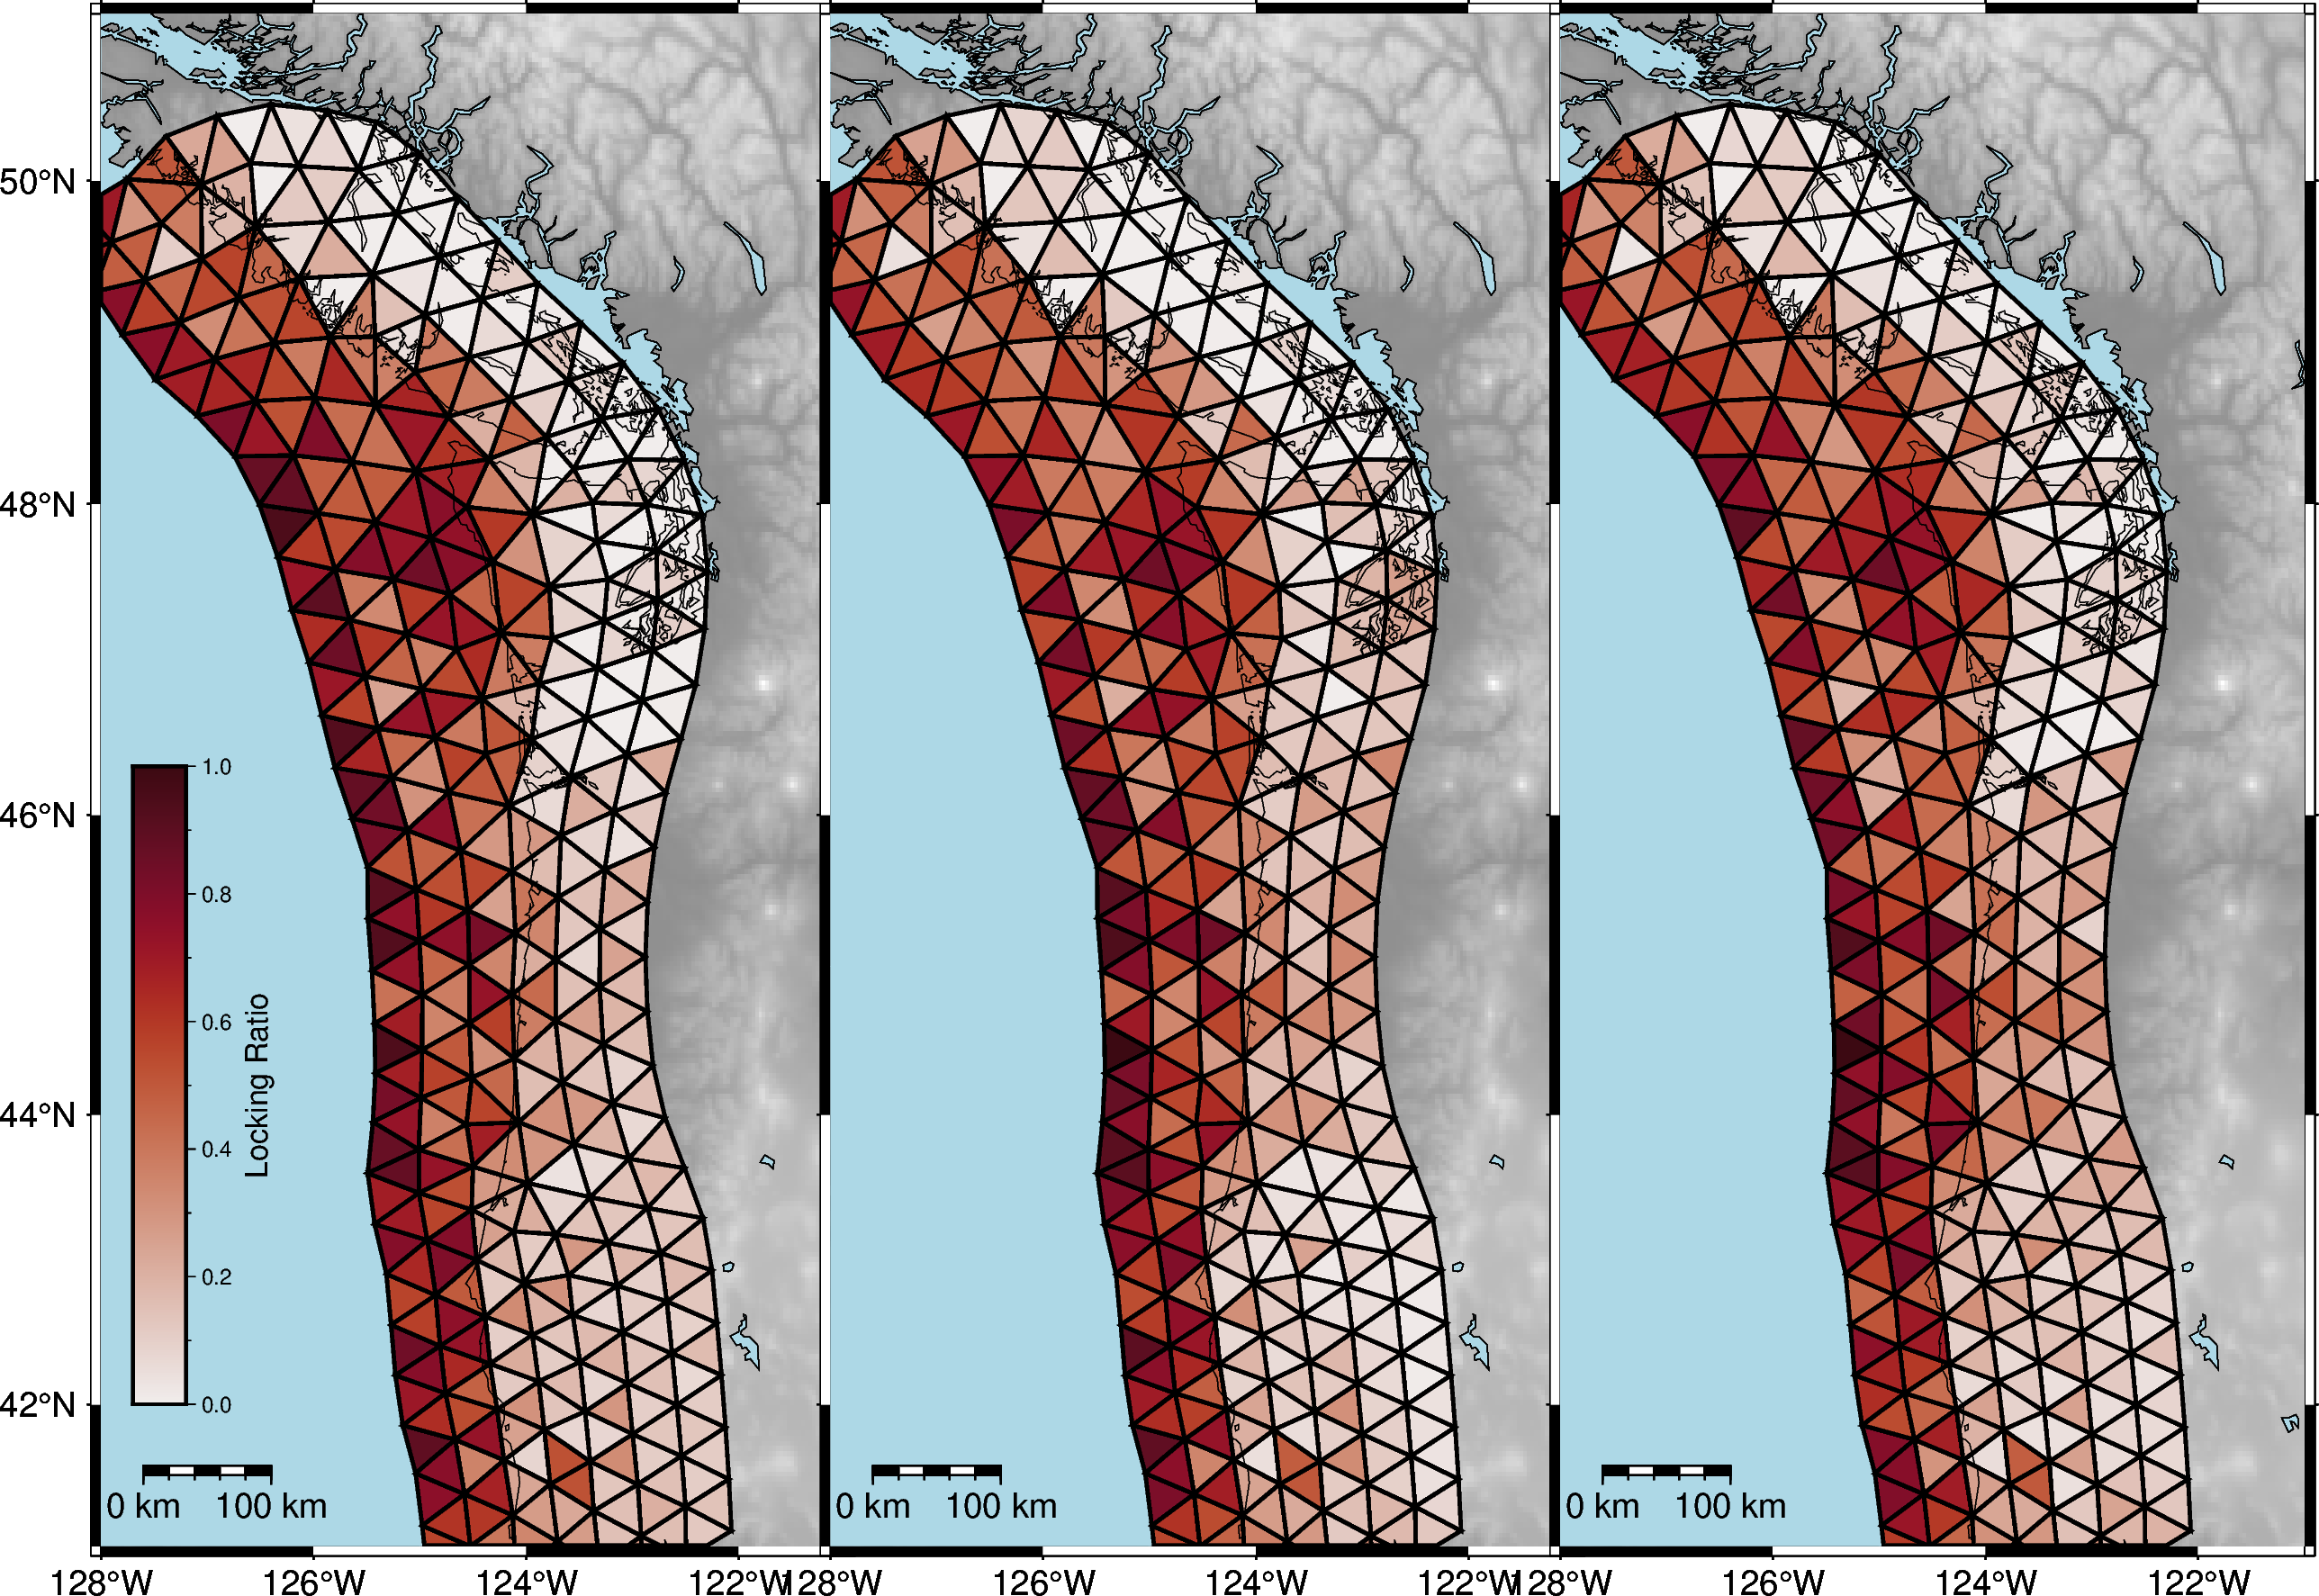
Figure S3. Series of locking models selected from the preferred distribution of locking models, using a correlation length between neighboring fault elements of 150 km. Correlated models are created by first calculating a correlation matrix, using the Gaussian kernel function based on the distance between model elements. Then, we generate Gaussian data from the correlation matrix and transform it to uniform marginals. Finally, we interpolate the correlated uniform data back onto the original distribution shapes, equivalent to using the inverse cumulative distribution function. Each locking model is a different realization of the posterior locking distribution.

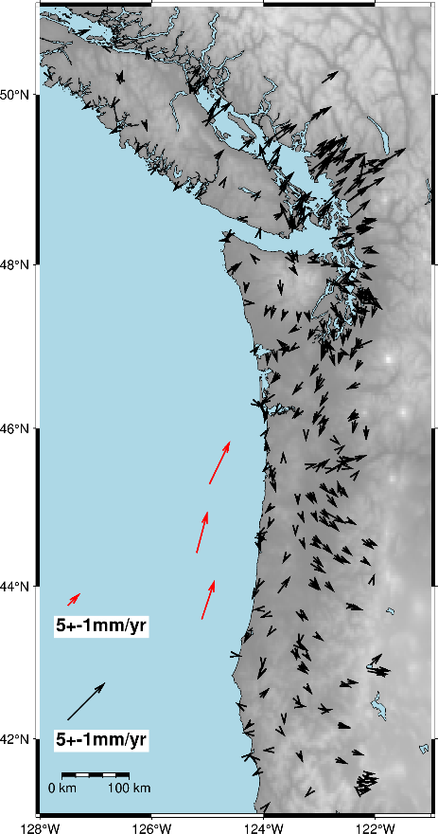
Figure S4. Residual horizontal velocities for the mean locking ratio (predictions from the model subtracted from the observed data), when using the forearc rotation values from McCaffrey et al., 2007. Note systematic rotational signal and higher overall residuals.

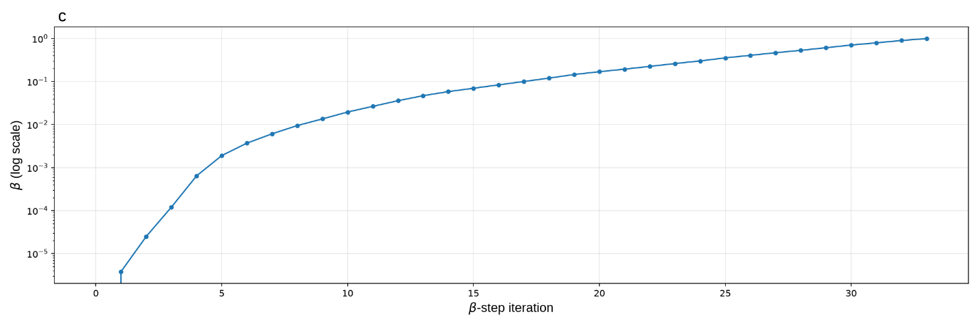
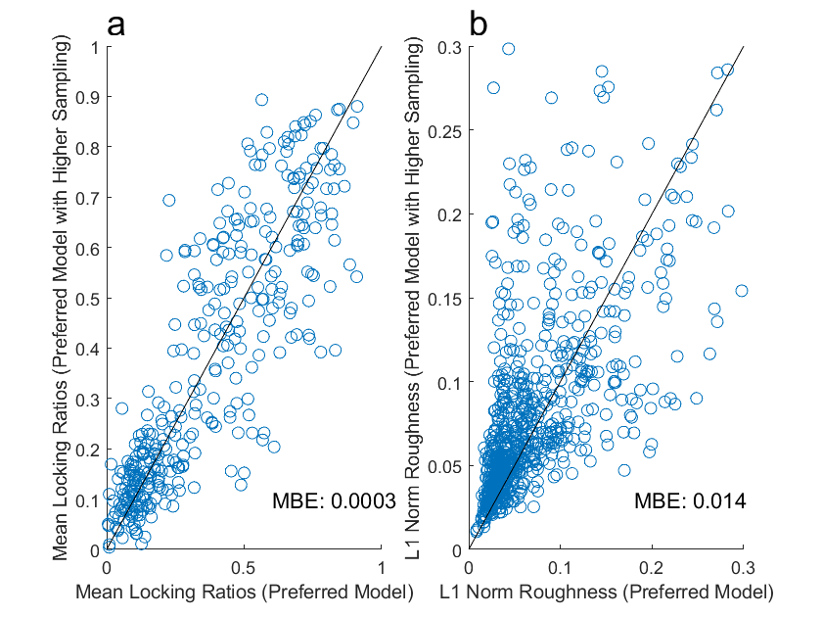
Figure S5. Assessing the sampling in an MCC run. Comparison of model results obtained using the preferred model and a model with 10x more samples, to evaluate whether apparent model roughness is an artifact of undersampling. The black line indicates a one-to-one relationship; systematic deviations from this line would indicate sensitivity of the model results to sampling density. Mean bias error (MBE) shown in the righthand corner. A slightly positive value in plot b indicates a slight tendency for higher roughness in the model with higher sampling. (a) Mean model locking ratio. (b) L1 norm, representing model roughness, (c) Convergence of tempering parameter β during the annealing sequence of the CATMIP algorithm for the preferred model, showing steady progression indicating that the algorithm did not have issues exploring the likelihood surface.
Parameter | Model Parameters Varied |  | Parameters for Best-Fit Model
Prior Uncertainty | Standard deviation | Zone of zero locking | 10 mm/yr
Prior Uncertainty | Standard deviation | Deformation front | 20 mm/yr
Prior Uncertainty | Standard deviation | All other areas | 40 m/yr
Prior Uncertainty | Bounds | Dextral component (-) | Lower Bound | Upper Bound
Prior Uncertainty | Bounds | Dextral component (-) | Maximum of [fully locked - 0.002, the mean value - 75% of the strike-slip range] | Minimum of [1 mm/yr, the mean value +25% of the strike-slip range]
Prior Uncertainty | Bounds | Sinistral component (+) | Opposite of the dextral component
Prior Uncertainty | Bounds | Reverse component (-) | Maximum of [fully locked-0.002, the mean value -75% of the dip-slip range] | North: 5 mm/yr, South: 0 mm/yr

Table S1. Set of model iterations tested within the algorithm to construct the standard deviation and bounds on the prior, along with the choice of parameters for the best-fit model.

Text S1: Construction of Prior
To define truncated Gaussian distributions for the strike-slip and dip-slip components of backslip rate on each element, we must include a standard deviation and limits. We use a high standard deviation to give the algorithm flexibility in fitting the data, but reduce it at the deformation front and at depth, where we have more confidence in how we expect the locking to behave based on prior knowledge of the sediments and thermal state of the system (Flück et al., 1997; Han et al., 2017; Seyler et al., 2020). We shift the limits of the truncated Gaussians based on a fixed distance from the mean of each distribution and narrow them further if a fixed distance would push the bounds much beyond 100% locked or in a direction inconsistent with the convergence vector. For the dip-slip component, the bounds are slightly broader in the north, as this improves the model fit.

