Supplementary Information #6
Comparison between the moment tensor solution and the P-polarities of a) earthquake 6, 201601212012; and b) 17, 202105300829.
a)
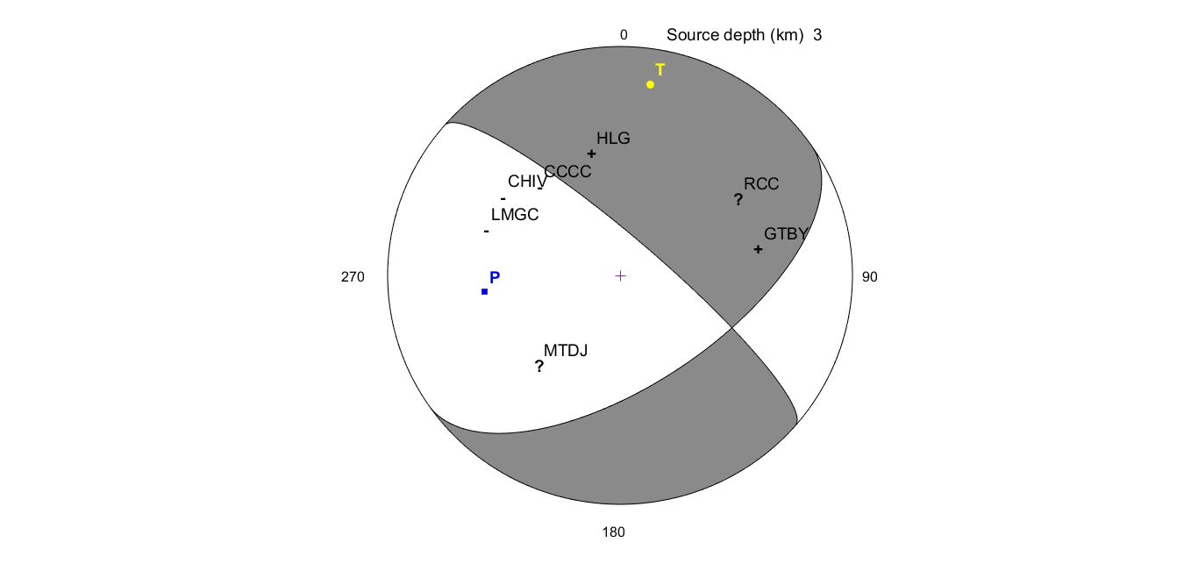
b) 