S1 Comparison of the MHT RSQSim catalogue rupture area scaling with global scaling relations
We performed the iterations to tune the a and b values so that the large earthquake magnitudes match the global scaling relation. We chose the Stirling et al. (2024), Thingbaijam et al. (2017), and Allen and Hayes (2017) scaling relations for the comparison and tuned the parameters. For the a and b values chosen (Table 1 in the main text), we observed that the rupture area from the simulator is comparable with the global scaling relations (Fig. S.1a).
Stirling et al. (2024) used a weighted combination of modern subduction scaling relations and historical earthquake rupture to develop scaling relations, while Thingbaijam et al. (2017) and Allen and Hayes (2017) are based on the finite-rupture model. We highlight here that although essentially a continental fault, due to its size and low dip, it has been typical to use subduction zone scaling for the MHT (Goda et al., 2016; Thingbaijam et al., 2017; Stevens et al., 2018).
We found that for M_{w} < 7.5, rupture areas from the RSQSim catalogue show a broad variation, but for M_{w} > 7.5, they lie between the area scaling from Stirling et al. (2024), Thingbaijam et al. (2017) and Allen and Hayes (2017) (Fig. S1). Overall, the RSQSim catalogue magnitude-area scaling is more closely aligned with the Thingbaijam et al. (2017) scaling; this may reflect that this scaling relation includes the Gorkha earthquake. By contrast, the slip versus the magnitude comparison shows that RSQSim generally overestimates the average slip relative to the slip derived from the finite rupture model (Fig. S1.b).
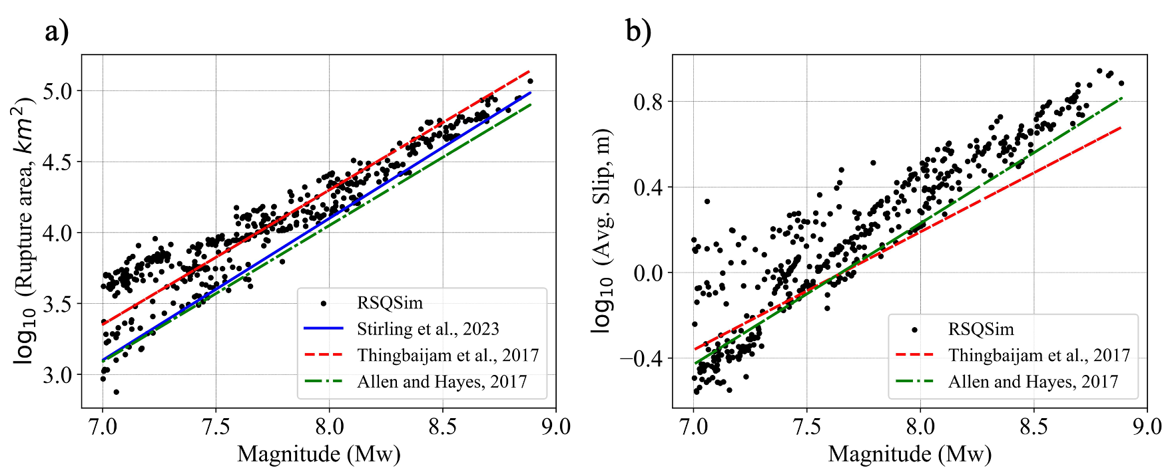
Figure S.1: (a) Rupture area versus magnitude from RSQSim compared with Stirling et al. (2024), Thingbaijam et al. (2017) and Allen and Hayes (2017). (b) Average slip versus magnitude from RSQSim compared with Thingbaijam et al. (2017) and Allen and Hayes (2017).

S2 Slip deficit rate and rate- and state-dependent friction parameters (a & b) adopted in the Main Himalayan Thrust RSQSim model
The slip deficit rate on the Main Himalayan Thrust (MHT; Fig. S.2a) is obtained by multiplying the coupling coefficient with the long-term slip rate obtained from geodetic modelling (Dal Zilio et al., 2020). The rate and state-dependent frictional parameters adopted in the MHT RSQSim model (Fig. S.2b, c) are adjusted to match the global scaling relation (Fig. S.1) for the subduction interface (e.g., Herrero-Barbero et al., 2021; Shaw et al., 2022). Based on the coupling factor value (Dal Zilio et al., 2020), three zones are defined as creeping (coupling ≤0.2, a =0.01, b = 0.008), transition (coupling ≤0.2, a = 0.001, b =0.0015) and locked (coupling ≥0.5, a = 0.001, b = 0.004).
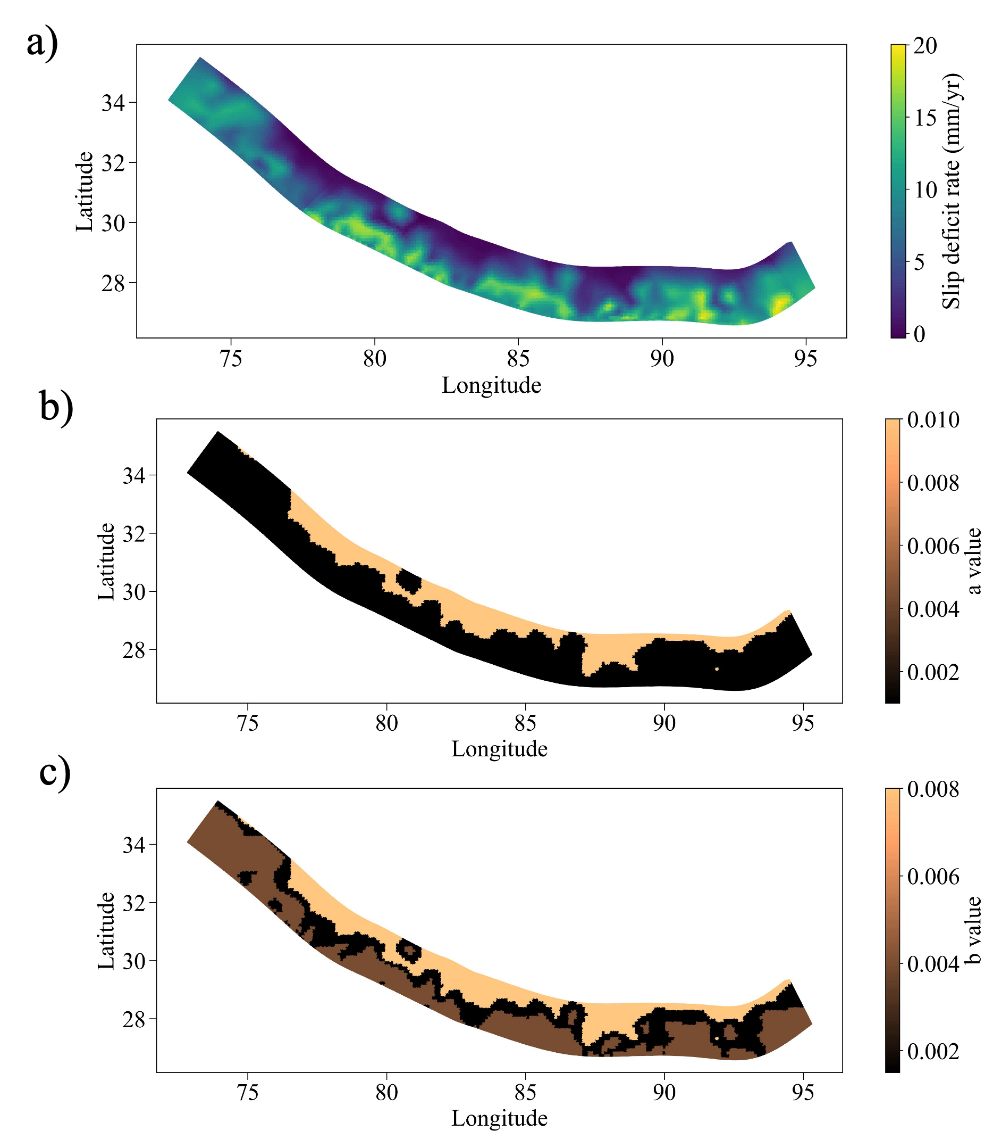
Figure S.2: (a) Slip deficit rate model for MHT, (b), (c) rate- and state-dependent frictional parameters in creeping (coupling≤0.2), transition (0.2< coupling <0.5) and locked zone (coupling≥0.5).

S3 Instrumental seismicity earthquake records on the MHT
Figure S.3 shows the instrumental seismicity records on the MHT. It is observed that seismicity records in the MHT increase after 1950 and are interpreted as complete for events M_{w} ≥5.5 to 1950.
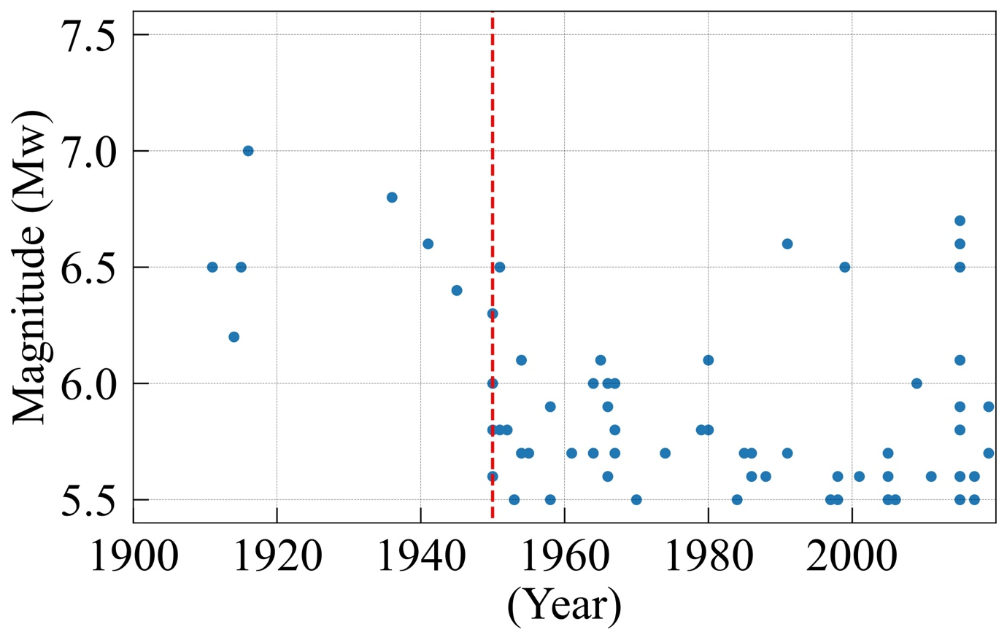
Figure S.3: Plot of the year versus magnitude on the MHT since 1900. Earthquake data are taken from ISC ((https://www.isc.ac.uk/iscbulletin/search/catalogue). Earthquake records show Mw> 5.5 events are complete since 1950.

S4 Interseismic period for surface-rupturing earthquakes in high coupling zones (Zone 1 to 4).
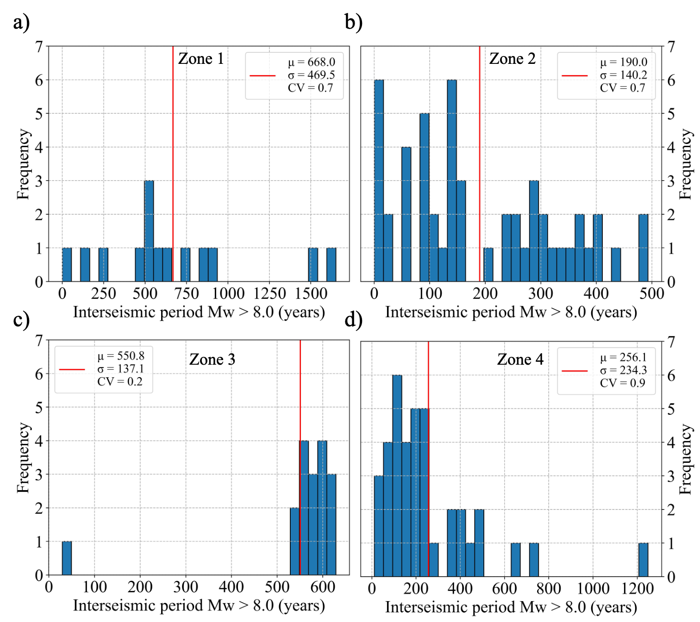

Figure S.4: (a)-(d): Interseismic period of surface-rupturing earthquake (M_{w} > 8.0) at four highly coupled zones (Zone 1 to Zone 4 from west to east; Fig. 5, in the main manuscript).

S5 Events Mw > 8.0 in Zone 2 within 4 months

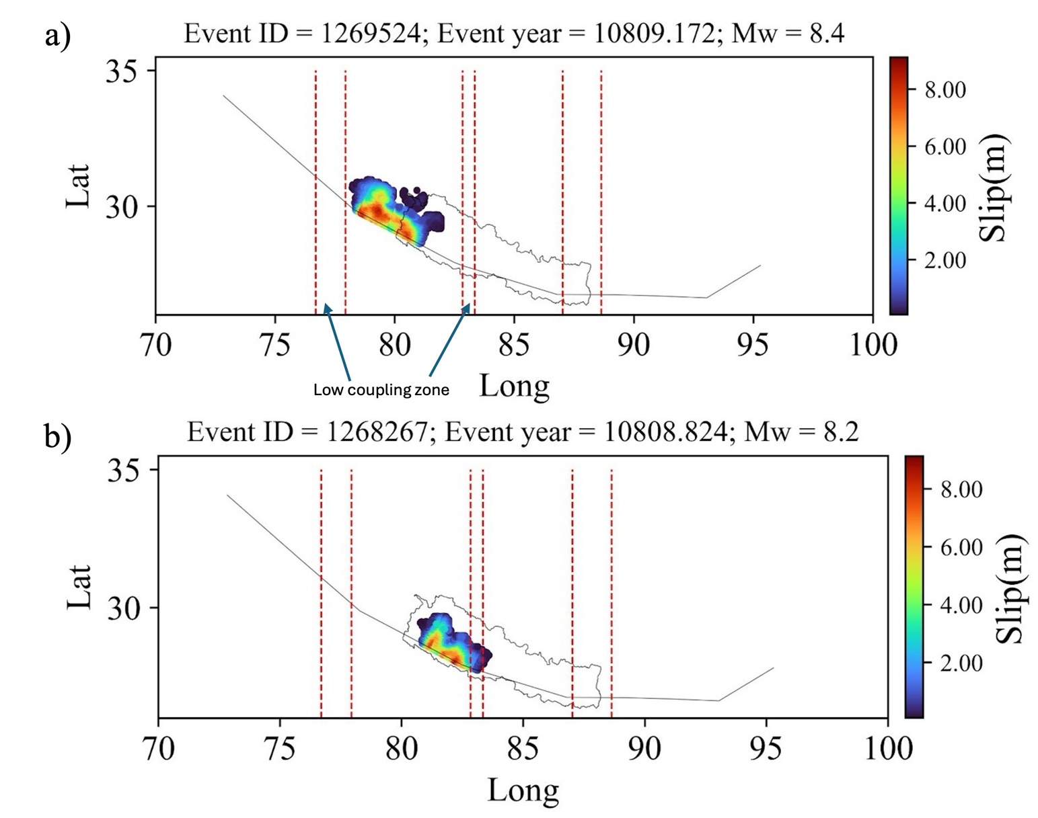
Figure S.5: Two Mw > 8.0 events in high coupling Zone 2 within 4 months.

S6 Site-wise comparison of hazard derived from MHT RSQSim catalogue with Classical hazard in Nepal.
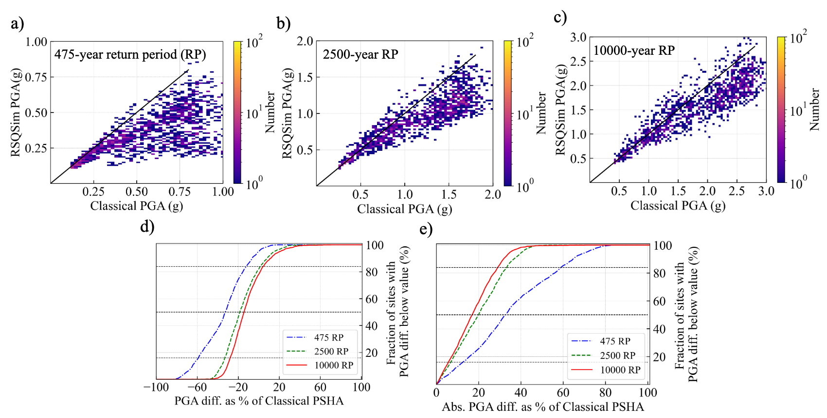
Figure S.6: Site-wise comparison of hazard from MHT RSQSim catalogue with classical in Nepal for (a) 10% PoE, (b) 2% PoE, and (c) 0.5% PoE in 50 years, respectively. (d) Percentage of sites with PGA difference below a value versus the PGA difference in % with respect to classical PSHA at 10%, 2% and 0.5% PoE in 50 years. (e) absolute PGA difference in % with respect to classical PSHA PGAs versus the proportion of sites with PGAs difference below this value.

At 2% and 0.5% PoE in 50 years, 50% of the sites show < 20% absolute difference in PGA, and 84% of sites show < 35% absolute PGA difference. Likewise, 100% of sites show PGA differences below 50%. In contrast, at 10 % PoE in 50 years, there is a higher difference in absolute PGAs than at 2% & 0.5%.

S7 Comparison of Historical & Instrumental earthquakes on the MHT with seismicity from RSQSim Ramp-Flat-Ramp MHT Geometry.
Figure S7: Comparison of historical & instrumental earthquakes on the MHT with seismicity rate from RSQSim Ramp-Flat-Ramp MHT geometry (Figure 1C in manuscript).
S8 Comparison between Dal Zilio et al. (2020) and (Stevens and Avouac, 2015) seismic moment rate on the MHT
There are two different coupling models available for the MHT. The model proposed by Dal Zilio et al. (2020) shows heterogeneity in the coupling factor (Fig. S.6a), while the model proposed by Stevens and Avouac (2015) shows uniform coupling throughout the MHT (Fig. S.6b). We compared the impact of the coupling factor on the seismic moment rate on the MHT due to these two models. For the same slip rate (20 mm/yr), the seismic moment deficit rate as per (Stevens and Avouac, 2015;1.22e²⁰ Nm/yr) is 32 % higher than that of Dal Zilio et al. (2020), 1.61e²⁰ Nm/yr.
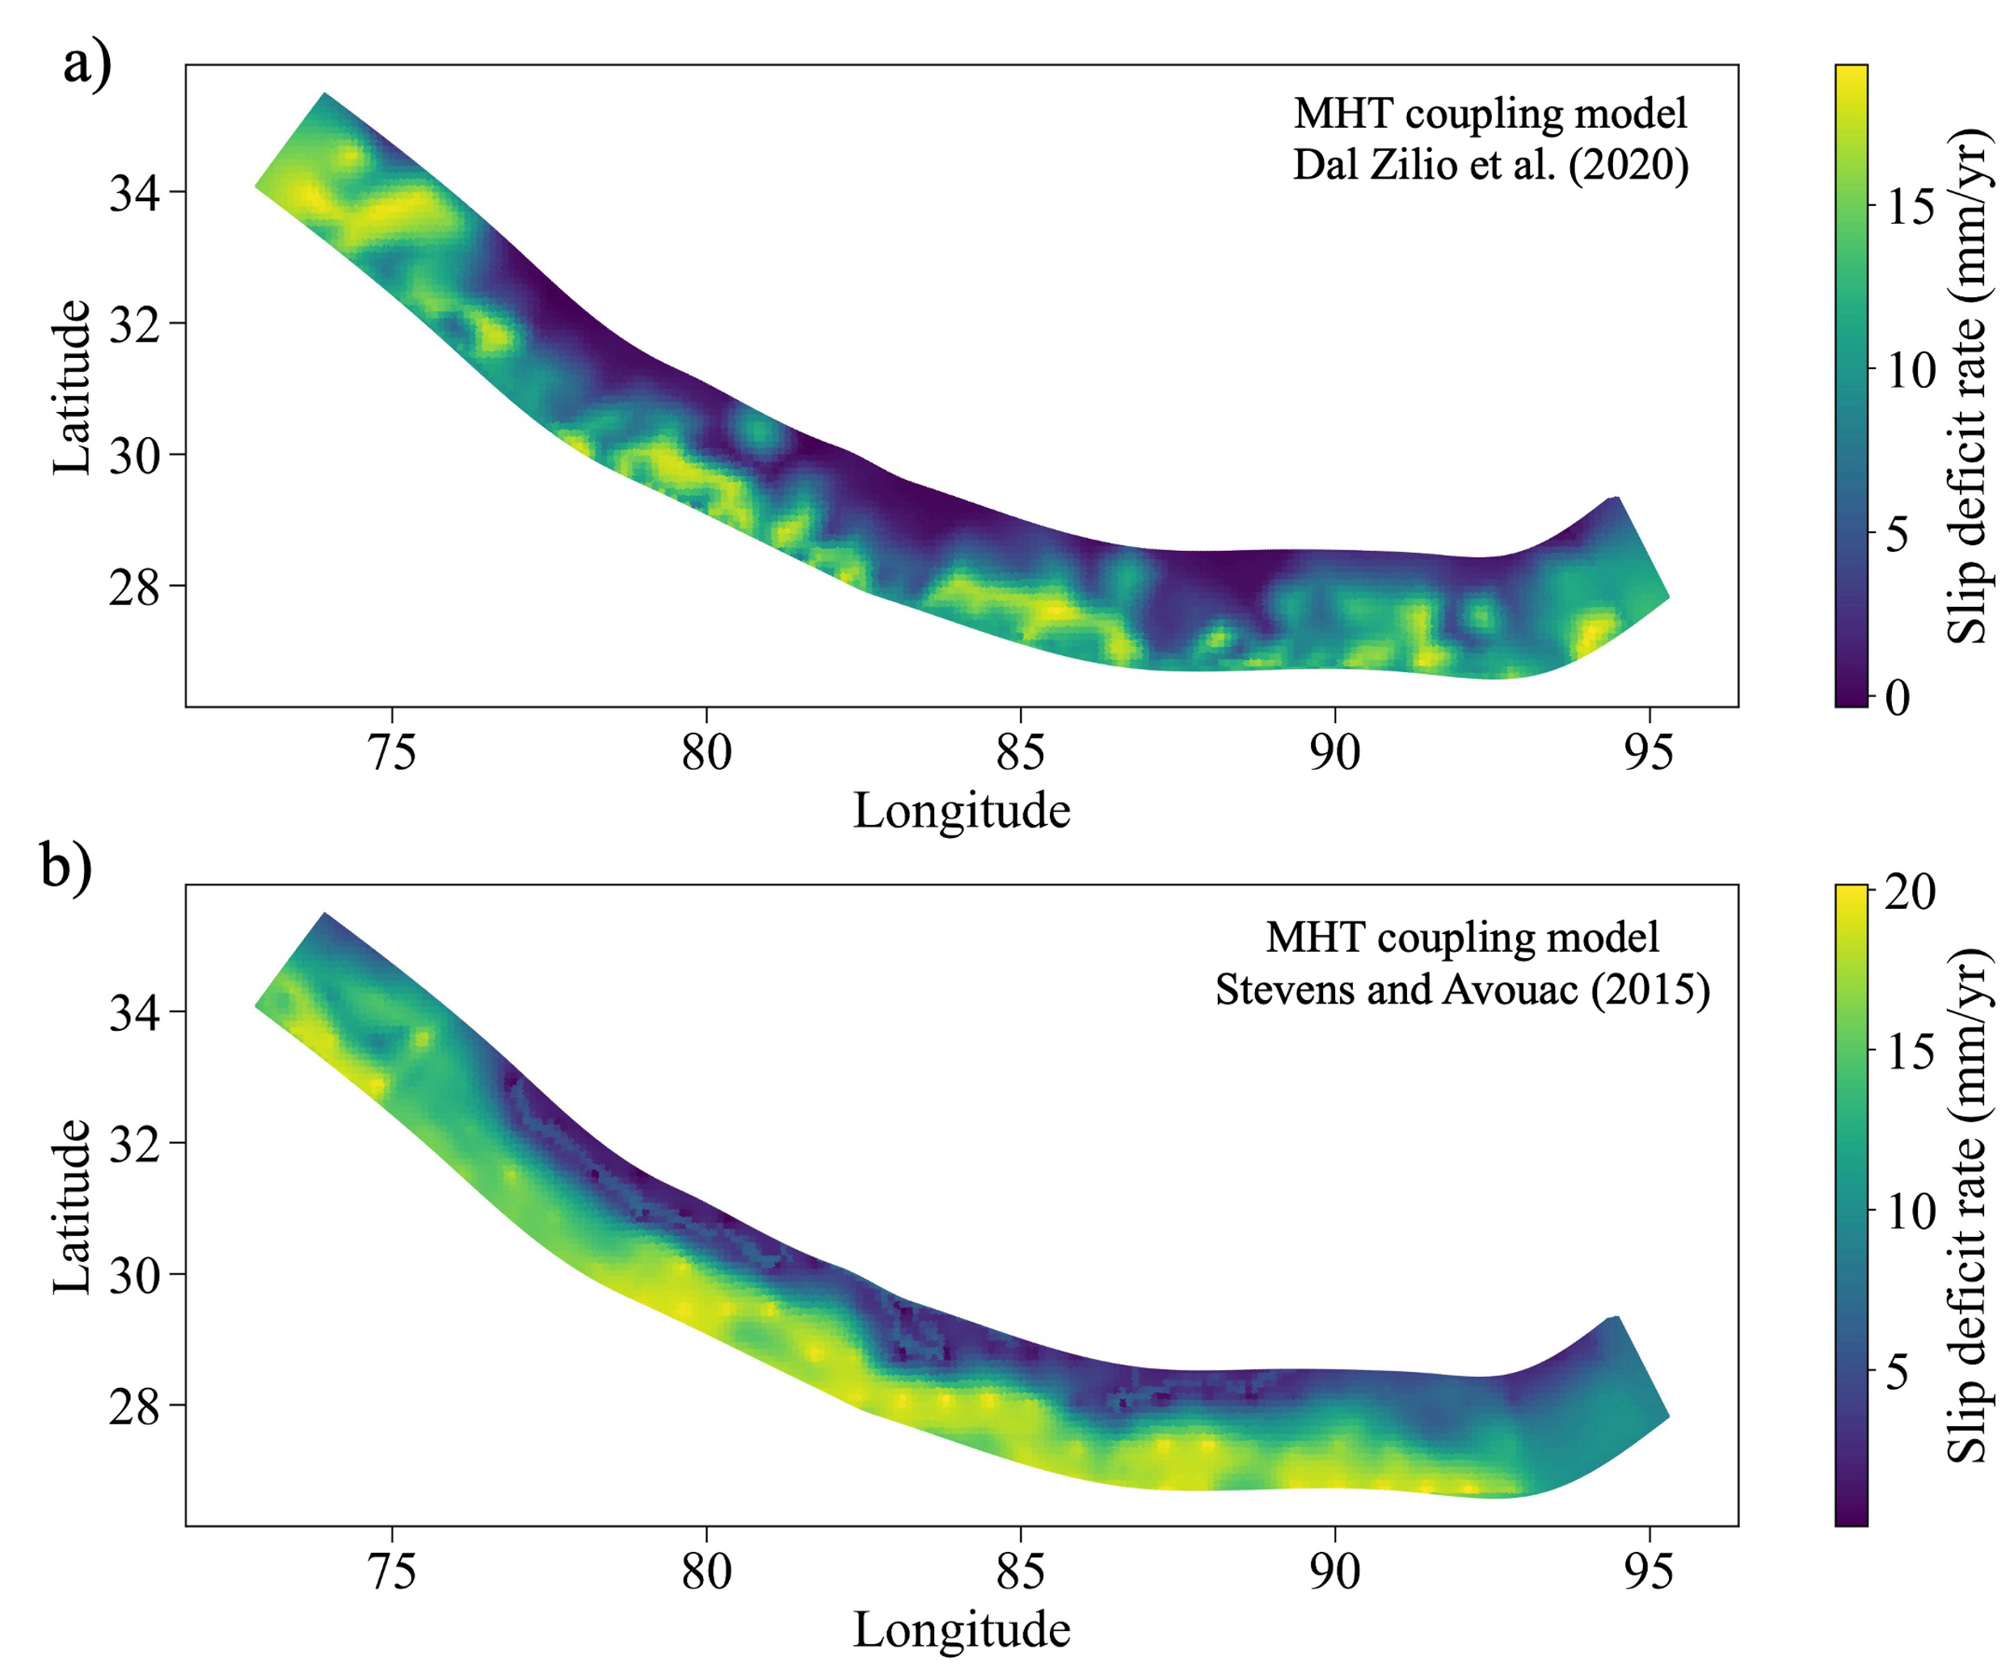
Figure S8: Slip deficit rate model for MHT after (a) Dal Zilio et al. (2020) and (b) Stevens and Avouac (2015). Coupling factors are multiplied by a constant slip rate (20 mm/yr) to get slip deficit rates from both models.

S9 Comparison of MFD from RSQSim with Historical and Instrumental seismicity and Steven et al. (2018) model.
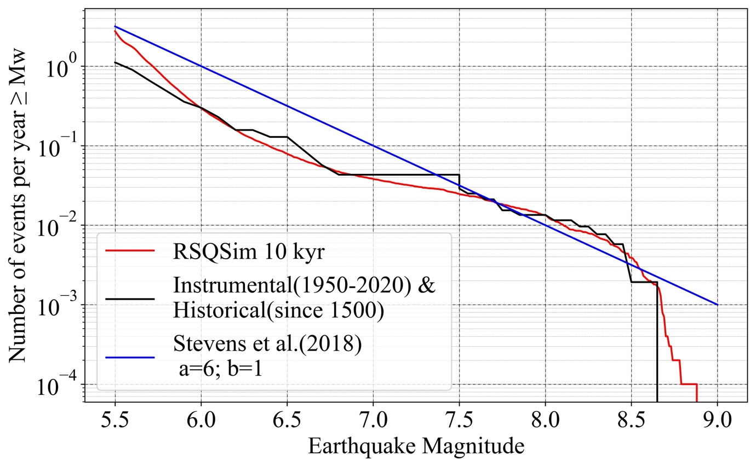
Figure S9: Comparison of MFD from RSQSim with Historical and Instrumental seismicity, and Stevens et al. (2018) model.

S10 Earthquake depth histogram from RSQSim and Instrumental earthquake records
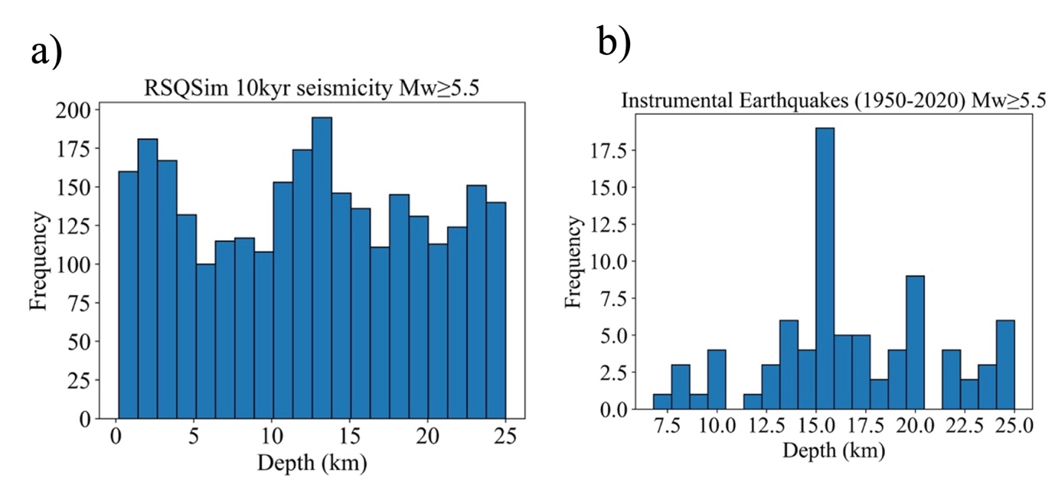
Figure S10: Depth histogram for (a) RSQSim earthquakes and (b) Instrumental earthquakes. The depths of historical earthquakes are not available; therefore, they are not included in the histogram plot.

