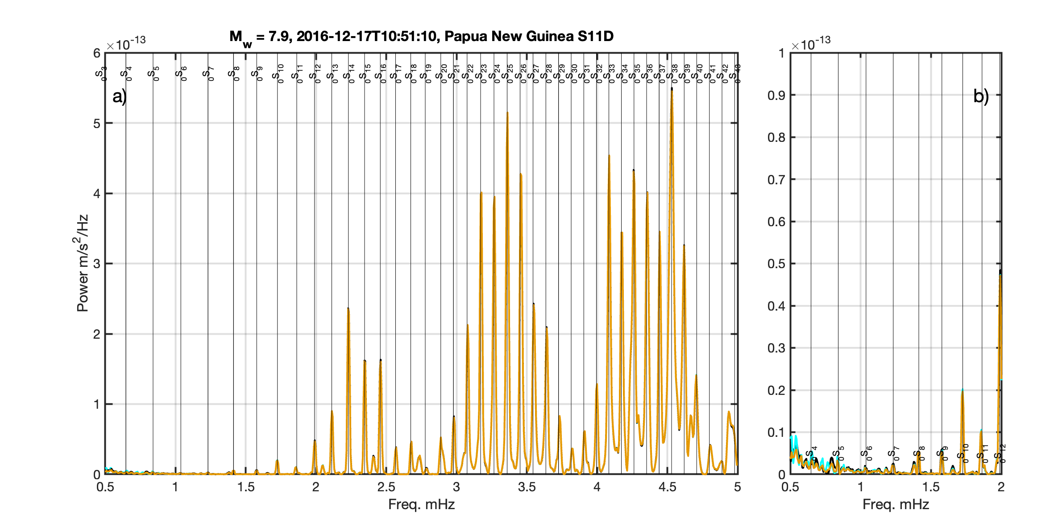
Figure S1. Example spectra after the application of tilt and compliance corrections for the 2016 event to station S11D which had a tilt of 0.13°. a) The spectra from 0.5-5.0 mHz and b) a zoom of 0.5-2.0 mHz are shown. In both panels, the black lines show the spectra of the uncorrected data. The blue line (visible in b) near ₀S₄) shows the tilt response corrected data. The orange line shows the tilt and compliance corrected data. The blue and orange lines are nearly identical, with the largest difference observed at ₀S₉. The cyan line shows the result from the spectral tilt correction (Bell et al., 2015; W. C. Crawford & S. C. Webb, 2000). Global average fundamental mode frequencies are shown by thin vertical lines, and modes are labeled (Masters and Widmer, 1995)

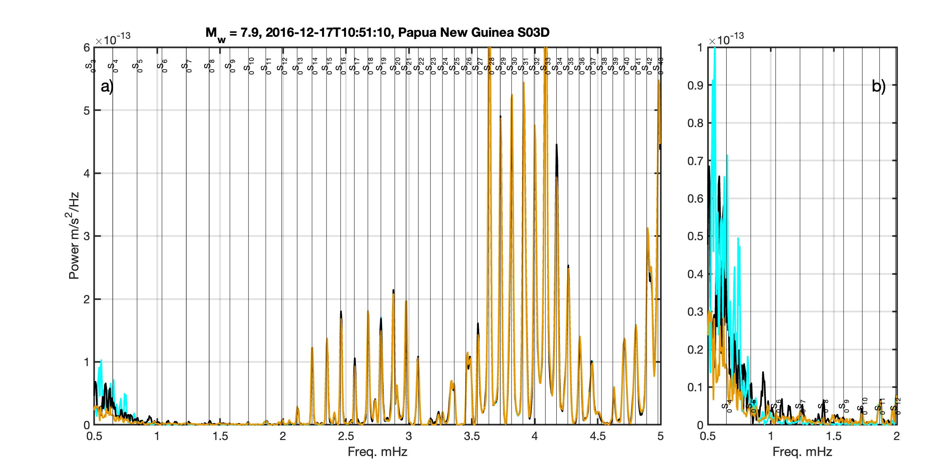
Figure S2. Example spectra after the application of tilt and compliance corrections for the 2016 event to station S03D which had a tilt of 0.48°. a) The spectra from 0.5-5.0 mHz and b) a zoom of 0.5-2.0 mHz are shown. In both panels, the black lines show the spectra of the uncorrected data. The blue line (visible in b) near ₀S₄) shows the tilt response corrected data. The orange line shows the tilt and compliance corrected data. The blue and orange lines are nearly identical, with the largest difference observed at ₀S₉. The cyan line shows the result from the spectral tilt correction (Bell et al., 2015; W. C. Crawford & S. C. Webb, 2000). Global average fundamental mode frequencies are shown by thin vertical lines, and modes are labeled (Masters and Widmer, 1995)

Matlab Function for Rotational Tilt Correction
%this function will determine the best fitting tilt direction and amount by
%minimizing energy on the vertical component.
%input are X(east), Y(north) and Z(vertical).
%output are Znew (tilt corrected Z), Xnew (rotated X), Ynew (rotated Y),
%angy (azimuthal rotation in degrees) and vrt (tilt angle from vertical in
%degrees)
%Note this operates on the second half of the time series-can be modified
%as need to operate on whole time series, etc by modifying inline function
%ff below.
%requires optimization toolbox

function [Znew,angy,vrt,Xnew,Ynew] = tilt_corr_rot(X,Y,Z);

%% first do polarization analysis on the data to get a guess of the tilt direction.
S=cov([Z(end-length(Z)/2:end) X(end-length(Z)/2:end) Y(end-length(Z)/2:end)]);
[V,D]=eig(S);
linny=1-(D(2,2)+D(1,1))/2/D(3,3);
planny=1-2*D(1,1)/(D(2,2)+D(3,3));
if linny>0.1 %this is a relatively linear phase recorded
%calculate the rotation angle
angy=atan(V(3,3)*sign(V(1,3))/(V(2,3)))*180/pi;
end
%% search for the best fitting azimuth (angy) and tilt (vrt)
[~,idd]=max(abs(V(1,:)));
vrt=acosd(V(1,idd));
ff=@(x)Zrot(Z(end-length(Z)/2:end),X(end-length(Z)/2:end),Y(end-length(Z)/2:end),x);
options=optimset('Display','iter');
warning off
[vrt,zvr2]=fminsearch(ff,[vrt;angy]);
angy=vrt(2);
vrt=vrt(1);
[Znew,Ynew,Xnew]=xyzrot(X,Y,Z,[vrt;angy]);

end
function zvr = Zrot(Z,X,Y,vrt)
[Znew,ynew,xnew]=xyzrot(X,Y,Z,vrt);
zvr=sqrt(Znew(:)'*Znew(:));
end
function [znew,ynew,xnew]=xyzrot(x,y,z,tst)
vrt=tst(1);angy=tst(2);
dipZ=-90+vrt;%sin change on vrt due to how it is determined
dipY=vrt*cosd(angy);
dipX=vrt*sind(angy);
%make vectors from dip and azimuth
zv=[-sind(dipZ);cosd(dipZ).*cosd(angy);sind(angy).*cosd(dipZ)];
yv=[-sind(dipY);cosd(dipY).*cosd(0);sind(0).*cosd(dipY)];
xv=[-sind(dipX);cosd(dipX).*cosd(90);sind(90).*cosd(dipX)];
C=[zv yv xv];
jk=inv(C)*[z y x]';
znew=jk(1,:)';
ynew=jk(2,:)';
xnew=jk(3,:)';
end

