2nd March 2026

Dear Editor of Seismica,

Thank you for taking the time to handle our manuscript during its revision process. We are grateful for the constructive and thorough comments provided by the reviewers, and we have considered and addressed them carefully.

In response to the reviewers' comments, the main changes to the manuscript are as follows: (i) the structure of the manuscript has been revised, with Section 1.1 promoted to a standalone Section 2, and the operational details of the injection relocated to the Supplementary Materials, Text S1; (ii) Sections 2.1 and 2.2 have been merged into a single section (now Section 3.1), which has been expanded with additional clarifications on the temporal b-value calculation; (iii) two new supplementary figures (Figures S4 and S5) have been added to support the methodological choices for the magnitude of completeness and b-value estimation; (iv) additional clarifications have been provided regarding the choice of the PCA-based fault plane fitting approach and the limitations of alternative clustering methods; and (v) several textual corrections and figure improvements have been made throughout the manuscript in response to specific comments.

We feel that these changes to the revised version adequately address the reviewer’s comments, making the manuscript suitable for publication – we hope that you agree.

Below, we have outlined the comments of the reviewers and our responses to those comments in blue. When necessary, changes have been made to the manuscript. The location of these changes within the tracked changes version of the manuscript (line number) is indicated in our responses.

Thank you again,

Federica Lanza & co-authors

Editor:

In addition to the reviewers’ comments, I would like to invite the authors to further reflect on the methodology used for estimating the Gutenberg-Richter b-value. Given the central role played by the b-value in the interpretation of the underlying physical mechanisms, and considering the non-stationary nature of the induced seismicity as well as the potential temporal variability of the magnitude of completeness, it would be helpful to clarify why alternative estimators that do not rely explicitly on a fixed completeness threshold were not considered. In particular, methods based on magnitude differences (e.g., b-positive or b-more-positive estimators) have been proposed to mitigate completeness-related biases and to increase the effective sample size. While I am not suggesting that the analysis must necessarily be redone using these approaches, a brief justification of the chosen methodology, or a discussion of the potential impact of alternative estimators on the results and interpretations, would strengthen the robustness of the conclusions.
We thank the editor for the comments on the statistical analysis. In response, we have now clarified our methodological choices more explicitly in the revised manuscript (lines 208–224) and have included two additional supplementary figures (Figures S4 and S5). Furthermore, we report here the main reasons for choosing maximum curvature (MAXC, Wiemer & Wyss 2000 and Woessner & Wiemer 2005) and the classical b-value estimator.

For the choice of the Mc method, the selection of MAXC+0.2 stemmed from a wish to use the same estimator for all stages (despite the low number of events in stage 1). MAXC with a correction of +0.2 allows for a reasonable estimation of the completeness (although subject to discussion as always for cases of highly tapered FMDs often seen in injection-induced seismicity, stage 3 showing a great example of such a tapered distribution). More conservative methods like Kolmogorov-Smirnov (K-S; Clauset et al., 2009 and Mizrahi et al., 2021) did not allow for a trustworthy estimation for all three stages (see table below).

In regards to alternative b-value estimators that would allow for independence from the magnitude of completeness, we did check for b+ (van der Elst, 2021): the comparison between stages remains consistent (see table below), and the transient b-value still displays a similar pattern (see also reply to Reviewer #1 point 2-a, and now Figure S5). This suggests that the catalog does not suffer from short-term aftershock incompleteness and that using the classical b-value is preferable as it allows the analysis to consider more events. We did not test b-more-positive, however, given the similarity of results between b+ and classical b-value approaches, we believe that further exploration of the latter is unlikely to yield meaningfully different conclusions.

 | Mc Method | Mc | b-value | std-b | b+ | std-b+
Stage 1 | MAXC +0.2 | -1.09 | 1.95 | 0.16 | 2.11 | 0.19
Stage 1 | K-S | not enough events
Stage 2 | MAXC +0.2 | -1.29 | 1.36 | 0.04 | 1.91 | 0.07
Stage 2 | K-S | -0.92 | 2.4 | 0.12 | 2.83 | 0.17
Stage 3 | MAXC +0.2 | -1.19 | 1.14 | 0.02 | 1.37 | 0.03
Stage 3 | K-S | -0.82 | 1.45 | 0.04 | 1.6 | 0.05

Finally, regarding the temporal variability of Mc, we refer to answer to Reviewer #1 point 2-c and the new supplementary Figure S4. In short, no significant changes are observed in the temporal evolution of b-value when using a fixed vs. variable Mc.

REVIEWER #1

Point 1: Suggested revisions to the overall structure
In the Introduction, I suggest separating Section 1.1 Utah FORGE into a standalone second section. In addition, the detailed description of hydraulic stimulation parameters could be significantly shortened and moved to Supplementary Information.
We agree with the reviewer, and we have now renamed “Section 1.1 Utah Forge” to “Section 2 Utah Forge”. Additionally, the description of the operational details of the injection has now been moved to the SI under the text: “Text S1: Expanded details on the Utah FORGE 2022 stimulation”.

Sections 2.1 and 2.2, which describe the calculation of the magnitude of completeness (Mc) and the b-value, could be merged into a single section. Both parameters are computed using the same package, and estimation of the b-value inherently depends on first determining Mc.
We have merged the two sections into one (now Section 3.1). We have also improved this section with further explanations on the temporal calculation of the b-value (see point 2).

Point 2: Temporal calculation of the b-value
a) It is unclear why different window sizes are used for calculating the temporal b-value evolution in Stage 1 versus Stages 2 and 3. I understand that Stage 1 has fewer events, making a 200-event window impractical. However, why were 200 events chosen for Stages 2 and 3 instead of 100? Figure S3 suggests that the differences between these choices are relatively small.
While 100 events seem to be enough to discern the pattern in the transient b-values (as seen in Fig S3), we opted to be a bit more conservative and chose 200 events per window for stage 2 and 3 in order to help mitigate potential biases associated with the use of a relatively non-conservative Mc method and a fixed Mc (see reply to point 2-c). The choice of 200 events was also primarily informed by a comparison with b-positive transient b-value (assuming that only about half of events are kept for b-positive) and a desire to keep at least 100 events per window even for b+(t). The figure below shows this comparison of the classical vs. positive b-value (this figure was added to the supplementary materials as Figure S5). For each stage, the main ‘signal’ is retained regardless of the method chosen.
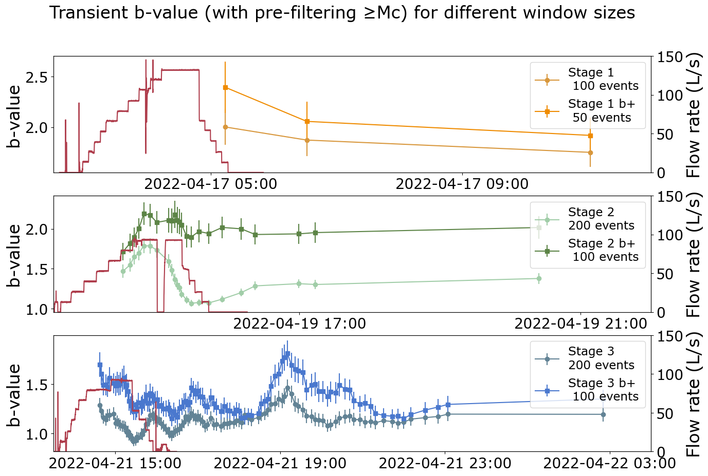
Figure S5: Comparison between the classical and b-positive approaches for b-value computation
b) What physical mechanism explains the continuous increase of the b-value after shut-in during Stage 3?
While we don’t have a full explanation for this continued increase of the b-value after shut-in in stage 3, we have a few hypotheses. If we had seen a decrease of the b-value, this could have suggested the reactivation of a potentially critically stressed fault, however, this is not supported by the spatial propagation of seismicity or the analysis of potential fracturing mechanisms. Instead, the increase in b-value, is consistent with seismicity remaining 'contained' within the stimulated fracture, and with the re-triggering of asperities that had already ruptured earlier in the stage (Ritz et al., 2022). This hypothesis is supported by the time-distance analysis (Fig. 4) which shows high b-values later in the stage for distances ~50-100 m from the check shot compatible with re-triggering. We have added a short sentence at line 388-389 of the annotated manuscript to reflect this possible explanation.

c) Temporal variations in the magnitude of completeness may influence the estimated b-values. Was a fixed Mc used throughout the calculation? If not, I suggest plotting the temporal evolution of Mc alongside the b-value to clarify this issue.
We thank the reviewer for this comment. It is true that the completeness can also vary in time and can impact the b-value quite severely. To investigate this further, we have plotted together the results obtained from both the fixed and variable Mc approaches (new supplementary Figure S4, also shown below). This comparison shows that, while the Mc does vary slightly over time, the general b-value pattern for each stage remains consistent (especially during the injection phase for stages 2 and 3) between the fixed and variable Mc approaches. Given the similarity, we thus prefer to retain the fixed Mc method, as it also ensures a more consistent number of events in each time bin. In addition to the new supplementary Figure S4, we have added a comment on completeness variability at lines 214-218 of the annotated manuscript.
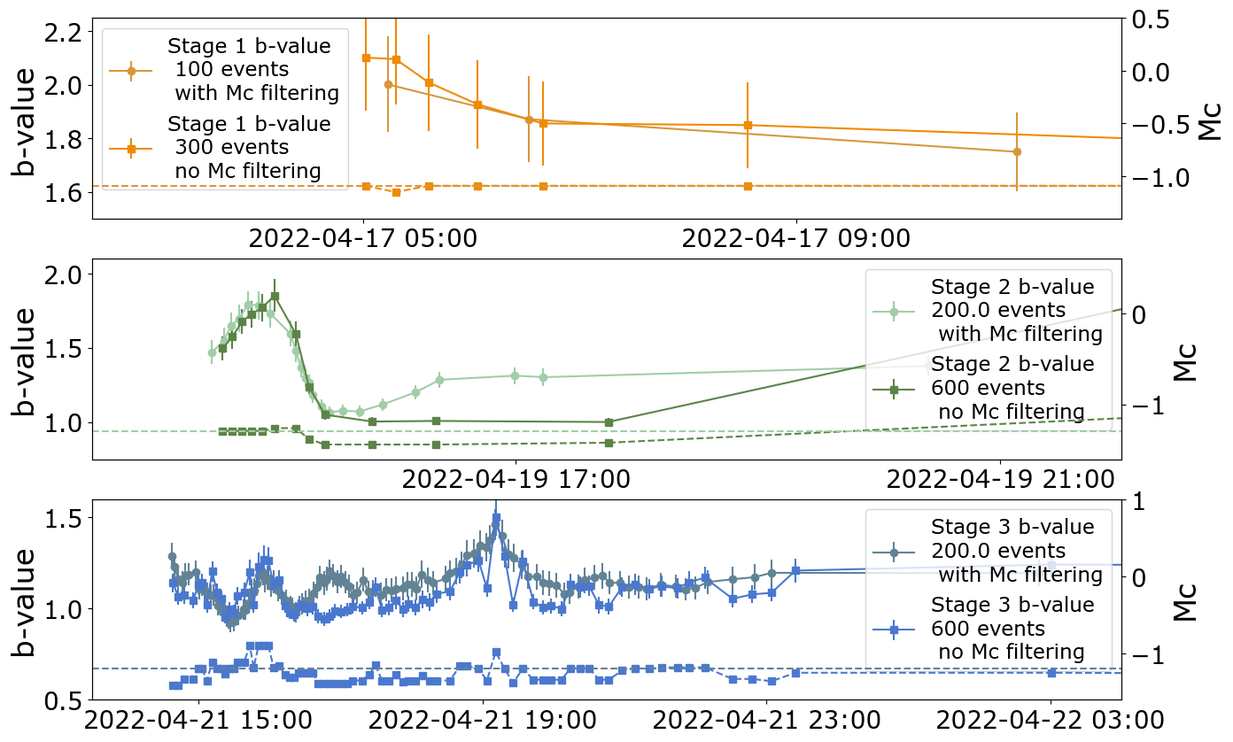
Figure S4: Comparison of the temporal evolution of the b-value with fixed Mc (pastel lines, as in the main text) and variable Mc calculated for each time bin (bright colours). The completeness used in each bin is indicated with the dashed lines. The number of events in the bins with variable Mc was adjusted to have a similar number of points in time as the results presented in the main text.
Point 3: PCA-based fault plane fitting
Using PCA to fit an ellipsoid and infer a fault plane is a simple and commonly used approach, but it is not always robust and may fail to capture complex structures within seismicity clusters. Recently developed methods that directly extract fault geometry from earthquake catalogs—such as SURF and E2F—could be considered as complementary or alternative approaches:
Travis Alongi, Austin J. Elliott, Robert J. Skoumal, David R. Shelly, Alexandra E. Hatem; SURF: An Automated Method for Building Nonplanar 3D Fault Models from Earthquake Hypocenters. Seismological Research Letters 2025.
Zhengtao He, Ruijia Wang; E2F: Extract Fault Geometry from Earthquake Catalogs. Seismological Research Letters 2025; 96 (6): 3880–3890.
We agree with the reviewer that PCA primarily captures the first-order orientation of the seismicity cloud. Although we recognize state-of-the-art methods like SURF and E2F, our attempts to apply more complex interpretations encountered significant limitations. We ultimately chose a simpler approach to define the aggregate properties of the seismic cloud. While we acknowledge that this results in the loss of some finer-scale details regarding hypocenter geometry and fracturing mechanisms, we believe it remains the most robust way to represent the general trends of the data.

In particular, we made several attempts to apply the DBSCAN algorithm to the hypocenters but found it to be highly unstable, as shown below in Figures R1 and R2. We explored the stability of cluster detection as a function of the two primary DBSCAN parameters: the minimum number of points per cluster (Nmin) and the neighborhood distance (epsilon or Eps). Although the algorithm identifies distinct clusters for Eps = 10m (Fig. R1a–c), increasing the search radius causes the number of identified clusters to drop to just one or two large groups, regardless of the Nmin value selected (Fig. R2).Because the results were unstable and heavily dependent on the subjective choices of the operator, we decided to fit a single geometry via PCA rather than subdividing the data into clusters first. The hypocenters are so tightly clustered in space and time that grouping them into stable subsets for meaningful physical interpretation proved difficult. We also tested alternative metrics, such as the spatiotemporal approach of Davis and Frohlich (1991) (as used in Passarelli et al., 2025, SRL) and hierarchical clustering, but encountered the same stability issues.

The recently published algorithms SURF and E2F, depend heavily on DBSCAN for clustering results, as well as on various other parameters. As we have demonstrated the instability of the DBSCAN outputs in this context, we prefer to maintain our current approach and focus on average, large-scale properties rather than embarking on a difficult interpretation of finer-scale features. Furthermore, even at a large scale, seismicity alone is not sufficient to definitively identify the driving mechanisms behind its spatiotemporal evolution; consequently, smaller features would be even more challenging to interpret reliably.

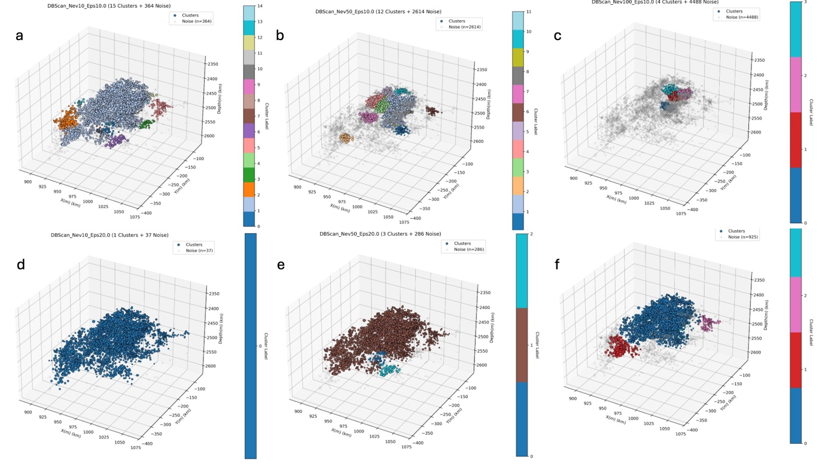
Figure R1: 3D plot of hypocenters color-coded as results of the application of DBSCAN algorithm using Euclidean distance as metrics for different values of Nmin (Nev) and Eps as reported in the title of each panel. Panels a) and d) refers to Nmin=10 events and Eps=10m, 20m. Panels b) and d) are Nmin = 50 and Eps =10m, 20m. Panels c) and f) are Nmin = 100 and Eps = 10m,20m. Crosses are non clustered earthquakes.

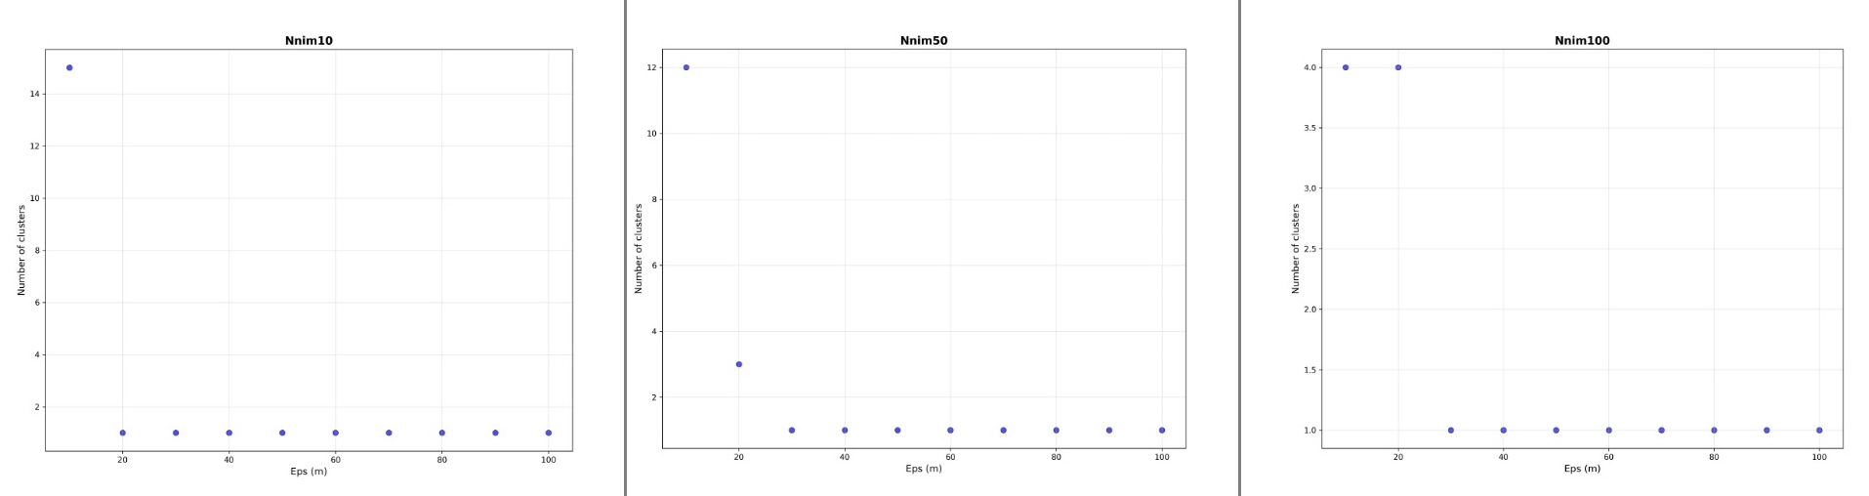
Figure R2: Number of identified clusters by DBSCAN vs Eps, radius and varying Nmin = 10 (left panel), Nmin = 50 (middle panel) and Nmin=100 (right panel). Eps ranges from 10m to 100m. As the search radius Eps becomes larger than 10m 20m the algorithm is able to identify only 1 big cluster.

Point 4: Fitting and interpretation of the three fracturing mechanisms models
Although the authors clearly state that their analysis does not lead to a unique conclusion, I remain cautious about the statement that the “However, the analysis of the time-distance evolution of the seismicity seems to indicate that the penny-shaped model is the best model during the injection phase.” in lines 505-506. There are two reasons:
The reported location uncertainty is approximately 40 m, while the maximum distance from the check-shot point is on the order of ~200 m. At this scale, location uncertainty could significantly affect model fitting results, especially given the very small difference in R² values between the diffusion model and the penny-shaped crack model.
Although the diffusion model performs poorly in fitting the seismicity back-front, this may also reflect the complexity of the hydraulic fracturing environment rather than an inherent inadequacy of the model. In addition, the seismicity clearly propagates in more than one direction. If directional dependence were explicitly accounted for, would the relative model performance change?
We have rephrased the sentences as suggested by the reviewer (Line 506-508 of the annotated manuscript): “However, the analysis of the time-distance evolution of the seismicity seems to indicate that the penny-shaped model is better to model all the injection phase, although the high pore pressure diffusion model fits better the first hour of injection phase and has a comparable R².”

In addition, we agree with the reviewer that the anisotropic hydraulic properties of the host rock may lead to varied propagation patterns. This is illustrated in the distance-time (R-T) plot in Figure R3, where earthquake propagation is plotted against the along-strike and down-dip distances derived from the PCA fit. The observed differences in migration rates and shapes could be explained by anisotropic permeability/diffusivity, an expanding tensile crack with an upward-elongated aspect ratio, or an aseismic fracture with a similar geometry. These possibilities highlight the inherent ambiguity in relying solely on seismicity features to distinguish between driving mechanisms. Furthermore, since all the analytical models we employed assume radial symmetry, we used radial distance as a first-order approximation to capture the primary migration trends of the seismicity.

We agree that the location errors and the overall distribution of seismicity are comparable. It should be noted that both the check-shot and all seismic events were located using the same algorithm and velocity model. Therefore, regardless of any absolute location offsets, the relative distances between hypocenters should be consistent. This internal consistency justifies the application of different models to the same dataset for comparative analysis. Adding a full statistical treatment of uncertainties in the location is beyond the scope of this study.

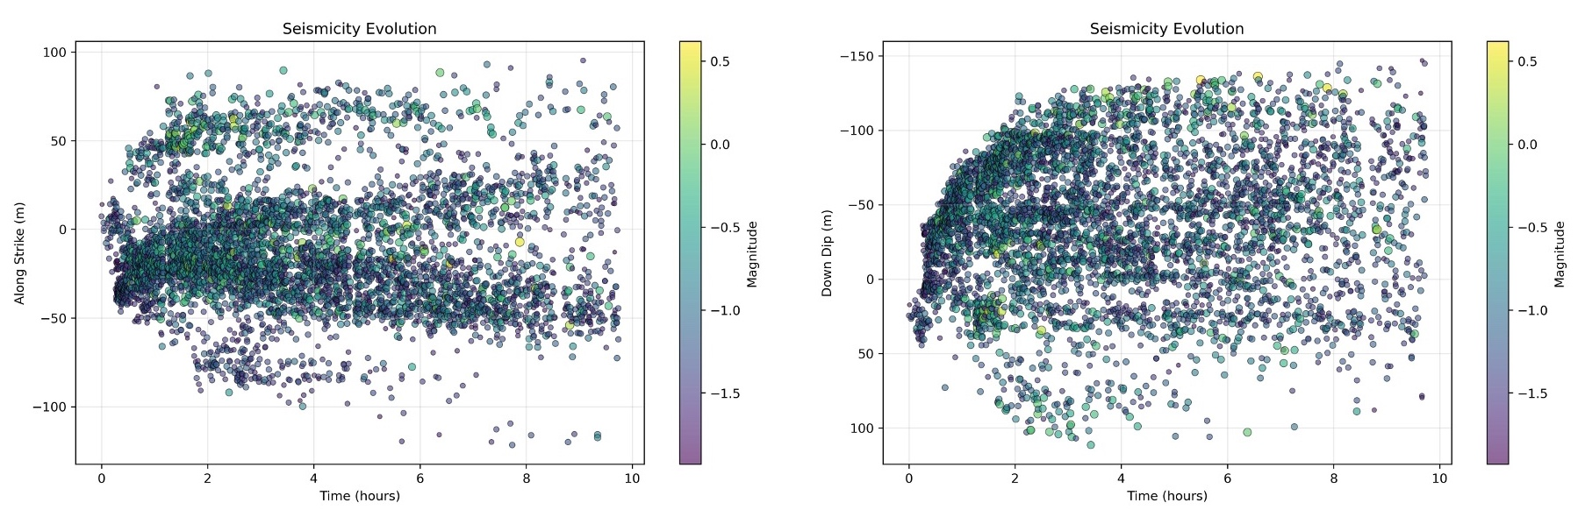
Figure R3: Along strike vs time (left panel) and downdip vs time (right panel). Downdip is positive downward highlighting a major upward propagation. Along strike is positive southward.

Additional comments

Point 5: Line 116: “which however,” should read “which, however,”.
Done.

Point 6: Line 126: “leveraging on” → remove “on”.
Done.

Point 7: Figure 1 is missing labels “a” and “b”. In addition, the well trajectory appears to extend from west to east in the left panel, but from north to south in the 3D view. The topographic projection in the right panel also appears inconsistent with the left panel.
Thanks for catching the missing labels. We have now added the labels “a)” and “b)”. Regarding the the well trajectories and topographic projection, this is an effect of the chosen prospective for the 3D view. We used pygmt to plot the 3D view and set a perspective = (210, 15) meaning an azimuth = 210° (clockwise from north) and elevation = 15° (very low above the horizontal plane). Thus the chosen 3-D perspective with azimuth 210° rotates the view clockwise 210° from north, making the well trajectory that goes west → east in the map view (top-down) to appear as north → south in the 3D view because of the rotated azimuth. Similarly, also the topography (which is in this case is represented as contour lines) can look twisted with respect to the map view. We have added a North arrow (rotated according to the perspective) also in the 3-D view to show the rotation.

Point 8: Line 247: Please clarify whether the events with Mw > –1.5 refer only to the manually reviewed 7,428 events, rather than the full catalog.
Correct. We have now clarified in the text that the events used for the PCA are indeed from the manually reviewed catalog.

Point 9: Lines 336–337: Grammatical issue. Should read: “The flow model is then used for t > tlearn to produce …”.
Corrected. Thanks for catching it!

Point 10: Line 361: “criteria” should be singular (“criterion”).
Done

Point 11: Figure 3 lacks a legend indicating how symbol size corresponds to magnitude. Same suggestion for Figure 4.
Done for both figures.

Point 12: Line 444: The statement that event magnitudes increase linearly during injection and peak at Mw ~0.6 is difficult to infer directly from Figure 3. I suggest plotting the maximum magnitude per time window to support this claim.
Thank you for the suggestion, we have added the figure below to the supplementary and referred to it in the main manuscript as Figure S7.
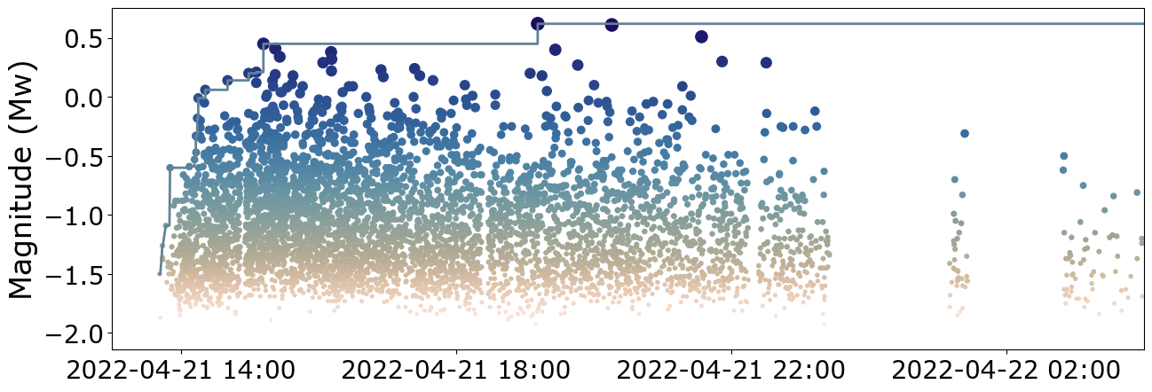
Figure S7: Timeline of the seismicity recorded during Stage 3 and evolution of the maximum observed magnitude (blue solid line).

Point 13: Figure 5: For clarity and aesthetics, shared legends should be plotted only once instead of being repeated in each panel. Why does the HM1D model predict zero uncertainty in the b-value? Also, please clarify what the two differently colored solid dots represent in the frequency–magnitude distributions.
Thank you for the suggestion. Figure 5 has now only one legend for the lines/dots, and each subplot also a legend for the estimated statistical values. The uncertainty for HM1D is now also included, the previous zero uncertainty was wrongly reported. The apparent different colored was caused by transparency in the figure (when multiple dots overlapped it looked darker). We have now fixed the transparency to avoid the effect and also corrected the discretization of the dots in the figure which was erroneously 0.01 while the models used 0.025.

Point 14: Line 584: It would be useful to show snapshot figures for the variable-Mc forecasts, possibly in the Supplementary Information.
We have added the suggested figure in the supplementary as Figure S8.

Point 15: Lines 717–718: Please report the computational time and hardware specifications used for each model. Also, “much faster the time …” should be “much faster than the time …”
The averaged time are now reported (Lines 718-722 of the annotated manuscript). We refer to Clasen-Repolles et al. (2025) for more details on the time performance of the various model.

REVIEWER #2

Review of the research article “The 2022 hydraulic stimulation at Utah FORGE: investigating fracturing mechanisms and testing forecasting approaches” by Lanza et al. (2020).
This study analyzes the seismicity associated with the Stage 3 hydraulic stimulation at the Utah FORGE site and evaluates several forecasting models, among which the HM1D model shows particularly promising performance. The manuscript is very well written, with a clearly defined objective, logical structure, well-explained methodology, and high completeness. My comments are minor given my limited expertise.

Comments

L162: I suggest noting that 16A(78)-32 is labeled as 16A-32 in Figure 1.
We have corrected the labels in the Figure as well as in the caption. We also noticed that 16B-32 should be 16B (78)-32. This has been also corrected.

L260: Should be “-pi/2”.
Done.

L272: n → v, m → μ; k_psc is not explained.
Corrected.

L434: Typo: “, however”.
Corrected.

L451: Please label the two lobes in Fig. 3b and 3c.
As the figure is already quite busy, we prefer not to overcrowd the figure with additional labels and refer to reader to the Movie.

L465: strike = N15°E.
Corrected.

L466: Does this refer to a dipping angle of 80°?
Corrected to 80ºonly.

L579: “observed rate final number of events” → “observed final number of events”.
Done. Thanks for catching this!

L580: Consider moving the sentence “Red color indicates a failed N-test”.
For clarity we prefer to retain the sentence.

L599: Does this refer to Figure 4?
Yes, we have corrected it.

L604: “A hydro-fracture generated …”.
Corrected, we have added commas for clarity

L719: “..” → “.”
Done.

Figures
Panel notation “(a), (b), …” or “a), b), …” should be used consistently across all figures.
All figures have now the same panel notation a), b), etc.

I suggest adding panel labels for Figure 1.
Done.

Consider plotting along-strike distance instead of northing distance.
We prefer to use cartesian coordinates while showing the data and PCA fit. However, given that the strike angle is 15º the displayed results do not change much.

I suggest adding a magnitude-size legend for Figure 3.
Done, also for Figure 4.

Please double-check the fault plane inconsistency in Figures 3b and 3c.
We do not understand what the reviewer refer to inconsistency in the 3D and map view plot of the fitted plane in Fig. 3b) and c) respectively.

As the timing and location of the largest event are important, I recommend labeling it in the figures.
We added a star to show the largest event in Figure 3a.

I suggest using relative time instead of absolute time in Figures 3 and 5
While we used relative time in Figure 4, we prefer to maintain absolute time in Figures 3 and 5 to provide the reader with a clearer context regarding the timing of the injection operations.

References:
- Clauset, A., Shalizi, C.R. & Newman, M.E., 2009. Power-law distributions in empirical data. SIAM review, 51(4), pp.661-703.
- Mizrahi, L., Nandan, S. & Wiemer, S., 2021. The effect of declustering on the size distribution of mainshocks. Seismological Research Letters, 92(4), pp.2333-2342.
- Ritz, V. A., Rinaldi, A. P., & Wiemer, S., 2022. Transient evolution of the relative size distribution of earthquakes as a risk indicator for induced seismicity. Communications Earth & Environment, 3. https://doi.org/10.1038/s43247-022-00581-9
- van der Elst, N. J., 2021. B-Positive: A Robust Estimator of Aftershock Magnitude Distribution in Transiently Incomplete Catalogs. Journal of Geophysical Research: Solid Earth, 126(2), 1–19. https://doi.org/10.1029/2020JB021027
- Wiemer, S. & Wyss, M., 2000. Minimum magnitude of completeness in earthquake catalogs: Examples from Alaska, the western United States, and Japan. Bulletin of the Seismological Society of America, 90(4), pp.859-869.
- Woessner, J. & Wiemer, S., 2005. Assessing the quality of earthquake catalogues: Estimating the magnitude of completeness and its uncertainty. Bulletin of the Seismological Society of America, 95(2), pp.684-698.

