Seismica
Supplementary Information for
Source Model and Characteristics of the 27 July 2022 M_{W} 7.0 Northwestern Luzon Earthquake, Philippines
Jeremy M. Rimando^{1,2}, Amy L. Williamson³, Raul Benjamin C. Mendoza^{1,4}, Tiegan E. Hobbs^{1,4,5}
¹Geological Survey of Canada – Pacific, Natural Resources Canada, 605 Robson St Suite 1500, Vancouver, BC V6B 5J3, Canada
²School of Earth, Environment & Society, McMaster University, 1280 Main Street West, Hamilton, ON, L8S 4K1, Canada
³Berkeley Seismological Laboratory, University of California Berkeley, 307 McCone Hall #4760, Berkeley, CA 94720-4760, USA
⁴Department of Earth, Ocean and Atmospheric Sciences, University of British Columbia, 2207 Main Mall #2020, Vancouver, BC, V6T 1Z4, Canada
⁵School of Earth and Ocean Sciences, University of Victoria, Bob Wright Centre A405, University of Victoria, Victoria BC V8W 2Y2, Canada

Contents of this file
Figures S1 to S19
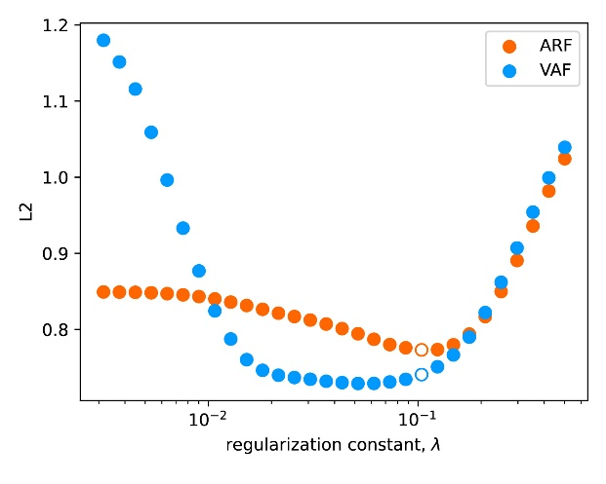
Figure S1. Smoothing vs. misfit curves for the Abra River Fault (orange) and Vigan-Aggao Fault (blue) for a range of regularization constants. The preferred model for both faults is generally at the minimum of the curves and represents a point between over-fitting the model and over-smoothing; that point for both models is shown with a hollow icon.

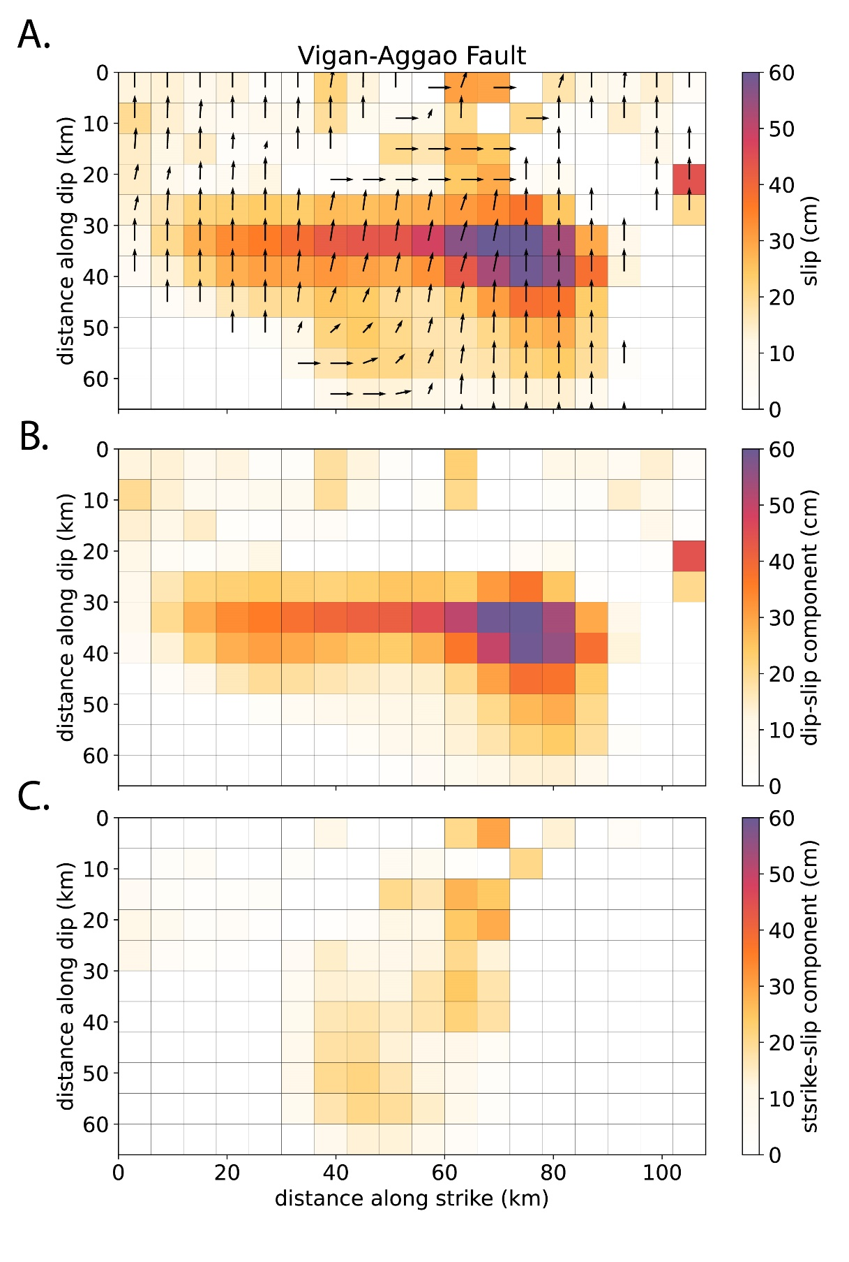
Figure S2. Panel A shows the slip distribution for our preferred model using an interpretation of the Vigan-Aggao fault source geometry. The rake angle of the slip is plotted as black arrows. Slip is broken down by dip-slip (positive slip is thrust) and strike-slip (positive slip is left-lateral) components in panels B and C, respectively.

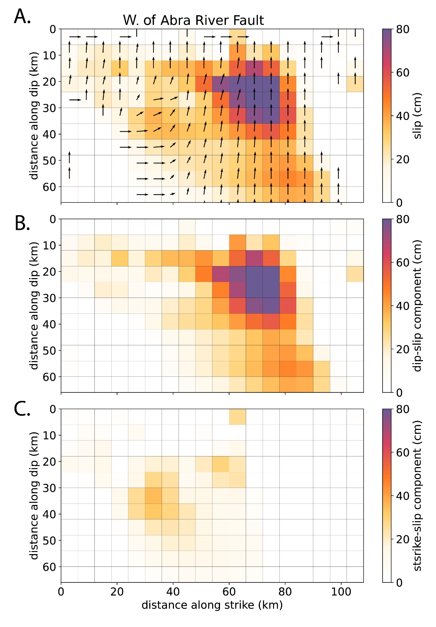
Figure S3. Panel A shows the slip distribution for our preferred model using an interpretation of the W. of Abra River Fault source geometry. The rake angle of the slip is plotted as black arrows. Slip is broken down by dip-slip (positive slip is thrust) and strike-slip (positive slip is left-lateral) components in panels B and C, respectively.

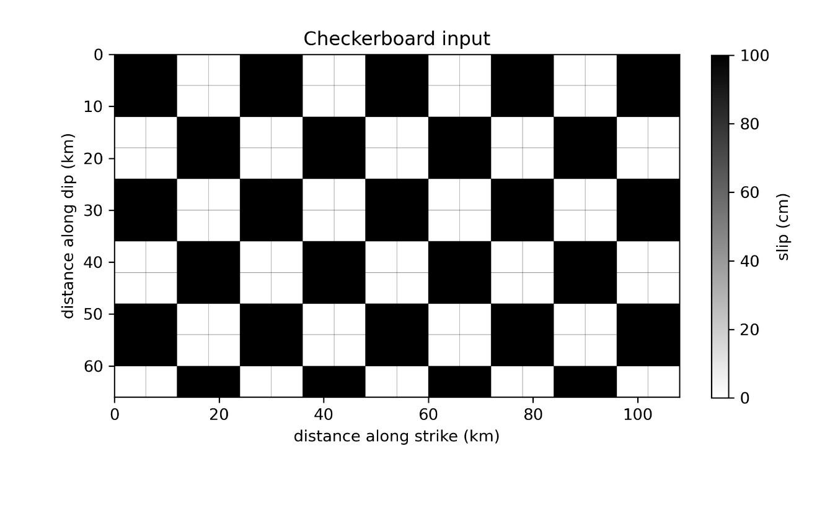
Figure S4. Input checkerboard solution for both faults. Both the VAF and the W. of ARF faults have the same number of fault patches along strike and dip. The orientation in relation to the LOS data varies between the two faults.

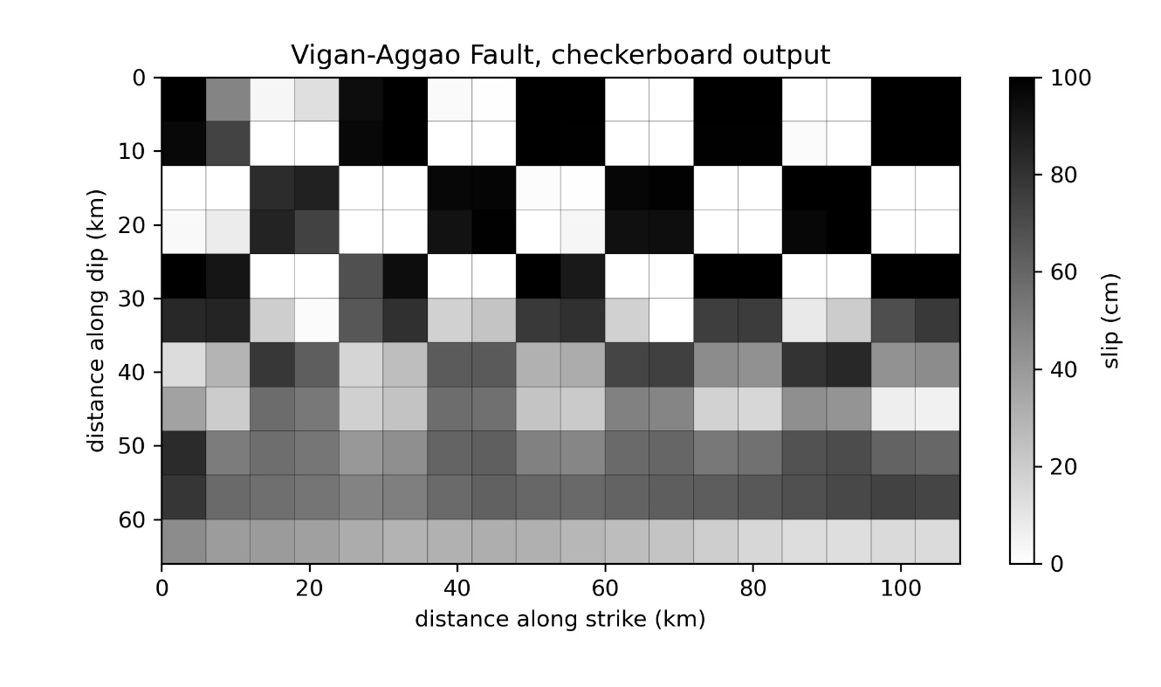
Figure S5. Checkerboard solution for the Vigan-Aggao fault source geometry, with dip slip checkers.

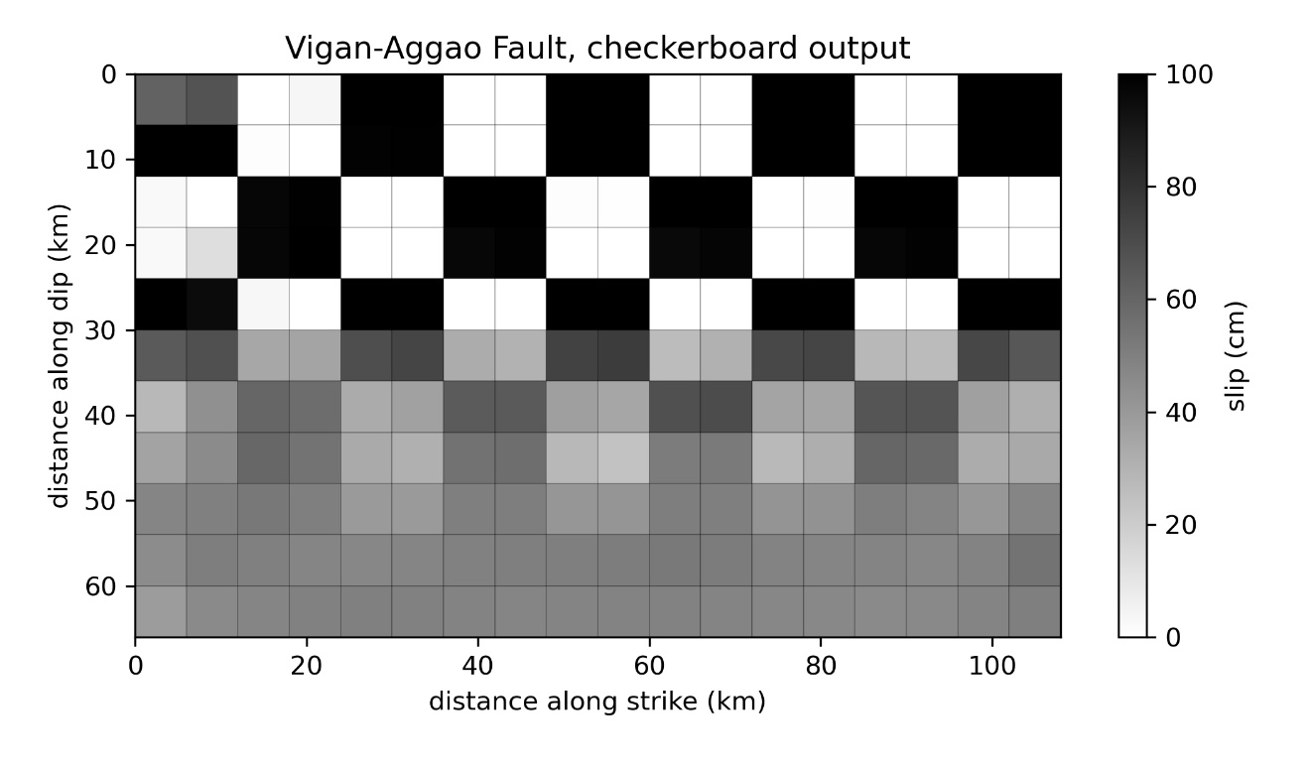
Figure S6. Checkerboard solution for the Vigan-Aggao fault source geometry, with strike-slip checkers. Strong smearing in the checkers occurs with greater depth due to limited resolution.

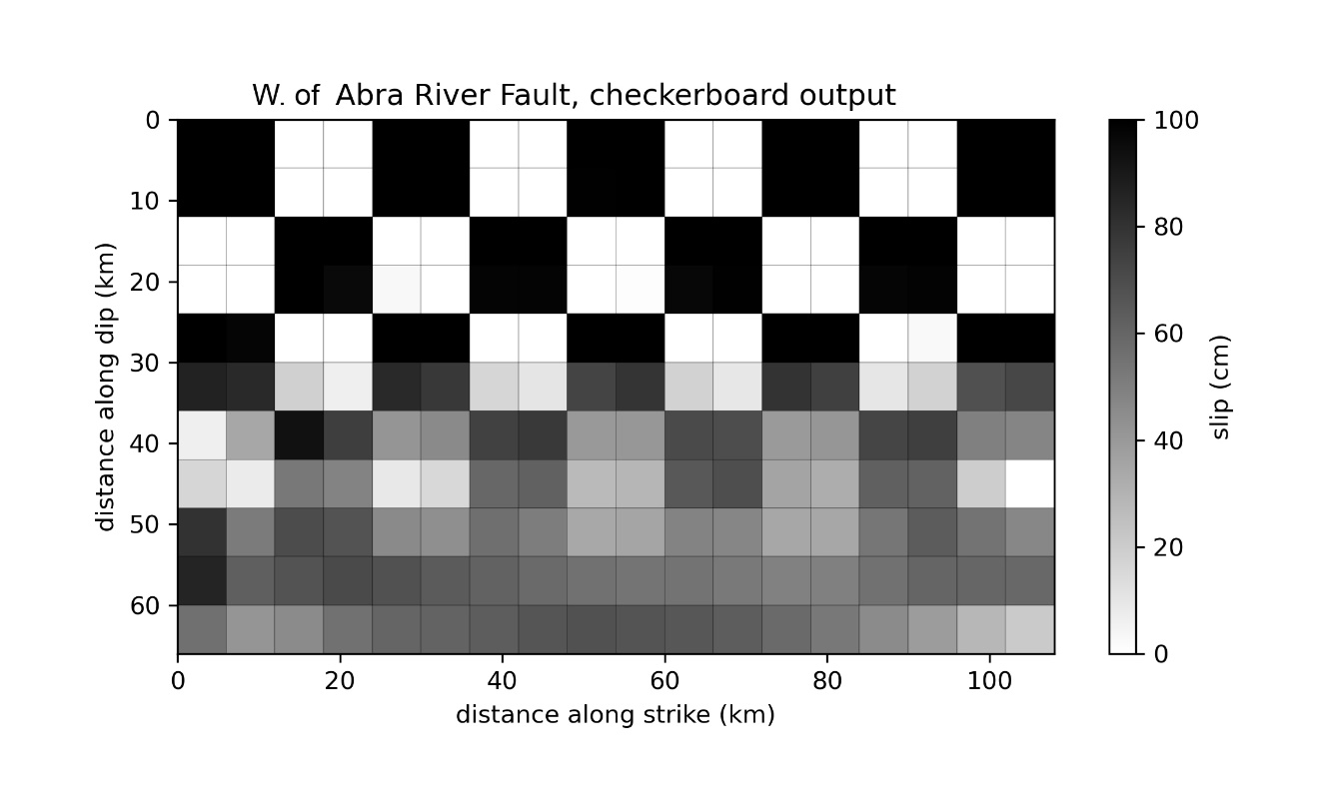
Figure S7. Checkerboard solution for the W. of Abra River Fault source geometry, with dip slip checkers.

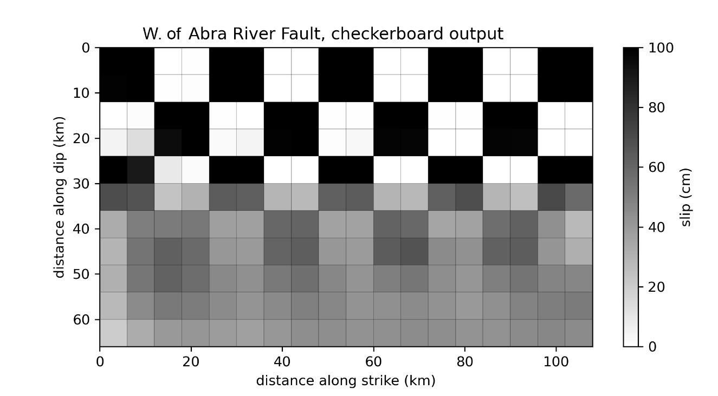
Figure S8. Checkerboard solution for the W. of Abra River Fault source geometry, with strike-slip checkers.

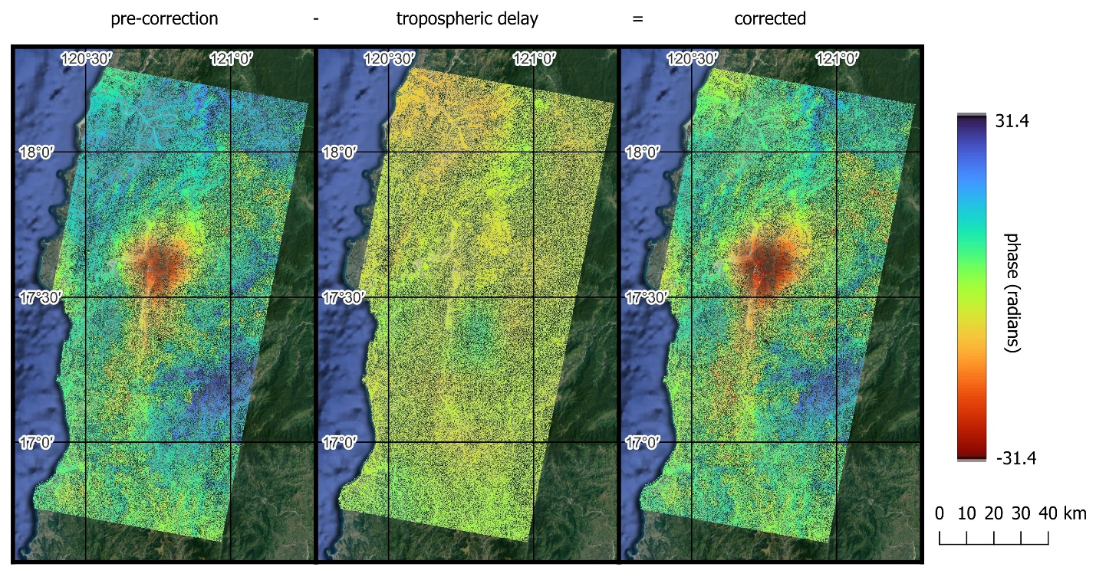Figure S9. Unwrapped phase diagrams illustrating the effects of tropospheric delay. The first panel shows the data prior to correction. The last panel shows the data after applying tropospheric correction using the General Atmospheric Correction Online Service (Yu et al., 152 2017; Yu et al., 2018a; Yu et al., 2018b). The middle panel shows the difference between the two and represents the tropospheric delay. The delay mean is -3.48 radians and the standard deviation is 2.51 radians.

