Paleoseismology of the Buffalo Valley, Buena Vista, and southern Shoshone faults, central Basin and Range, Nevada, USA

Rich D. Koehler¹, Mark W. Stirling², and Brad Sion³

¹Nevada Bureau of Mines and Geology, University of Nevada, Reno, Reno, NV, USA. rkoehler@unr.edu
²Department of Geology, University of Otago, Dunedin, New Zealand. mark.stirling@otago.ac.nz
³ Division of Earth and Ecosystem Sciences, Desert Research Institute, Reno, NV, USA. brad.Sion@dri.edu
Table of Contents

1 Soil descriptions for pits BVSP-1 and BVSP-2 along the Buffalo Valley fault

2 Geochronologic data report (methodology and results) for ³⁶Cl depth profiles from pits BVSP-1 and BVSP-2 and 10Be surface exposure age analyses along the Buffalo Valley fault

3 Summary of age modelling results for soil pits BVSP-1 and BVSP-2
4 Photographs and GPS coordinates for boulders sampled for ¹⁰Be cosmogenic exposure dating along the Buffalo Valley, Buena Vista, and southern Shoshone faults.
5 CRONUS ¹⁰Be cosmogenic exposure ages for boulders from faulted surfaces on the Buffalo Valley, Buena Vista, and southern Shoshone faults.
6 Be production rate plots for ¹⁰Be surface exposure simples
7 Data tables for inputs to the CRONUScalc Matlab program for geochronologic samples from soil pits BVSP-1 and BVSP-2. Geochemical data analyzed by ALS, Reno, Nevada under certificate #RE24107371.

1 Soil descriptions for pits BVSP-1 and BVSP-2 along the Buffalo Valley fault

Soil description for soil pit BVSP-1 (GPS coordinates 40.500615°, -117.427569°), exhibiting stage II+ to III carbonate development.
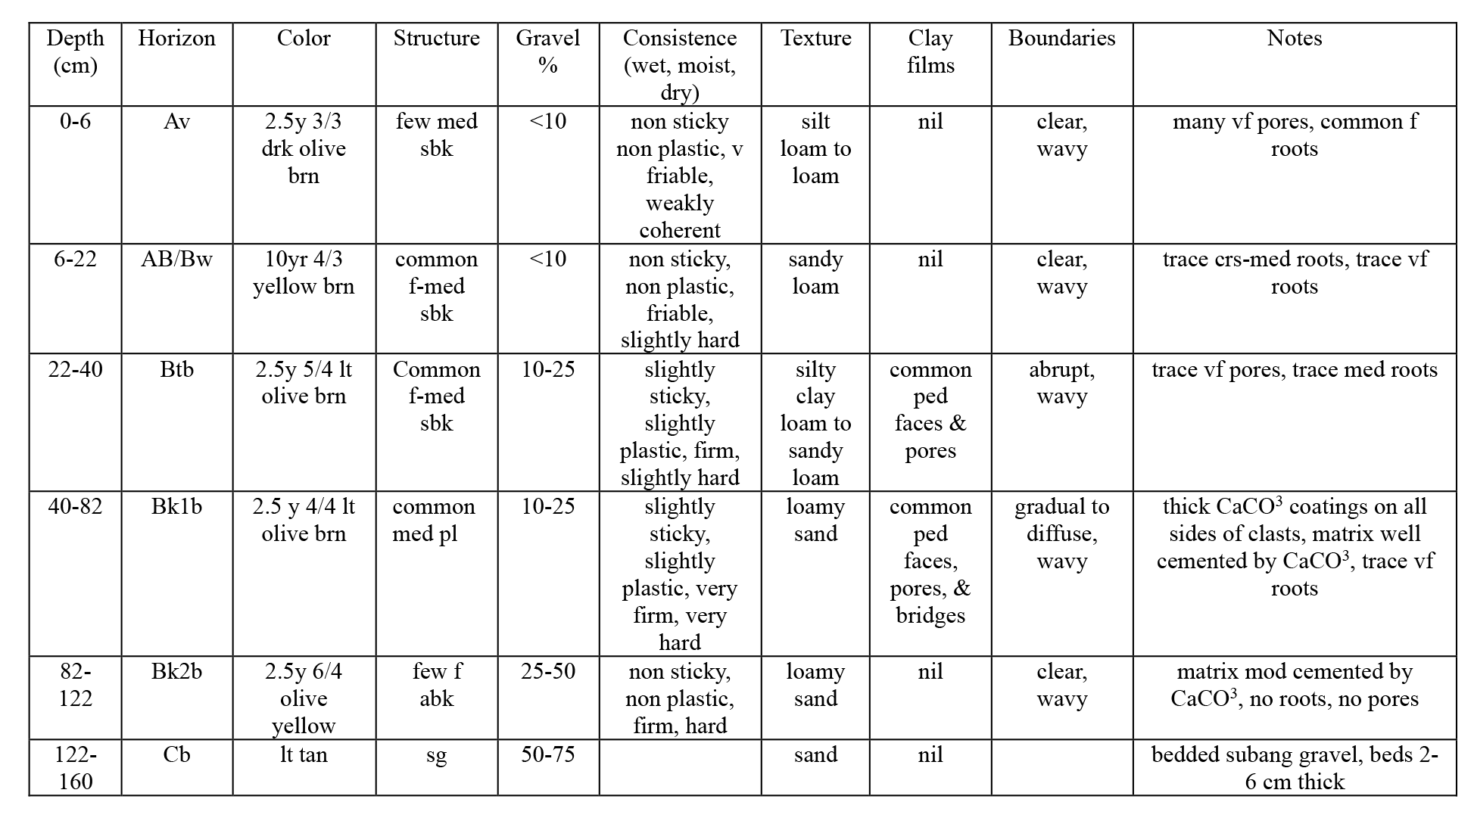

Soil description for soil pit BVSP-2 (GPS coordinates 40.458022°, -117.438129°), exhibiting stage II+ carbonate development.
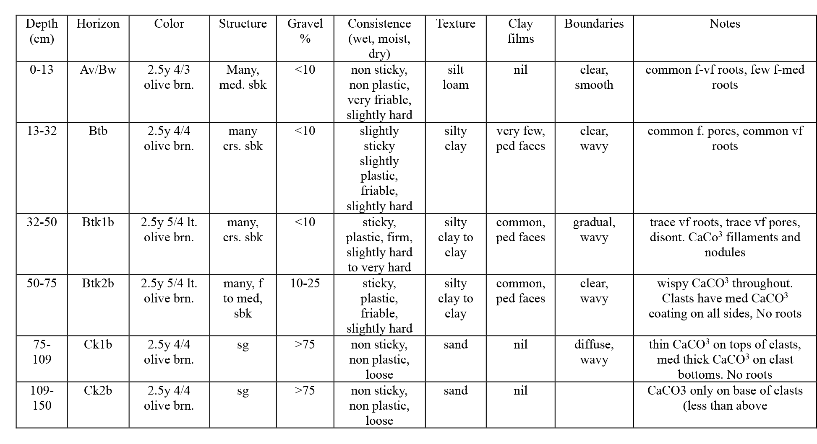

2 Geochronologic data report (methodology and results) for ³⁶Cl depth profiles from pits BVSP-1 and BVSP-2 and 10Be surface exposure age analyses along the Buffalo Valley fault
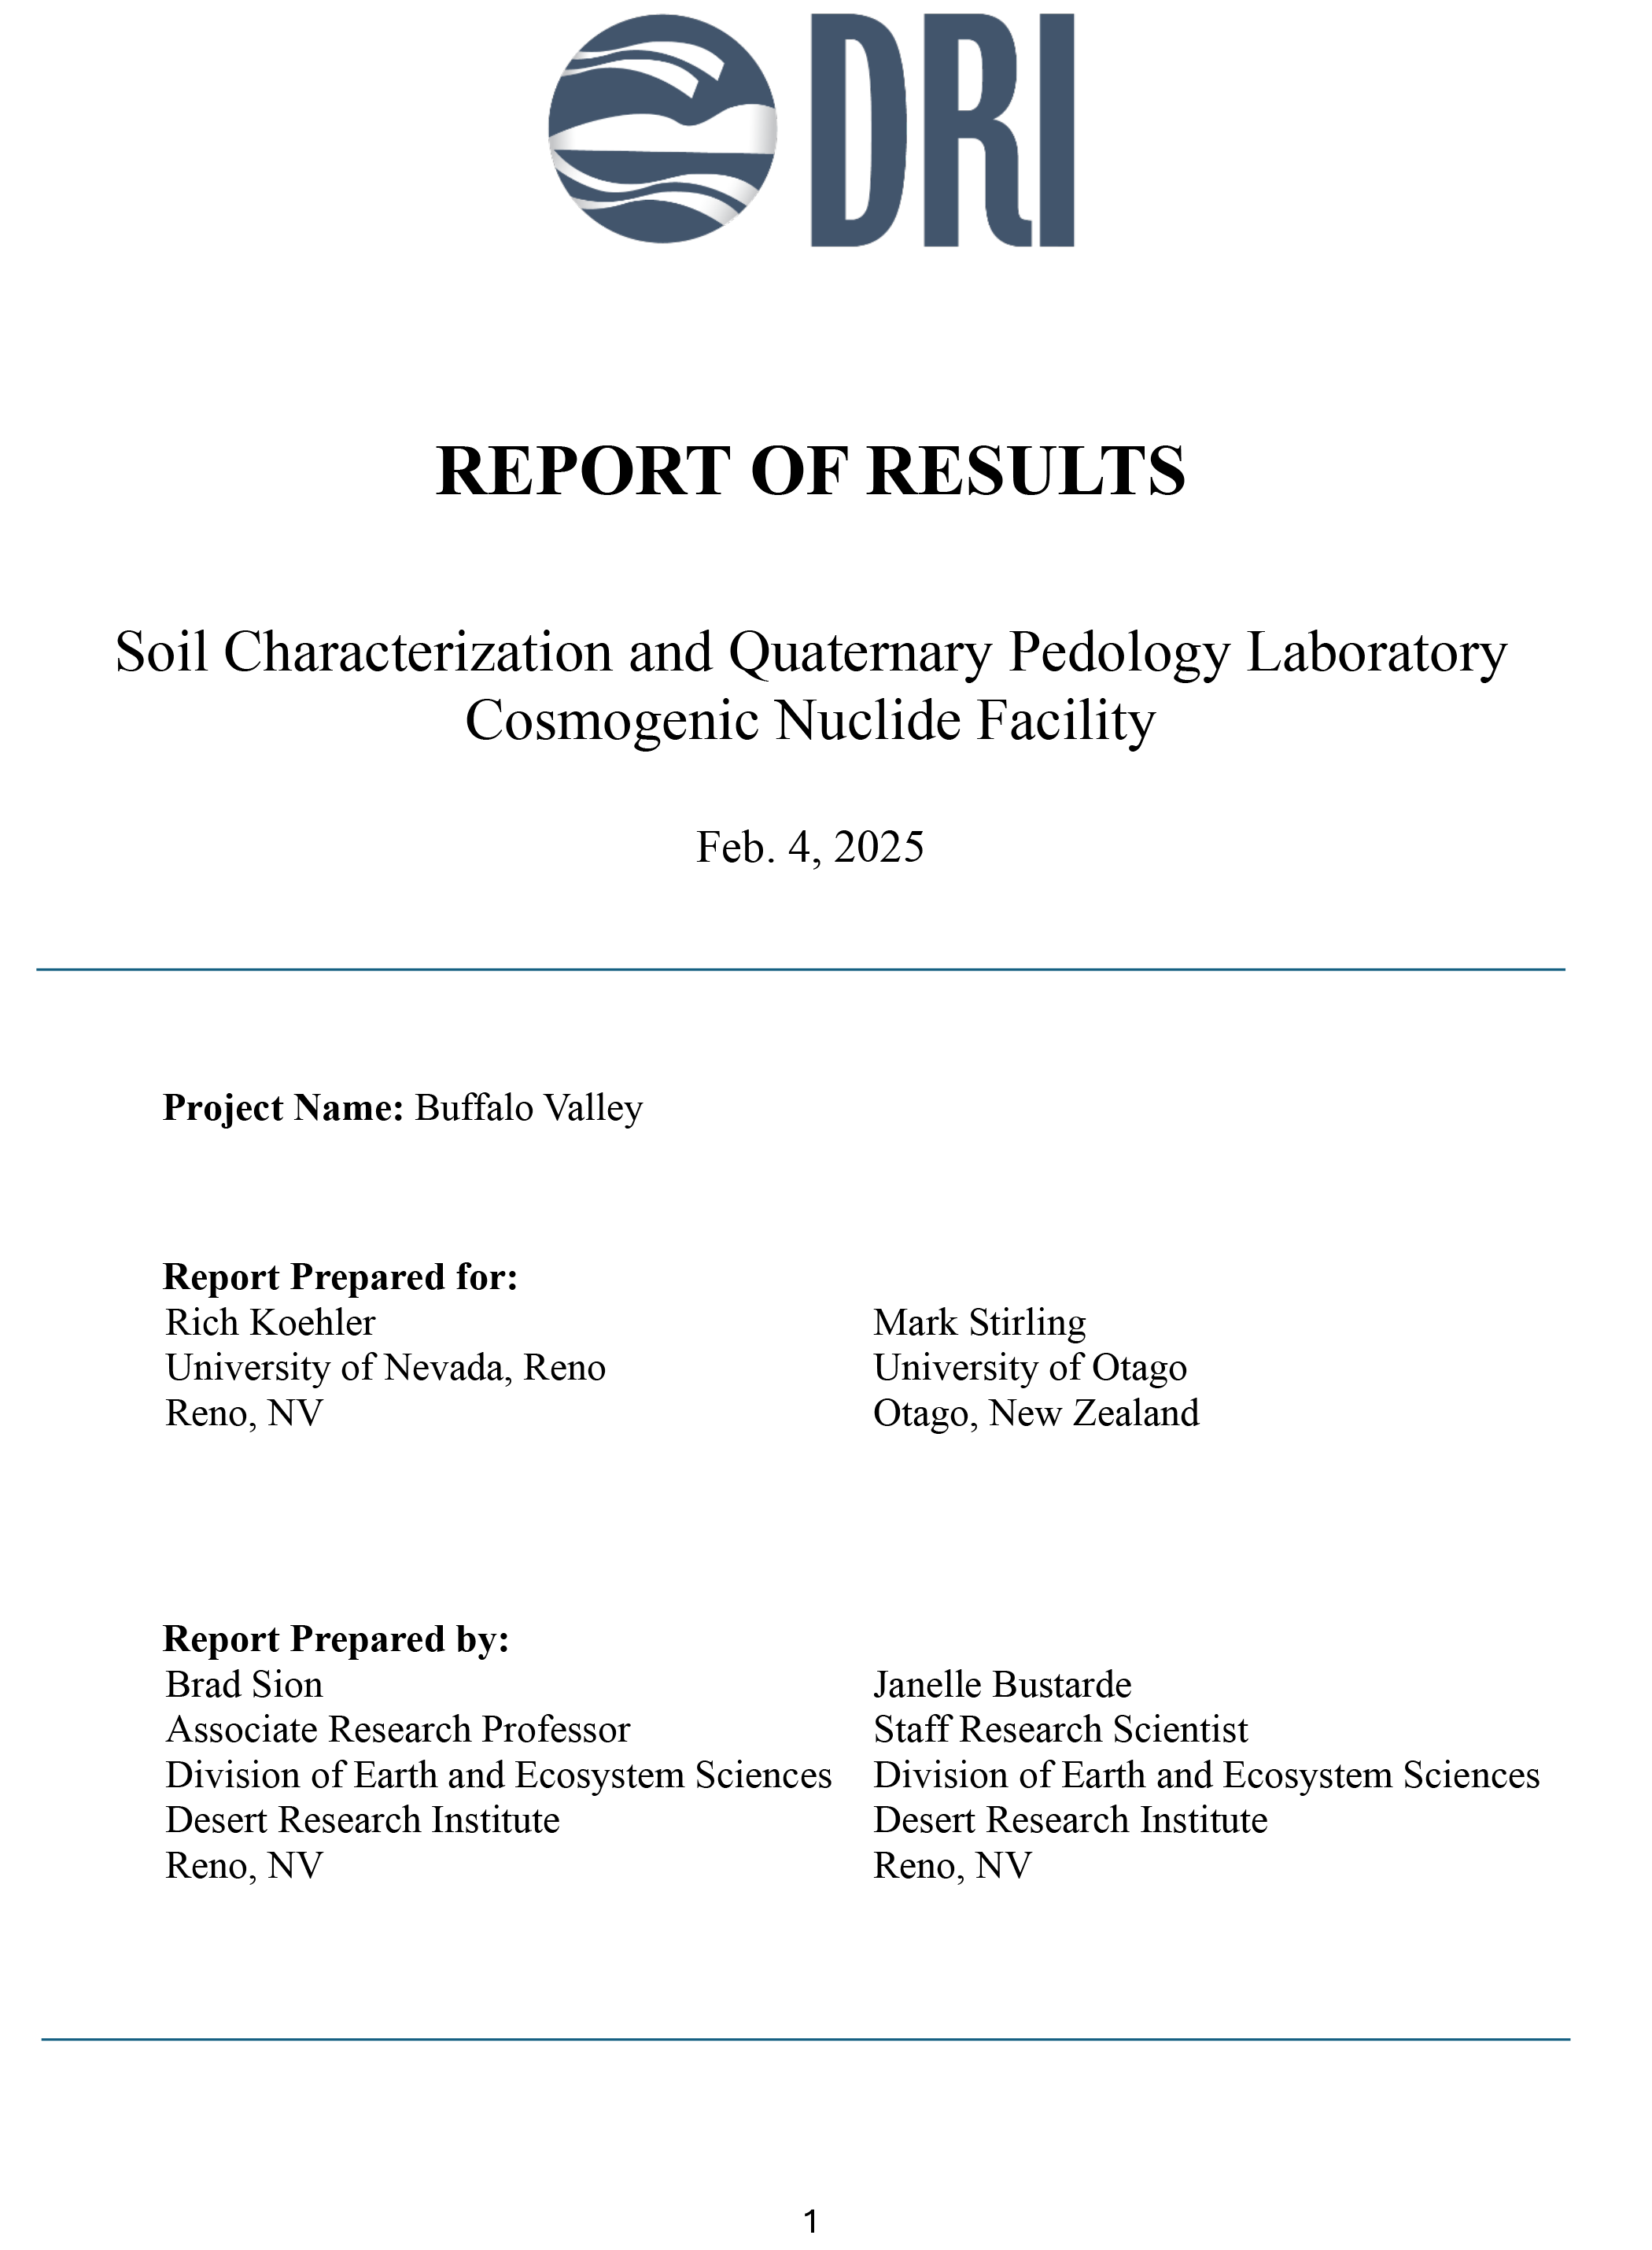
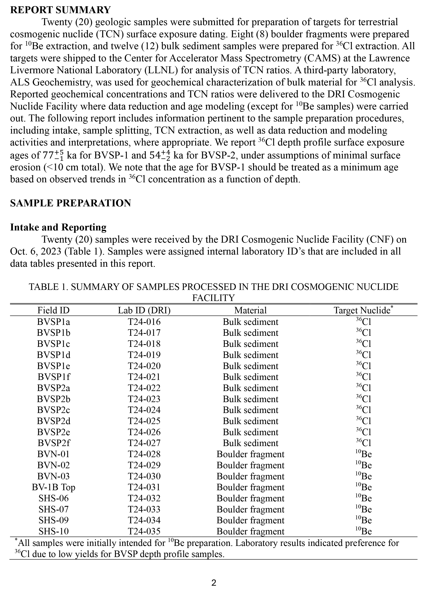
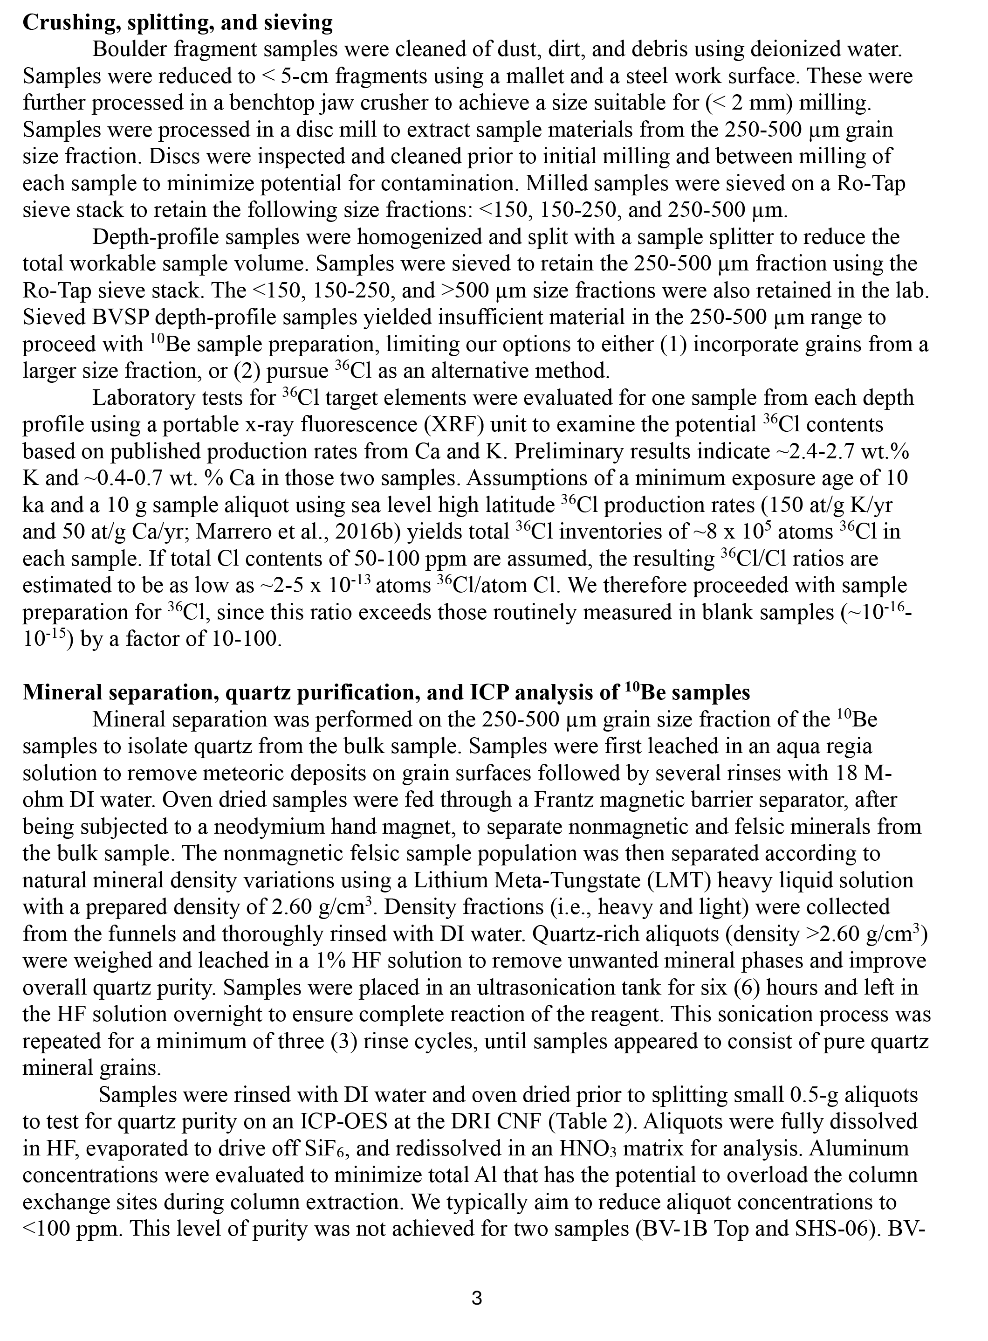
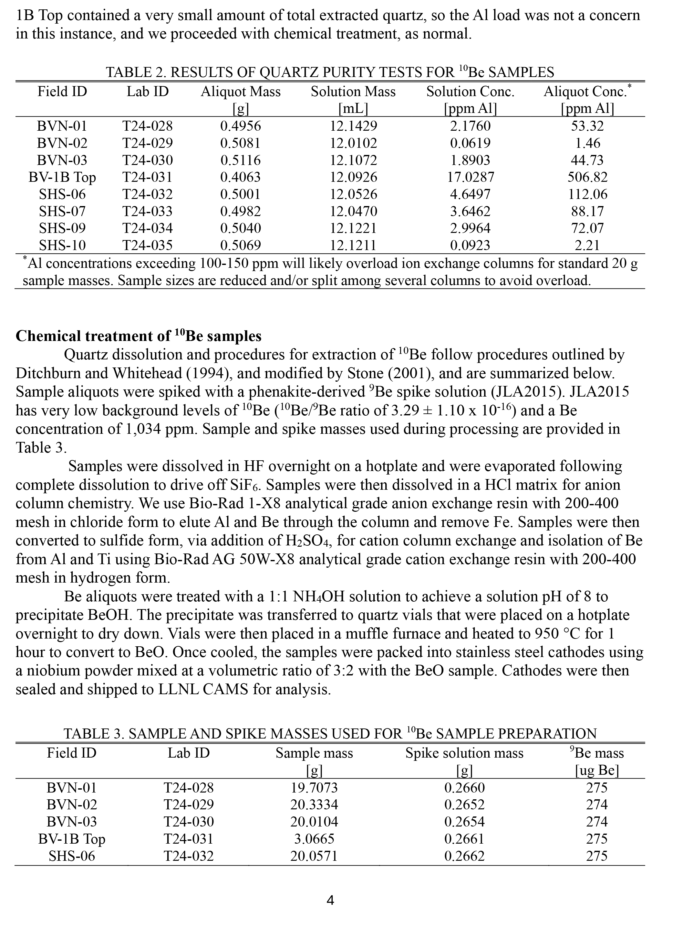
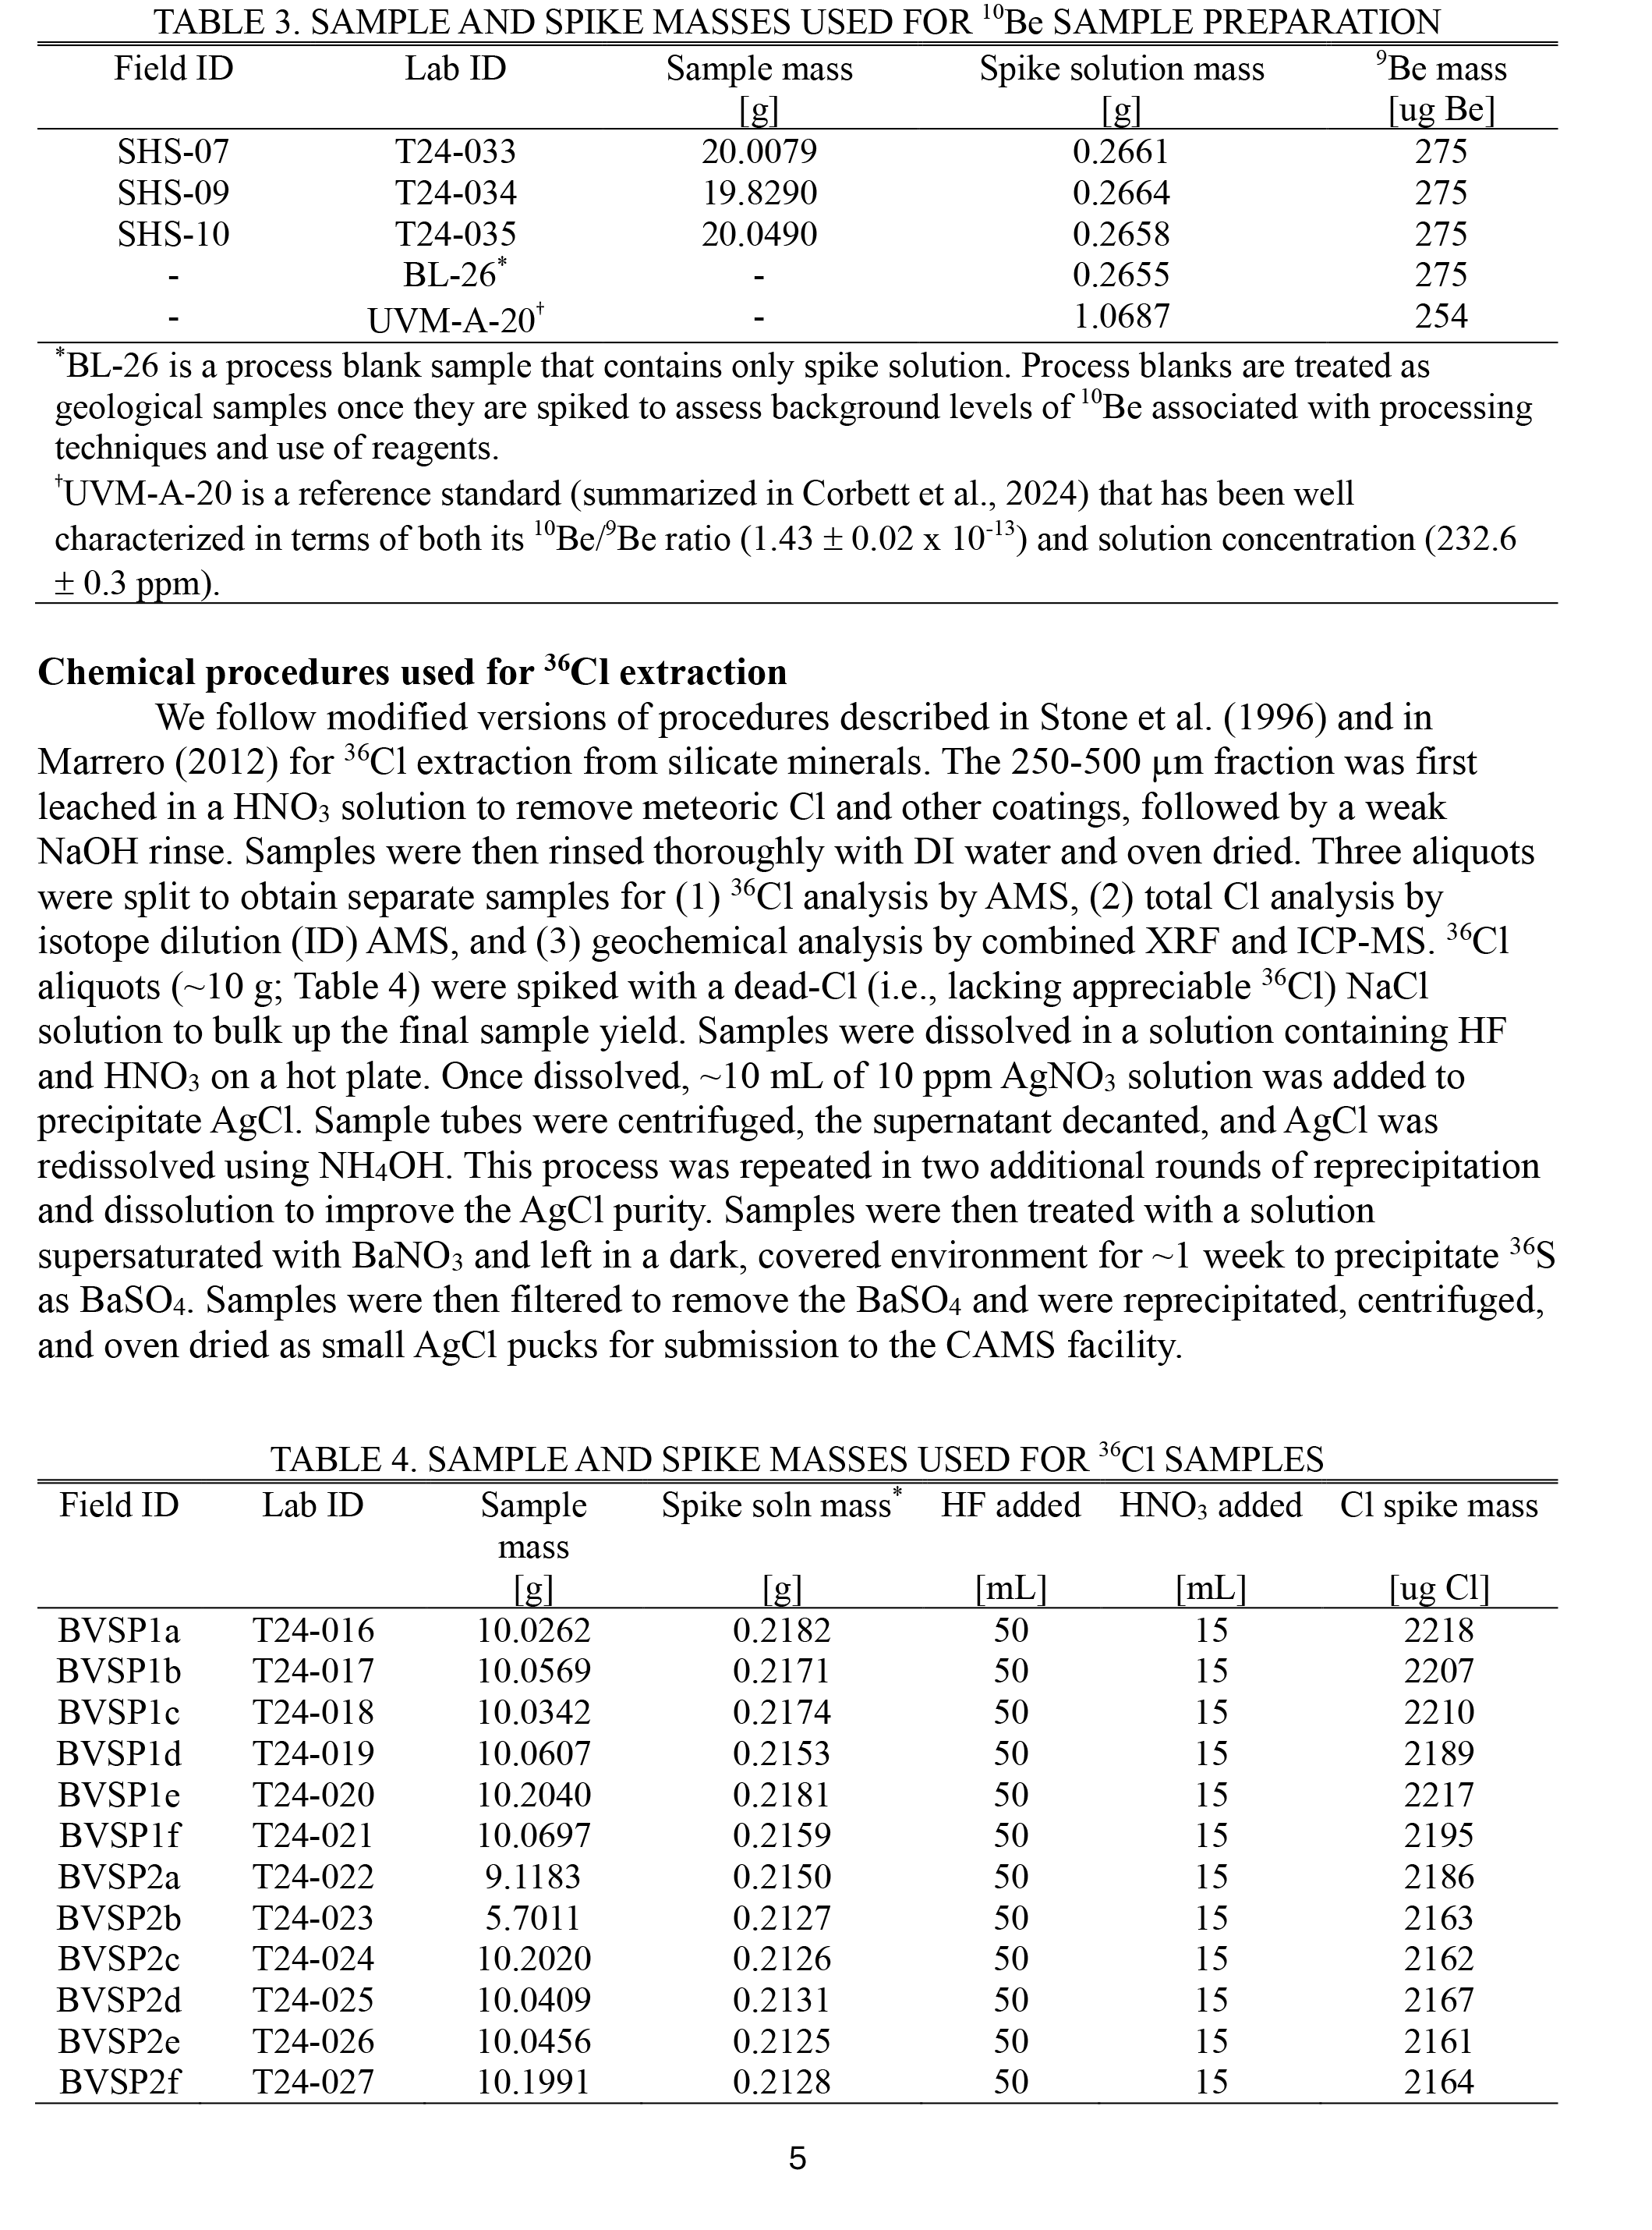
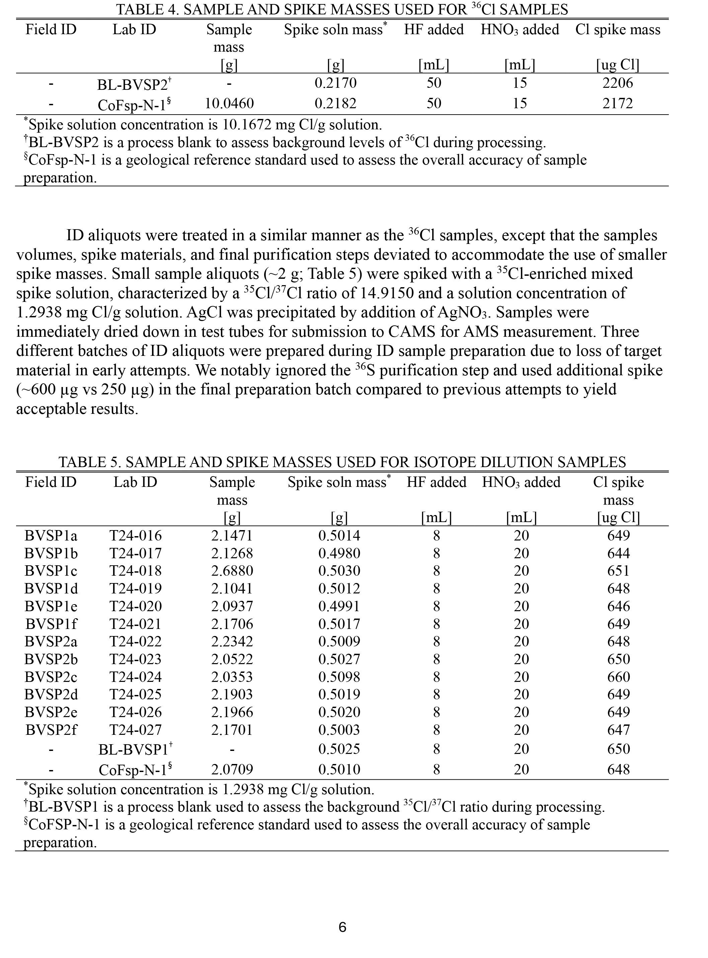
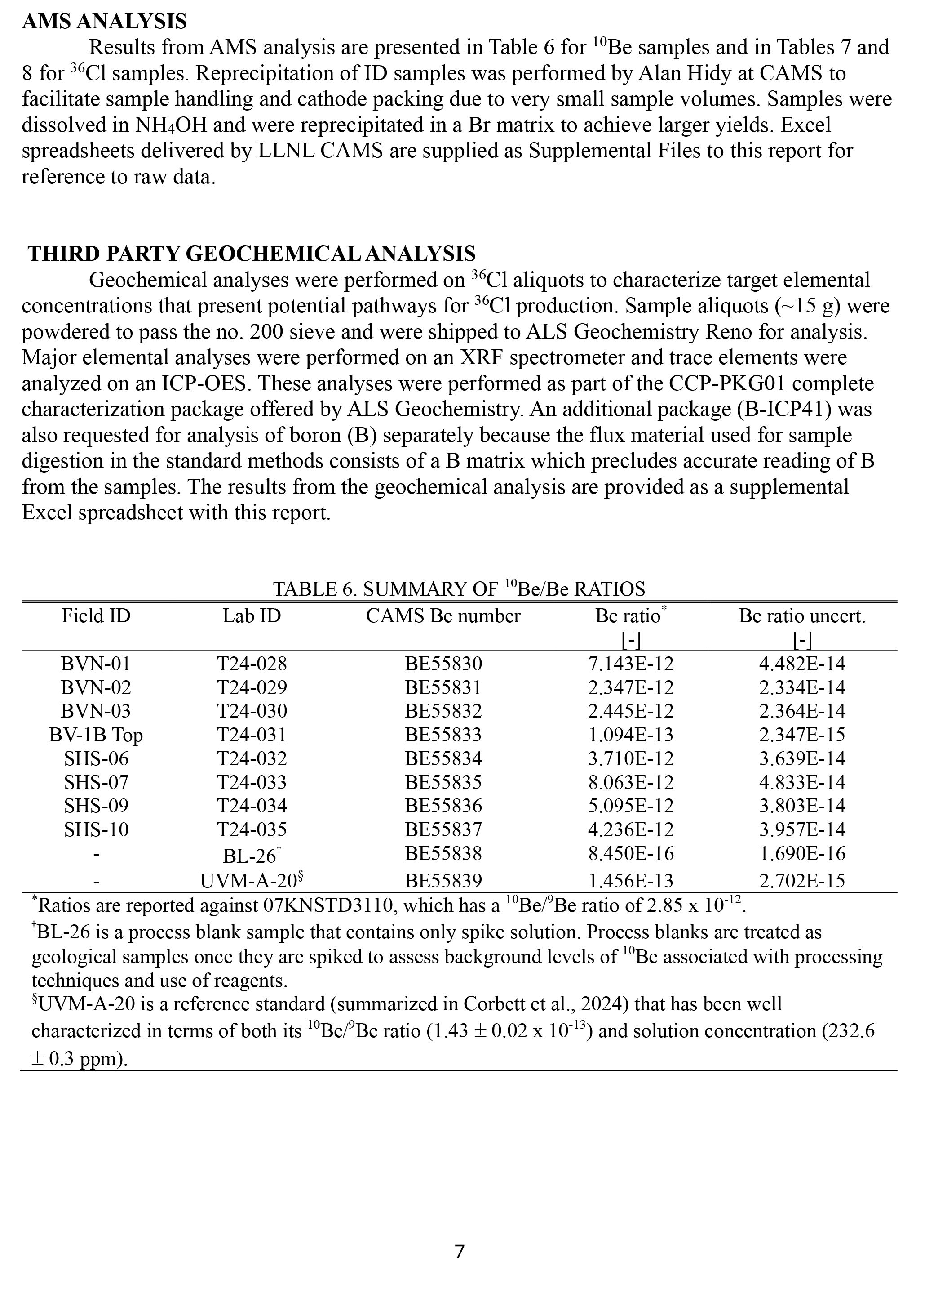
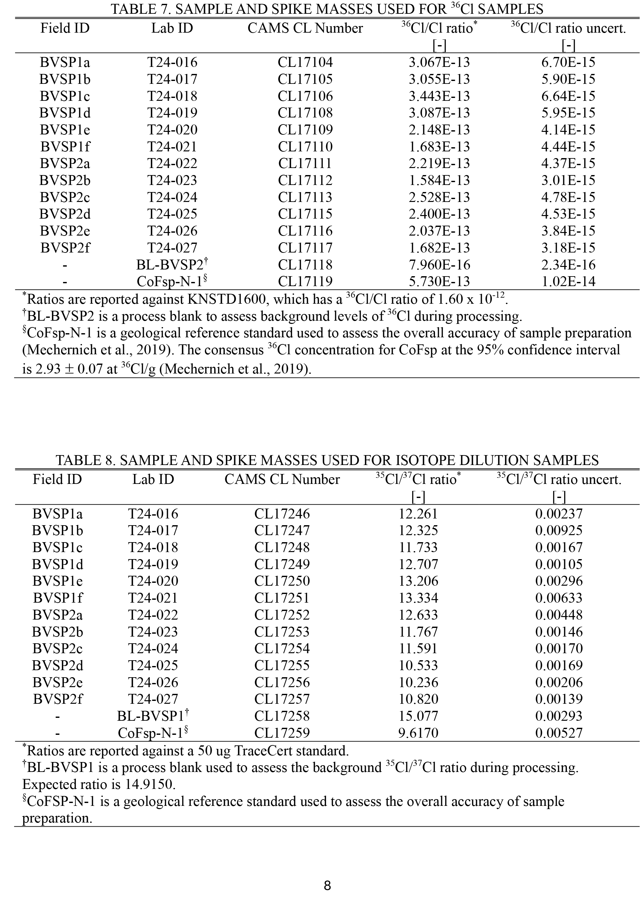
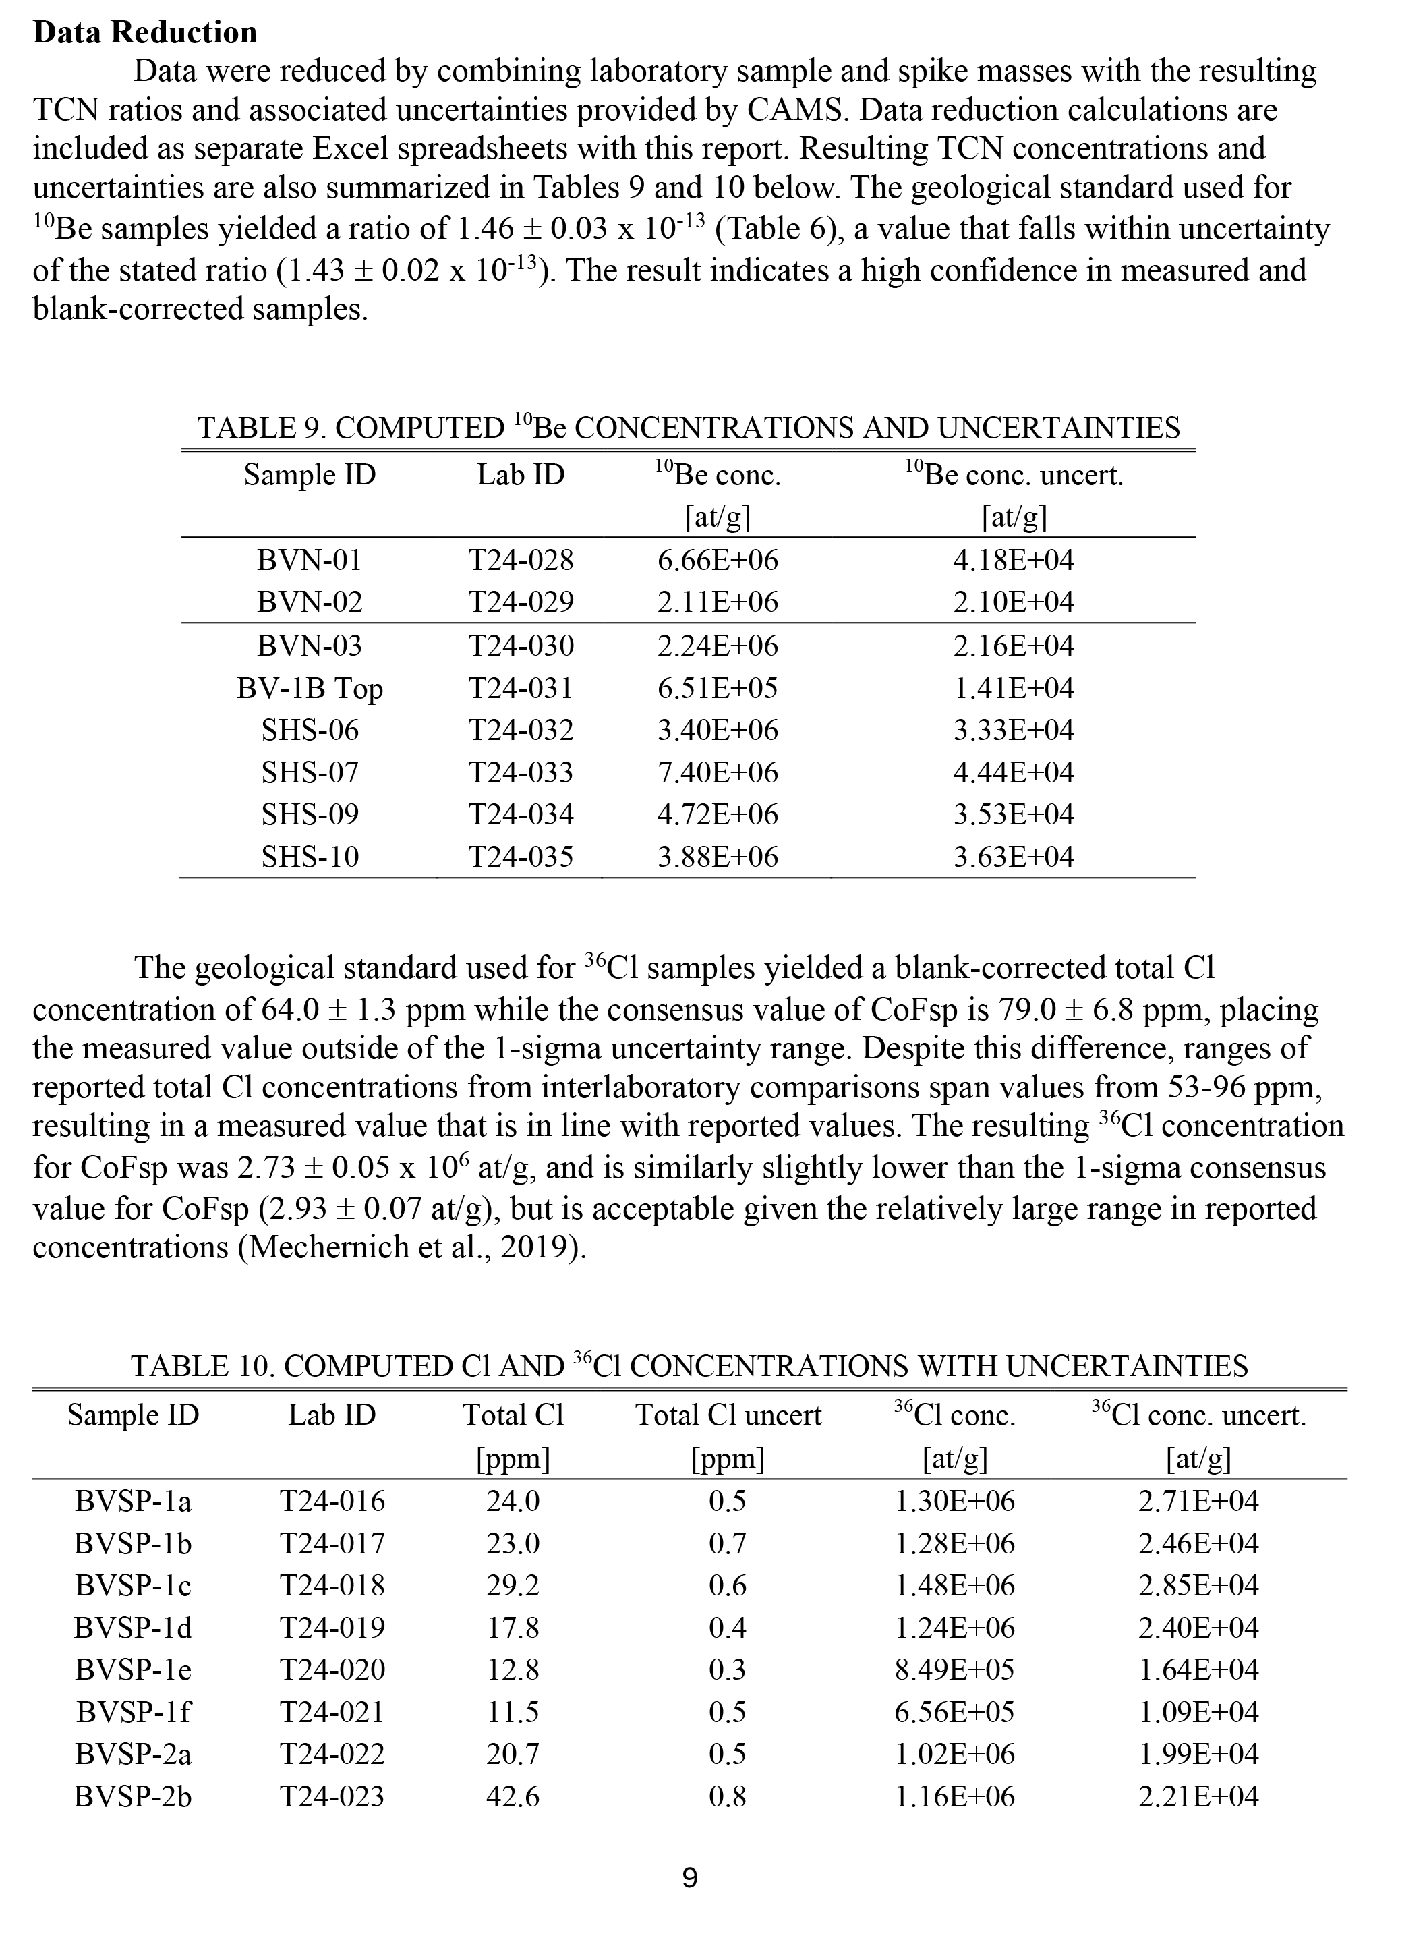
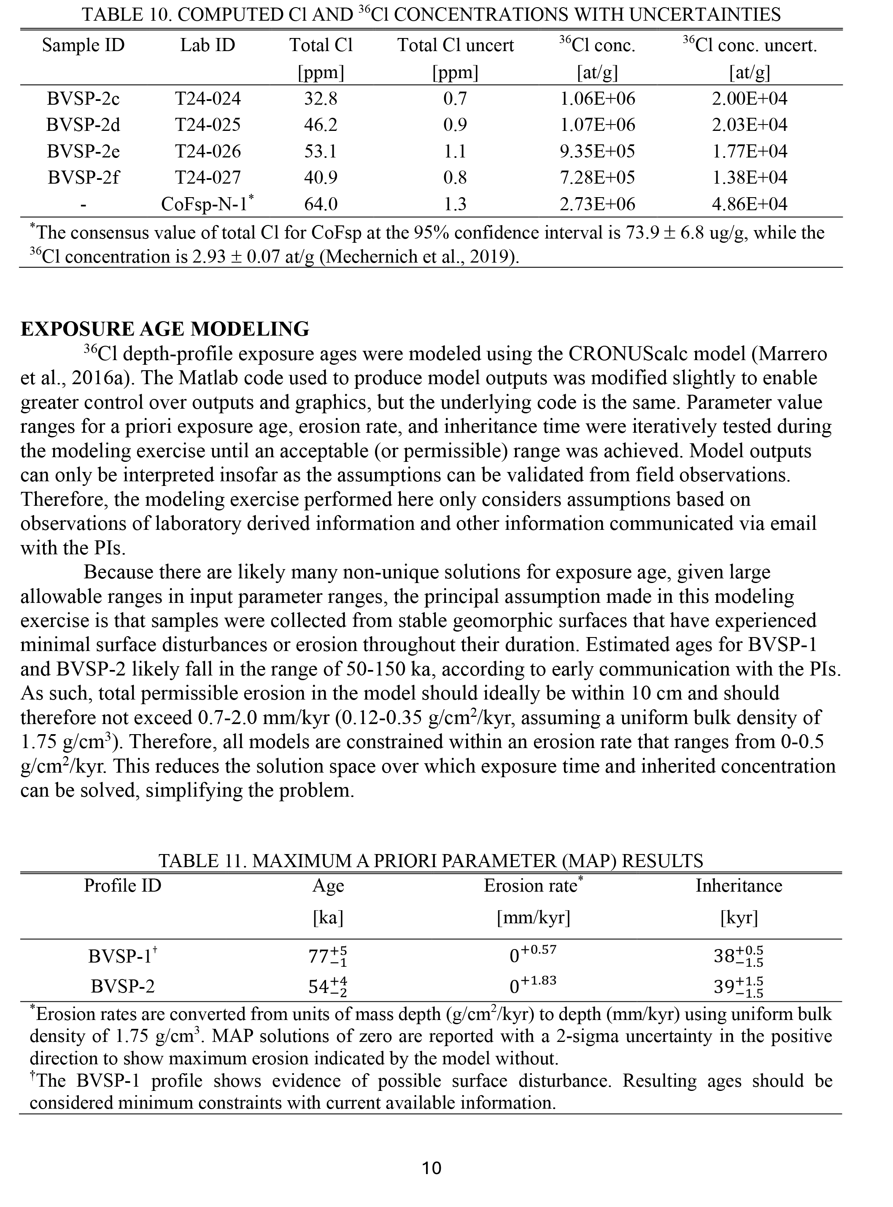
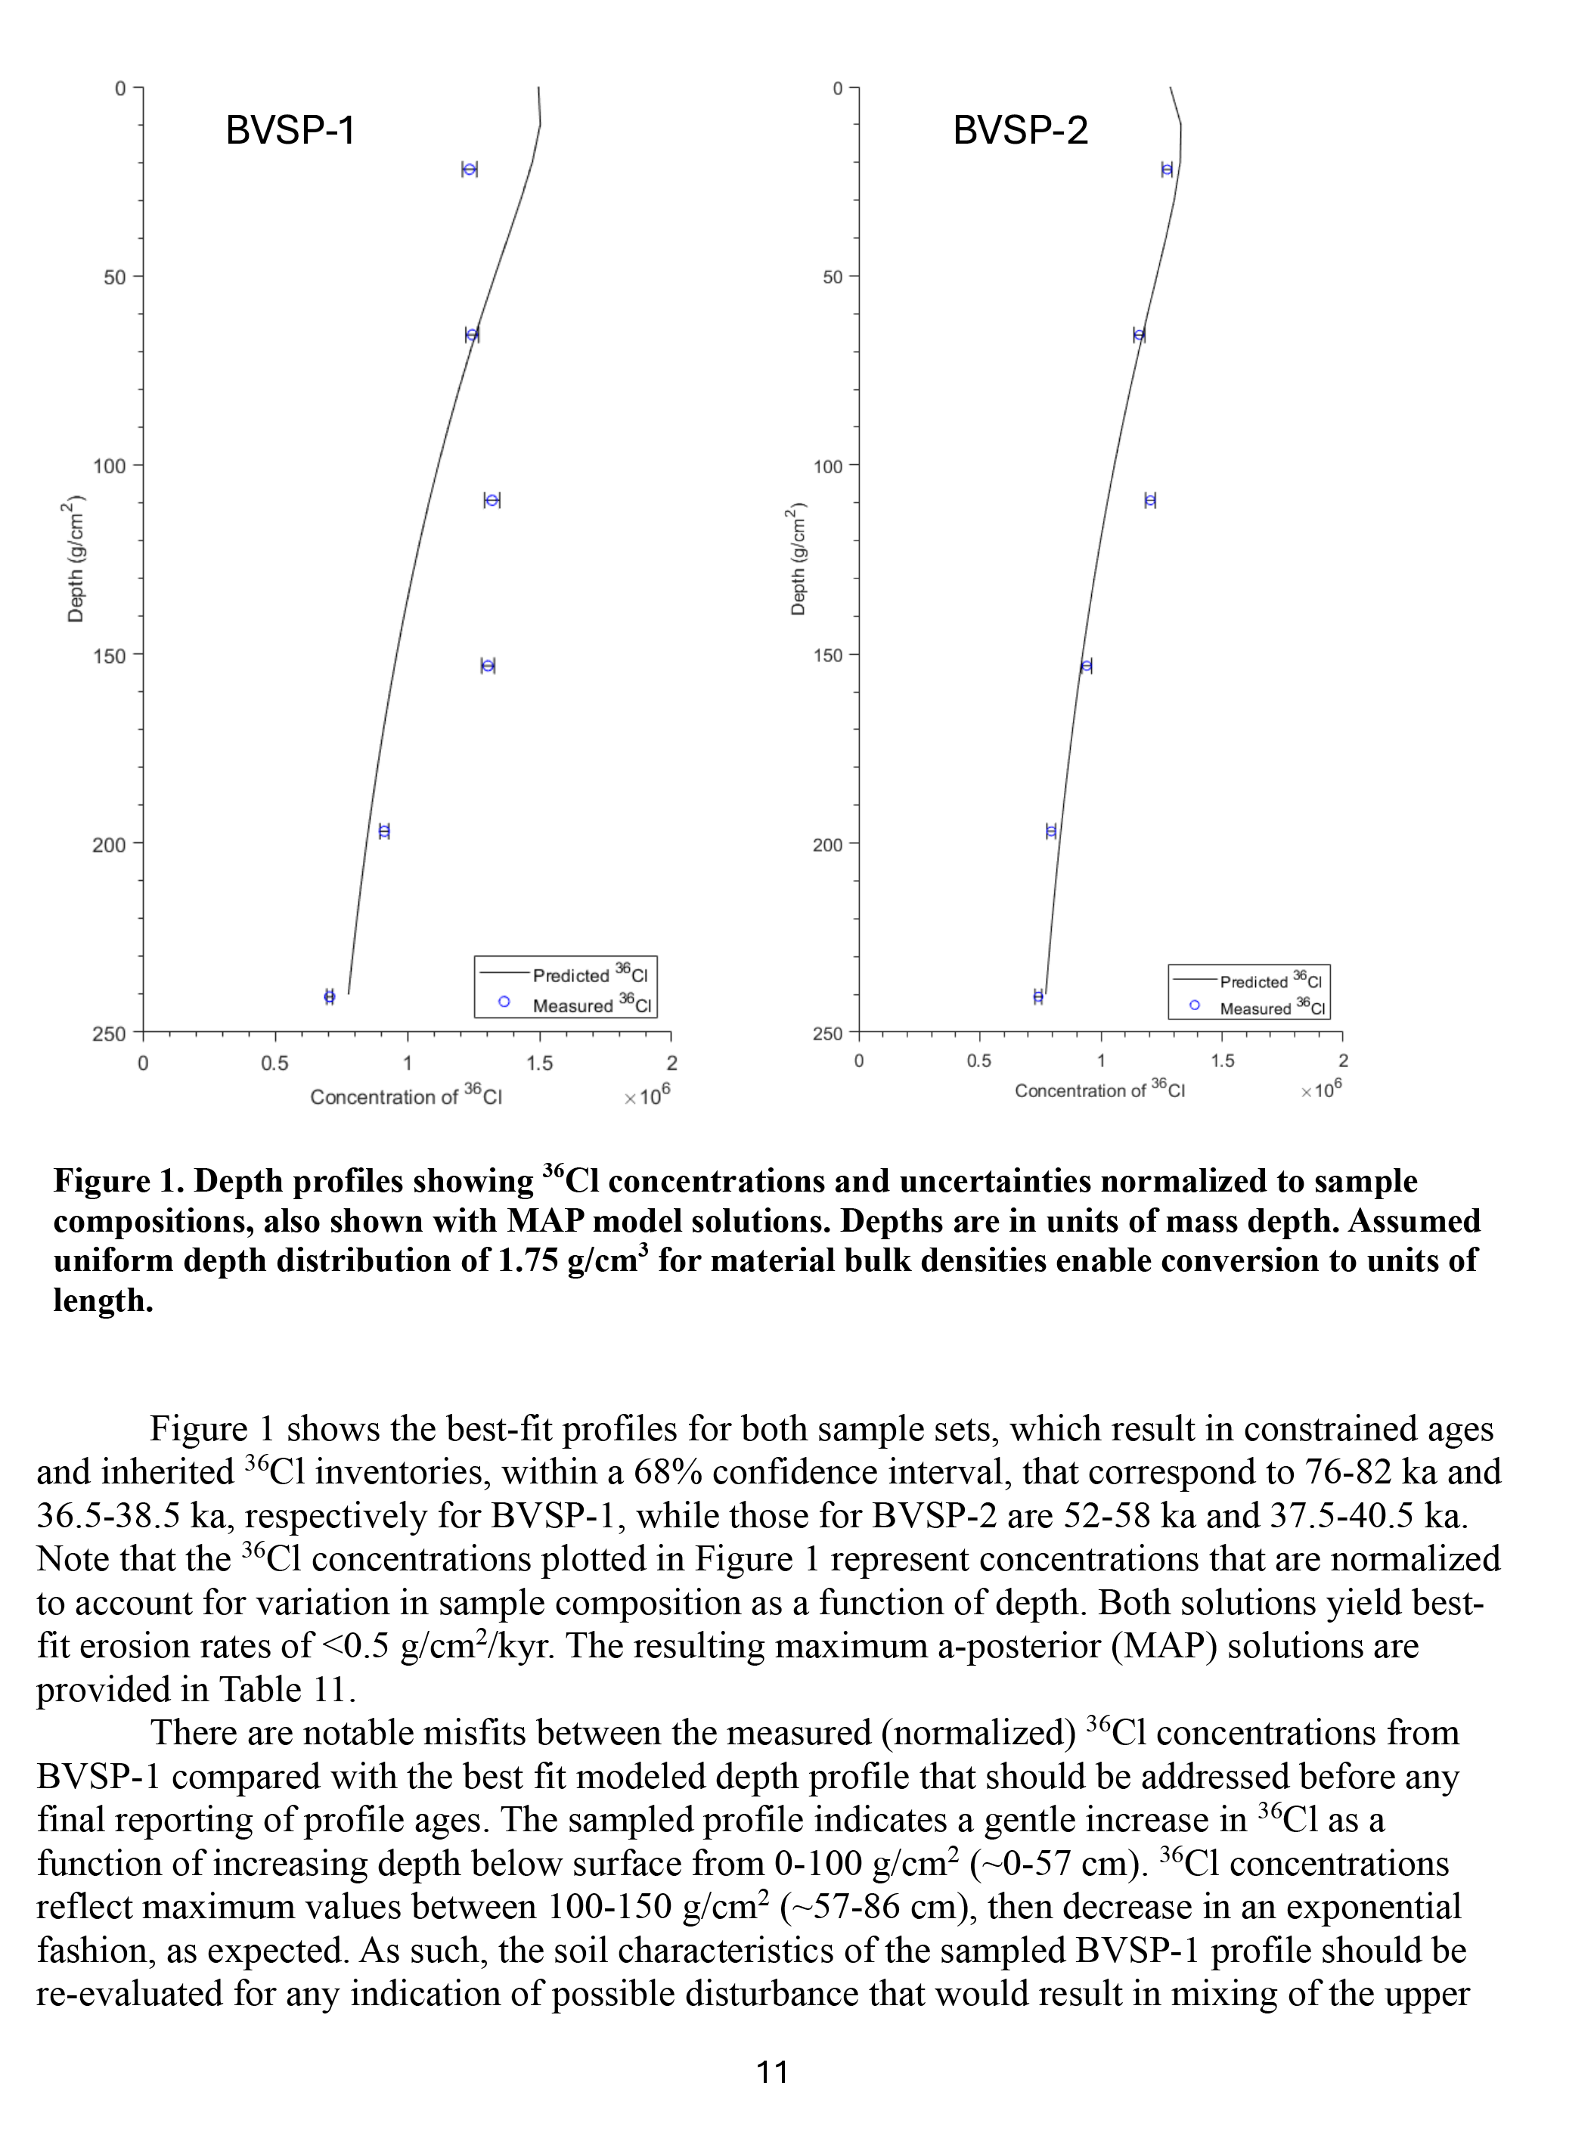
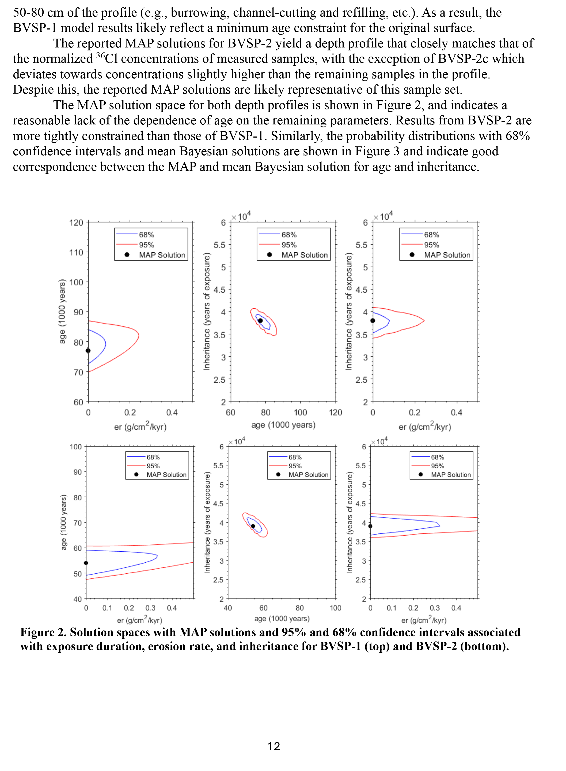
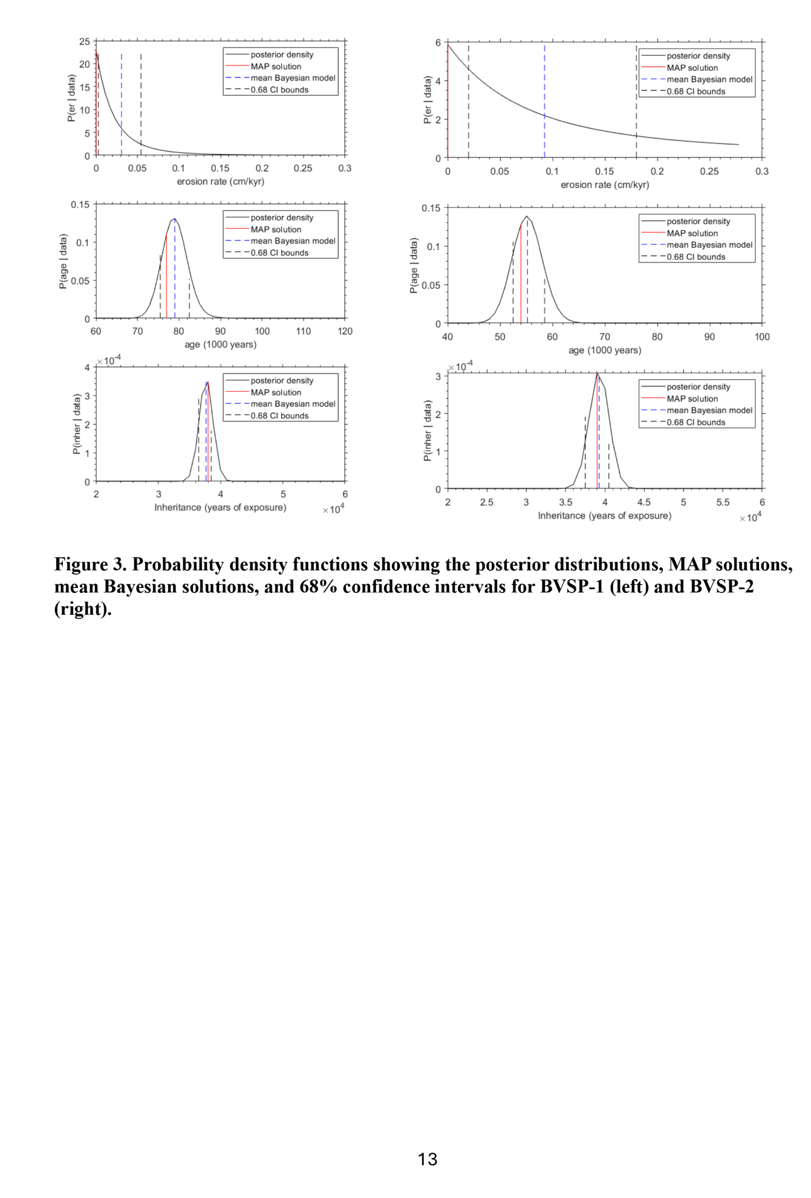
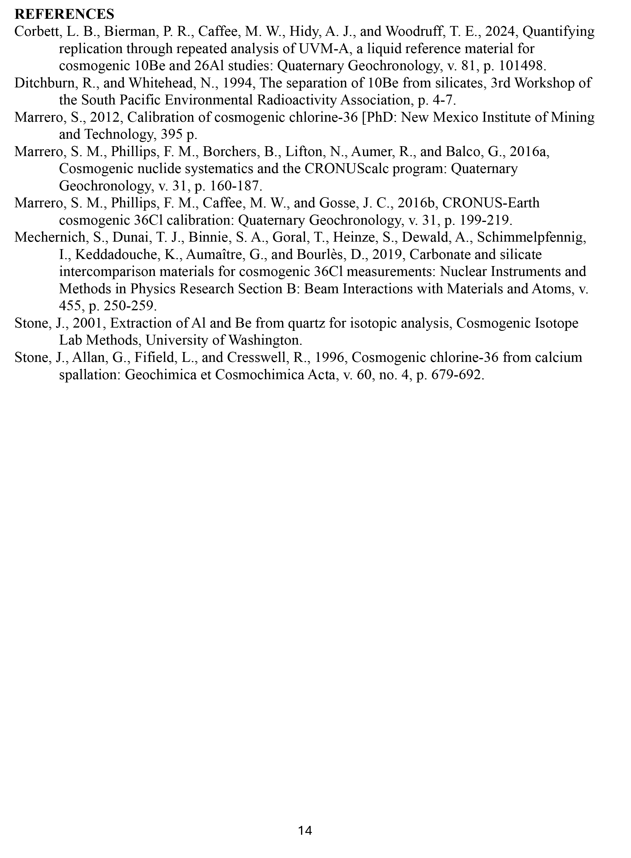
3 Summary of age modelling results for soil pits BVSP-1 and BVSP-2
In each soil depth profile the upper samples including the sample from the AB/Bw horizon in BVSP-1 and the sample from the top of the Btb horizon in BVSP-2 complicated the modelling and appear to reflect soil disturbance. Thus, age models were run in two separate ways; first including all depth samples, and second using only samples below 50 cm. The “mean Bayesian solutions” reflect the solutions within the 1-sigma ranges of model results from which the upper 2 samples were discarded prior to running the models. The Bayesian solution is the method used to solve the best fitting depth profile. The modelling was performed without information from the upper samples and assumes that any erosion was comparable to the subsequent deposition of new material (in terms of overall thickness), and that erosion and deposition occurred as instantaneous events relative to the production rate of 36Cl. Thus, the attenuation length and production rate in the sampled intervals is unchanged during erosional/depositional processes.
Summary of age models
 |  | age range | erosion rate | inheritance
 |  | (ka) | (g/cm2/kyr) | (kyr)
BVSP-01 | all samples | 76-82 | 0-0.05 | 36.5-38.5
 | exclude 0-50 cm | 202-220 | 0.05-0.15 | 7.5-12.5
 | mean bayesian solution | 213 | 0.07 | 10
BVSP-02 | all samples | 52-60 | 0.05-0.55 | 37.5-40.5
 | exclude 0-50 cm | 100-136 | 0.25-0.85 | 23.5-27.5
 | mean bayesian solution | 118 | 0.54 | 26

4 Photographs and GPS coordinates for boulders sampled for ¹⁰Be cosmogenic exposure dating along the Buffalo Valley, Buena Vista, and southern Shoshone faults.

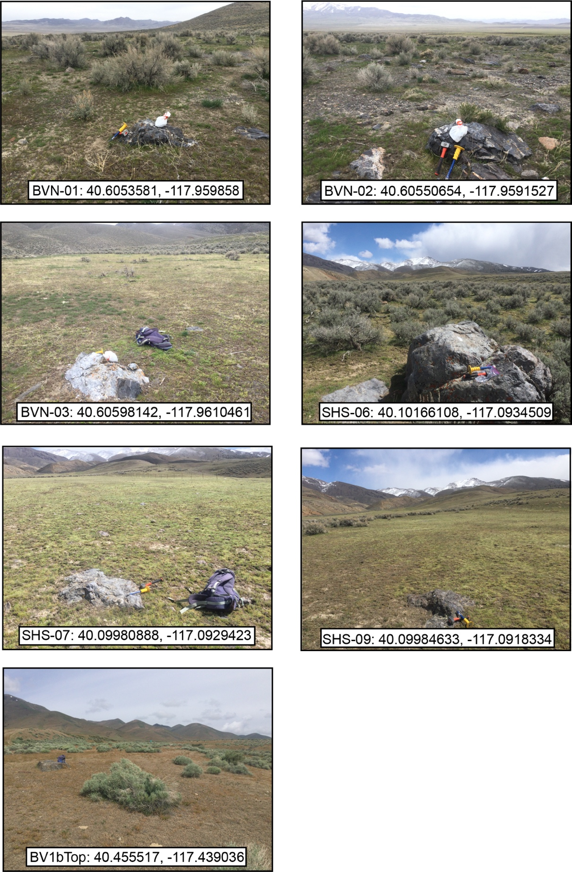
5 CRONUS ¹⁰Be cosmogenic exposure ages for boulders from faulted surfaces on the Buffalo Valley, Buena Vista, and southern Shoshone faults.
The table shows for each each nuclide/mineral pair in each sample, the exposure age (Age), internal uncertainty (Interr), and external uncertainty (Exterr) for each available production rate scaling method (St, Lm, and LSDn). The internal uncertainties consider measurement uncertainties on the nuclide concentration only, and the external uncertainties include both measurement uncertainty and production rate uncertainty.

Sample | Nuclide | St Age (yr) | Interr (yr) | Exterr (yr) | Lm Age (yr) | Interr (yr) | Exterr (yr) | LSDn Age (yr) | Interr (yr) | Exterr (yr)
BVN-01 | Be-10 (qtz) | 698754 | 6765 | 85416 | 614556 | 5631 | 67520 | 624138 | 5754 | 54397
BVN-02 | Be-10 (qtz) | 166683 | 1831 | 14645 | 153497 | 1672 | 12714 | 156288 | 1706 | 10254
BVN-03 | Be-10 (qtz) | 178085 | 1908 | 15747 | 164052 | 1743 | 13667 | 167050 | 1778 | 11022
BV-1B  Top | Be-10 (qtz) | 45003 | 1001 | 3785 | 42136 | 935 | 3371 | 42858 | 952 | 2762
SHS-06 | Be-10 (qtz) | 261504 | 2993 | 24327 | 236783 | 2670 | 20616 | 239558 | 2705 | 16521
SHS-07 | Be-10 (qtz) | 725997 | 6841 | 90333 | 635057 | 5637 | 70688 | 643418 | 5743 | 56759
SHS-09 | Be-10 (qtz) | 389042 | 3679 | 39034 | 347505 | 3202 | 32272 | 350993 | 3241 | 25775

6 Be production rate plots for ¹⁰Be surface exposure samples

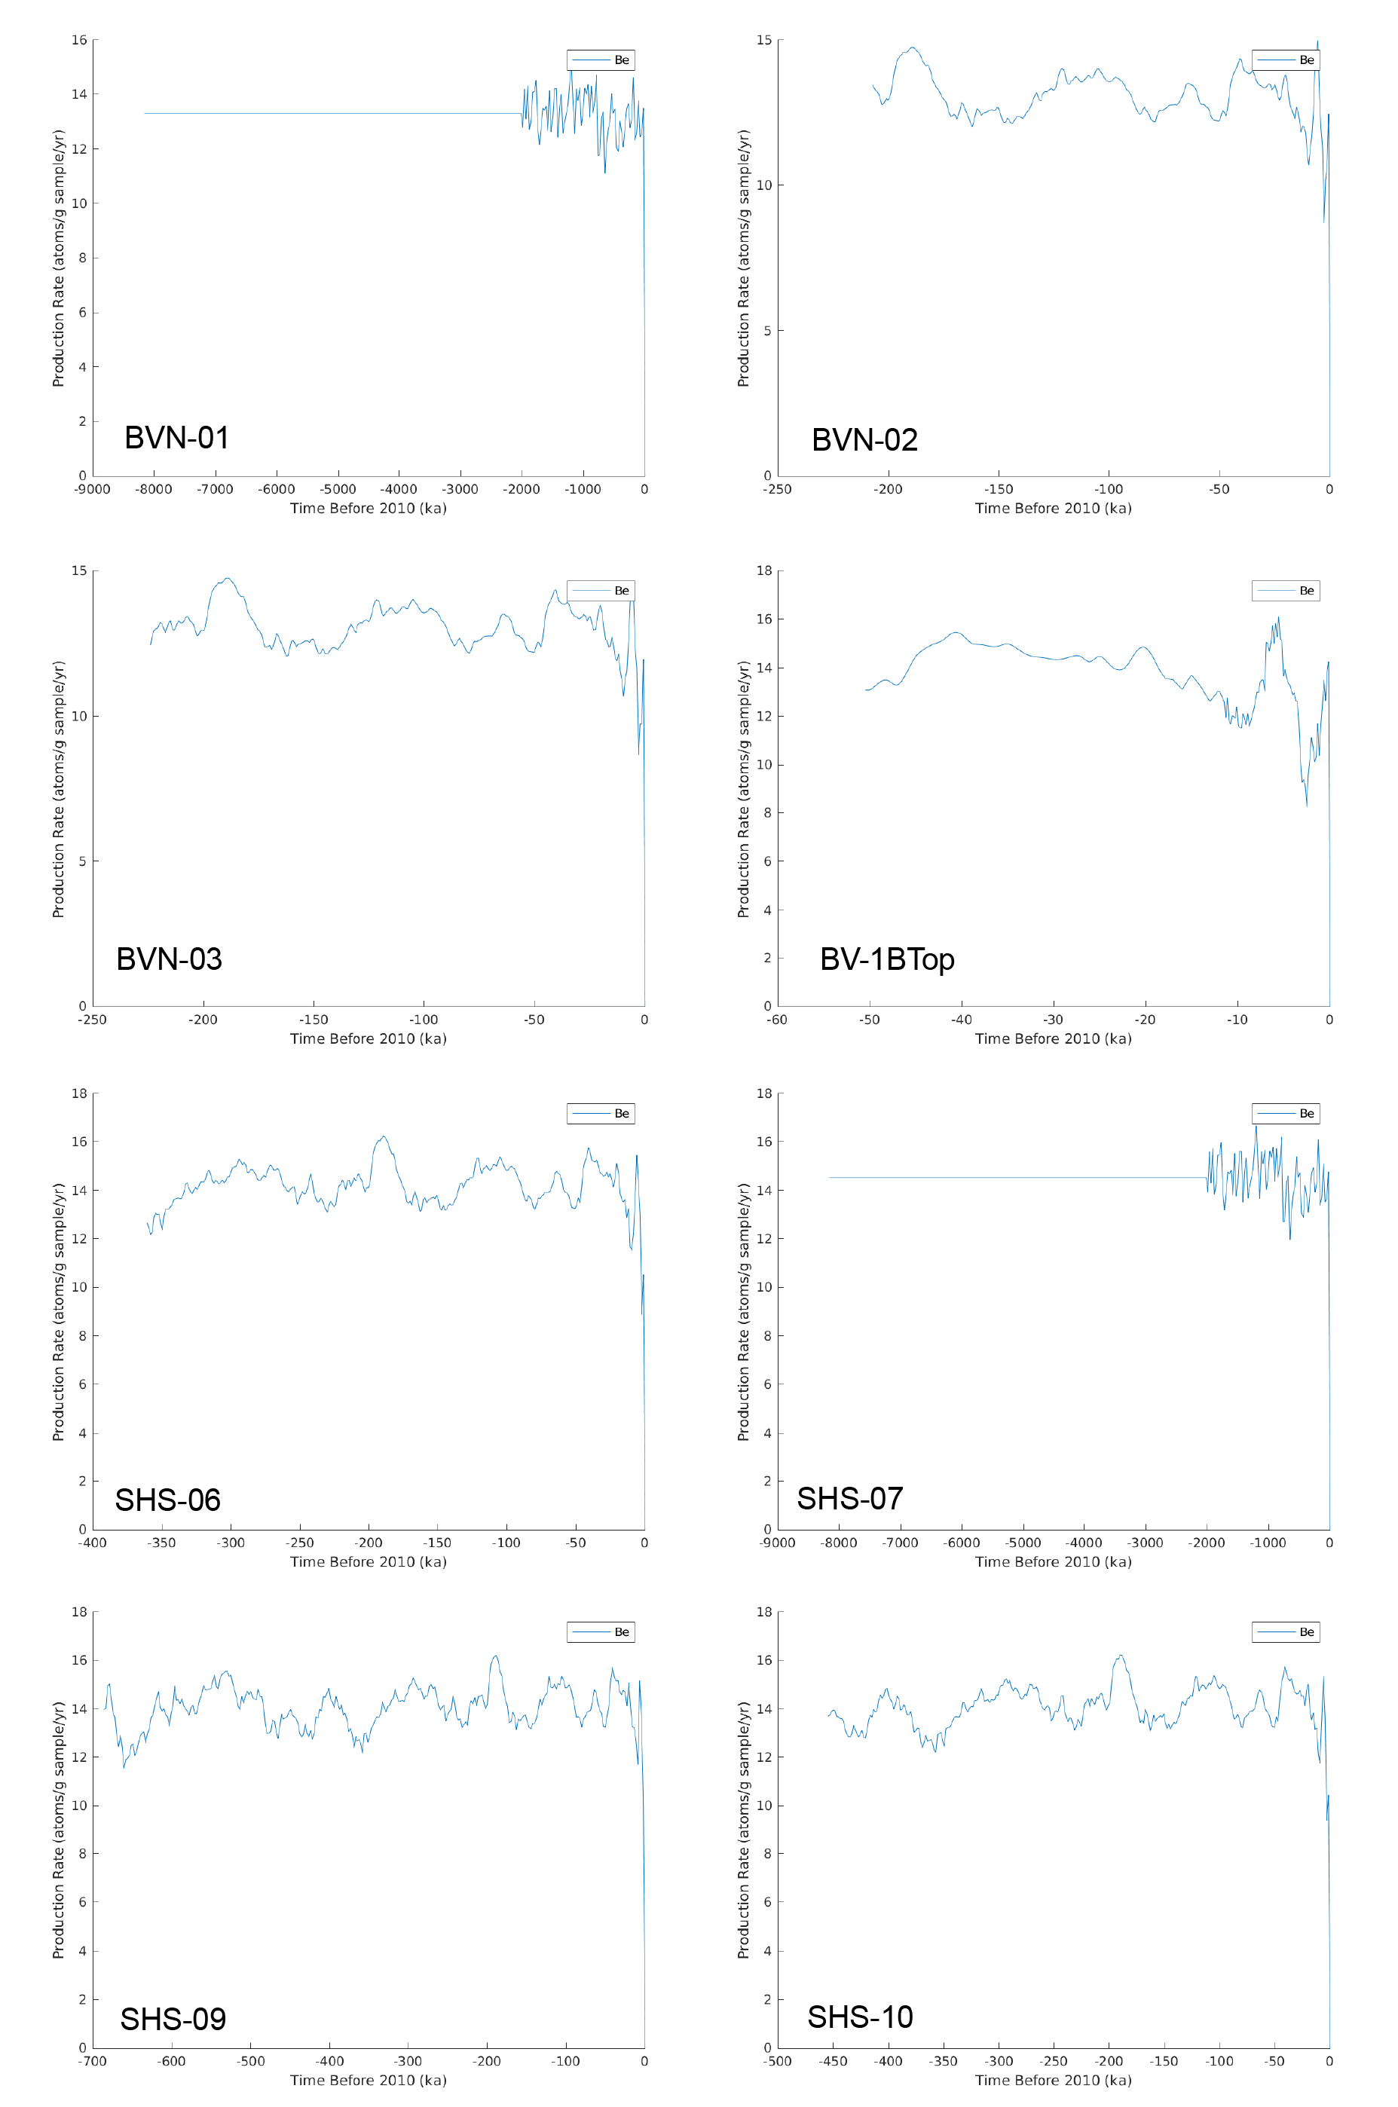
7 Data tables for inputs to the CRONUScalc Matlab program for geochronologic samples from soil pits BVSP-1 and BVSP-2. Geochemical data analyzed by ALS, Reno, Nevada under certificate #RE24107371.
Name | latitude | longitude | elevation | Pressure | sample thickness | bulk density | Shielding | Erosion rate
- | dd | dd | m | hPa | cm | g/cm3 | unitless | mm/kyr
BVSP-1a | 4.05E+01 | -117.427532 | 1660 | 834.849 | 25 | 1.75 | 1 | 0
BVSP-1b | 4.05E+01 | -117.427532 | 1660 | 834.849 | 25 | 1.75 | 1 | 0
BVSP-1c | 4.05E+01 | -117.427532 | 1660 | 834.849 | 25 | 1.75 | 1 | 0
BVSP-1d | 4.05E+01 | -117.427532 | 1660 | 834.849 | 25 | 1.75 | 1 | 0
BVSP-1e | 4.05E+01 | -117.427532 | 1660 | 834.849 | 25 | 1.75 | 1 | 0
BVSP-1f | 4.05E+01 | -117.427532 | 1660 | 834.849 | 25 | 1.75 | 1 | 0
BVSP-2a | 4.05E+01 | -117.438764 | 1604 | 840.506 | 25 | 1.75 | 1 | 0
BVSP-2b | 4.05E+01 | -117.438764 | 1604 | 840.506 | 25 | 1.75 | 1 | 0
BVSP-2c | 4.05E+01 | -117.438764 | 1604 | 840.506 | 25 | 1.75 | 1 | 0
BVSP-2d | 4.05E+01 | -117.438764 | 1604 | 840.506 | 25 | 1.75 | 1 | 0
BVSP-2e | 4.05E+01 | -117.438764 | 1604 | 840.506 | 25 | 1.75 | 1 | 0
BVSP-2f | 4.05E+01 | -117.438764 | 1604 | 840.506 | 25 | 1.75 | 1 | 0

Name | Conc. Cl-36 | inheritance | Lambda Effective | Depth to Top of sample | Year Collected | Water content in pores | SiO2 [%] | TiO2 [%]
- | at Cl-36/g sample | at Cl-36/g | g/cm2 | g/cm2 | Year AD | Volumetric fraction | bulk rock weight % | bulk rock weight %
BVSP-1a | 1.30E+06 | 0 | 155.05 | 0 | 2018 | 0.05 | 73.1 | 0.55
BVSP-1b | 1.28E+06 | 0 | 155.05 | 43.75 | 2018 | 0.05 | 76 | 0.56
BVSP-1c | 1.48E+06 | 0 | 155.05 | 87.5 | 2018 | 0.05 | 73.1 | 0.55
BVSP-1d | 1.24E+06 | 0 | 155.05 | 131.25 | 2018 | 0.05 | 77.1 | 0.55
BVSP-1e | 8.49E+05 | 0 | 155.05 | 175 | 2018 | 0.05 | 78.4 | 0.55
BVSP-1f | 6.56E+05 | 0 | 155.05 | 218.75 | 2018 | 0.05 | 77.9 | 0.52
BVSP-2a | 1.02E+06 | 0 | 154.94 | 0 | 2018 | 0.05 | 76.1 | 0.58
BVSP-2b | 1.16E+06 | 0 | 154.94 | 43.75 | 2018 | 0.05 | 76.1 | 0.58
BVSP-2c | 1.06E+06 | 0 | 154.94 | 87.5 | 2018 | 0.05 | 78.9 | 0.55
BVSP-2d | 1.07E+06 | 0 | 154.94 | 131.25 | 2018 | 0.05 | 74.3 | 0.54
BVSP-2e | 9.35E+05 | 0 | 154.94 | 175 | 2018 | 0.05 | 73.5 | 0.53
BVSP-2f | 7.28E+05 | 0 | 154.94 | 218.75 | 2018 | 0.05 | 79.2 | 0.54

Name | Al2O3 [%] | Fe2O3 [%] | MnO [%] | MgO [%] | CaO [%] | Na2O [%] | K2O [%] | P2O5 [%]
- | bulk rock weight % | bulk rock weight % | bulk rock weight % | bulk rock weight % | bulk rock weight % | bulk rock weight % | bulk rock weight % | bulk rock weight %
BVSP-1a | 1.12E+01 | 4.27 | 0.07 | 1.21 | 0.38 | 0.61 | 2.46 | 0.06
BVSP-1b | 1.11E+01 | 4.32 | 0.06 | 1.18 | 0.4 | 0.61 | 2.39 | 0.05
BVSP-1c | 1.09E+01 | 4.07 | 0.1 | 1.56 | 1.28 | 0.75 | 2.27 | 0.1
BVSP-1d | 1.02E+01 | 3.56 | 0.03 | 0.84 | 0.42 | 0.63 | 2.31 | 0.07
BVSP-1e | 9.79E+00 | 3.35 | 0.04 | 0.75 | 0.27 | 0.5 | 2.48 | 0.04
BVSP-1f | 9.69E+00 | 4.01 | 0.08 | 0.89 | 0.14 | 0.33 | 2.59 | 0.05
BVSP-2a | 9.66E+00 | 4.03 | 0.22 | 1.28 | 0.42 | 0.65 | 2.19 | 0.1
BVSP-2b | 9.66E+00 | 4.03 | 0.09 | 1.28 | 0.42 | 0.65 | 2.19 | 0.1
BVSP-2c | 9.07E+00 | 3.36 | 0.09 | 1.2 | 0.38 | 0.46 | 2.14 | 0.11
BVSP-2d | 9.00E+00 | 3.7 | 0.1 | 1.32 | 2.51 | 0.48 | 2.04 | 0.2
BVSP-2e | 8.96E+00 | 3.9 | 0.11 | 1.39 | 2.3 | 0.57 | 2.06 | 0.2
BVSP-2f | 9.07E+00 | 3.67 | 0.09 | 1.28 | 0.6 | 0.57 | 2.14 | 0.13

Name | Analytical Water | CO2 [%] | Cl (ppm) | B (ppm) | Sm (ppm) | Gd (ppm) | U (ppm) | Th (ppm)
- | bulk rock weight % | bulk rock weight % | bulk rock ppm | bulk rock ppm | bulk rock ppm | bulk rock ppm | bulk rock ppm | bulk rock ppm
BVSP-1a | 4.91E+00 | 0 | 24 | 104 | 3.76 | 3.14 | 3.04 | 9.56
BVSP-1b | 4.62E+00 | 0 | 23 | 102 | 3.8 | 3.24 | 2.66 | 9.5
BVSP-1c | 5.83E+00 | 0 | 29 | 110 | 4.22 | 3.53 | 4.63 | 8.85
BVSP-1d | 4.10E+00 | 0 | 18 | 112 | 2.9 | 2.33 | 3.52 | 6.74
BVSP-1e | 3.25E+00 | 0 | 13 | 115 | 2.89 | 2.77 | 3.03 | 6.91
BVSP-1f | 3.17E+00 | 0 | 11 | 114 | 2.99 | 2.7 | 2.15 | 7.62
BVSP-2a | 2.76E+00 | 0 | 21 | 99 | 5.26 | 4.73 | 2.13 | 7.59
BVSP-2b | 2.76E+00 | 0 | 43 | 99 | 5.26 | 4.73 | 2.13 | 7.59
BVSP-2c | 2.43E+00 | 0 | 33 | 114 | 3.58 | 3.54 | 2.27 | 6.48
BVSP-2d | 4.21E+00 | 0 | 46 | 106 | 4.21 | 3.74 | 3.18 | 6.66
BVSP-2e | 4.35E+00 | 0 | 53 | 111 | 4.05 | 4.07 | 2.95 | 6.29
BVSP-2f | 2.69E+00 | 0 | 41 | 104 | 3.96 | 3.6 | 2.31 | 6.5

Name | Cr(ppm) | Li(ppm) | Target K2O[%] | Target CaO[%] | Target TiO2[%] | Target Fe2O3[%] | Target Cl[ppm]
- | bulk rock ppm | bulk rock ppm | target weight % | target weight % | target weight % | target weight % | target ppm
BVSP-1a |  | 30 | 2.46 | 0.38 | 0.55 | 4.27 | 24
BVSP-1b |  | 30 | 2.39 | 0.4 | 0.56 | 4.32 | 23
BVSP-1c |  | 40 | 2.27 | 1.28 | 0.55 | 4.07 | 29
BVSP-1d |  | 30 | 2.31 | 0.42 | 0.55 | 3.56 | 18
BVSP-1e |  | 30 | 2.48 | 0.27 | 0.55 | 3.35 | 13
BVSP-1f |  | 30 | 2.59 | 0.14 | 0.52 | 4.01 | 11
BVSP-2a |  | 40 | 2.19 | 0.42 | 0.58 | 4.03 | 21
BVSP-2b |  | 40 | 2.19 | 0.42 | 0.58 | 4.03 | 43
BVSP-2c |  | 40 | 2.14 | 0.38 | 0.55 | 3.36 | 33
BVSP-2d |  | 40 | 2.04 | 2.51 | 0.54 | 3.7 | 46
BVSP-2e |  | 40 | 2.06 | 2.3 | 0.53 | 3.9 | 53
BVSP-2f |  | 40 | 2.14 | 0.6 | 0.54 | 3.67 | 41

 | Uncertainty | Uncertainty | Uncertainty | Uncertainty | Uncertainty | Uncertainty | Uncertainty | Uncertainty
Name | latitude | longitude | elevation | Pressure | sample thickness | bulk density | Shielding | Erosion rate
- | dd | dd | m | hPa | cm | g/cm3 | unitless | mm/kyr
BVSP-1a | 2.00E-03 | 0.002 | 3 | 8 | 2 | 0.15 | 0 | 0.1
BVSP-1b | 2.00E-03 | 0.002 | 3 | 8 | 2 | 0.15 | 0 | 0.1
BVSP-1c | 2.00E-03 | 0.002 | 3 | 8 | 2 | 0.15 | 0 | 0.1
BVSP-1d | 2.00E-03 | 0.002 | 3 | 8 | 2 | 0.15 | 0 | 0.1
BVSP-1e | 2.00E-03 | 0.002 | 3 | 8 | 2 | 0.15 | 0 | 0.1
BVSP-1f | 2.00E-03 | 0.002 | 3 | 8 | 2 | 0.15 | 0 | 0.1
BVSP-2a | 2.00E-03 | 0.002 | 3 | 8 | 2 | 0.15 | 0 | 0.1
BVSP-2b | 2.00E-03 | 0.002 | 3 | 8 | 2 | 0.15 | 0 | 0.1
BVSP-2c | 2.00E-03 | 0.002 | 3 | 8 | 2 | 0.15 | 0 | 0.1
BVSP-2d | 2.00E-03 | 0.002 | 3 | 8 | 2 | 0.15 | 0 | 0.1
BVSP-2e | 2.00E-03 | 0.002 | 3 | 8 | 2 | 0.15 | 0 | 0.1
BVSP-2f | 2.00E-03 | 0.002 | 3 | 8 | 2 | 0.15 | 0 | 0.1

 | Uncertainty | Uncertainty | Uncertainty | Uncertainty | Uncertainty | Uncertainty | Uncertainty | Uncertainty
Name | Conc. Cl-36 | inheritance | Lambda Effective | Depth to Top of sample | Year Collected | Water content in pores | SiO2 [%] | TiO2 [%]
- | at Cl-36/g sample | at Cl-36/g | g/cm2 | g/cm2 | Year AD | Volumetric fraction | bulk rock weight % | bulk rock weight %
BVSP-1a | 2.71E+04 | 0 | 1.55 | 0 | 0 | 0.02 | 0.01 | 0.01
BVSP-1b | 2.46E+04 | 0 | 1.55 | 0.44 | 0 | 0.02 | 0.01 | 0.01
BVSP-1c | 2.85E+04 | 0 | 1.55 | 0.88 | 0 | 0.02 | 0.01 | 0.01
BVSP-1d | 2.40E+04 | 0 | 1.55 | 1.31 | 0 | 0.02 | 0.01 | 0.01
BVSP-1e | 1.64E+04 | 0 | 1.55 | 1.75 | 0 | 0.02 | 0.01 | 0.01
BVSP-1f | 1.09E+04 | 0 | 1.55 | 2.19 | 0 | 0.02 | 0.01 | 0.01
BVSP-2a | 1.99E+04 | 0 | 1.55 | 0 | 0 | 0.02 | 0.01 | 0.01
BVSP-2b | 2.21E+04 | 0 | 1.55 | 0.44 | 0 | 0.02 | 0.01 | 0.01
BVSP-2c | 2.00E+04 | 0 | 1.55 | 0.88 | 0 | 0.02 | 0.01 | 0.01
BVSP-2d | 2.03E+04 | 0 | 1.55 | 1.31 | 0 | 0.02 | 0.01 | 0.01
BVSP-2e | 1.77E+04 | 0 | 1.55 | 1.75 | 0 | 0.02 | 0.01 | 0.01
BVSP-2f | 1.38E+04 | 0 | 1.55 | 2.19 | 0 | 0.02 | 0.01 | 0.01

 | Uncertainty | Uncertainty | Uncertainty | Uncertainty | Uncertainty | Uncertainty | Uncertainty | Uncertainty
Name | Al2O3 [%] | Fe2O3 [%] | MnO [%] | MgO [%] | CaO [%] | Na2O [%] | K2O [%] | P2O5 [%]
- | bulk rock weight % | bulk rock weight % | bulk rock weight % | bulk rock weight % | bulk rock weight % | bulk rock weight % | bulk rock weight % | bulk rock weight %
BVSP-1a | 1.00E-02 | 0.01 | 0.01 | 0.01 | 0.01 | 0.01 | 0.01 | 0.01
BVSP-1b | 1.00E-02 | 0.01 | 0.01 | 0.01 | 0.01 | 0.01 | 0.01 | 0.01
BVSP-1c | 1.00E-02 | 0.01 | 0.01 | 0.01 | 0.01 | 0.01 | 0.01 | 0.01
BVSP-1d | 1.00E-02 | 0.01 | 0.01 | 0.01 | 0.01 | 0.01 | 0.01 | 0.01
BVSP-1e | 1.00E-02 | 0.01 | 0.01 | 0.01 | 0.01 | 0.01 | 0.01 | 0.01
BVSP-1f | 1.00E-02 | 0.01 | 0.01 | 0.01 | 0.01 | 0.01 | 0.01 | 0.01
BVSP-2a | 1.00E-02 | 0.01 | 0.01 | 0.01 | 0.01 | 0.01 | 0.01 | 0.01
BVSP-2b | 1.00E-02 | 0.01 | 0.01 | 0.01 | 0.01 | 0.01 | 0.01 | 0.01
BVSP-2c | 1.00E-02 | 0.01 | 0.01 | 0.01 | 0.01 | 0.01 | 0.01 | 0.01
BVSP-2d | 1.00E-02 | 0.01 | 0.01 | 0.01 | 0.01 | 0.01 | 0.01 | 0.01
BVSP-2e | 1.00E-02 | 0.01 | 0.01 | 0.01 | 0.01 | 0.01 | 0.01 | 0.01
BVSP-2f | 1.00E-02 | 0.01 | 0.01 | 0.01 | 0.01 | 0.01 | 0.01 | 0.01

 | Uncertainty | Uncertainty | Uncertainty | Uncertainty | Uncertainty | Uncertainty | Uncertainty | Uncertainty
Name | Analytical Water | CO2 [%] | Cl (ppm) | B (ppm) | Sm (ppm) | Gd (ppm) | U (ppm) | Th (ppm)
- | bulk rock weight % | bulk rock weight % | bulk rock ppm | bulk rock ppm | bulk rock ppm | bulk rock ppm | bulk rock ppm | bulk rock ppm
BVSP-1a | 1.00E-01 | 0 | 0 | 10 | 0.1 | 0.1 | 0.1 | 0.1
BVSP-1b | 1.00E-01 | 0 | 1 | 10 | 0.1 | 0.1 | 0.1 | 0.1
BVSP-1c | 1.00E-01 | 0 | 1 | 10 | 0.1 | 0.1 | 0.1 | 0.1
BVSP-1d | 1.00E-01 | 0 | 0 | 10 | 0.1 | 0.1 | 0.1 | 0.1
BVSP-1e | 1.00E-01 | 0 | 0 | 10 | 0.1 | 0.1 | 0.1 | 0.1
BVSP-1f | 1.00E-01 | 0 | 0 | 10 | 0.1 | 0.1 | 0.1 | 0.1
BVSP-2a | 1.00E-01 | 0 | 1 | 10 | 0.1 | 0.1 | 0.1 | 0.1
BVSP-2b | 1.00E-01 | 0 | 1 | 10 | 0.1 | 0.1 | 0.1 | 0.1
BVSP-2c | 1.00E-01 | 0 | 1 | 10 | 0.1 | 0.1 | 0.1 | 0.1
BVSP-2d | 1.00E-01 | 0 | 1 | 10 | 0.1 | 0.1 | 0.1 | 0.1
BVSP-2e | 1.00E-01 | 0 | 1 | 10 | 0.1 | 0.1 | 0.1 | 0.1
BVSP-2f | 1.00E-01 | 0 | 1 | 10 | 0.1 | 0.1 | 0.1 | 0.1

 | Uncertainty | Uncertainty | Uncertainty | Uncertainty | Uncertainty | Uncertainty | Uncertainty
Name | Cr(ppm) | Li(ppm) | Target K2O[%] | Target CaO[%] | Target TiO2[%] | Target Fe2O3[%] | Target Cl[ppm] | Covariance
- | bulk rock ppm | bulk rock ppm | target weight % | target weight % | target weight % | target weight % | target ppm | Unitless
BVSP-1a | 1.00E+01 | 10 | 0.01 | 0.01 | 0.01 | 0.01 | 0 | 310
BVSP-1b | 1.00E+01 | 10 | 0.01 | 0.01 | 0.01 | 0.01 | 1 | 240
BVSP-1c | 1.00E+01 | 10 | 0.01 | 0.01 | 0.01 | 0.01 | 1 | 270
BVSP-1d | 1.00E+01 | 10 | 0.01 | 0.01 | 0.01 | 0.01 | 0 | 1700
BVSP-1e | 1.00E+01 | 10 | 0.01 | 0.01 | 0.01 | 0.01 | 0 | 730
BVSP-1f | 1.00E+01 | 10 | 0.01 | 0.01 | 0.01 | 0.01 | 0 | 670
BVSP-2a | 1.00E+01 | 10 | 0.01 | 0.01 | 0.01 | 0.01 | 1 | 970
BVSP-2b | 1.00E+01 | 10 | 0.01 | 0.01 | 0.01 | 0.01 | 1 | 2000
BVSP-2c | 1.00E+01 | 10 | 0.01 | 0.01 | 0.01 | 0.01 | 1 | 1900
BVSP-2d | 1.00E+01 | 10 | 0.01 | 0.01 | 0.01 | 0.01 | 1 | 3000
BVSP-2e | 1.00E+01 | 10 | 0.01 | 0.01 | 0.01 | 0.01 | 1 | 580
BVSP-2f | 1.00E+01 | 10 | 0.01 | 0.01 | 0.01 | 0.01 | 1 | 320

